The Noonan Academy Chess Club
would like to invite you to a
Scholastic Chess Tournament
Friday, November 21, 2025
Doors Open 5:00 pm
Check in and Registration Close at 5:45
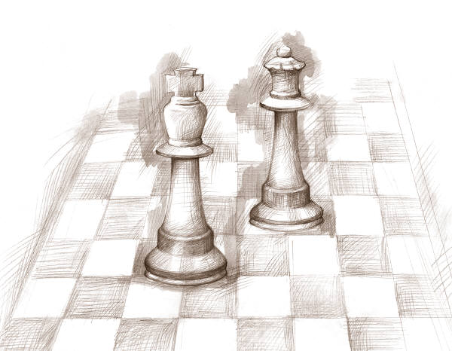
6:00 p.m. Tournament Begins - 9:00 p.m. Awards Ceremony
Sections K-1, 2-3, 4-5, 6-8

Also Including
Trophies to the top three teams and top five individuals in each section. Medals for everyone in the scholastic division not receiving a trophy.

Student Entry fee is $25 if registered before November 20th and $30 thereafter.
Registration at the door will be $35 for all participants.
Please note this event is not rated and is open to players rated less than 500 (USCF) or unrated.

Register Online at: https://kingregistration.com Select tournaments; search for Noonan Academy

Student registration includes slice of cheese pizza and drink. Adult dinner ($10) and Sibling ($5) pizza available if pre-ordered by 11/19 by contacting mbmueller@noonanacademy.org
Accompaniment: We ask that a parent or a designated responsible adult be present with the child.

Noonan Academy – Junior High Gym
19101 Henry Drive
Mokena, IL 60448
(708) 479-8988

