GALLATIN GATEWAY SCHOOL

Long-Range Facility Plan

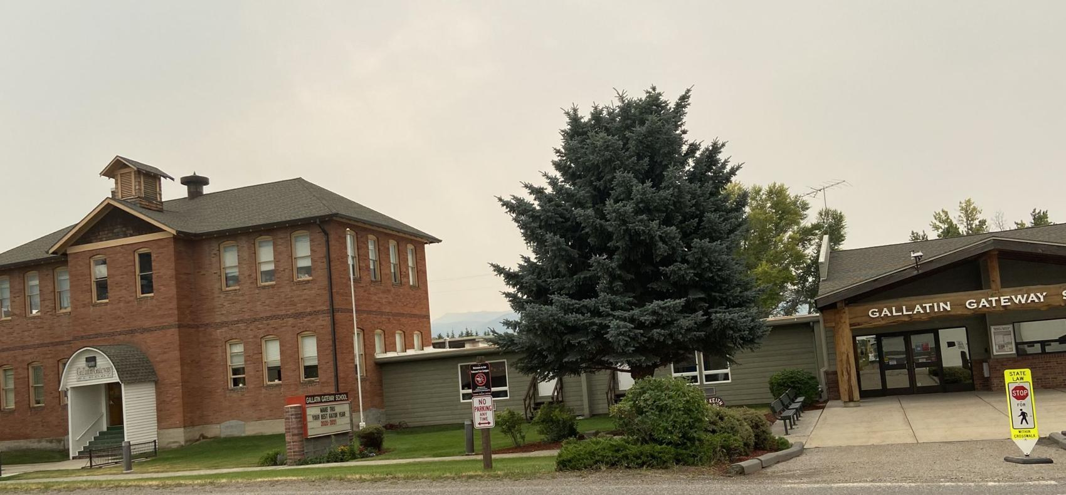

Reviewed and adopted: May 2024
Contents
District Overview 3
Campus Information 3
Building Assessments 5
Identified Deficiencies 5
District Educational Program Standards 8
School Capacity and Demographics 9
Future Facility Needs and Options 11
Meeting District Needs – Now and Into the Future 11
Evaluating Potential School Sites 11
Facility Improvement Finance Options 13
Conclusions and Recommendations 14

District Overview
Gallatin Gateway School District is a rural elementary school District in southwest Montana. The District’s geographic area includes approximately 175,207 acres and is located approximately 13 miles from Bozeman. The District currently operates one campus comprising a school building, playground, and parking area.

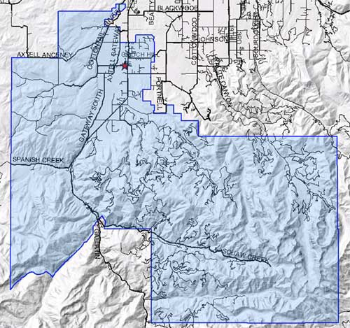

Campus Information
Gallatin Gateway School
100 Mill Street, Gallatin Gateway, MT 59730

Year of original construction: 1915 (1914)
Major renovations: 1961, 1966, 1978, 2001
Lot size (acres): approximately 3.6
Building size: 35,136 SF
Grades: PreK-8
Teaching spaces/Classrooms: 15
Capacity: 236

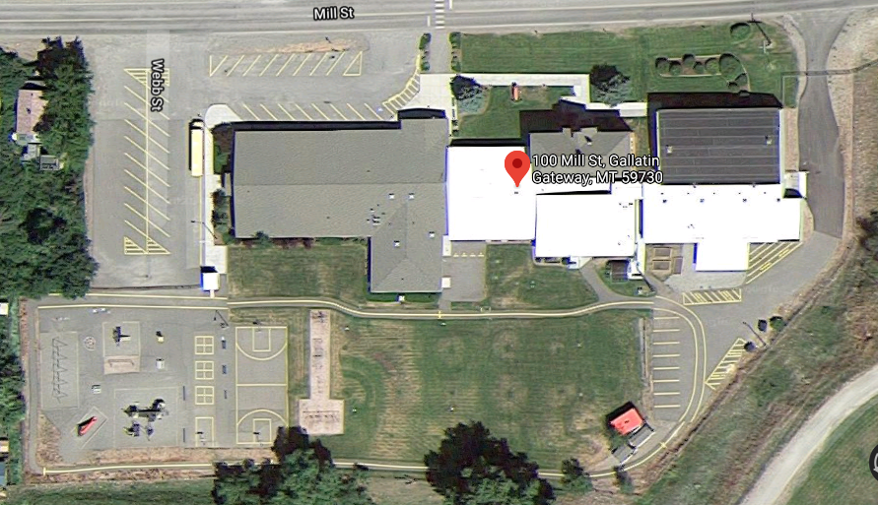

The Gallatin Gateway School building is comprised of multiple eras of additions as illustrated below:

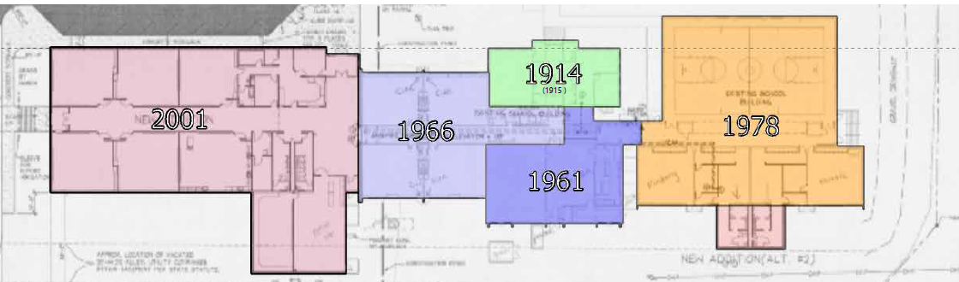

The Pre-Bond Assessment completed by Cushing Terrell & DCI Engineers in 2020 describes how each addition currently functions and is used:

1914
The original two-story school was constructed and remains at its original location. This structure includes a basement with two floors above. The 1914 school building contained four classrooms, four restrooms, one office, and storage areas. This structure was constructed using load-bearing masonry walls and wood-framed floor and roof assemblies.

1961
The first single-story addition was constructed south of the original school. This included four classrooms, a multi-purpose room, and restrooms.

1966
The second single-story addition was constructed west of the original school and the 1961 addition. This included four classrooms with each pair of rooms sharing a small restroom.

1978
The third single-story addition was constructed to the east of the 1961 addition. This included a gymnasium, locker rooms, and two classrooms.

2001
The fourth and most recent addition was built to the west of the 1966 addition. This included six additional classrooms, restrooms, administrative offices, library & computer lab. Additional restrooms were included as an alteration south of the locker rooms on the far east side of the building.

Building Assessments
Multiple assessments have been completed on the District building in recent years (i.e. 2012, 2016, & 2020) Most recently, in June 2020, Cushing Terrell and DCI Engineers conducted a Pre-Bond Assessment which identified many life-safety issues and identified many areas and systems throughout the building and noted the following in their summary of findings:
“The Gallatin Gateway School was constructed with quality materials and portions remain in serviceable condition. The multiple eras of additions throughout the years have some building envelope repairs that are needed, as well as a roof replacement. Throughout the interior, safety, and security upgrades need to be made in the Main Office area and exiting, to provide further security for the school; thermal comfort and ventilation in the classrooms need improving and updated HVAC systems; fire alarms need to be consolidated, non-serviceable electrical panels need replaced.”

“Most deficiencies identified are related to materials close to, or over, their lifespan. Life safety, building envelope, & safety/security items are the focus for prioritizing recommendations.

The June 2020 report also indicated the following site challenges:
“The primary challenges of this site are due to pedestrian and vehicular circulation for pick up and drop off times, general wear in the asphalt near the playground, visual surveillance from interior to exterior, and building and site drainage which are directing water back towards the building.”

Identified Deficiencies
Per the June 2020 Pre-Bond Assessment conducted by Cushing Terrell and DCI Engineers the following deficiencies have been identified and recommended the following priorities:
- To bring the entire building in compliance with today’s building codes:
  - Replacement of the non-rated corridor doors to 20-minute rated doors with closers and smoke seals, replacement of all non-rated glazing (doors & walls) in the corridors with rated/safety glazing, and
  - the installation of an automatic fire sprinkler system (entirety of building).
  - Items specific to the original 1914 building:
    - Add an interior fire-rated stairwell,
    - re-work the fire escape to accommodate a second means of egress from the second floor,
    - redesign of the bathrooms to make them handicap accessible,
    - install an elevator for accessibility,
    - replace the non-rated glazing in doors with safety glazing, patch & repair the holes in the upper floor rooms and re-paint,
    - replace the run of stairs from the first floor to the main level of the building to have consistent riser heights & eliminate the tripping hazard, and
    - re-glaze and repaint the original windows.
  - Other exterior items to be considered on or adjacent to the 1915 building include:
    - brush off the efflorescence patches visible on the exterior brick walls,
    - patch the failing mortar joints,
    - reconstruct the fence and gate (at the exterior fire stair) to accommodate an opening size for egress exiting.
  - Structural systems considerations for the 1915 building:
    - The structural members of the roof and floors are undersized per today’s loading standards.
    - The roof and floor systems need to be better tied to the masonry walls to increase resistance to a seismic event
    - The floors and interior side of the walls should be sheathed in plywood to increase resistance to seismic event
- Exterior elements to prioritize include repair of the building envelope failures, such as:
  - filling in voids around windows, doors, and exposed joints in CMU & brick wainscot walls.
  - The mechanically fastened roof membrane appears to be close to its lifespan and should be considered for replacement.
  - Revising the fire exit stair discharge/roof access doorway for adequate exiting requirements and limiting unwarranted rooftop access is recommended.
- The additional interior building recommendations are:
  - to remove and replace the failing VCT flooring in the 2001 portion with a product suitable for the location.
  - Safety and security review concludes that the main entry administration offices and lobby are disconnected from key opportunities for visual surveillance. Not being able to see visitors entering the campus and entry doors poses challenges and safety concerns for the school administration. Recommend to provide appropriate visual connections, secure entry lobby, as well as opportunities to shut portions of the school off to public access during after-hour events, and provide adequate exiting.
- Mechanical priorities and considerations include:
  - Update the entire building to modern Direct Digital Controls (DDC) supervisory controller.
  - Improve thermal comfort and ventilation in the classrooms.
  - Update the HVAC systems in all occupied spaces of the building.
  - Replace the Gymnasium Air Handling units with new units.
  - Replace the cafeteria heating unit with a small air handler to handle ventilation, heating, and cooling.
  - Replace the four existing boilers with new high-efficiency boilers.
- Electrical/Fire Alarm/IT Infrastructure Upgrade Priorities and consideration:
  - Upgrade and consolidate fire alarm systems under a single manufacturer and location.
  - Add mass notification functionality for campus-wide audible messaging capability.
  - Replace non-serviceable/dangerous electrical panels and follow up with a campus-wide Arc Flash Hazard Analysis.
  - Address emergency lighting deficiencies throughout the school campus.
  - Provide separate, secured IT space with dedicated cooling/ventilation.

District Educational Program Standards
Gallatin Gateway School community values a small school setting, which currently supports one classroom per grade level, K-8. Gallatin Gateway School is an Accredited Independent K-8 Elementary School. We are a Targeted Title I school, which means that we receive supplemental funding to support students who are considered academically at-risk. We provide Special Education and Federal 504 services based on Federal and State Guidelines. We value and hold ourselves accountable for the individual success of each student.

Gallatin Gateway School is a one-to-one laptop district. Students take keyboarding in grades K-5, then transition to technology applications at the Middle School Level. The use of technology is an integral part of the learning and curriculum for all students. Maintaining and planning future network and device growth to support the increasing use of technology is a major part of effective facility planning.

Primary classrooms (Grades K-5) are self-contained classrooms where students have the same teacher throughout the day, except for their special classes (P.E., Music, and Art). We offer full-day Kindergarten.

Middle School classrooms (Grades 6-8) follow a traditional Middle School Schedule with seven periods, which include their Core Courses (E.L.A., Math, Social Studies, and Science) and two elective periods. Our community is committed to offering a rich variety of elective courses, including Technology applications, Exploratory Science, Band, Choir, Spanish, Art, and many others.

The Gallatin Gateway School community greatly values a rigorous Music and Art program throughout grades K-8. In grades K-3, students are provided with a comprehensive music curriculum. In grade 4, students begin learning the recorder. In grade 5, all students are included in the band, where they can select an instrument to learn and perform. In grades 6-8, students have the opportunity to continue with band, participate in choir, or learn guitar. Art, including art history, is taught at every grade level, using all mediums.

Maintaining the small school setting, as well as providing a rich accredited academic program requires prudent facility planning that takes into account class size, full-time educators, and spaces that support a vibrant counseling program, Title I, Special Education, and opportunities for individualized instruction based on individual student needs.

School Capacity and Demographics

School Year | Enrollment | OPI Maximum Capacity by number of students (1 class/1 grade) | Recommended Classroom Square Footage (45 ft2 per student current enrollment)
2018-2019 | 167 | 236 | 7515
2019-2020 | 172 | 236 | 7740
2020-2021 | 153 | 236 | 6885
2021-2022 | 160 | 236 | 7200
2022-2023 | 146 | 236 | 7200
2023-2024 | 137 | 236 | 6165
2024-2025 | 128 | 236 | 5,760
2025-2026 |  | 236

Based on the 2023 Demographics Study, enrollment at Gallatin Gateway School is predicted to remain relatively static until 2027-2028, when enrollment is predicted to slowly increase. The study predicts an increase in total enrollment by 27.7% (15 students) from 2027-2033.

Part of the small community feel of Gallatin Gateway School is due to small class sizes. Classrooms have had, on average, 17 students per classroom over the last five years. If the school district were to maximize class size to an enrollment of 236, we could continue to maintain one grade for one classroom. The consequence of maximizing class sizes means that Kindergarten, First, and Second Grade classrooms would each have 20 students. Third and Fourth-grade classrooms would each have 28 students, and fifth-grade through eighth-grade classrooms would have 30 students each. While maximum class sizes are possible, there would be an adverse effect on the small-community feel.

The classroom square footage supports the current smaller class sizes at the recommended square footage -- an average of 45 sq. ft. per student. However, when class sizes increase, the classroom square footage remains finite at 7406 sq ft. The amount of square footage per student decreases, and at a maximum enrollment of 236, the square footage per student would be 36 sq. ft per student. The district could reduce class sizes by increasing the number of teachers and using non-core classroom learning spaces as additional core classrooms (i.e. technology lab, art, music, etc.).

New legislation requires Gallatin Gateway School to consider Non-resident students. While non-resident students make up 25% of student enrollment, the district will be required to pay other districts property tax funding to support non-resident students from our district to theirs. Welcoming students from outside the district increases the district’s ability to fund personnel to provide the academic program described in District Educational Program Standards. We receive general fund support from the state and also are provided tax funding from the leaving district. We provide a rich and rigorous curriculum due to the number of teaching staff we can fund. If we did not welcome out-of-district students this year, for example, we would have to decrease our current teaching staff by three teachers, due to a loss of per-student state funding. This would require at least two grade levels to combine and be taught by one teacher in one classroom. Music and art would also have to become classroom activities, rather than consistent courses taught by qualified teachers.

Future Facility Needs and Options

Meeting District Needs – Now and Into the Future
Phase I: 0-5 years
Based on assessments of the current building structure there are many deficiencies and deferred maintenance needs. In addition to the aforementioned needs, the district is not currently prepared for substantial growth but does have the current capacity for limited growth.

Recommended Solution:
Research and utilize grant funding and capital fundraising to begin remediation of deficiencies and deferred maintenance needs. The district will complete a facilities energy audit to improve efficiencies throughout the building.

Phase II: 5-7 years or 90% capacity
Assuming Phase I is completed. Once the District reaches 90% capacity it will trigger phase II and the district will need to begin the process of increasing the building capacity, updating, and renovating spaces. The 1914 building will be preserved through energy efficiencies to include HVAC, windows, and insulation.

Recommended Solution(s):
Utilize the District’s maximum bonding capacity (approx.: $7M) to update and remodel the current facility with a plan to address future expansion. The district should also continue to monitor options for adjacent land acquisition within the District Boundaries to increase the current footprint of the district. Explore a plan to purchase additional property for a future school site (elementary, K-8, or middle school) within the district boundaries that meets the criteria for potential school sites.

Phase III: 5-10 years or 100% capacity
Assuming no additional construction has occurred (Phase I and II not completed) the district facility will be beyond its lifespan and will have reached full capacity. Once the District reaches 100% capacity it will trigger phase III to increase the building capacity.

Recommended Solution(s):
Explore and develop a plan to demolish the 1966 portion of the building and rebuild a two-story addition to match renovations and additions from phase II. This addition will likely include more classrooms, gym space, and cafeteria space. Modular units could be used to accommodate any capacity exceeding 100% until a plan is developed and implemented. Explore and develop a plan to update, renovate, and expand the district facility. This addition will likely include more classrooms, gym space, and cafeteria space. To meet projected capacity demands increased school capacity and updating will be required. Continue to explore a plan to purchase additional property for a future school site (elementary, K-8, or middle school) or purchase/lease adjacent property to increase the district’s footprint within the district boundaries that meets the criteria for potential school sites.

Evaluating Potential School Sites
Upon determining that there is a need for new facilities, a review of potential sites must consider many factors including health and safety, location, accessibility, environment, physical characteristics (soil and topography), acquisition and development costs (including utilities, and coordination with local comprehensive plans. The criteria outlined below are designed to select sites that provide the best environment for the instructional program and learning process:

Safety:
- If adjacent to or near arterial roadways the site must have adequate room on the property to maintain sufficient setback to ensure a good learning environment- preferably a 200-foot
- Easily reachable by emergency response vehicles
- These factors should be avoided:
  - Crossed by high-voltage (500 KV) power lines
  - Close to high-decibel noise sources
  - Close to open-pit mining
  - In a dam inundation area or 100-year floodplain
  - Social hazards such as high incidence of crime, drug use, or alcohol use
  - Areas which allow for air, water, and soil pollution
  - Danger of slides or liquefaction
  - Obstacles such as crossings on major streets and intersections, narrow or winding streets, heavy traffic patterns
  - Remote areas (with no sidewalks) where students walk to and from school

Location:
- Logical for families within the enrollment area
- Proximate to Gateway proper
- Safe walking areas can be provided
- Multiple street approaches available (2+ frontages ideal)
- Provides aesthetic view from and of the site
- Desirable features include a variety of trees and plants or a wooded area for use in education programs such as biology or outdoor learning

Size & Shape
- Minimum of 10 acres
- Length-to-width ratio does not exceed 2:1
- Sufficient open play area and open space
- Potential for expansion for future needs
- Area for adequate and separate bus loading and parking

Soils & Topography
- Stable subsurface and bearing capacity
- Generally, level
- Flat sites preferred; if a flat site is unavailable, choose a site with minimal need for major excavation
- Positive drainage
- Adequate surface and subsurface drainage

Cost & Availability
- Reasonable costs for purchase of property, site preparation including but not limited to, drainage, parking, driveways, removal of any existing building, grading, and environmental mitigation
- On the market for sale or likely be available
- Title clearance- unencumbered
- Condemnation of building and relocation of District residents to be avoided

Facility Improvement Finance Options
General Operating Fund:
Capital improvement projects are large projects that cannot generally be funded from the annual operating budget. However, regular maintenance and upkeep of the facility and grounds have generally been covered by the general fund operating budget and should continue to ensure all systems are operating at maximum efficiency and well-maintained.

Building Reserve (voted levy):
The Building Reserve Fund is used to accumulate funds for future construction, equipping or enlarging school buildings, or purchasing land needed for school purposes. The fund is established upon passage of a voted levy that authorizes the levy for up to 20 years.

The District approved a 5-year building reserve levy in the amount of $35,000/year ($175,000 total) in May 2017 to properly maintain equipment, furnishing, remodeling, and retrofitting buildings and grounds of the district. The last year of this levy is FY27.

The levy has been used to cover the cost of improvements such as, but not limited to: bathroom remodeling, painting, plumbing repairs and improvements, sewer repairs, regular maintenance and upkeep of building and grounds, and building assessments and projects associated with the FY21 bond process. Primarily, the funds have been utilized to remediate the HVAC/Boiler system needs in the last two years with 22-23 school year utilizing approximately $70,000 to repair the aging system.

As of April 18, 2024 the balance of funds was: $85,940.00.

Building Reserve (permissive levy):
According to SB307 (2017), the trustees of a district may authorize and impose a levy of no more than 10 mills on the taxable value of all taxable property within the district for that school fiscal year to raise revenue for identified school major maintenance projects.

The levy has been used to cover the cost of improvements such as, but not limited to: LED lighting upgrades, gutter repairs/replacements, HVAC upgrades/repairs, building/safety assessments, and safety upgrades such as security entrance upgrades.

As of April 18, 2024 the balance of funds was: $58,058.00

Debt Service Fund:
The Debt Service Fund is used to budget and pay for a school district’s bond debt, including principal and interest payments, agent fees, and/or special improvement district payments (SIDs). This is a budgeted fund with a voted levy. The last voted levy imposed on Gallatin Gateway District taxpayers was in October 2000 for $1,540,000. The general obligation bonds were paid in full June 30, 2021.

District Bonding Capacity & Taxable Value:
Montana’s current limit on debt is 100% of the estimated tax base.
FY21 District Tax base/Taxable Value: $7,124,119
The Governing Board and Facilities Committee have discussed the possibility of asking for a bond to update and renovate spaces, assist with energy efficiencies (windows, HVAC, solar, upgraded electrical panels, lighting systems, automated systems, etc), deferred maintenance, remodel the 1914 building for usable space, upgrade the playground and community park, updated instructional technology and systems, and purchase/lease property to increase the current footprint.

Conclusions and Recommendations
Gallatin Gateway School District’s facility has reached or is beyond its life expectancy in many of its systems and is in dire need of extensive upgrades, repairs, and renovations. In the past, the focus has been to maintain the facilities and perform timely preventative maintenance to preserve facility assets, but the time has come when the District has an immediate need for replacement of many systems such as HVAC, boilers, roofing, electrical, mechanical, plumbing, and flooring.

Therefore, the overall recommendation for the District moving forward would be to:
- Address all facility deficiencies and deferred maintenance issues.
- Monitor student enrollment vs. facility capacity retaining the small school community feel
  - Maintain our support for Non-Resident Student policy with a threshold of 25% of the total student population -- revise if enrollment reaches 75% of capacity (177 students) to accommodate in-district student enrollment growth.
  - Maintain an average student-to-teacher ratio between 17-20 students in each classroom. Utilize non-core instructional classrooms and hire additional staff to maintain the ratio.
  - When enrollment reaches 90% of capacity (212 students), recommend Phase II in Future Facility Needs and Options.
- Explore options for property acquisition and monitor property availability within District boundaries that meet the criteria within this plan for potential school sites.
- Ensure the District is prepared to move forward at each phase outlined in the plan.
- Re-evaluate the current plan as each phase is reached and/or completed.

