McCloud Union School District
We, the staff of McCloud Elementary School, in partnership with our students, parents, and community members, are committed to preparing our students for success in the present and future world.

Health and Wellness Policy

1. Goals and strategies for increasing student participation in the school breakfast & lunch programs.
- Nutrition Services employs well-prepared staff that efficiently serve appealing choices of compliant, nutritious foods at breakfast, snack, and lunch time.
- Our District will participate in available federal school meal programs.
- Our school currently participates in CEP, Community Eligibility Provision. CEP benefits students and schools. When a child’s nutritional needs are met, they can focus on learning, not hunger. CEP:
- Increases equity by removing the financial barrier of school meals for families.
- Reduces administrative burden because household applications are not necessary.
- Eliminates barriers families may face in completing household applications, such as language or literacy barriers or fear related to immigration status.
- Eradicates school meal debt by ensuring all students receive meals at no charge.

- Qualified Child Nutrition professionals will provide students with access to a variety of affordable, nutritious, and appealing foods that meet the health and nutrition needs of students; will accommodate the cultural diversity of the student body in meal planning; and school sites will provide a clean, safe, and pleasant setting in which to enjoy the meals, including adequate time and seating for all students to eat.
- Schools are encouraged to permit all full-day students a daily lunch period of not less than 20 minutes.
- A working link to the USDA website outlining the nutrition standards for school meals is provided here: https://www.fns.usda.gov/school-meals/nutrition-standards-schoolmeals

- The department offers appealing fresh fruits, vegetables, whole grains, and low-fat dairy products in portion sizes that will meet the caloric needs of the child.
- The department will provide professional development for Nutrition Services staff throughout the school year on department and district policies.
- Nutrition Services staff will be regularly trained in food safety.
- Students and staff will have access to free, safe, and fresh drinking water throughout the school day. Drinking water fountains will be made available to students and staff throughout the school campus.
- Information for nutrition promotion will be provided to parents and students via the department website, in the cafeteria and on the menus.
- The District will promote compliant, healthy food and beverage choices for all students throughout the school campus, as well as encourage participation in school meal programs. This promotion will occur by implementing evidence-based healthy food promotion techniques through school meal programs, such as the Smarter Lunchroom techniques (https://www.smarterlunchrooms.org). This promotion will use low or no-cost strategies to increase participation, improve consumption of healthy food, and reduce food waste.

2. Nutritional standards for the school breakfast and lunch programs that meet or exceed state and federal standards.
- Always meet or exceed state and federal standards.
- Our school ensures foods and beverages sold and served on school campus to students starting at midnight and up to one half hour after the school day, including fundraisers, will promote optimal health and will meet or exceed state and federal guidelines.
- Information regarding nutrition standards will be provided to parents by the District through various means, including but not limited to, nutrition education articles and updates posted on the district's website, presentations that focus on healthy lifestyles, and through any other appropriate means available to reach parents. Nutrition Services staff should be invited to speak or interact with parents during school events, as requested.
- Our school will encourage fundraising efforts that support healthy eating by selling non-food items or foods that are low in fat, sodium and added sugars.
- Documentation of nutrition information for foods sold outside of Nutrition Services on school campus starting at midnight and up to one half hour after the school day shall be kept on file by the school at which the event occurs.
- Food safety and sanitation standards must be followed at all school-related events. Any persons handling food or utensils will: (Refer to www.foodsafety.gov for more details.) -
-Wash their hands properly
-Properly hold foods at correct temperatures: cold foods at or below 41 degrees
Fahrenheit and hot foods at or above 135 degrees Fahrenheit
-Clean and sanitize utensils and work surfaces
-Not handle food or utensils when sick
-Not handle foods with bare hands
- To comply with state and federal regulations, each school prohibits the marketing and advertising of noncompliant foods and beverages through signage, posters, menu boards, coolers, trashcans, other foodservice equipment, as well as cups for beverage dispensing, logos, scoreboards, school supplies, advertisements in school publications, coupon or incentive programs, free giveaways, or other means (Appendix E: Competitive Food Regulations Summary).
- Our school will encourage non-food rewards for recognition of classroom success and achievement.
- Classroom celebrations involving food are limited to no more than four celebrations per year for K-12. Classroom celebrations involving food for kindergarten through 5th grade (K-5) must occur after the last lunch period. Classroom celebrations involving food may occur throughout the school day for grades 6 through 12 (6-8). Foods and beverages provided for these classroom celebrations will meet or exceed state and federal regulations that pertain to Nutrition Services (Appendix E: Competitive Food Regulations Summary).
- Homemade foods will not be allowed for students during the school day. This does not apply to students’ lunches and snacks brought from home for individual consumption.

3. The amount of time allowed for students to eat and the adequacy of lunchroom facilities.
- Keep 40-minute lunch time for grades 1-8 and 30-minute lunch time for kindergarteners.

4. Guidelines and standards for foods and beverages sold outside of the district's meal programs, such as through vending machines, school stores, school-sponsored events, school fundraisers, and other venues on campus, as well as foods and beverages offered as rewards for academic performance or good behavior.
- At events - offer fresh fruit, healthy bars, string cheese, fruit leather, trail mix, nuts, or other healthy alternatives.
- For meals and fundraisers - provide a detailed menu/list of ingredients upon request.
- Do not use food items for academic or other rewards, can use vouchers or coupons (food, movies, etc.) as rewards.

5. Food and beverages donated for class parties or other school events.
- Only "store bought" (from certified kitchen) foods.
- Provide prior notice so parents can make alternative plans for food.
- Encourage other donations that are non-food items.
- Offer a healthy choice. Class parties (not birthday parties) must offer a healthy choice and follow other school board policies.
- Parties need to be scheduled after lunch when possible.

6. School-based marketing of foods and beverages, such as through advertisements in school publications, school buildings, athletic fields and/or other areas accessible to students, and activities such as coupon or incentive programs.
- School year book advertisements will be consistent with the intended K-8 audience.
- Allow coupon or incentive programs consistent with the intended K-8 audience.

7. Age-appropriate, skill-building nutrition education at each grade level that is focused on behavior change.
- Provide nutrition education following the Health Framework.
- Implement Harvest of the Month Program with community support (i.e. Resource Center)
- PE will enable students to acquire the knowledge and skills necessary to maintain physical fitness, and participate in physical activities which result in healthy lifestyle choices.

8. Opportunities for all students to be physically active, including the amount of time devoted to physical education, the quality of the physical education program, and additional opportunities such as recess and before and after school programs.
- Follow Fitness Framework.
- Encourage walking/biking to school during good weather.
- For in-school fitness, do not prohibit except for safety concerns.
- No more than 10 minutes of each recess can be used for make-up work; however, students can be counseled during recess by staff. Students can be prohibited from recess for safety concerns, or at the request of a parent/guardian.
- Encourage participation in after school sports and activities.

9. Outreach strategies to encourage families to reinforce and support healthy eating and physical activity.
- Informational meetings or fliers for parents (i.e. Harvest of the Month fliers and website)
- Open gym.
- Encourage healthy options when students are menu planning.

10. Priorities for implementing the recommended strategies in the wellness policy.
- Get more kids into school food program.
- Implement nutritional education into classroom and promote good nutrition.
- Limit food parties and provide prior notification.

11. Family, Staff, and Community Involvement
- The Superintendent or designee shall implement strategies for promoting staff wellness and for involving parents/guardians and the community in reinforcing students’ understanding and appreciation of the importance of a healthy lifestyle.
- Staff shall model healthy behaviors.
- The community and students’ families are encouraged to promote a healthy lifestyle for students. Community-based partnerships can help promote these behaviors through health promotion materials, lessons, and community activities.

12. Policy and Plan Evaluation
- At least every three years, as required by law, the District will measure and make available to the public the results of an assessment of the implementation of the District’s wellness policy. This “triennial assessment” will evaluate the extent to which our school is compliant with the wellness policy, the progress made in attaining the goals of the wellness policy, and the extent to which the wellness policy and plan compare with any state- or federally designated model policies. The Wellness Committee will consider evidence-based strategies when setting and evaluating goals and measurable outcomes.

13. Public Notification
- Annually, the District will notify the public about the content and implementation of the wellness policy and plan and any updates to these materials via student handbooks, newsletters, Catapult messaging and on our web page.
- To comply with the legal requirement to annually inform and update the public about the content and implementation of the local wellness policy, the District will create a wellness page on its website to document information and activity related to the school wellness policy, including:
- A copy of the wellness policy
- An invitation for parents and community members to become involved flyer;
- The name, position, and contact information of the District official responsible for oversight and implementation of the wellness policy and wellness plan;
- Notice of any Wellness Committee meetings at which the wellness policy or implementation documents are scheduled for discussion;
- The Wellness Committee’s triennial assessment; and
- Any other relevant information.
- The District will also publish the above information in appropriate District or campus publication Processes for evaluating the Wellness Committee wellness policy, including evaluation methods, indicators that will be used to measure success, and frequency of reports.
- Evaluate policy at least once per year using the following methods and indicators:
- Student use of breakfast/lunch program.
- After "events" report of food sold.
- Sports participation report.
- Results of survey of parents, students, and staff.

14. Evaluation Forms
- We will use the WellSAT 3.0 Model Wellness Policy to complete our comparison to a model policy. We will document the results using the model wellness policy comparison sample in the Triennial assessment template from CA Local School Wellness Policy Collaborative. (https://dairycouncilofca.org/who-we-are/get-involved/california-local-school-wellness-policy-collaborative/triennial-assessment - Triennial assessment)
- The School Site-Level Assessment Questionnaire (https://ucanr.edu/site/npi-assessment-questionnaires/school University of California Nutrition Policy Institute for the California Department of Public Health) will be distributed to key school stakeholders to assess compliance. This assessment will be used to document the extent to which our school is in compliance with our LSWP and to monitor progress in achieving LSWP goals. Progress will be documented using the example provided in the Triennial Assessment template from the CA Local School Wellness Policy Comparison.
- We will share our report to the public in our February school newsletter, which targets parents/caregivers, teachers, and community partners. We will share it with our school board during a meeting no later than April each school year. We will post it on our parent informational bulletin board in the front entry of the school. We will add it to our website which targets the community as well as parents/caregivers and we will send it out via Catapult, our school wide communication system via email and text to our parents/caregivers.

15. As it deems appropriate, the council or committee (i.e. School Site Council) may make policy
recommendations related to other health issues that are necessary to promote student and staff
health.
- No additional recommendations other than following Board policies as they relate to health and wellness issues.

16. Wellness Committee Updates
- School Year 2023-2024
The Wellness Committee continued to provide messaging and implementation from school to parents. The major goal of the committee in 2023-2024 was to promote health and wellness through MES sponsored events. We also worked with the District to support the consideration of healthy products for school fundraising and school hosted events. The Wellness committee met once during the 2023-2024 school year to review, update and revise the MES Wellness Policy for the upcoming school year.
- School Year 2024-2025
The Wellness committee’s goals are to plan and implement more activities that will help all members of the district become more aware about decisions to increase their own and other’s wellbeing. The Wellness Committee partnered with the PTO to host a BMX assembly to get students excited about riding their bikes. The Nutrition Services Department ordered posters to place in the cafeteria that promote healthy eating.

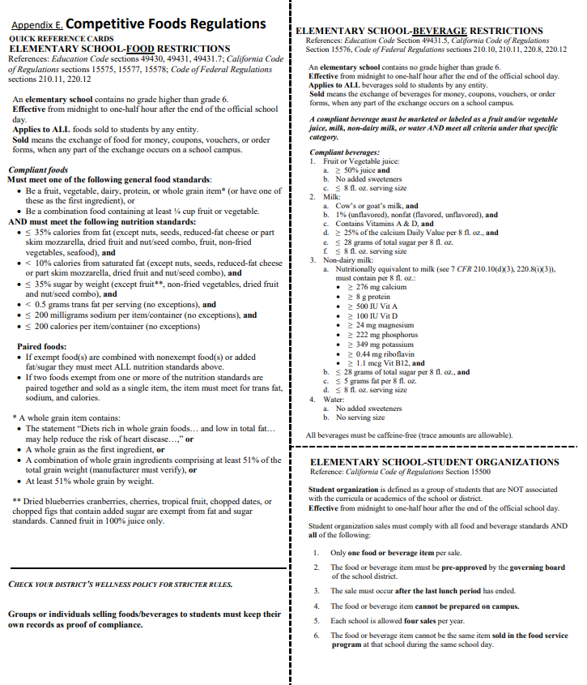

USDA Nondiscrimination Statement
In accordance with federal civil rights law and U.S. Department of Agriculture (USDA) civil rights regulations and policies, the USDA, its agencies, offices, employees, and institutions participating in or administering USDA programs are prohibited from discriminating based on race, color, national origin, religion, sex, disability, age, marital status, family/parental status, income derived from a public assistance program, political beliefs, or reprisal or retaliation for prior civil rights activity, in any program or activity conducted or funded by USDA (not all bases apply to all programs). Remedies and complaint filing deadlines vary by program or incident.
Persons with disabilities who require alternative means of communication for program information (e.g., Braille, large print, audiotape, American Sign Language, etc.) should contact the state or local agency that administers the program or contact USDA through the Telecommunications Relay Service at 711 (voice and TTY). Additionally, program information may be made available in languages other than English.
To file a program discrimination complaint, complete the USDA Program Discrimination Complaint Form, AD-3027 (PDF), found online at How to File a Program Discrimination Complaint and at any USDA office or write a letter addressed to USDA and provide in the letter all of the information requested in the form. To request a copy of the complaint form, call 866-632-9992. Submit your completed form or letter to USDA by:
- mail:
U.S. Department of Agriculture
Office of the Assistant Secretary for Civil Rights
1400 Independence Avenue, SW, Mail Stop 9410
Washington, D.C. 20250-9410;
- fax:
202-690-7442; or
- email:
Program.Intake@usda.gov.
This institution is an equal opportunity provider.

Adopted April 12, 2006
First revision April 13, 2009
Second Revision November 2012
Reviewed, 2018, 2023, 2025

