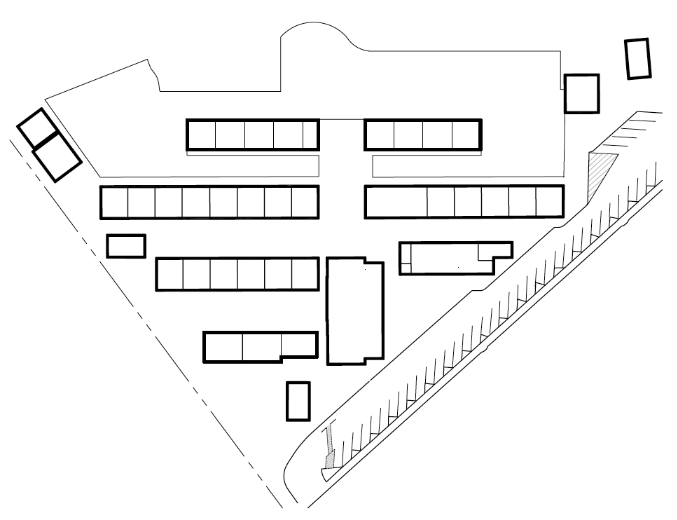

**Room 6**

Learning Lab

Defino

**Room 20**

r

**Room 19**

Hunter

5th

**Room 18**

Templeton

5th

**Room 17**

Ouye/ Merrifield

4th

**Room 29**

Ransdell

4th/

**Room 28**

Alexander

4th/

**Room 27**

Learning Lab

**Room 26**

Medeiros

Science

**Room 23**

Kids Country

**TK-K3**

Tan/Boyle

Roy

**Kinder-K2**

Priess

**Kinder-K1**

Roberson

**Kinder-Rm1**

**Principal Grim**

**Room 12**

Wettig

3rd

**Room 21**

**Smith**

Music

**Kazem**

**Room 24**

Counselor

Maker’s Space

Goering

**Room 4**

Damaschino

1st

**Room 5**

Hanson

1st

**Resource**

Worth

Beaver

Ramos

Stage

Bertolero

Instrumental Music

Child

Nutrition

MPR

**Room 3**

TK Workroom

**Room 15**

ART

**Room 22**

ELOP

*Green Valley Elementary*

*1001 Diablo Road, Danville 94526*

**Crean**

**Psych**

**Room 14**

Halvorson

2nd

**Room 11**

Hasty

3rd

Library

Dvorak

**Room 7**

Roderick

K/1s

**Room 10**

Brown

2nd

**Room 9**

Robinson

2nd

**P.E**

Struempf

Diablo Road

Conference

Speech

Kids’,

Country

**820-3646**

**Room 8**

Bering/

Dyer

/3rd

*Main:925.855.5400*

**Kiln**

Main Office

Ericson

Staff Lounge

Restrooms

C1

Rainbow