Washington, D.C. Handbook
Gallatin Gateway School Field Trip

From the Hallways of GGS

To
Washington, D.C. & New York City

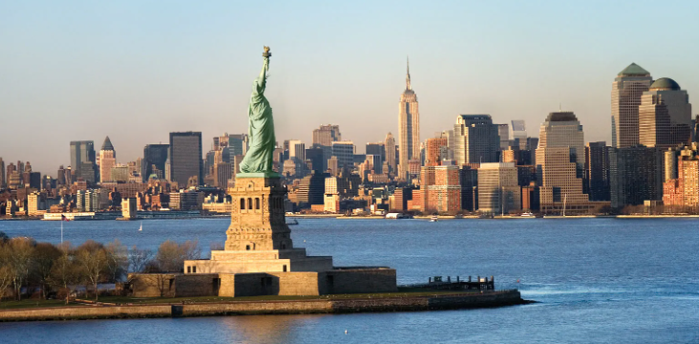

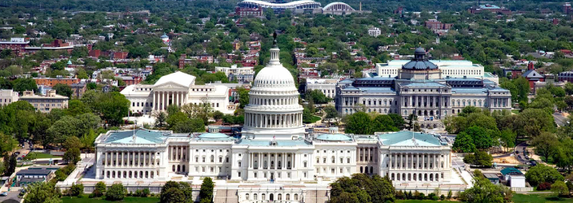
Note: *Approved as an official school-sponsored field trip
See August 2012 Board minutes

*Revised & Updated Aug. 2024
Contents
SECTION ONE 5
Purpose 5
Timeline 5
Expenses 7
Fundraisers 7
Duration of the trip 8
Possible Tour Options 8
SECTION TWO: PROCEDURES 10
Policy 10
Overview 10
Field Trip Participants 10
Procedure Student Wreath Presentation 11
Procedure for Respect at Memorials/Ceremonies 11
Attire to Avoid 11
Procedure for Packing for the Trip 11
Procedures for Hotels 12
Procedures for Airplane 13
Procedure for Transportation 14
Walking Etiquette in a City and Crowded Public Areas 14
Procedure for Medication 14
Procedure for Background Check 15
Procedures for an Emergency 15
Standard Behavior Expectations Acknowledgement 16
Behavioral Expectations, Consequences and Contract 17
SECTION 3: COMMUNICATION 19
Summary of the Paperwork for Washington, D.C. Trip 19
Procedures for Trip Supervisor Communication 19
Appendix 20
Adult Participant Training and Information Form 20
Parent Chaperones 22
Washington, D.C. Adult Participation Contract 24
Instructions for Getting A Fingerprint-Based Background Check 25
Applicant Rights and Consent to Fingerprint 27
NCPA/VCA Applicants 29
Privacy Act Statement 31
Fingerprint Redissemination Request 32
Montana Authorization to Carry and Self-Administer Asthma Medication 33
Prescription Medication Permission 35
Consent for Emergency Medical Care During a Field Trip 39
Example of the Washington, D.C. Trip 40
Planning a Field Trip 41
We’re going on a Field Trip! 42
Dinner for Two Raffle 43
Donation Form 48
Thank you note 49
Sweetheart Spaghetti Supper 53
Sportsman’s Banquet Raffle 62
Example of Timeline and Schedule 64
Example: Estimated Trip Expenses 67
How to login for Metro SmarTrip Cards 68
Student Travel Journal 72
Washington, D.C. Research Project 79

Philosophy:
The Gallatin Gateway School believes field trips supplement and enrich the classroom by providing learning experiences in an environment beyond the classroom.

Mission:
It is the mission of the Gallatin Gateway School to provide an 8th grade experience of United States history through a guided tour of Washington, D.C.

Vision:
“All Means All”
Students, teachers, parents, and adults all teaming for the inclusion of all.

Fundraisers:
Fall PIE fundraiser – Wreaths
Dinner for Two – ends December
Spaghetti Dinner - February
GGS Foundation Sportsman’s Banquet & Raffle – ends in April

SECTION ONE

Purpose

First and foremost, this annual trip to Washington, D.C. is an educational experience for Gallatin Gateway students. The focus is student education and student safety. Respect and responsibility are the number one criteria for all participants.

Timeline

June (with report cards) – *Trip Supervisor: At the end of the 7th-grade school year provide a letter to parents in the June report card mailing about the upcoming 8th-grade field trip. This letter will provide fundraising information and ask about adult interest in chaperoning. Also included should be the estimated cost and payments expected for those adults attending. Payments will be in October, November, February, March, and April.

Sent out with June report cards Appendix 2.

July - n/a

August – *Trip Supervisor: Set the date for the week in May when the group will be traveling. The trip Supervisor will check the D.C. convention center schedule dates of large conventions and booked weeks and then the Trip Supervisor will talk with the Travel Coordinator to find the best week in May for room availability for the 8th-grade group. If the Travel Coordinator does not, contact the Washington, D.C. offices of the Montana members of Congress by email to set up meetings with the senators and representatives and to request private tours from the office’s aides for the Capitol, White House, FBI Experience, etc. Contact airlines for group rate quotes.

September
First mandatory parent meeting to determine the adults attending and to distribute information on fundraising – appoint chairs for each event. Provide annual Fundraising Procedures handouts to parents and students. Provide forms for attending.
*Trip Supervisor: With the Travel Coordinator, book rates including one to two new GGS 8th grade students with the estimate in case of new enrollment through December. (After the last school day of December, no one can be added to the event.)

Create thank you notes in advance to be used by students/teachers for each event on the schedule.

October
Confirm the number for adult chaperone attendance and collect the first deposit. Provide payment dates to the adults attending.
Coordinate CPR/First Aid for adults participating in the trip. Request class through Adult Ed. Adults will need to seek instruction outside of the school if needed.
*Trip Supervisor: Collect deposits from adults.

November
Adults attending must have a fingerprint background check submitted to the school
Dinner for Two Raffle – Collecting gift cards ready to go by Dec. 1.

December
Dinner for Two Raffle set up a display in the lobby
Second parent meeting: Plan annual spaghetti supper – all food and miscellaneous items must be donated to ensure profit for the class.

*Trip Supervisor to review schedules for attractions- Ford’s Theatre, Nationals Baseball/DC United Soccer, Holocaust Museum tickets, Spy Museum, etc. to make reservations and reserve attendance by making deposits, US Mint tickets (if available, and if schedule permits; you can request this up to a year in advance), Mt. Vernon cruise (they have early schedules), Ford's Theatre tickets -- purchase as soon as they become available, FBI Experience and White House tours (scheduled through senator’s office, Smithsonian Museum hours, National Archives, etc. – Arlington Cemetery Trolley if budget allows
Students design t-shirt logos and students select the t-shirt color for the trip.
No additional chaperones can be added to the trip after the last school day in December, due to reservations made during December that cannot add additional guests unless in case of emergency.

January
Order T-shirts.
Third parent meeting: Planning meeting for Spaghetti Supper
*Trip Supervisor: Create and send a letter to Arlington for Tomb of the Unknown Social for wreath presentation– www.arlingtoncemetery.mil to see about the ceremony.

February
Spaghetti Supper final communications with parents
Thank you notes as needed for donations to spaghetti dinner
Adult Deposit Due
*Trip Supervisor:
Daily reload funds on Smartrip account for metro use – www.wmata.com (see procedure)
Gallatin Gateway School Foundation and the Sportsman’s Banquet committee will talk to students about the raffle ticket fundraiser and auction for March/April.

March
Fourth parent meeting – provide an itinerary to parents for confirmed events
Begin selling Raffle Tickets and the committee gathers Auction donations
*Trip Supervisor: Reconfirm hotel and airplane, give the hotel the room assignments, prepare to pay airline tickets
Collect Chaperone Deposit
Selection of students to present the wreath if selected – see procedure
Order a wreath if selected to present at the Tomb of the Unknown Soldier
Collect Emergency Medical Forms and Permission Slips for Chaperones, Parents, and students
April
*Trip Supervisor: Confirmation of names to the airline for all travelers, and final payment to Trip Coordinator, renew Smithsonian membership to save money for lunch in the museums.
Collect final Chaperone Deposit
Present the final itinerary for the field trip to staff, parents, and students
Office will prepare name badges with photos and contact information for students.

May – Month of the Trip
*Trip Supervisor: Final chaperone meeting - packing, behavior, emergencies, medicine,
Student and adult airline and Metro/transportation training with the teacher during
Packing review
Provide adults with the student research on monuments to provide background knowledge (Student assignments in May attached)
Provide itinerary to all students, chaperones, and families
Meet at the airport for an early am departure
Line-up order for Bozeman airport is alphabetical by last name with their bags.
Send Thank you notes as needed

June
*Trip Supervisor:
Reconcile all receipts for credit card statements.
Report all purchases and amounts to the business office.
Ensure thank you notes have been delivered.

Expenses
- The Gallatin Gateway School District funds two Superintendent-appointed school employees for a class size of up to 20 and three for a class size of 20 to 25.
- Student field trip expenses are covered by the fundraising efforts of the entire class.
- If inadequate funds are raised for student participation, parents provide the remaining funding for the trip. The needed funds divided by the number of students will equal the amount due from each family.
- Adult participants pay trip expenses in advance for participation in the class.
- All parents and chaperones are expected to help the class raise funds for all student expenses.

Fundraisers
Student fundraisers will each have a description provided to parents with the ultimate goal of using fundraising money to cover expenses for:
- partially fund the 5th grade overnight to Butte
- partially fund the 6th grade Yellowstone trip, and
- fully fund the 8th Washington, D.C. trip

School-Sponsored (Deposited into school-held class account)
Dinner for Two Raffle at the Winter Program – 8th-grade students
Annual Spaghetti Supper – Parents, adults, and 8th grade students
School Dances by 8th grade committees- 8th grade students
Extra fundraisers can be created to cover student expenses as needed

Foundation-Sponsored (Deposited into Foundation-held class account)
GGSF Sportsman’s Banquet & Raffle – Grade 5-8 Classes

The cost of the trip less the proceeds from school fundraisers will be invoiced for final payment from the GGS Foundation.

Duration of the trip
5 days and 4-5 nights using the best rates available. The group will meet at the airport
Students are picked up from the airport by parents when returning from the trip.

Possible Tour Options
- Mount Vernon: cruise, tour
- Pentagon and Memorial
- Spy Museum: Reserve through groups early
- FBI Experience
- Capitol: Contact senators for tour & schedule meetings
- Arlington Cemetery– wreath, Tomb of the Unknown, JFK and Arlington House
- National Mall - Lincoln, Korean, Vietnam, Jefferson, FDR, MLK, WWII
- White House: Contact senators for tours– Albert Gallatin Statue (northeast corner)
- American History Museum
- Natural History Museum
- Nationals Baseball Game
- DC United Soccer
- Holocaust Museum: Reserve Jan./Feb.
- Ford’s Theatre, Peterson House, & Aftermath Exhibits
- Kennedy Center
- Air and Space Museum
- Native American Museum
- Grand Central Station – Train

Food options
- Minneapolis Airport – Firehouse Subs, Food Court: Panda Buffet, Wendy’s, Taco Bell & Burger King,
- Chevy’s – Pentagon Mall
- Chili’s – Crystal City
- Smithsonian Food Courts
- Crystal City Underground
- Dirksen Cafe (Senate Building)
- California Pizza Kitchen – Pentagon City – near Chevy’s 703-412-4900
- L’Enfant Plaza Food Court
- Ronald Reagan Building Food Court

SECTION TWO: PROCEDURES

Policy
Following Gallatin Gateway School Policy the following procedures will be followed:

- The Superintendent reserves the right to deny the participation of any individual on a field trip. Denial will be based on adult or student present and past behavior.
- The Superintendent will designate a trip supervisor(s) who will be responsible for the coordination of the trip.
- Any additions to the enrollment after the last Friday of school in December.

Overview
The District intends that the safety and well-being of students shall be protected at all times; that each field trip is properly planned, integrated with the curriculum, and followed up by appropriate activities that enhance its usefulness; that the effectiveness of field trip activities are monitored and continually evaluated; that teachers and trip supervisors are allowed a considerable degree of flexibility and innovation in planning the field trip; and that no field trip will be approved unless it contributes to the achievement of specific instructional objectives.

Field Trip Participants
Adults are welcome to chaperone and share this experience, but they are not necessary to the success of this school-based field trip. This field trip is for the academic enrichment of students. Even though chaperones self-pay, the trip is still based on the school's academic curriculum. Those attending with the school will follow the trip schedule, and not ask for personal accommodations for eating, shopping, etc. Adult requests will not supersede the trip itineraries. It is in no way to be considered a personal vacation. Any changes in the schedule will be given to the group by the trip supervisor(s).

*Procedure of criteria for accompanying the students on the trip: Who can travel with the 8th grade class on this trip?
Adults who:
- Attend all school planning meetings for the trip.
- Attend adult participant training which will review the trip expectations and liabilities in detail.
- Participate in student fundraising events (at the event or behind the scenes).
- Obtain a fingerprint background check through the approved agency & process. (Policy 5022).
- Provide proof of current First Aid certification or a willingness to be certified.
- Pay approximately $2000-$3000 for expenses as determined by the trip supervisor.
- Can walk long distances daily -- average per day about 7 miles.
- Can be on feet all day.
- Consider the health risks – severe asthma, allergies, heat, mobility, etc.
- Contribute to the experience as a role model for students on the trip through behavior, dress, attitude, and respect.
- Represent the philosophy, mission, and vision of the Gallatin Gateway School.
- Follow the district’s procedures and policies as related to the trip.
- Read student projects provided by the teacher so as an adult participant you are prepared to have the same background knowledge as the students.
- Supervise children as instructed by the Trip Supervisor including hotel rooms.
- Complete and follow the guidelines of the GGS Volunteer Handbook.
- Abstain from smoking, alcohol, or controlled substances as outlined in the GGS Volunteer Handbook.

Procedure Student Wreath Presentation
Selection:
Select four students to present the wreath by placing each student's name in a tool to randomize the selected names.
If a child is selected who may not wish to participate, the trip supervisor will contact the parents and the student and the parents will discuss the event with the trip supervisor or the superintendent. If the parents withdraw their child from participating, another name will be drawn.
Attire:
Students selected will be required to dress semi-formally- black slacks, black solid color shoes, black socks, and white button-up shirt

Procedure for Respect at Memorials/Ceremonies
All participants will know in advance the higher expectations of behavior when observing a memorial or attending a ceremony.
Participants on the trip will be expected to:
-Stand with respect without leaning, sitting, or talking during a ceremony
-Phones cannot be used for calling out, receiving calls, or texting when observing a memorial or a ceremony.
-No hats

Attire to Avoid
- Participants will be required (student or adult) to follow the school dress attire procedures for this field trip.
- No spaghetti-strap tank tops or low-cut shirts.
- No midriff exposure
- No pants with holes or rips
- No tight or uncomfortable clothing due to the weather’s dampness/humidity
- Belts as needed, to keep pants up and bottom fully covered.
- Shorts need to be an appropriate length for professional settings.
- Avoid shirt logos that are distracting or inappropriate for the setting.

Procedure for Packing for the Trip
Participants are responsible for their personal property and assume the risk of any losses or damage to their personal items.

- All luggage is subject to a check by the trip supervisor(s) and should be tagged with appropriate tags for departure.
- Luggage weight limit is less than 50 pounds.
- One carry-on bag per person. and one personal item.
- Phones can be used in the evenings only for calling parents. Phones may be used as a camera only for the day. No access to games or social media allowed while on the trip. Movies and music are allowed on airplanes. (See Phone Use Agreement.)

Each participant should pack lightly – adults are encouraged to share a suitcase with their children
- Small, light backpack with pens, pencils, and journal & airplane snack (protein),
- Liquids must follow airline regulations
- GOOD walking shoes – not new
- Hat and Chapstick
- Class t-shirt
- Light jacket (rain)
- Sweater or sweatshirt – or buy one on the trip!
- Jeans– comfortable – not too tight or too loose – no holes
- Pants/capris for Tomb of Unknown Soldier
- Nice shorts (not athletic shorts)
- Long sleeve shirt – Depending on weather
- Short sleeve shirts - For daily use
- Socks and underwear for each day – clean socks will help tired feet. Pack extra!
- Toiletries – (Minimum sizes. Follow airline restrictions for your carry-on!)
- Pajamas (pajama pants for hotel only – not on tours)
- Sunscreen
- Sunglasses
- Prescription medications (student medication forms completed and submitted)
- Spending money
- Do not pack a hair dryer – each room has one!
- Do not pack a pocket knife
- No basketball shorts on tours – only hotel room
- Student Cell phones can be brought on the trip, but only used in the hotel rooms for parent calls and cameras during the day.
- Cell phones will be confiscated if used by students for social media, gaming, texting, or calling during the day.
MONEY:
- Personal Money (Students will visit gift shops and souvenir stands during the week)

Procedures for Hotels
Trip supervisor(s) are responsible for assigning participants to hotel rooms.

Hotels will be chosen considering ease of supervision. Each hotel room may not have a supervising adult; however, procedures will be implemented and instruction and expectations will be given for appropriate behavior outcomes. A trip supervisor must be on the same floor as and close to student rooms and adjoining rooms will be used whenever possible for increased supervision. Efforts will be taken to acquire accommodations that do not have doors directly from student rooms to the exterior. The trip supervisor shall be responsible for making the room arrangements with the greatest safety of the children in mind.

The curfew will be strictly enforced. Each student must be in his or her assigned room at the time designated by the trip supervisor. No one will be permitted to leave his or her room after that time. Specifically, boys are not to be in the girls’ rooms or girls in the boys’ rooms unless directly supervised by chaperones. Also, outsiders (those not directly involved with the field trip) are not permitted in any student’s room at any time.

Students will never leave the hotel without an adult – students will wait to join another group or the class if the adult in their hotel room is not ready to join the group.

Before leaving hotel rooms, students must check to see that the rooms are left in good order and that no personal belongings have been left behind.

Four students to a room with two beds is likely. Students can choose to bring a sleeping bag and foam pad if choosing not to share beds.

Procedures for Airplane
1 Check-in:
- Students should pack light and have only one carry on and one personal item.
- Carry on must meet the designated size limits.
- Fill out luggage tag.
- Any liquids must be packed to follow airline regulations.
- All participants will arrange in groups with assigned chaperones.
- Students do not need a photo ID.
- All adults need a photo ID.

2 Security:
- Trip supervisor will instruct the participants to follow TSA regulations.
- Students will never leave the assigned supervising adult.

3 Boarding:
- Follow boarding procedures by zone provided by the gate agents.

4 Airplane Etiquette:
- Listen to all crew member instructions which means stop talking while the crew is giving safety instructions.
- Seat is assigned by the airline and you are to stay in that seat.
- Use restroom before boarding and as needed while on the plane to avoid an emergency when arriving at the terminal.
- Each participant’s garbage will be disposed of properly.
- Clean up after yourself in all traveling environments.
- Use an appropriate voice level and monitor age-appropriate behavior.
- Deplaning requires respect for others who are also deplaning – wait your turn!
- Wait at the gate exit area until the remainder of the group arrives.

Procedure for Transportation
SmarTrip cards are the primary transportation method (MetroRail, MetroBus) during the Washington, D.C. field trip. School-purchased SmarTrip cards are stored in the school vault with usernames, passwords, and security information.

Trip Supervisor – reload SmarTrip cards according to the trip itinerary. Reference procedures on www.wmata.com. A minimum of $60 per card, so check rates.

Trip supervisor(s) will designate the chaperone group leaders, and they will maintain their groups’ Metro Cards throughout the trip. This person is responsible for the possession, supervision, and application of the SmarTrip card for the duration of the trip. This is to prevent the loss or damage of the SmarTrip cards.

Using the Metro consists of waiting, loading, and unloading the train. Rules and manners are required. The following list is the federal guidelines for usage: www.wmata.com

Walking Etiquette in a City and Crowded Public Areas
Estimated walking per day may exceed 7 miles.
Guidelines for sidewalk use, escalators, stairs, museums, gift shops, etc.
- Observe your environment.
- Stay to the right.
- Stay single file on pathways unless instructed otherwise by the trip supervisor(s).
- Stay on the sidewalk or designated walking areas.
- Do not climb or step off sidewalks or walking areas.
- Stay with the group – Walk briskly to allow for all walkers in the group to stay together.

Procedure for Medication
Any student taking medication of any kind must follow the Gallatin Gateway School medication procedures. Medication forms are in the Appendix of this handbook.

The medication must be reported to the Trip Supervisor by the parent using the “Permission for Medication To Be Given During a Field Trip” form. The medication must be given to the Trip Supervisor by the designated deadline along with the parent-signed approval form.

*GGS Medication Forms Available in Appendix
- Consent for Emergency Medical Care During a Field Trip- required
- Permission for Medication to be Given During Field Trip - required
- Montana Authorization to Carry and Self-Administer Asthma - only if planning to bring an inhaler/nebulizer.

Procedure for Background Check
Review Volunteer Handbook
Complete the Fingerprint Procedure through Gallatin Detention Center (see packet in Appendix)
Submit to Gallatin County Superintendent of Schools

Procedures for an Emergency
Students are to report any accidents or illness immediately to the Trip Supervisor(s).
In the case of an accident, the parent/guarding will be notified as soon as practicable. Should it be necessary that a student require hospitalization, it will be the responsibility of the parent/guardian to go to the hospital and/or make arrangements for transportation home and notify the trip supervisor of these arrangements. Financial responsibility for any transportation (student or adult) required will rest with the parent of the student involved or the adult involved.

In case of illness, family emergency, or disciplinary action which would require a student to be sent home by the best available means of transportation, it will be the immediate responsibility of the parent or guardian to make financial and physical arrangements for transportation home and notify the trip supervisor of these arrangements.

The school office will have a copy of all forms, itinerary, and contact information for the duration of the trip. The school office will also serve as a means of sending information out to all parents. Contact the school at 406-763-4415.

Standard Behavior Expectations Acknowledgement
Attending the 8th-grade Washington, D.C. trip requires maturity, a commitment to meeting schoolwide expectations, motivation to fundraise, and consistent school attendance and work completion. Without the ability to maintain these expectations, traveling cross-country with a student who has behavior challenges can become a liability and threatens to impact the experience of the trip for other students.
This trip is a tremendous opportunity for our students, and we expect them to maintain socially appropriate behavior, attend school, and complete their classroom assignments for the duration of the school year to demonstrate the maturity and motivation to participate in the Washington, D.C. trip. Students failing to meet expectations will have their trip privileges revoked pending the successful completion of a field trip participation plan. This plan will specify behavior concerns, address remediation opportunities, state completion criteria, and provide a timeline for completion. A field trip participation will be written by school personnel and provided to parents to assist student success.
Additionally, any student who has been placed on a behavior intervention plan at any time during sixth and seventh grades will automatically begin the eighth-grade year with a field trip participation plan to demonstrate the importance of school attendance, academic achievement, appropriate conduct, and respect for adults and peers. Any expectations are following the GGS Handbooks.
I acknowledge that I have received notification of school expectations in order for my child to travel on field trips. If requested, I will participate in the field trip participation plan process.
______________________________________________________ ______________________
Signature Date

______________________________________________________ ______________________
Signature Date

Behavioral Expectations, Consequences and Contract
Students will be expected to maintain the highest standard of conduct and behavior from the moment we meet at the airport, to the moment we return and say goodbye. Students will be representing not only themselves as individuals, but also our school and our community. The teacher and adult chaperones will enforce a “zero tolerance” policy as detailed in the following list of expectations for this field trip because there are multiple teaching opportunities and express acknowledgement of expectations. Of course, considering circumstances that may or may not be detailed in this contract, school personnel will make any and all disciplinary judgments.
Learning is the primary focus of this trip. Coupled with the fun aspects of this experience, students are expected to be involved with, engaged in, and enthusiastic about the academic nature of this journey. This includes asking thoughtful questions; completing any and all work assigned by the teacher; and focusing energy and attention on learning.
Students agree to the following:
- I will be entirely respectful of others. This means that I will not gossip, make any disparaging or mean remarks, or engage in any other types of rude, hurtful, annoying, disrespectful, excluding, or unwelcome behavior to anyone.
- I will make every attempt to resolve any conflicts maturely, swiftly, and responsibly with adult support if necessary.
- I understand that I will be expected to be prepared, on time, and keep up with my group.
- I will make every effort to maintain a consistent, pleasant disposition, even in the face of unpleasant challenges that may come up. I understand that fatigue, hunger, interpersonal differences, temperature extremes, and so on are not excuses for complaining, whining or being pessimistic. I will instead take responsibility for myself and my needs to ensure that a good time is had by all, including me!
- I agree to voice concerns in a respectful and constructive manner, and to express concerns about those situations that might be remedied. Obviously, some situations (such as temperatures) cannot be “fixed” by anyone and complaining will not change anything, except to dampen others’ moods! Adults are ready to help students with challenges as much as possible to improve any situation, and I will accept their response without argument.
- I will be honest and will make good overall choices about behavior, attitude, relations with others, and learning.
- I will not cause physical harm to myself or to others.
- I will not be physically intrusive to anyone’s personal space in any fashion, and will also be respectful of all property. I understand that I may be removed from the group if I am bothering others.
- I will be respectful of all places and objects in every way. This means that I will use extreme caution and heed guidance and authority with regard to touching and interacting with any objects or structures. I will not climb on structures or walk where I am not supposed to walk.
- I will respond to behavioral warnings respectfully and with swift self-reflection. I will do what I am told without argument or complaint.
- I agree to respect the curfew set by the teacher and the chaperones. This means I will be in my room and ready for lights out at the expressed time. I understand that curfew violations are serious matters and will result in consequences.
- I agree that I will not enter other rooms without express permission and/or supervision of the chaperone. I will not leave the groups without express permission of the group adults. I agree to check in with chaperones as required.
- I will not use my cell phone for any reason other than to take pictures during the day and call home in the evening. The trip supervisor may confiscate and keep my phone for the duration of the trip.
- In addition to the above listed expectations, I agree to honor all GGS Handbook Rules.

As a student, if I violate any of the expectations or rules as listed above, I know that the consequences include being removed from the group, having activity privileges revoked, or to call my parents and be sent home immediately at the discretion of school personnel.

_______________________________________ __________________
Signature of Student Date

_______________________________________ __________________
Signature of Parent/Guardian Date

_______________________________________ __________________
Signature of Student Date

_______________________________________ __________________
Signature of Parent/Guardian Date

SECTION 3: COMMUNICATION

Summary of the Paperwork for Washington, D.C. Trip

Trip Supervisor:
Planning a Field Trip Form for school district
Adult Emergency Information

Student:
Field trip permission form – “We’re going on a field trip”
Consent for Emergency Medical Care During a Field Trip- required
Permission for Medication to be Given During Field Trip - required
Permission for Prescription Medication to be Given by GGS Staff- as needed
Cell Phone Use Contract- required
Montana Authorization to Carry and Self-Administer Asthma – as needed
Washington, D.C. Participation Contract- required by both student and parent
Acknowledgment of Behavior Expectations for D.C. Trip- require student and parent

Adult:
Adult Emergency Information
Volunteer Handbook
First Aid/CPR Certification
Background check information must be received by the school no later than December 18.
Washington, D.C. Handbook
Washington, D.C. Adult Participation Contract

Procedures for Trip Supervisor Communication
- Minimum of five parent and student meetings – listed in timeline
- Provide an itinerary to adults and students prior to the trip
- Provide summaries of each destination – menus, schedules, descriptions as available will be provided.
- Provide folders containing destination maps, emergency contact information, itinerary, first aid information, etc. to adults attending the trip.
- Web site resources identifying and giving information on sites visited will also be provided.

Appendix

Adult Participant Training and Information Form

Philosophy:
Field trips supplement and enrich the classroom by providing learning experiences in an environment beyond the classroom.

Mission:
It is the mission of the Gallatin Gateway School to provide an 8th-grade experience of United States History through a guided tour of Washington, D.C.

Vision
All Means All: Students, parents, adults, and teachers teaming to support 8th-grade students in attending.

Overview:
It is the District’s intent that the safety and well-being of students shall be protected at all times; that each field trip is properly planned, integrated with the curriculum, and followed up by appropriate activities that enhance its usefulness; that the effectiveness of field trip activities are monitored and continually evaluated; that teachers and trip supervisors are allowed a considerable degree of flexibility and innovation in planning the field trip; and that no field trip will be approved unless it contributes to the achievement of instructional objectives.

Student Field Trip
Adults are welcome to share this experience and are partners in the success of this school-based field trip. This field trip is for the academic enrichment of students based on the social studies curriculum. Those attending with the school will follow the trip schedule, and not expect personal accommodations for eating, shopping, etc. Adult requests will not supersede the trip itinerary. Any changes in the schedule will be given to the group by the trip supervisor(s).

Criteria for traveling with the students on the trip:

- Attend all school planning meetings for the trip.
- Attend adult participant training, which will review the trip expectations and liabilities in detail.
- Participate in student fundraising events (at the event or behind the scenes).
- Submit to a fingerprint background check as through Board-adopted process only..
- Provide proof of current First Aid certification or a willingness to be certified.
- Pay approximately $1500 prior to trip, and up to a total of $2000 for expenses as determined by the trip supervisor.
- Can walk long distances daily -- average per day about 7-10 miles.
- Can be on your feet all day without limitations.
- Consider the health risks and elements – severe asthma, allergies, heat, mobility, etc.
- Contribute to the experience as a role model for students on the trip through behavior, dress, attitude, respect.
- Represent the philosophy, mission, and vision of the Gallatin Gateway School.
- Follow the District’s procedures and policies as related to the trip.
- Read student projects provided by the teacher so as an adult participant you are prepared to have the same background knowledge as the students.
- Supervise children as instructed by the Trip Supervisor including sharing a hotel room with students.
- Complete and follow the guidelines of the GGS Volunteer Handbook.
- Abstain from smoking, alcohol, or controlled substances as outlined in the GGS Volunteer Handbook.
- If attending with your child, be aware that if the child is sent home, you will need to accompany them, and your trip fees will not be refunded.

Parent Chaperones
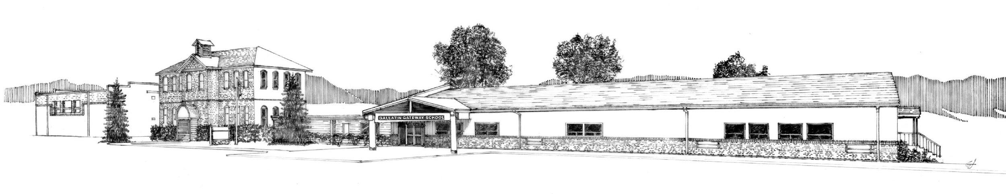

GALLATIN GATEWAY SCHOOL
PO BOX 265, GALLATIN GATEWAY, MT 59730

TO: 8th Grade Parent Chaperones

FROM: Trip Supervisor, 8th Grade Teacher

DATE: _______________________________________

RE: Chaperone Emergency Information

Please complete the information below for the school to have on file while we are on our Washington, D.C. trip.

NAME: ___________________________________________________________________________
ADDRESS: __________________________________________________________________________
HOME PHONE: _____________________ BIRTHDATE: _________________________

KNOWN ALLERGIES/MEDICAL CONDITIONS: ___________________________________________________________________________________________________________________________________________________________________
MEDICAL INSURANCE PROVIDER, ADDRESS & PHONE #: ___________________________________________________________________________________
MEDICAL COVERAGE POLICY #________________________________________________________________________
DRIVER’S LICENSE # ______________________________________________
EMERGENCY CONTACT PERSON #1: _________________________________________________________________
RELATIONSHIP: __________________CONTACT PHONE #: ___________________________________

EMERGENCY CONTACT PERSON#2:___________________________________________________________________
RELATIONSHIP: __________________CONTACT PHONE #: ___________________________________
*SOCIAL SECURITY # may be requested for national security clearance on federal tours.

Washington, D.C. Adult Participation Contract

Yes, I_______________________________________________ meet the criteria provided and plan to accompany the Class on their 8th grade field trip to Washington, D.C. in May.

I will pay approximately ___________ between October and April as listed below:

Please expect the following amounts as payments from me: October, November, February, March, and April will be any additional fees determined by reservations.

October 10 ___________

November 10 ___________

February 10 ___________

March 10 ___________

April 10 ___________ (Final Balance)

(Checks payable to Gallatin Gateway School: submit payment to the school office for deposit into the eighth-grade class account).

If I find later that I cannot attend, I will forfeit my participation on the field trip aware of the following:
- I will forfeit any deposits or purchases including airline fees and admission cost to attractions that cannot be refunded by the vendor.
- All remaining deposits, less any expenses incurred on my planned attendance, will be returned. (For example: If the Ford’s Theatre tickets are purchased by the school for this trip, they become nonrefundable, and I lose those funds.)

I will:
- Submit to a fingerprint background check as determined by County Superintendent of Schools procedure.
- Provide proof of current First Aid certification by February.
- Review Volunteer Handbook.

Name _________________________________________________________

Signature ________________________________________________ Date ___________________

Email address _____________________________________________ Phone __________________

Instructions for Getting A Fingerprint-Based Background Check
(For School Employment, Volunteers, and Chaperones if unable to complete with GGS office)
A fingerprint-based background check is required for persons seeking to work, volunteer, or chaperone in the public schools in Gallatin County. The steps to obtain a fingerprint based background check are as follows:
1) Have your fingerprints taken at a public fingerprinting location. The Gallatin County Detention Center at 605 S. 16th Avenue in Bozeman offers public fingerprinting on the following days and times:
• Tuesday, Wednesday, Thursday, 3:00-4:30 PM
• Tuesday, 7:00-8:30 PM
• Saturday, 12:00-2:00 PM
Photo ID and a $15.00 fee are required and exact payment must be made by cash or check only. Be sure to request two fingerprint cards. Most city police departments (Belgrade, Manhattan, West Yellowstone,) and the MSU Police Department also provide public fingerprinting. Contact police departments directly for fees and availability. A map and contact information for the Gallatin County Detention Center and a list of city police departments are provided on the reverse side.
2) Submit your fingerprint cards to the Gallatin County Superintendent of Schools office located in Room 107 of the Gallatin County Courthouse at 311 W. Main Street in Bozeman. Complete the attached forms and submit them with your fingerprint cards while there:
• NCPA/VCA Applicants form
• Applicant Rights and Consent to Fingerprint form
• Privacy Act Statement
• Fingerprint Re-dissemination Request form (Not required in all circumstances.)
A processing fee of $32.00 is required for employment, $27.00 for volunteers, and must be paid by cash or check made payable to “Gallatin County Superintendent of Schools.” Note: This fee may be billed directly to school districts or may be eligible for reimbursement in some cases. We can help you determine if the fee is eligible for direct billing or reimbursement.
3) The Gallatin County Superintendent of Schools will forward your fingerprint cards to the Montana Department of Justice for processing. Current processing time is approximately three weeks. Background checks are generated by the Department of Justice and returned to the County Superintendent. Results of background checks are forwarded by the County Superintendent to school district superintendent(s).
For questions or more information, please contact the Gallatin County Superintendent of Schools at 311 W. Main St., Room 107, Bozeman, MT 59715, (406) 582-3090 or by email at: superintendentofschools@gallatin.mt.gov.
March 1, 2019
Gallatin County Detention Center
605 S. 16th Avenue
Bozeman, MT 59715
(406) 582-2130
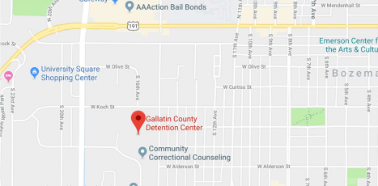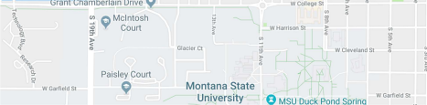
Information on fingerprinting at the Gallatin County Detention Center is available at: http://gallatincomt.virtualtownhall.net/Public_Documents/gallatincomt_detention/fingerpri nts.
Belgrade City Police Department
91 E. Central Ave.
Belgrade, MT 59714
(406) 388-4262
(City residents only)
Manhattan Police Department 207 S. Sixth St.
Manhattan, MT 59741
(406) 284-6630
West Yellowstone Police Department 124 Yellowstone Ave.
West Yellowstone, MT 59758 (406) 646-7600
MSU University Police
7th Avenue and Kagy Blvd.
Bozeman, MT 59715
(406) 994-2121

Applicant Rights and Consent to Fingerprint
As an applicant who is the subject of a national fingerprint-based criminal history record check for a noncriminal justice purpose (such as an application for employment or a license, an immigration or naturalization matter, security clearance, or adoption), you have certain rights which are discussed below.
  - You must be provided written notification⁸ by Gallatin County Superintendent of Schools that your fingerprints will be used to check the criminal history records of the FBI.
  - You must be provided, and acknowledge receipt of, an adequate Privacy Act Statement when you submit your fingerprints and associated personal information. This Privacy Act Statement should explain the authority for collecting your information and how your information will be used, retained, and shared.
  - If you have a criminal history record, the officials making a determination of your suitability for employment, license, or other benefit must provide you the opportunity to complete or challenge the accuracy of the information in the record.
  - The officials must advise you that the procedures for obtaining a change, correction, or updating of your criminal history record are set forth at Title 28, Code of Federal Regulations (CFR), Section 16.34.
  - If you have a criminal history record, you should be afforded a reasonable amount of time to correct or complete the record (or decline to do so) before the officials deny you the employment, license, or other benefit based on information in the criminal history record.⁹
You have the right to expect that officials receiving the results of the criminal history record check will use it only for authorized purposes and will not retain or disseminate it in violation of federal statute, regulation or executive order, or rule, procedure or standard established by the National Crime Prevention and Privacy Compact Council.¹⁰
If agency policy permits, the officials may provide you with a copy of your FBI criminal history record for review and possible challenge. If agency policy does not permit it to provide you a copy of the record, you may obtain a copy of the record by submitting fingerprints and a fee to the FBI. Information regarding this process may be obtained at http://www.fbi.gov/about-us/cjis/background-checks.
If you decide to challenge the accuracy or completeness of your FBI criminal history record, you should send your challenge to the agency that contributed the questioned information to the FBI. Alternatively, you may send your challenge directly to the FBI at the same address as provided above. The FBI will then forward your challenge to the agency that contributed the questioned information and request the agency to verify or correct the challenged entry. Upon receipt of an official communication from that agency, the FBI will make any necessary changes/corrections to your record in accordance with the information supplied by that agency.
If a change, correction, or update needs to be made to a Montana criminal history record, or if you need additional information or assistance, please contact Montana Criminal Records and Identification Services at dojitsdpublicrecords@mt.gov or 406-444-3625.
Your signature below acknowledges this agency has informed you of your privacy rights for fingerprint-based background check requests used by the agency.
Signed:

_______________________________________________ __________
Name Date

NCPA/VCA Applicants
To _________________________________________________________________________________:
You have applied for employment with, will be working in a volunteer position with, or will be providing vendor or contractor services to Gallatin County Superintendent of Schools for the position of (please be specific)________________________________________________________________.
The National Child Protection Act of 1993 (NCPA), Public Law (Pub. L.) 103-209, as amended by the Volunteers for Children Act(VCA), Pub. L. 105-251 (Sections 221 and 222 of Crime Identification Technology Act of 1998), codified at 42 United States Code (U.S.C.) Sections 5119a and 5119c, authorizes a state and national criminal history background check to determine the fitness of an employee, or volunteer, or a person with unsupervised access to children, the elderly, or individuals with disabilities.
1. Provide your name, address, and date of birth, as appears on a document made or issued by or under the authority of the United States Government, a State, political subdivision of a State, a foreign government, a political subdivision of a foreign government, an international governmental or an international quasi-governmental organization which, when completed with information concerning a particular individual, is of a type intended or commonly accepted for the purpose of identification of individuals. 18 U.S.C. §1028(D)(2).
2. Provide a certification that you (a) have not been convicted of a crime, (b) are not under indictment for a crime, or (c) have been convicted of a crime. If you are under indictment or have been convicted of a crime, you must describe the crime and the particulars of the conviction, if any.
3. Prior to the completion of the background check, the entity may choose to deny you unsupervised access to a person to whom the entity provides care.
The entity shall access and review State and Federal criminal history records and shall make reasonable efforts to make a determination whether you have been convicted of, or are under pending indictment for, a crime that bears upon your fitness and shall convey that determination to the qualified entity. The entity shall make reasonable efforts to respond to the inquiry within 15 business days.

Your Name: ________________________________________________________________________________
First Middle Maiden Last
Date of Birth: _____________________________ Telephone: ______________________________
Address: _________________________________City State Zip _____________________________
 I have been convicted of, or am under pending indictment for, the following crimes [include the dates, location/jurisdiction, circumstances and outcome]:
 I have not been convicted of, nor am I under pending indictment for, any crimes
 I authorize Montana Department of Justice, Criminal Records and Identification Services Section to disseminate criminal history record information to Gallatin County Superintendent of Schools.
__________________________________________________Signature of Applicant _____________________Date

In accordance with federal law regarding notices and disclosures, MT Dept of Justice requires the entity to which you are applying to work or volunteer to use this form Form number APR&CF 20170213

Privacy Act Statement
This privacy act statement is located on the back of the FD-258 fingerprint card.
Authority: The FBI’s acquisition, preservation, and exchange of fingerprints and associated information is generally authorized under 28 U.S.C. 534. Depending on the nature of your application, supplemental authorities include Federal statutes, State statutes pursuant to Pub. L. 92- 544, Presidential Executive Orders, and federal regulations. Providing your fingerprints and associated information is voluntary; however, failure to do so may affect completion or approval of your application.
Principal Purpose: Certain determinations, such as employment, licensing, and security clearances, may be predicated on fingerprint-based background checks. Your fingerprints and associated information/biometrics may be provided to the employing, investigating, or otherwise responsible agency, and/or the FBI for the purpose of comparing your fingerprints to other fingerprints in the FBI’s Next Generation Identification (NGI) system or its successor systems (including civil, criminal, and latent fingerprint repositories) or other available records of the employing, investigating, or otherwise responsible agency. The FBI may retain your fingerprints and associated information/biometrics in NGI after the completion of this application and, while retained, your fingerprints may continue to be compared against other fingerprints submitted to or retained by NGI.
Routine Uses: During the processing of this application and for as long thereafter as your fingerprints and associated information/biometrics are retained in NGI, your information may be disclosed pursuant to your consent, and may be disclosed without your consent as permitted by the Privacy Act of 1974 and all applicable Routine Uses as may be published at any time in the Federal Register, including the Routine Uses for the NGI system and the FBI’s Blanket Routine Uses. Routine uses include, but are not limited to, disclosures to: employing, governmental or authorized non governmental agencies responsible for employment, contracting, licensing, security clearances, and other suitability determinations; local, state, tribal, or federal law enforcement agencies; criminal justice agencies; and agencies responsible for national security or public safety.

03/30/2018 In accordance with federal law regarding notices and disclosures, MT Dept of Justice requires the entity to which you are applying to work or volunteer to use this form
Form number APR&CF 20170213

Fingerprint Redissemination Request
Gallatin County Superintendent of Schools
Matthew Henry
311 W. Main Room 107 Bozeman, MT 59715
582-3090
582-3093 Fax
Admin. R. Mont 10.57.201A requires all applicants for initial licensure or reinstatement of former licensure complete a fingerprint based background check.
If your fingerprint result is on file with a Montana public school or County Superintendent, or a unit of the Montana University system, those results can be distributed from one public Montana education entity to another, as long as the result is less than 2 years old and meets the requirements of your school policy.
It is against FBI policy for results to be shared across state lines or from private institutions (colleges and universities, or private schools).
Applicant Information

Last Name: First Name: Middle Initial:
Folio ID (assigned by OPI): Former Name(s) (Maiden or Other): Date of Birth: Last four digits of your SSN:
I authorize:
o Gallatin County Superintendent of Schools
o A Unit of the Montana University System; or Name of University
o Montana Public School; Enter Name of School
to share the results of my fingerprint based background check with:
o Gallatin County Superintendent of Schools
X Montana Public School: Gallatin Gateway School

If you are requesting to distribute your fingerprint results to a Montana University, a Montana public school, or county superintendent, please provide the specific person you wish to receive the background check results:
Recipient Name: ______________________________,
Superintendent Address: PO Box 265
City: Gallatin Gateway State: MT Zip Code: 59730 Recipient Phone: 763-4415
Signature of Applicant: | Name of applicant: | Date:

Montana Authorization to Carry and Self-Administer Asthma Medication
For this student to carry and self-administer asthma medication on school grounds or for school sponsored activities, this form must be fully completed by the prescribing physician/provider and an authorizing parent or legal guardian.

Student’s Name:_______________________________ School:________________________
Sex: (Please circle) Female/Male City/Town: ____________________
Birthdate: _____/_____/_____ School Year: ______(Renew each year)

Physician’s Authorization:
The above named student has my authorization to carry and self-administer the following medication:

Medication: (1)________________________ Dosage: (1) ___________________
(2) ________________________ (2) ___________________

Reason for prescription(s): _____________________________________________________________
Medication(s) to be used under the following conditions: ___________________________________________________________________

I confirm that this student has been instructed in the proper use of this medication and is able to self-administer this medication on his own without school personnel supervision. I have provided a written treatment plan for managing asthma or anaphylaxis episodes and for medication use by this student during school hours and school activities.

_________________________ __________________ __________________
Signature of Physician Physician’s Phone Number Date
Backup Medication – The law provides that if a child’s health care provider prescribes “backup” medication to be kept at the school, it must be kept in a predetermined location, known to the child, parent and school staff.
The following backup medication has been provided for this student: __________________________

For Completion by Parent or Guardian
As the parent/guardian of the above named student, I confirm that this student has been instructed by his/her health care provider on the proper use of this/these medication(s). He/she has demonstrated to me that he/she understands the proper use of this medication. He/she is physically, mentally, and behaviorally capable to assume this responsibility. He/she has my permission to self medicate as listed above if needed. If he/she has used an auto-injectible epinephrine, he/she understands the need to alert an adult that emergency medical personnel need to be called. If he/she has used his/her asthma inhaler as prescribed and does not have relief from an asthma attack, he/she is to alert an adult.
I also acknowledge that the school district or nonpublic school may not incur liability as a result of any injury arising from the self-administration of medication by the pupil and that I shall indemnify and hold harmless the school district or nonpublic school and its employees and agents against any claims, except a claim based on an act or omission that is the result of gross negligence, willful and wanton conduct, or an intentional tort.
I agree to also work with the school in establishing a plan for use and storage of backup medication if prescribed, as above, by my child’s physician. This will include a predetermined location to keep backup medication to which my child has access in the event of an asthma or anaphylaxis emergency. Authorization is hereby granted to release this information to appropriate school personnel and classroom teachers.
I understand that in the event the medication dosage is altered, a new “self-administration form” must be completed, or the physician may rewrite the order on his prescription pad and I, the parent/guardian, will sign the new form and assure the new order is attached.
I understand it is my responsibility to pick up any unused medication at the end of the school year, and the medication that is not picked up will be disposed of.
Parent/Guardian Signature: _____________________________ Date: _______________________
(Original signed authorization to the school; a copy of the signed authorization to the parent/guardian and health care provider)

Prescription Medication Permission

Gallatin Gateway School District
PERMISSION FOR PRESCRIPTION MEDICATION TO BE GIVEN BY GGS STAFF

PLEASE PRINT CLEARLY

STUDENT NAME: ______________________________________ GRADE: ________________

TEACHER: __________________________________________________________________________

DIAGNOSIS: _______________________________________________________________________

MEDICATION: _________________________________________ DOSAGE: _________________

PURPOSE OF MEDICATION: ___________________________________________________________

TIME OF DAY MEDICATION IS TO BE GIVEN: ______________________________________________

POSSIBLE SIDE EFFECTS: _______________________________________________________________

ANTICIPATED NUMBER OF DAYS IT NEEDS TO BE GIVEN AT SCHOOL: __________________________

ADDITIONAL INSTRUCTIONS: ___________________________________________________________________________________
__________________________________________________________________________________
_______________________________________________________________________________
(DATE) (SIGNATURE OF HEALTH CARE PROVIDER)

I hereby give my permission for _____________________________to take the above prescription at school as ordered. I understand that it is my responsibility to furnish this medication. I authorize the release and exchange of information concerning this medication between the school and this physician.

___________________________________________________________________________________
(DATE) (SIGNATURE OF PARENT/GUARDIAN)

*NOTE: The prescription medication is to be brought to school in a container appropriately labeled by the pharmacy or Health Care Provider, stating the name of the student, the name of medication, and the dosage.

Gallatin Gateway School District
STUDENTS Page 1 of 2

Permission for Medication to Be Given During Field Trip

This form is a release for the designated teacher, _____________________________________, to administer medication
as needed to your child during the dates of ______________________________________________ while on the trip to
Washington, D.C.. This form will allow treatment for your child with over-the-counter medications. A medication administration log will be kept during the field trip.

Please fill out the form completely.

Student name: ___________________________________________________________

Allergies to medication:____________________________________________________

Allergies to environment:___________________________________________________

Health conditions:_________________________________________________________

Over the Counter Medications
The designated teacher will have a supply of the following medications. Please check the ones you give approval for the designated teacher to administer.

For Pain (headaches, injuries, bumps, bruises, etc.):
⁭ Acetaminophen (Tylenol) ⁭Ibuprofen (Motrin) Naproxen (Aleve)

For stomach discomfort (nausea, stomachache)
⁭Maalox ⁭Tums Pepto

For sinus congestion/cough
⁭Sudafed Claritin/Allegra
⁭Benadryl ⁭Dextromethorphan (Robitussin DM)

For allergic reaction (rash or more severe symptoms)
⁭Benadryl Hydrocortisone cream

Other:
⁭Other (parent supplied to teacher):__________________________________________

I hereby give my permission for the Gallatin Gateway School designated teacher to administer the above over-the-counter medications if needed during the trip to ________________________________________________, during the dates of ___________________ - _________________, 20___________.

____________________________________ _________________________________________
(Signature of parent) (date)

Prescription Medications (Please send in the originally labeled container with a dosing spoon as needed.):

Name of medication: _________________________________________________________________

Dosage of medication: ________________________________________________________________

Reason for medication: _______________________________________________________________

Time of day to be given: ______________________________________________________________

How long will it be given: ______________________________________________________________

Possible side effects: _________________________________________________________________

Additional instructions: ______________________________________________________________

I hereby give my permission for ________________________________________________ (Student’s name) to take the above prescribed medications. I authorize the release and exchange of information concerning any prescription medications between the school and physician/nurse practitioner.

______________________ _________________________________
(date) (Signature of parent)

*NOTE: The prescription medication is to be brought to the school in the container appropriately labeled by the pharmacy or Health Care Provider, stating the name of the student, the name of the medication, and the dosage.

Consent for Emergency Medical Care During a Field Trip

In case of an illness, accident, or medical emergency, Gallatin Gateway School designated teacher __________________________________________, is authorized to seek and obtain medical care for my child, _____________________________, and may authorize any physician, hospital, or medical institution to render the necessary care during a field trip to Washington, D.C., during the dates of _________ - ________, 20____.

Parent’s personal phone number: ______________________________________________________

Parent’s work phone number: __________________________________________________________

Alternative person to contact in emergency:

Name:_____________________________________________________________________________

Phone: ____________________________________________________________________________

Relationship: ________________________________________________________________________

Health Insurance Information:

Health Insurance Company: ____________________________________________________________

Policy # ____________________________________________________________________________

Group# ____________________________________________________________________________

Insurance Company’s 800 Tele #: _______________________________________________________

Insurance Company’s Address: _________________________________________________________
_____________________________________________________________

Date of student’s last Tetanus immunization: ______________________________________________

Parent’s name: ______________________________________________________________________

Parent’s signature: __________________________________________Date: ___________________

Example of the Washington, D.C. Trip

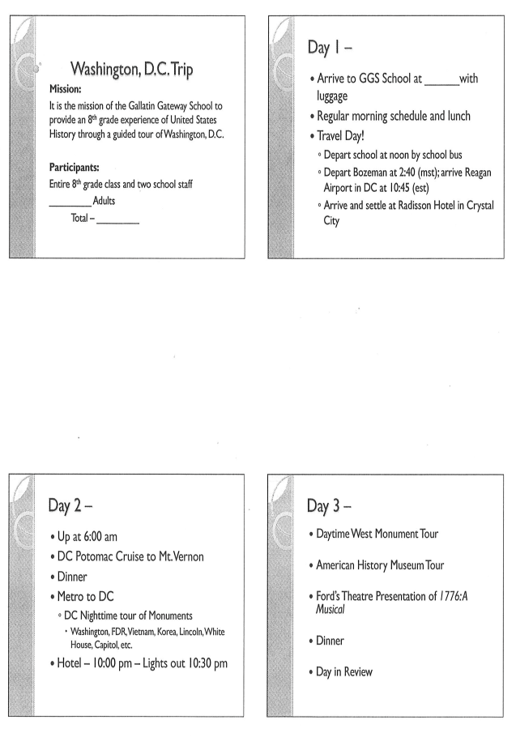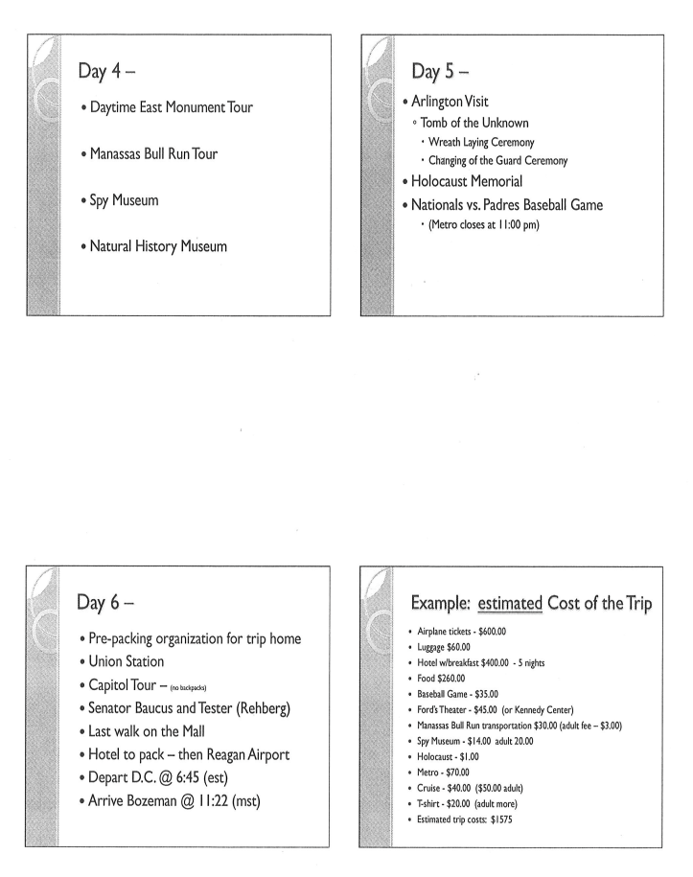

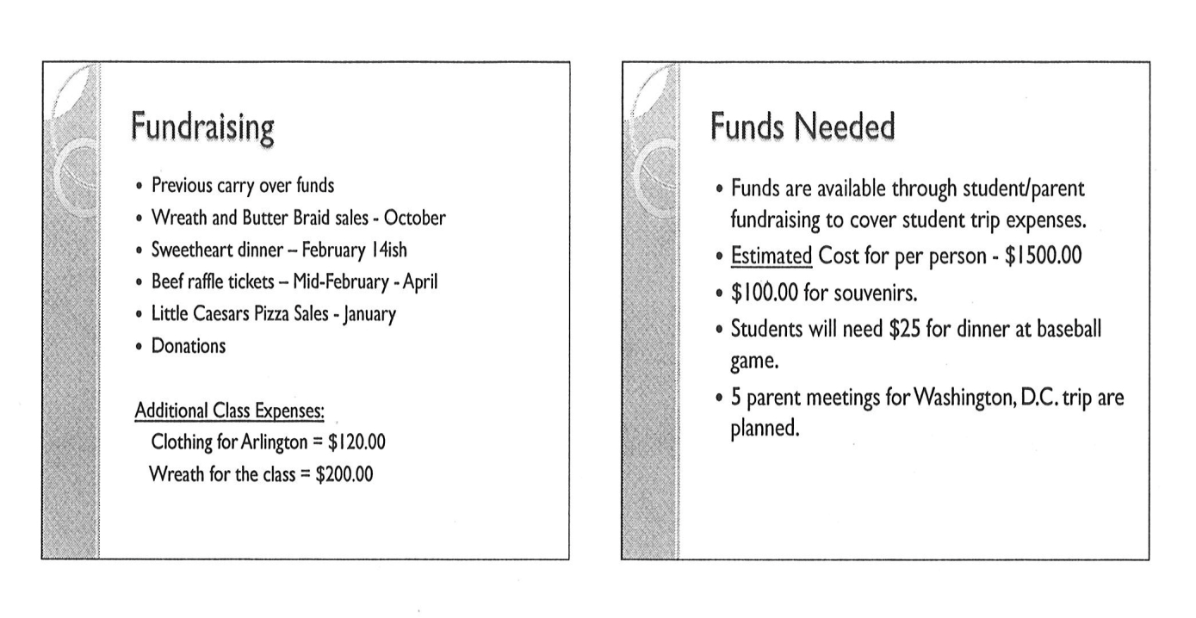

Planning a Field Trip
Teacher(s):
Grade(s): 8th
Date of Request: _____________
Destination: Washington, D.C.

Dates of the ﬁeld trip: Cost to student $ 0

Times including travel time: _______am on _______, 2023 to ______ pm on _______, 2023
Any special needs: Bus Needed: yes or no How many? 1 2

- Subject areas to be addressed on ﬁeld trip:
Social Studies, ELA, PE, MBI

- Rationale/objectives for the ﬁeld trip: see attached

- Speciﬁc educational connections to grade level curriculum: see attached
Schedule:
Departure from Gallatin Gateway School (see attached) Arrival at ﬁeld trip destination Activities to
Departure from ﬁeld trip
Arrival at Gallatin Gateway School

Permission note for parents: yes or no (please attach) Recess/Afterschool/Before School duty covered by N/A

Discussion with Superintendent Superintendent signature

Upon Approval
Teacher notiﬁcation to: Kitchen Music Gifted/Talented
Learning Lab ______
Co-op specialists (speech/psychologists) Guidance Library Coaches
Custodian Title I Recess Duty
Secretary documents- master calendar
Bus driver(s) schedule

We’re going on a Field Trip!

Your child’s class is participating in an educational trip. It is the policy of the Gallatin Gateway School District to require parental permission before allowing a student to travel with members of his/her class. If you would like your child to participate, please carefully read and sign this document.

I hereby give permission for my child, _____________________, to go with other students to Washington, D.C. from May 23 -27 for a class trip. Students will be transported by airline, subway, automobile, and trolley.

As a parent or guardian, I understand that the school and the staff will do everything possible to prevent any accidents. However, I fully understand that some activities on field trips involve inherent risks to students regardless of all feasible safety measures that may be taken by the district. In consideration of the district’s agreement to allow my child to participate in the referenced field trip, I agree to accept responsibility for any loss, damage, or injury to my child that occurs during my child’s participation in this field trip that is not the result of fraud, willful injury to a person or property or the willful or negligent violation of a law by a trustee, employee or agent of the Gallatin Gateway School District.

In the event it becomes necessary for the district staff in charge to obtain emergency care for my child, neither they nor the school district assumes financial liability for expenses incurred because of an accident, injury, illness and or unforeseen circumstances.

I have been informed the students will leave on Monday, May 23, 2022 at approximately 5:50 a.m. from the Bozeman Airport and return at approximately Friday, May 27, 2022 at about 11:04 p.m.

Parent or Guardian _____________________ Signature____________________________

Phone number (to be reached during the field trip) _______________________ Date: ____________

Does your child have a medical condition, which the school should be aware of before allowing your child to participate on a field trip? Yes_______ No________. If yes, please state the nature of the medical condition _______________________________________________________________.

**In the event that unforeseen circumstances arise creating a need for you to contact your student or information to be relayed to you about an emergency, change in itinerary, etc., call the Gallatin Gateway School at 763-4415.

Dinner for Two Raffle

Class Sales- up to $1000
Advertising – Flyers posted by students.

October: Trip Supervisor assigns students to a restaurant to seek a donation of a gift certificate for a dinner for two. The goal is to select upscale restaurants.
October- second week of Nov. collect gift cards by email and phone. Provide tax receipt.
Goal one per child or 10 minimum (Partner students for large class sizes)

Write a press release and give to the office to be sent out two weeks before and week of program. Ask attendees to bring cash.
Flier- Send home with K-8 students Friday before event.
Marquee – list the sales for one week before raffle

Need All Gift certificates
Need Donation form from GGS
Need the Thank you cards from the class
Need Raffle Tickets – buy a roll. Buyer name and phone number.
$1 per ticket or 6 tickets for $5.00
Need a can for each dinner meal to allow a separation for the drawing – Cans are kept upstairs.
Drawing is during the Winter Program. See script.
Minimum 10 dinner meals to raffle each year

Trip Supervisor: role play the request in class so each student is comfortable with the format. Restaurant contact may take place by phone or email from school if needed.

Parent: Email or call ahead for the best time to arrive at the assigned restaurant-- explaining that your child will be asking for a donation for the school field trip.

Student and Parent: Go in person to your restaurant
Respectfully ask the manager for the donation. Please use the words ‘please’ and ‘thank you’. Explain to the manager who you are and why you are there. “Good afternoon. I am an 8th grader from Gallatin Gateway School and I (we) are seeking donations to raise money for our class trip to Washington, D.C.” Offer the school’s letter of introduction.

“We are collecting certificates from the finer restaurants in the valley to raffle off in our Dinner for Two Raffle in December. The certificates should be large enough to provide a meal for two people.”

Explain to the manager that the restaurant will receives an official receipt with our school’s Federal Tax ID # on it. Show them a copy. Tell them you will finish filling it out if they can contribute a gift certificate.

Ask them if they are willing to assist the 8th grade class.
Information about the “Dinner-for-Two” Raffle Fundraiser

October Parent meeting—Fundraiser begins!

November All donated certificates due

December Raffle at the Winter Program 12/__ @ 6:30 p.m.

Parent/Student Responsibilities:
Each student, with parent support, is responsible for contacting several restaurants to request a donation. After donations are collected, students will sell raffle tickets for the drawing taking place at the winter program on December ____. Students will also sell tickets before the program and participate in the raffle during the concert.

Information about the “Dinner-for-Two” Raffle Fundraiser

October __ Parent meeting—Fundraiser begins!

November __ All donated certificates due

December __ Raffle at the Christmas Program 12/__ @ 6:30 p.m.

Parent/Student Responsibilities:
Each student, with parent support, is responsible for contacting several restaurants to request a donation. After donations are collected, students will sell raffle tickets for the drawing taking place at the winter program on December __. Students will also sell tickets before the program and participate in the raffle during the concert.

EXAMPLE of DINNER FOR TWO LETTER – letter of introduction

GALLATIN GATEWAY SCHOOL
PO BOX 265, GALLATIN GATEWAY, MT 59730

DATE

Greetings!

This letter is presented by an 8th grader, at Gallatin Gateway School. They are here today to request a tremendous favor. We are asking the finer restaurants in the Gallatin Valley to contribute a “Dinner for Two” for us to raffle off in December during our winter program.

The 8th-grade class is raising money to go to Washington D.C. for a school social studies trip. This trip is an incredible educational and historical experience and will cost about $_______ per student. To reach this goal, we are requesting help from our community.

A donation of a gift certificate for our fundraiser is tax deductible. Every donor receives a school receipt listing the school’s Federal Tax ID number.

We would greatly appreciate any help that you can offer and hope that you will make a generous contribution to our efforts. Community-oriented citizens and businesses can greatly add to the educational experience that we receive in the classroom. Thank you for your time and consideration.

If you have any questions or comments about this request please contact me at school at 763-4415 ext. 21 or herdina@gallatingatewayschool.com.

Sincerely,

Trip Supervisor and the 8th-grade class of Gallatin Gateway School
“Educating the Future”

“Dinner for Two” Raffle Fundraiser Facts

Who? Gallatin Gateway School 8th-grade class

What? The 8th-grade class is asking area restaurants to donate gift certificates for a “Dinner for Two” that will be raffled as part of a fundraiser. Your donation is tax-deductible and you will be given a receipt.

Why? To raise needed funds for the class trip to Washington, D.C., each student must raise approximately $_________. The students have been working as a class to earn money since 5th grade. Everyone participates to give each student the opportunity to earn the trip.

When? The “Dinner-for-Two” gift certificates will be raffled at the school’s annual Winter Program on December __. If you choose to give, donations are needed no later than November __ to allow us time to prepare for our drawing.

What else? Your participation is greatly appreciated, and this trip would not be possible without generous donors like you. Thank you!

Who to contact: ____________________________________________

Or you can direct any questions or donations to ___________, Trip Supervisor, ________@gallatingatewayschool.com

Eighth Grade “Dinner for Two” Idea List

- Ferraro’s
- Olive Garden
- The Gallatin River Lodge - Belgrade
- Ale Works
- Blackbird
- Squire House
- Tanglewood
- Ted’s Grill
- Land Of Magic - Logan
- Stacey’s – Gallatin Gateway
- Dave’s Sushi
- The Oasis - Manhattan
- The Bay
- Sacajawea Inn – Three Fork
- Feast
- Hop Lounge
- Rib and Chop House
- Thai Basil

These forms will be available in the office for the trip supervisor to distribute to the students for use when collecting donations. Supervisor will instruct students on how to complete the form. Yellow copy is returned to the Trip Supervisor for the thank you card to be completed and mailed. Trip Supervisor will keep a copy of each thank you stapled to each yellow donation card.

Gallatin Gateway School

Donation Form

Name: ___________________________________________ Date: ______________

Business Name: _______________________________________________________

Mailing Address: ______________________________________________________

City: ______________________ State: _______ Zip code: __________________

Item(s) donated: _______________________________________________________

______________________________________________________________________

Approximate Value: $_____________________ Thank you for your donation!

School Representative accepting donation: _______________________________

Student Representative accepting donation:______________________________

The Gallatin Gateway School is a political subdivision of the State of Montana. For your tax reporting purposes, the Gallatin Gateway School’s federal tax identification number is 81-6000425.

Thank you note
** Make sure you make a scanned copy of each card for school records!*
For a donation from a person/business:

Dear ___________________,

Thank you for supporting the Gallatin Gateway Class of _______ with your donation. We sincerely appreciate your support!

Thank you!
GGS Class of ________

For a volunteer and/or helper:

Dear ___________________,

Thank you for supporting the Gallatin Gateway Class of _______ with all of your time and hard work! We sincerely appreciate your support!

Thank you!
GGS Class of _______.
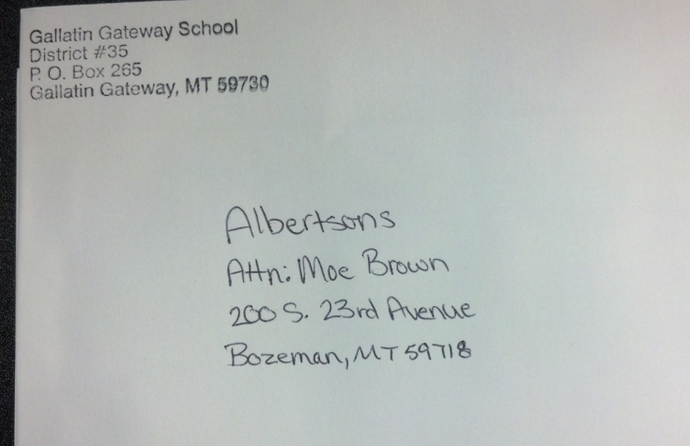

Envelope: (outside) example

🍽 Dinner for Two Raffle 🍽

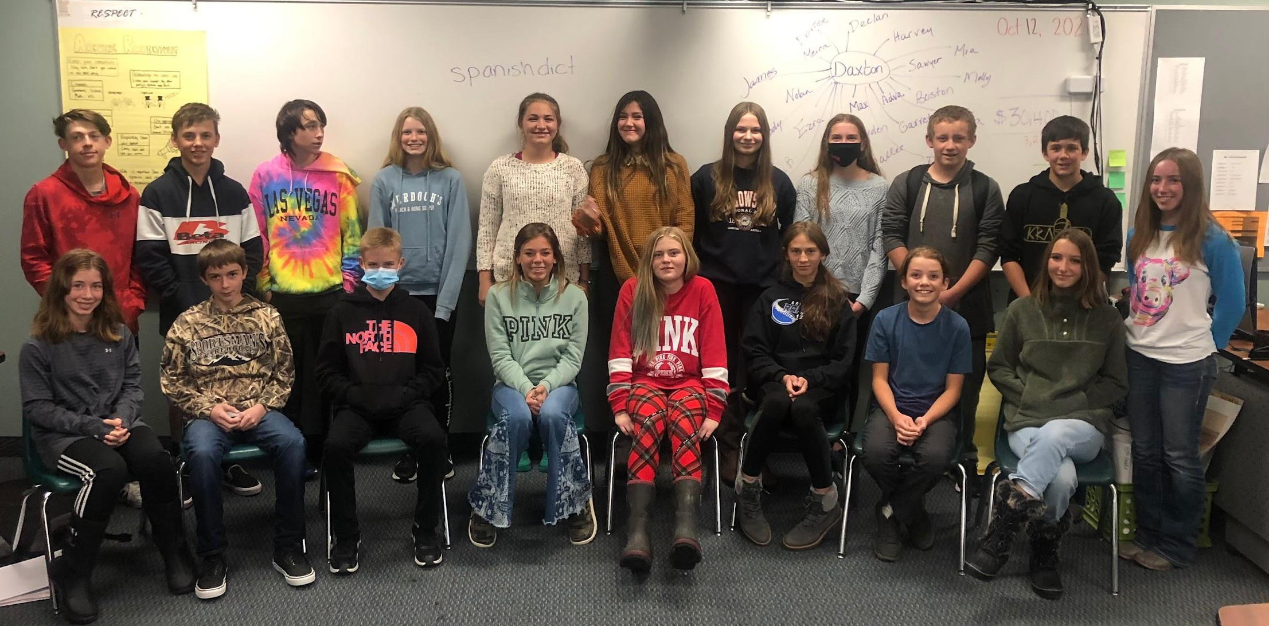
Thank you Gallatin Gateway School community, parents, staff, students, greater Gallatin County, and many generous organizations and businesses for your contributions to our fundraisers.

Restaurants
The Mint * Dave’s Sushi’ *Sweet Chili
Mackenzie River
Blacksmith Italian * Sacajawea Bar
Sidewinders
December 16 at 6:30 pm

Purchase Tickets
Winter Program @ GGS
December 16 at 6:30 pm
$1 per ticket (sold at door)
Winners drawn during the performances.
Need not be present to win.

Support
Proceeds benefit the eighth-grade class trip to Washington, D.C. in May.
We will visit the Capitol, meet Montana’s senators, tour the Holocaust Museum and Arlington Cemetery, attend a Washington Nationals’ baseball game, and take in the sights of the nation’s capital.

Dinner for Two Selling & Drawing Procedure

Parent Volunteers Needed
2 per table
1 for announcing assistance
Setup in lobby

6:00 pm Report to duties

Raffle tables: $1/ticket, $20 arm-length.
- Ask every person:
- “Would you like to purchase a raffle ticket to support the 8th-grade class?”
- Money placed in bank bag
- Buyer gets ticket stub. Place in can for selected restaurant(s)
- They may put a ticket in as many cans as they choose.
- Let them know about second table with 6 other restaurants.
- Say, “Thank you!” and “Happy Holidays!”

6:30 pm Close Lobby Raffle Table
- Teacher will take money bag to the vault.
- Raffle table students bring raffle cans filled with tickets to the gym.
- All lobby students respectfully return to the gym to assigned seats.

Drawing (When __________ is finishing their song)
- Two students lead the drawing students with cans followed by the rest of the class in a line up to the microphone. Smile!
- Read introduction from the script. Loud and Clear!!!
- Begin the drawing.
  - Assigned (alternate) will announce the number and restaurant.
  - Each student reads the number selected.
  - Hand ticket of winner to teacher. Record restaurant & winner.
  - Alternate drawers between students. They will read the names.
  - Runners will deliver gift cards to winners
- Students read from the script to say thank you and goodbye.
- From the students at the end of the line respectfully walk back to seats.
  - Place cans against the wall in the hallway.

Dinner for Two Drawing Script

Student A: Hello everyone and thank you for attending our winter program. Thank you also for supporting our 8th-grade Dinner for Two fundraiser.

Student B: The procedes of this fundraiser go towards our Washington D.C. history trip in May, there we will visit the Capitol, meet Montana’s senators, tour the Holocaust Museum and Arlington Cemetery, attend a Nationals’ baseball game, and take in the sights of the nation’s capital.

Student A: Gift certificates will be available for pick-up at the exit after the program.

Student A: Now we’re going to start off with________, drawing for The Mint…
And the winner is..._______ (Student)

Student B: Next we have_____ drawing for the Sacajawea Bar…
And the winner is..._______! (Stidemt)

Student B: Next we have_____ drawing for Mackenzie River Pizza…
And the winner is..._______! (Student)

Student A: Next we have_____ drawing for Sweet Chili…
And the winner is..._______! (Student)

Student A: Next we have_____ drawing for Dave’s Sushi…
And the winner is..._______! (Student)

Student B: Next we have_____ drawing for Sidewinders…
And the winner is..._______! (Student)

Student B: Next we have_____ drawing for Blacksmith Italian…
And the winner is..._______! (Student)

Student A: Thank you so much, and have a great night and a happy holiday season!

Sweetheart Spaghetti Supper

Class Sales: up to $3400

Takes place the Saturday before Valentine's Day. Ask for volunteers early in the year. Committee will meet the first week in January to make plan.
Time 5:30-7:30.

NOTHING is purchased for this event – everything is donated. Committee, Trip Supervisor, parents, and students will work together to find donors to make this happen!

Dinner is provided by donation from our guests.

Trip Supervisor:
- Schedule event on Master Calendar in September
- Advertising – Print posters. Committee and students will distribute.
- Prepare flyers to send home with students. (Friday folders, etc.)
- Write a press release and send by email to the office: Office will send out two weeks before event and week of event.
- Marquee – advertise event
- Reserve Community Center in the fall through the Willing Workers
- Server training at GGS in 8th-grade class – white shirts, black pants, black shoes
- Food service training through Safe Schools for whole class
- Arrange for parent to roll plasticware and napkins with students
- Decorations available at the school upstairs and other items may be brought in by students to decorate.
- Black linens are located upstairs.
- Desserts – Donated by GGS/request must be given to the Superintendent. Ask the cook to prepare enough brownies for 250 servings
- Set up tables and chairs with students Friday morning

Estimated Food Needs for 300 people:
Noodles 60 lbs
Gluten-free noodles 2 lbs
Meat – 10 lbs
Red Sauce – 9 gallons total
White Sauce – 7 gallons total
Parmesan Cheese- bagged shredded
Breadsticks - 300
Brownies – school donates
Salad Romaine – 9 big bags
Salad Toppings - Parmesan Cheese, Croutons
Lemonade – enough to make 40 gallons or more
Olive Oil – quart or less – needed for noodles when stored in the coolers
Chocolate Syrup- 2 bottles
Ice- 4 bags
Ziploc gallon size – 80 bags
Plastic gloves for servers
Coolers – BIG for storing cooked pasta (Provided by parents)

Plates
Utensils
Napkins
Cups

Cash Bag
Music & speaker

People to work at the event
Parents pre-cook noodles at home
Students in 8th grade class are the servers
Parents to help servers
Student and parent at front for taking $$ for the dinner
In the kitchen: Parents & students for food prep, serving line, dishes
Trip supervisors oversee event
Cleanup- All parents & students


Sweetheart Spaghetti Supper 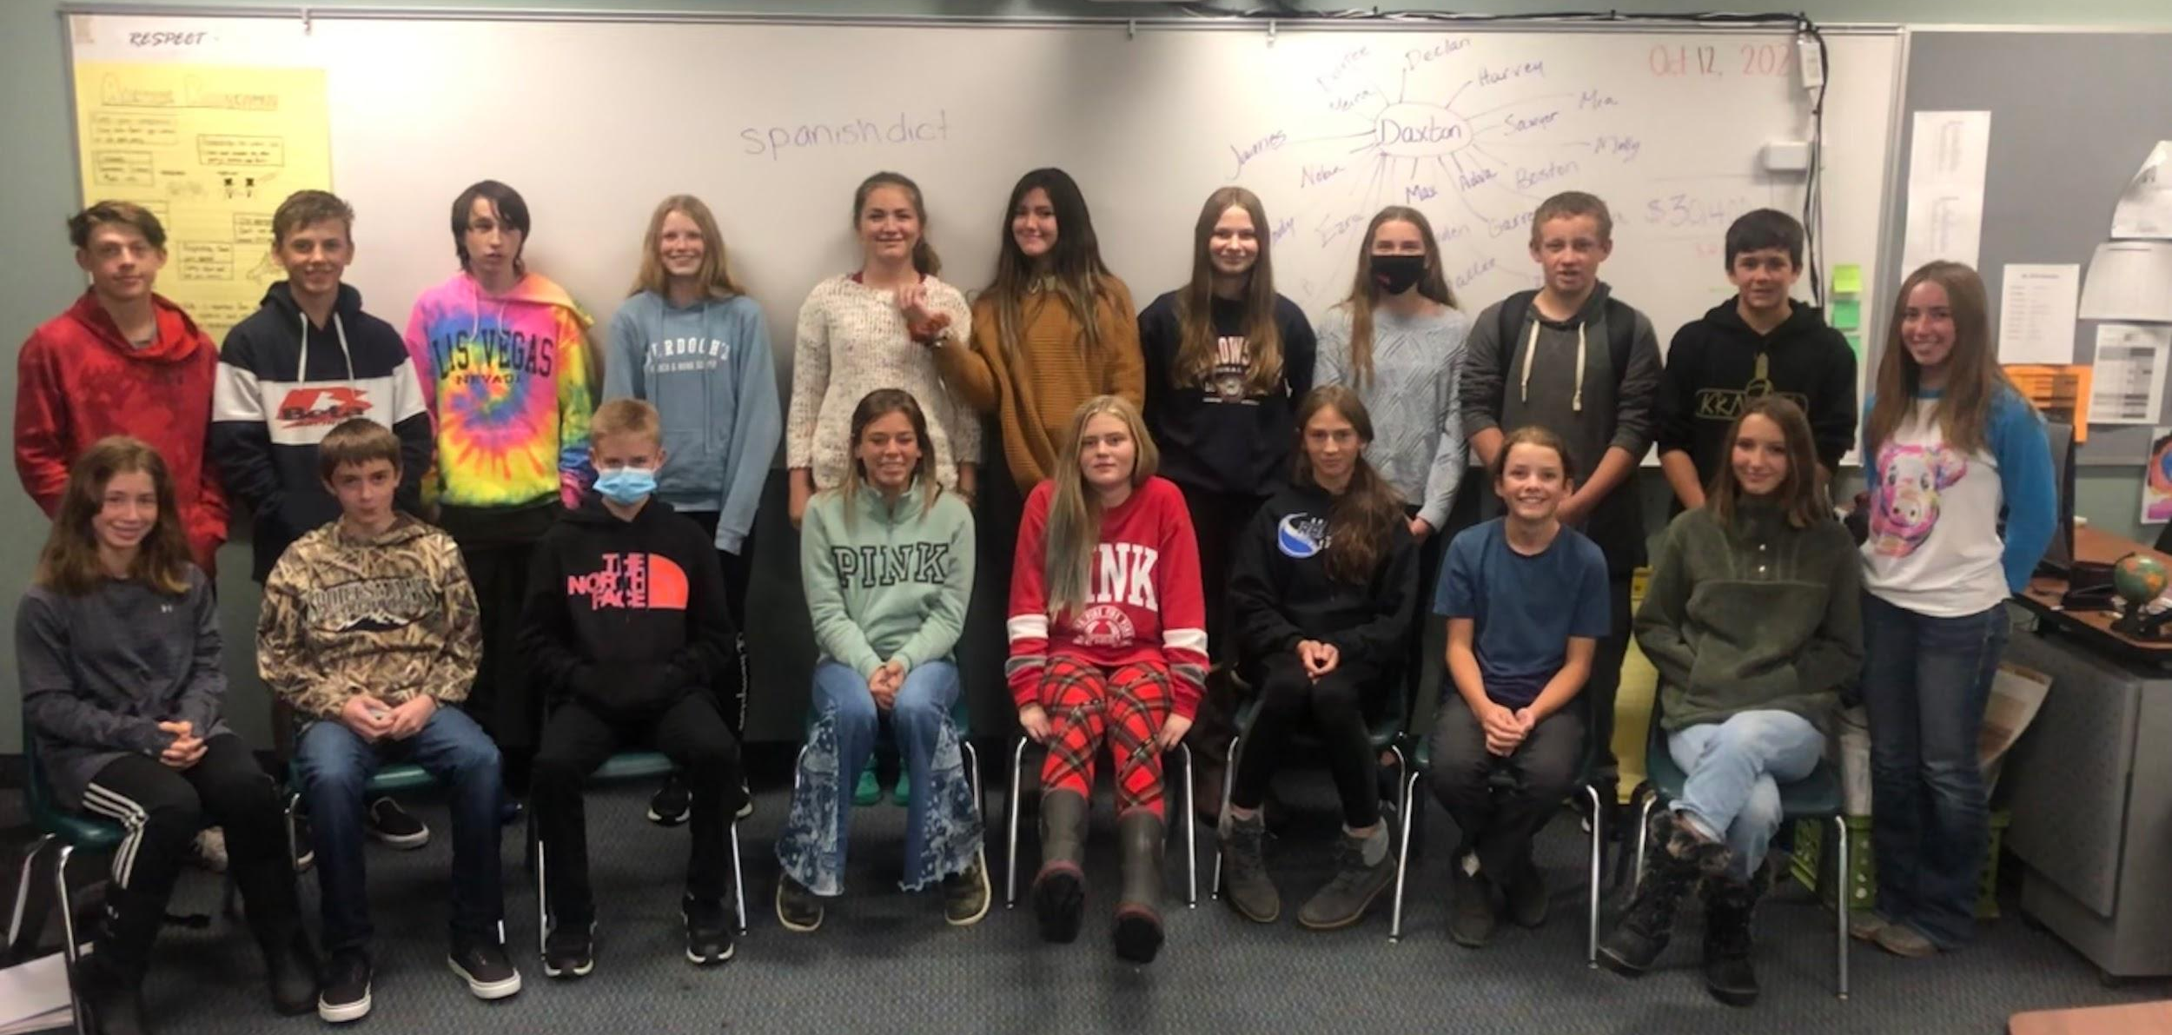
WHEN: February 12th 5:00pm - 7:00pm

WHERE: Gallatin Gateway Community Center

Spaghetti with marinara or alfredo sauce, Caesar salad, Italian breadsticks, dessert, and beverages

All community members are welcome!

Enjoy a delicious meal, great company, and friendly service from our 8th-grade students at no charge.

*Donations accepted if desired to support the upcoming class history trip!

Generous local donors: Montana Linen, Storm Castle Cafe, Pizza Hut, Town & Country,
Cold Smoke, The Jump & GGS 8th-grade Families

Special Thanks: Ms. McClure & Ms. Mitchell
Spaghetti Supper Schedule

Friday
8:00 am- Setup up tables and chairs
-parents set up decorations

Saturday
4:00 pm- Set entryway, silverware, signs.
-Create chalkboard sign and easel
-Roll remaining silverware
-Food in roasters
-Set music
-Lighting
-Place Menus
-Drink table and pitchers
-Mix salad
-Gluten-free + salad option

4:30 pm- Students eat

5:00 pm: All places set
-Students change into server clothes
-Wash hands
-Cut and plate brownies.
-Plate salads
-Set lights, music
-Host posted
-Clipboards
-Servers with pens and ordering notepads

5:30 pm- 7:00 pm
-Servers share responsibility for sections
-Stage:
-Near stage:
-Center:
-South-end:
(Rotate through serving drinks, meals, dessert, and clearing)
-Reset Napkins on table and rolled silverware as needed
-Siblings will fill positions pouring drinks, rolling silverware

-Adult Assignments-
-Noodles & Sauce:
-Salad Plating:
-Drinks: Heidi
-Brownies:
-Host/Seating: Ashley
-Remind guests that we are closing at 7:30

7:00 pm: Closing
-Dishes
-Pack dishes in cars
-Take out garbages
-Bag linens (send home to wash)
-Vacuum
-Check bathrooms
-Check closing list on fridge
-Pack leftovers

Spaghetti Supper Info Cards for Tables

Thank you for spending your Saturday evening with us! Our class trips depend on the fundraising efforts of our students and families with the generous support of the Greater Gallatin community. The 8th graders aim to raise $2000/person for our trip in May. Any funds raised from the Sweetheart Spaghetti Supper go into the school’s class accounts. We greatly appreciate your role in GGS education!

Thank you for spending your Saturday evening with us! Our class trips depend on the fundraising efforts of our students and families with the generous support of the Greater Gallatin community. The 8th graders aim to raise $2000/person for our trip in May. Any funds raised from the Sweetheart Spaghetti Supper go into the school’s class accounts. We greatly appreciate your role in GGS education!

Thank you for spending your Saturday evening with us! Our class trips depend on the fundraising efforts of our students and families with the generous support of the Greater Gallatin community. The 8th graders aim to raise $2000/person for our trip in May. Any funds raised from the Sweetheart Spaghetti Supper go into the school’s class accounts. We greatly appreciate your role in GGS education!

Thank you for spending your Saturday evening with us! Our class trips depend on the fundraising efforts of our students and families with the generous support of the Greater Gallatin community. The 8th graders aim to raise $2000/person for our trip in May. Any funds raised from the Sweetheart Spaghetti Supper go into the school’s class accounts. We greatly appreciate your role in GGS education!

Thank you for spending your Saturday evening with us! Our class trips depend on the fundraising efforts of our students and families with the generous support of the Greater Gallatin community. The 8th graders aim to raise $2000/person for our trip in May. Any funds raised from the Sweetheart Spaghetti Supper go into the school’s class accounts. We greatly appreciate your role in GGS education!

Thank you for spending your Saturday evening with us! Our class trips depend on the fundraising efforts of our students and families with the generous support of the Greater Gallatin community. The 8th graders aim to raise $2000/person for our trip in May. Any funds raised from the Sweetheart Spaghetti Supper go into the school’s class accounts. We greatly appreciate your role in GGS education!

Spaghetti Supper Server Script

Good evening and thank you for joining us!

Tonight we are serving your choice of pasta- Alfredo or Marinara (with or without meat), Caesar salad, and breadsticks.

May we bring your beverages to get started? We have:
Lemonade, Ice Tea, and Water

(Write down the number of each choice.)

Once you bring beverages, ask each guest if they would like salad and which type of pasta sauce).

Tell them thank you and you will bring the salads out first.

Bring salads and refill drinks as needed.

Bring pasta and breadsticks. Remove salad plates. Offer to refill drinks.

Keep an eye on your tables for refills.

When most guests have finished eating, offer to take their plates. Ask if they are ready for dessert. We are serving brownies with chocolate sauce.

Bring dessert with small napkins and dessert fork. Check for refills.

When guests are leaving, thank them for coming. Remove any dirty dishes or garbage. Refresh the linens and reset with silverware.

Sweetheart Spaghetti Supper


Caesar Salad

Spaghetti
Choice of Alfredo sauce
or marinara sauce (w/ or w/o beef)

Fresh-baked breadsticks

Dessert
Bobby Jo's Scrumptious Brownies

Beverages
Iced Tea
Lemonade
Iced Water

Thank you for your generous support of our students.
Donations & Tips accepted by host.
Sweetheart Spaghetti Supper

Caesar Salad

Spaghetti
Choice of Alfredo sauce
or marinara sauce (w/ or w/o beef)

Fresh-baked breadsticks

Dessert
Bobby Jo's Scrumptious Brownies

Beverages
Iced Tea
Lemonade
Iced Water

Thank you for your generous support of our students.
Donations & Tips accepted by host.


Sweetheart Spaghetti Supper

February 8th Everyone welcome!
5 pm- 7:30 pm Community Center

Your donation supports the eighth-grade class trip to Washington, D.C.!

Sweetheart Spaghetti Supper

February 8th Everyone welcome!
5 pm- 7:30 pm Community Center

Your donation supports the eighth-grade class trip to Washington, D.C.!

Sweetheart Spaghetti Supper

February 8th Everyone welcome!
5 pm- 7:30 pm Community Center

Your donation supports the eighth-grade class trip to Washington, D.C.!

Sportsman’s Banquet Raffle
March-April event

Class Profits – up to $10,000

Full profit -- so sell $2000 make $2000

Sportsman’s Banquet Committee (See Sportsman’s Banquet Guide)
- Advertising – Flyers to send home in Friday folders
- Committee will write a press release at beginning of sale and reminders for office to send out.
- Marquee – Advertise raffle sales

Role of the homeroom teachers and trip supervisors: collect and return raffle packets weekly. Post and encourage sales. Help students sign up to sell tickets at public locations.

Organization of Murdochs, Albertsons, and other businesses allow students to sell tickets on the weekends – the raffle chairperson organizes and informs students of opportunities. Provides sign-up.

Ticket price 1 for $5.00 or 5 for $20.00

Students are given opportunities to sell tickets for two ½ beef raffles, pig, and gun as organized by the Sportsman’s Banquet committee. All funds raised by each class goes to the classes’ Foundation accounts. Grades 5-8 participate.

Sportsman’s Banquet Auction
April event

Class Sales – $10,000+ goal

Profit -- Auction sales divided by number of students. Subtract expenses.

Sportsman’s Banquet Committee (See Sportsman’s Banquet Guide)
- Advertising – Flyers to send home in Friday folders
- Committee will write a press release to announce event date and reminders for office to send out.
- Marquee – Advertise auction date

Role of the homeroom teachers and trip supervisors: announce committee information to students and parents. Encourage parents and students to sign up for auction help.

Ticket price 1 for $5.00 or 5 for $20.00

Example of Timeline and Schedule
 | Monday | Tuesday | Wednesday | Thursday | Friday
Times | 23-May | 24-May | 25-May | 26-May | 27-May
 | Comfortable/Navy Blue | Black | Gator Shirt | Black | Gray-Comfortable
4:00 AM
5:00 AM | Meet @ BZN & Check in at Delta counter @ 4:30
6:00 AM | 6:00AM: Depart from Bozeman -9:13 AM Arrive to Minneapolis | Wake up & Get Ready | Wake up & Get Ready | Wake up & Get Ready
6:30 AM | 6:00AM: Depart from Bozeman -9:13 AM Arrive to Minneapolis
7:00 AM | 6:00AM: Depart from Bozeman -9:13 AM Arrive to Minneapolis | Breakfast | Breakfast | Breakfast | Wake up & Get Ready
7:30 AM | 6:00AM: Depart from Bozeman -9:13 AM Arrive to Minneapolis |  |  |  | Breakfast & Final Journal Reflection
8:00 AM | 6:00AM: Depart from Bozeman -9:13 AM Arrive to Minneapolis |  |  | Arlington Cemetery & Marine Corps Memorial | Breakfast & Final Journal Reflection
8:30 AM | 6:00AM: Depart from Bozeman -9:13 AM Arrive to Minneapolis |  |  | Arlington Cemetery & Marine Corps Memorial | Pack up & Room Check
9:00 AM | 6:00AM: Depart from Bozeman -9:13 AM Arrive to Minneapolis |  | Steps of Supreme Court | Arlington Cemetery & Marine Corps Memorial | Pack up & Room Check
9:30 AM | 6:00AM: Depart from Bozeman -9:13 AM Arrive to Minneapolis | Pictures in front of White House |  | Arlington Cemetery & Marine Corps Memorial | Meet in Lobby
10:00 AM | Food Court To Go Lunch | Metro to SAHM | Metro to Hart Building | Arlington Cemetery & Marine Corps Memorial | Metro to Ford's
10:30 AM | 10:35 AM: Depart from Minneapolis- 2:05 PM: Arrive to D.C. | National American History Museum |  | Arlington Cemetery & Marine Corps Memorial | Souvenir Shop
11:00 AM | 10:35 AM: Depart from Minneapolis- 2:05 PM: Arrive to D.C. |  | Meet with Sen. Tester | Lunch
11:30 AM | 10:35 AM: Depart from Minneapolis- 2:05 PM: Arrive to D.C. | Lunch- eat @ National Place | Meet with Sen. Tester | Lunch | Ford's Theatre!!!!
12:00 PM | 10:35 AM: Depart from Minneapolis- 2:05 PM: Arrive to D.C. | Lunch- eat @ National Place | Meet Sen. Daines | Hold Space-TBD based on scheduling National Zoo | Ford's Theatre!!!!
12:30 PM | 10:35 AM: Depart from Minneapolis- 2:05 PM: Arrive to D.C. | Walk to National Archives through Sculpture Garden | Capitol Tour | Hold Space-TBD based on scheduling National Zoo | Shuttle to Airport
1:00 PM | 10:35 AM: Depart from Minneapolis- 2:05 PM: Arrive to D.C. | Walk to National Archives through Sculpture Garden |  | Hold Space-TBD based on scheduling National Zoo | Check In at DCA
1:30 PM | 10:35 AM: Depart from Minneapolis- 2:05 PM: Arrive to D.C. |  | Lunch- Eat @ National Place | Hold Space-TBD based on scheduling National Zoo | Lunch at DCA
2:00 PM | 10:35 AM: Depart from Minneapolis- 2:05 PM: Arrive to D.C. | National Archives Museum | Lunch- Eat @ National Place | Hold Space-TBD based on scheduling National Zoo
2:30 PM | Baggage Claim | National Archives Museum |  | Hold Space-TBD based on scheduling National Zoo | Leave for Airport
3:00 PM | Shuttle to Hotel | Museum of Natural History |  | Metro to Nationals Stadium | 3:15 PM Flight to Minneapolis by 4:50
3:30 PM | Check in Courtyard by Marriot Crystal City | Museum of Natural History | National Mall Walking Tour | Metro to Nationals Stadium
4:00 PM | Check in Courtyard by Marriot Crystal City | Museum of Natural History
4:30 PM |  | Museum of Natural History
5:00 PM | Dinner @ Hotel | Order online for pick up: Young Chow or Honeygrow | Pentagon Memorial
5:30 PM | Dinner @ Hotel | Order online for pick up: Young Chow or Honeygrow
6:00 PM | Metro to National Mall | Order online for pick up: Young Chow or Honeygrow |  | Metro to Nationals Stadium
6:30 PM | National Mall Washington Monument, WWII, Korean War, Vietnam, & Lincoln Memorials | Order online for pick up: Young Chow or Honeygrow |  |  | Leave Minneapolis at 9:30.
7:00 PM |  | Order online for pick up: Young Chow or Honeygrow | Dinner
7:30 PM |  | Metro to Hotel |  | Washington Nationals v. Rockies Dinner @ Stadium Concessions
8:00 PM |  | Group Meeting |  | Washington Nationals v. Rockies Dinner @ Stadium Concessions | 11:04 PM Arrive in Bozeman Meet all parents at Delta Baggage Claim
8:30 PM |  | Get ready for bed & Prep for next day | Metro to Hotel | Washington Nationals v. Rockies Dinner @ Stadium Concessions
9:00 PM |  | Get ready for bed & Prep for next day |  | Washington Nationals v. Rockies Dinner @ Stadium Concessions
9:30 PM | Reflection Journal | Reflection Journal | Reflection Journal | Washington Nationals v. Rockies Dinner @ Stadium Concessions
10:00 PM |  |  |  | Washington Nationals v. Rockies Dinner @ Stadium Concessions
10:30 PM | Lights out | Lights out | Lights out | Lights out | Lights out
11:00 PM

Example: Estimated Trip Expenses

Estimates
 | Student | Adult
5/15 - Metro Cards | $65.00 | $65.00
5/15 - Plane Ticket | $562.89 | $562.89
5/15, 5/20 - Luggage | $60.00 | $60.00
5/15 - lunch, MSP Food Court | $10.00 | $10.00
5/15 - Dinner | $15.00 | $15.00
5/16 - Breakfast (hotel) | $16.95 | $16.95
5/16 - Lunch | $10.00 | $10.00
5/16 - Dinner | $15.00 | $15.00
5/16 - Breakfast (hotel) | $16.95 | $16.95
5/17 - Lunch | $10.00 | $10.00
5/17 - Dinner | $15.00 | $15.00
5/18 - Breakfast (hotel) | $16.95 | $16.95
5/18 - Lunch | $10.00 | $10.00
5/18 - Dinner | $15.00 | $15.00
5/19 - Breakfast (hotel) | $16.95 | $16.95
5/19 - Lunch | $10.00 | $10.00
5/19 - Dinner | $15.00 | $15.00
5/20 - Breakfast (hotel) | $16.95 | $16.95
5/20 - Lunch | $10.00 | $10.00
5/20 - Dinner | $15.00 | $15.00
5/15-5/20 Hotel | $350.63 | $350.63
5/16 - Spy Museum | $21.27 | $21.27
5/17 - Hello, Dolly! Play | $45.00 | $45.00
5/18 - Mt. Vernon/Cruise | $40.00 | $48.00
5/19 - Manassas Entrance | $0.00 | $3.00
5/19 - Manassas Trans | $26.10 | $26.10
5/19 - DC United Game | $50.00 | $50.00
Transportation | 600 | 600
Polo | $20.00 | $20.00
Grand total | approx. 2000 | approx. 2000

How to login for Metro SmarTrip Cards

visit: https://smartrip.wmata.com and log in to our account:
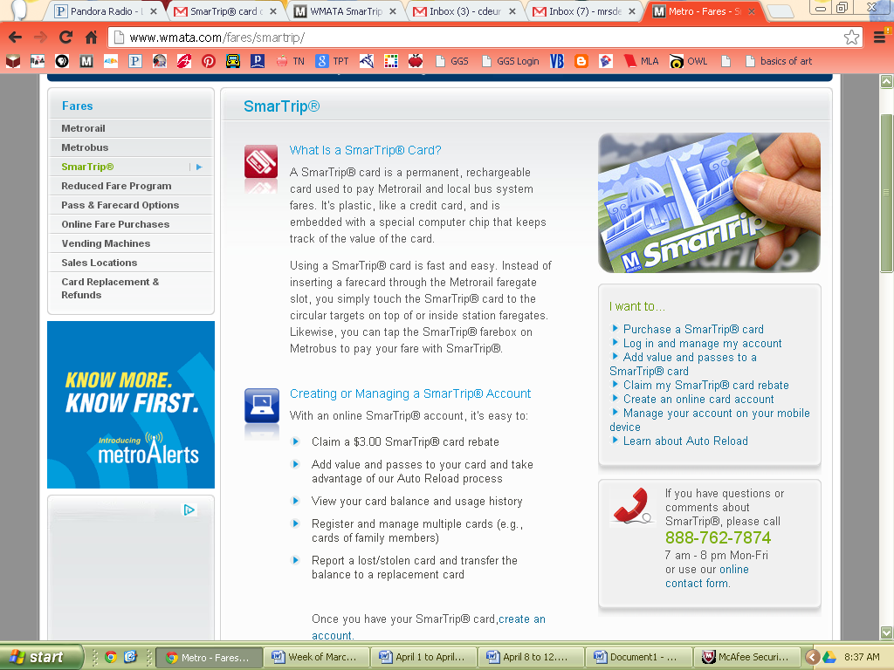

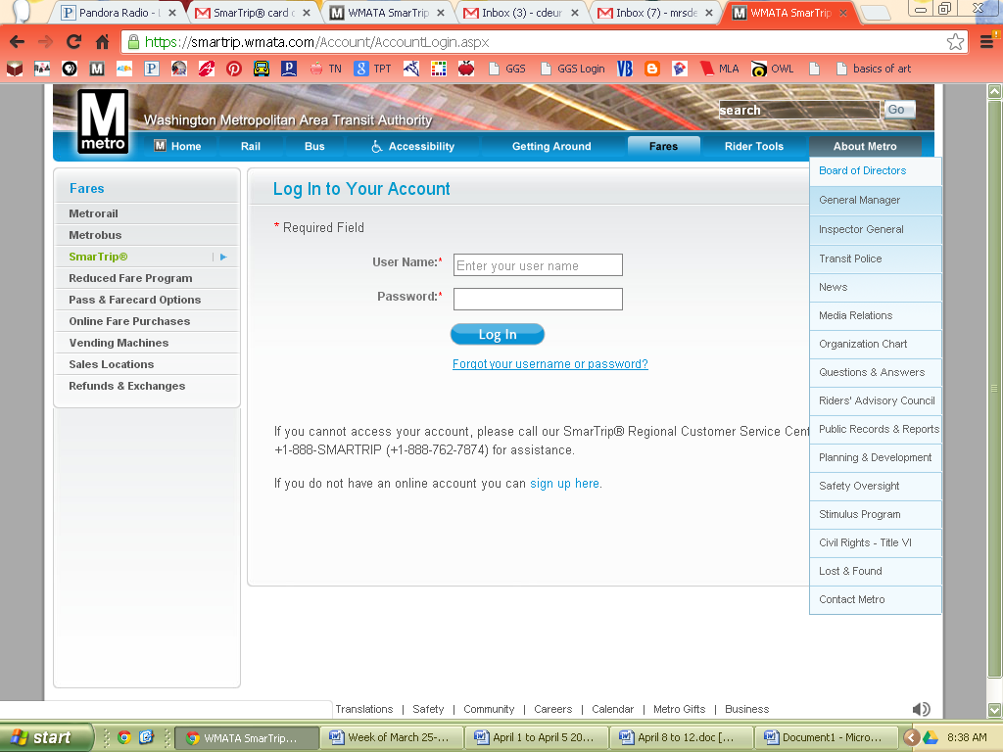
Username: Gallatin Gateway (watch capitals AND spaces!)
Password: gogators11!
This screen should pop up:

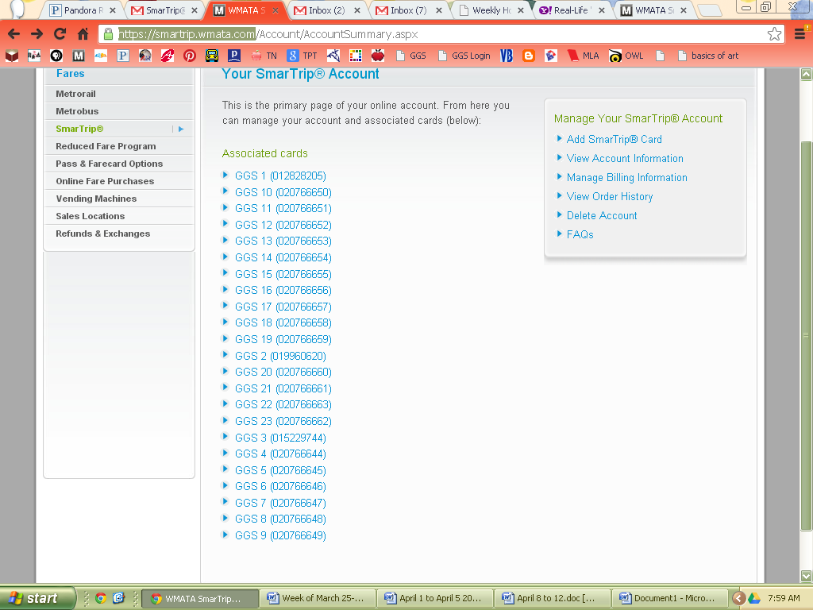

Click on the cards you want to reload. For this trip (2013) we are only going to load #’s 1-16
* notice! they are out of numerical order, use only the ones you need)

once you click on the card, this screen should appear:
you will want to click on “Add Value/Set up Auto Reload”

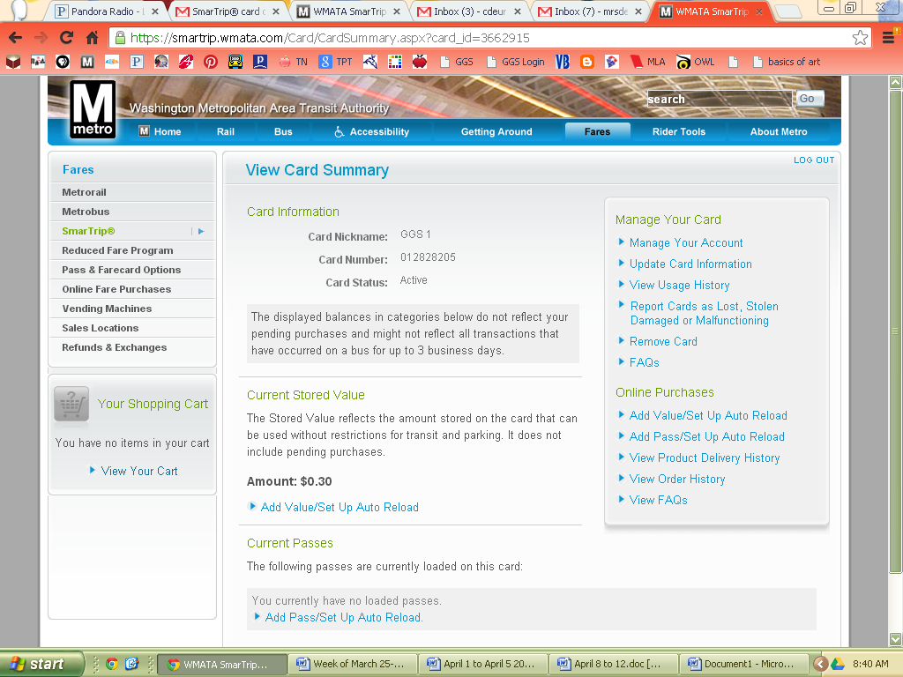

This screen should appear:
- write in the amount you want to add. Must be in whole dollar amounts.
*for the 2013 trip we are adding 65.00 to each card
- click “Add” and it will add the item to your cart

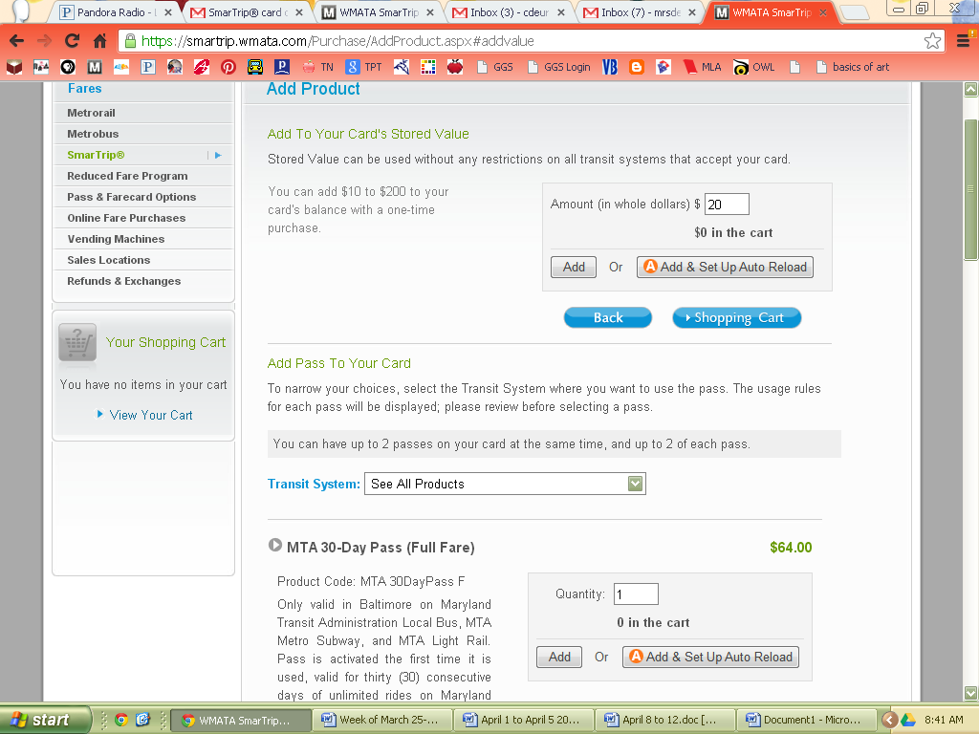

Then, click the arrow next to smart trip on the left hand side:

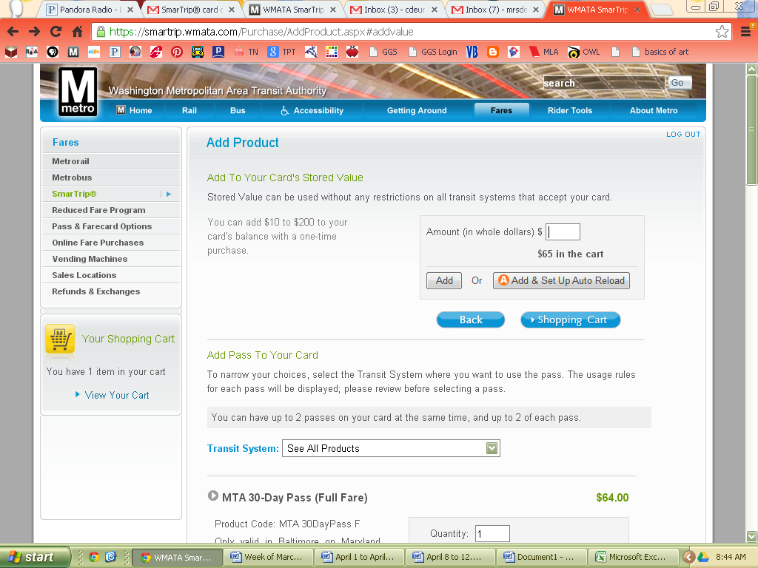
Click on “Manage Your Account”
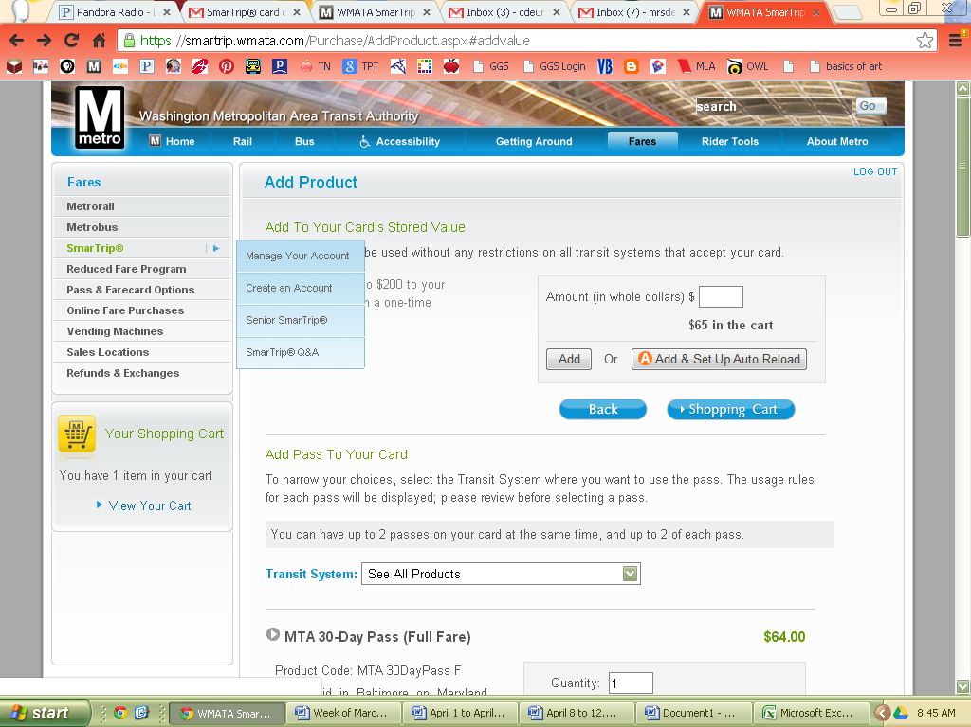

This screen should appear:
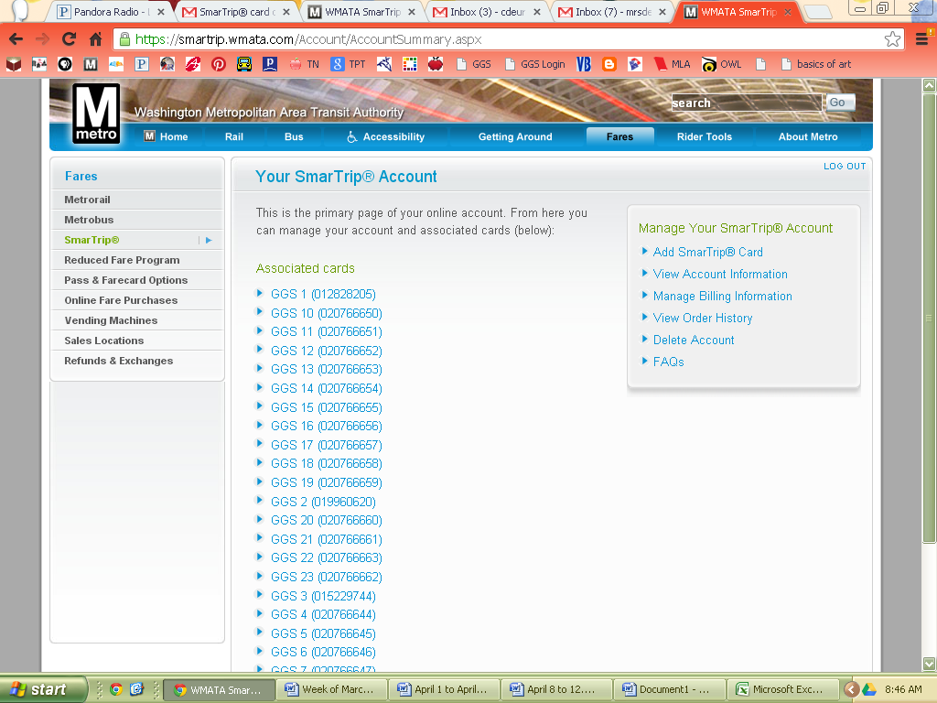
Continue adding value to your cards. Sometimes, it will only let you add $200 per credit/debit card per day.

Student Travel Journal
Washington, D.C.


8th Grade Field Trip 2022

Name:___________________________________

*Note: Journals should be completed as the days progress.

Day 1 – Plane Trip, Traveling, and Nighttime Tour
_____/50
Answer each question with at least two complete sentences (or more) for the answer. Each question is worth 10 points towards your Q4 grade.
What one activity are you looking forward to viewing the most during this five-day excursion? Why?
_______________________________________________________________________________________________________________________________________________________________________________________________________________________________________________________________________________________________________________________________________________________________________________________________________________________________

National Mall Tour -- Night: What was your first impression when you exited the Metro onto the National Mall?
_______________________________________________________________________________________________________________________________________________________________________________________________________________________________________________________________________________________________________________________________________________________________________________________________________________________________

Which monument was your favorite? Describe why.
_______________________________________________________________________________________________________________________________________________________________________________________________________________________________________________________________________________________________________________________________________________________________________________________________________________________________

What role does water play in The National Mall monuments? Describe.
_______________________________________________________________________________________________________________________________________________________________________________________________________________________________________________________________________________________________________________________________________________________________________________________________________________________________

Today you embarked on your first WMTA Metro Ride. What was it like? What is your impression of the Metro-Rail stations? The people?
_______________________________________________________________________________________________________________________________________________________________________________________________________________________________________________________________________________________________________________________________________________________________________________________________________________________________

Arlington National Cemetery
_____/20

Arlington is a solemn place. Describe a sight that shocked, comforted, and/or amazed you.
________________________________________________________________________________________________________________________________________________________________________________________________________________________________________________________________________________________________________________________________________________________________________________________________________________

There are several meaningful sites in Arlington. Which stood out most to you? Why?
____________________________________________________________________________________________________________________________________________________________________________________________________________________________________________________________________________________________________________________________________________

Daytime Monument Tour, American
History Museum
_____/50

Do you prefer the monuments at night, during the day, or both? Explain.
_______________________________________________________________________________________________________________________________________________________________________________________________________________________________________________________________________________________________________________________________________________________________________________________________________________________________

Approximately how many names reside on the Vietnam War Wall Memorial? Describe your impressions of this memorial.
____________________________________________________________________________________________________________________________________________________________________________________________________________________________________________________________________________________________________________________________________________

What speech is etched inside the Lincoln Memorial? What is its significance?
____________________________________________________________________________________________________________________________________________________________________________________________________________________________________________________________________________________________________________________________________________

The Star Spangled Banner is more than a song; it’s an actual object. What type of object is it? What is its significance to United States History?
____________________________________________________________________________________________________________________________________________________________________________________________________________________________________________________________________________________________________________________________________________

In the American History Museum which section drew your interest? Why?
____________________________________________________________________________________________________________________________________________________________________________________________________________________________________________________________________________________________________________________________________________

Ford’s Theatre
_____/20

The Museum offers many interesting facts about President Lincoln. Which did you find most fascinating? Why?
_______________________________________________________________________________________________________________________________________________________________________________________________________________________________________________________________________________________________________________________________________________________________________________________________________________________________

Where did President Lincoln die? What is its location in relation to Ford’s Theatre?
_______________________________________________________________________________________________________________________________________________________________________________________________________________________________________________________________________________________________________________________________________________________________________________________________________________________________

Natural History Museum
_____/30

List exhibits you viewed at the Museum of Natural History Which exhibit was the most interesting to you? Explain.
_______________________________________________________________________________________________________________________________________________________________________________________________________________________________________________________________________________________________________________________________________________________________________________________________________________________________

In the rotunda of the Natural History museum, there is a large display. Describe this display. What is the significance of this display to the museum?
_______________________________________________________________________________________________________________________________________________________________________________________________________________________________________________________________________________________________________________________________________________________________________________________________________________________________

Montana has famously lent an exhibit to the Museum. What is it, and why is it so important?
____________________________________________________________________________________________________________________________________________________________________________________________________________________________________________________________________________________________________________________________________________
Washington Nationals Game
_____/20
Describe the experience on the way to Nationals Park?
_______________________________________________________________________________________________________________________________________________________________________________________________________________________________________________________________________________________________________________________________________________________________________________________________________________________________

Who won the baseball game? Recount your experience at the game.
__________________________________________________________________________________________________________________________________________________________________________________________________________________________________________________________________________________________________________________________________________________________________________________________________________________________________________________________________________________________________________________

Senators and Capitol Tour
_____/40

What is the significance of the Supreme Court Building? Why do you think it is so close to the Capitol Building?
_______________________________________________________________________________________________________________________________________________________________________________________________________________________________________________________________________________________________________________________________________________________________________________________________________________________________

What was the most unique feature of the Capitol Building? Why?
____________________________________________________________________________________________________________________________________________________________________________________________________________________________________________________________________________________________________________________________________________

How many Senators are from Montana? What are their names? Describe something you learned after listening to each.
_______________________________________________________________________________________________________________________________________________________________________________________________________________________________________________________________________________________________________________________________________________________________________________________________________________________________

Where in the Capitol do all of the Senators meet?
______________________________________________________________________________________________________________________________________________________________________

Sculpture Garden and National Archives
_____/40

Which three founding documents are preserved at the National Archives Museum? Which one do you believe is most important? Why?
_______________________________________________________________________________________________________________________________________________________________________________________________________________________________________________________________________________________________________________________________________________________________________________________________________________________________

In sixth grade we studied medieval Europe. The Record of Rights exhibit houses the document we discussed. What is it, and when was it written?
____________________________________________________________________________________________________________________________________________________________________________________________________________________________________________________________________________________________________________________________________________

Locate the sculpture, Puellae (Girls, by Magdalena Abakanowicz. What does this sculpture seem to show? What does it mean?
_______________________________________________________________________________________________________________________________________________________________________________________________________________________________________________________________________________________________________________________________________________________________________________________________________________________________

Which sculpture fascinated you the most? Describe it.
______________________________________________________________________________________________________________________________________________________________________

Pentagon Memorial
_____/40

Why do the memorial benches face different directions? Explain the meaning.
_______________________________________________________________________________________________________________________________________________________________________________________________________________________________________________________________________________________________________________________________________________________________________________________________________________________________

What is the purpose of the Age Wall? What does it symbolize?
______________________________________________________________________________________________________________________________________________________________________

National Museum of the American Indian

Where in the museum did you make a connection with what you have previously learned in school? Explain.
_______________________________________________________________________________________________________________________________________________________________________________________________________________________________________________________________________________________________________________________________________________________________________________________________________________________________

What is the meaning of the Raven in the Tlingit culture? How do you know?
______________________________________________________________________________________________________________________________________________________________________

Trip Reflections
_____/40

What has been the most meaningful part of your entire trip? Explain.
____________________________________________________________________________________________________________________________________________________________________________________________________________________________________________________________________________________________________________________________________________________________________________________________________________________________________________________________________________________

What would you say has been the most valuable learning experience? Why?
____________________________________________________________________________________________________________________________________________________________________________________________________________________________________________________________________________________________________________________________________________

Washington, D.C. Research Project

CITE information that you gather.

Outline for Report
Use this as a guide. You may need to include more sentences/paragraphs than what you see in this outline.
** Include a title and photo.**

- Introduction – brief, do not go into detail
  - Thesis– main topics you will be discussion
  - Supporting sentences (2-3+)
  - Conclusion – Summary of paragraph, transition to next paragraph
- Body – Point of Interest
  - History (2-3+)
  - Conclusion – Summary of paragraph, transition to next paragraph
- Body – Point of Interest
  - Facts (2-3+)
  - Conclusion – Summary of paragraph, transition to next paragraph
- Body – Point of Interest
  - Location (2-3+)
  - Conclusion – Summary of paragraph, transition to next paragraph
- Conclusion

