

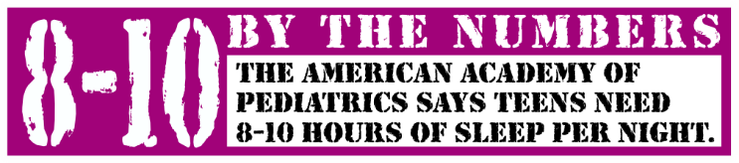


Freshly Made & Served Daily
in the Wild Cat Café

Salads**/++
Sandwiches**

Fresh Fruits & Vegetables Offered
With each meal

These Lunches Served in the
Wild Cat Café

Monday
Orange Chicken or Teriyaki Chicken
Veggie Egg Rolls++
with Broccoli & Rice
Tuesday
Nachos with Beef and Beans**
Nachos with Beans and Salsa++
Bean & Cheese Burrito++
Wednesday
Cheeseburger, Hamburger, Hot Dogs
Spicy or Crispy Chicken Burger
Grilled Cheese Sandwich**/++
With Fries
Thursday
Chicken Alfredo w/roll or Spaghetti w/roll
Bosco Cheese Sticks w/Marinara++
With Garden Salad##
Friday
Chicken Tenders (Crispy or Spicy)
Macaroni & Cheese++
With Fries

1% White Milk
Non-Fat Chocolate Milk
Offered Daily!
Available Daily
Breakfast
Cereal++
Breakfast Pizza
Sausage & Egg Breakfast Sandwich
Homemade Cinnamon Roll**/++
Eggo Mini Pancakes++
French Toast Sticks++
Breakfast Bars++
Assorted Juice, Fresh Fruit & Milk
Lunch
Hamburger Meal
Spicy Chicken or Crispy Chicken Meal
Pizza Meal (Pepperoni or Cheese++)
Burrito Meal++
These Lunches served
at the Wildcat Snack Bar
Wild Cat Snack Bar
Fresh Fruit Cup 1.00
Whole Fruit .50
Cheez-its .75
Chex Mix 1.00
Baked Hot Cheetos 1.00
Chocolate Chip Cookie .75
Brownie 1.00
Water .50
Milk .75
** All Snack items meet NSLP
Compliance Standards
Menu for
Lee Middle School
Wild Cat Café

2026-2027

This institution is an equal opportunity provider.
Menus are subject to change.

Featured Daily Lunch

Specials

