

**External Applicant User Guide**

**Navigation Basics** **3**

Accessing the External Applicant Portal 3

Creating an Account 4

Resetting Your Password 5

**Edit Profile/My Profile** **7**

Updating Your Contact Information 7

Updating Your Work Preferences 8

Answering Required Questions 9

Filling Out Your Talent Profile 10

Uploading Attachments 11

**Job Listings** **12**

Browsing Open Positions 12

Viewing a Job Listing 13

Saving and Viewing Saved Jobs 14

Applying for a Position 15

Finishing Incomplete Applications & Viewing Your Application Status 16

**Quick Links** **17**

**Need Further Assistance?** **17**

# Navigation Basics

## Accessing the External Applicant Portal

**\*\*PLEASE USE GOOGLE CHROME\*\***

1. Go to the *NEISD Homepage*, <https://www.neisd.net>
2. Select the yellow *Careers* *| Join NEISD* button from the main page
3. Under the *External Applicants* section, click the link that says:   
   *Click here to apply for jobs or view current openings*
4. Select the *Login* button on the upper right hand corner of the screen
5. In the dropdown menu, select the blue *Register* button to create a new account

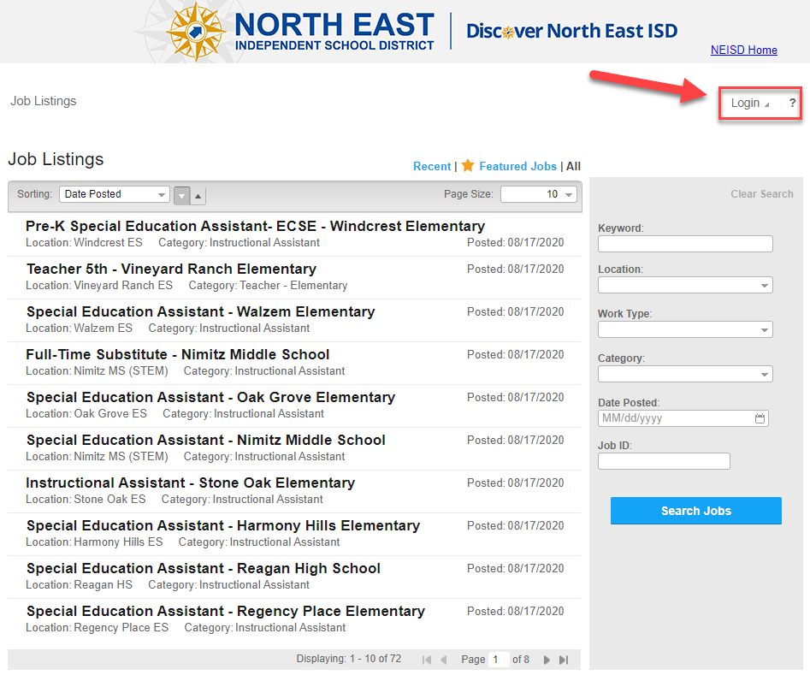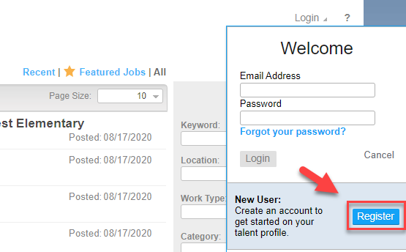

## Creating an Account

1. Enter the required information, including your email address, first name, last name, and a password. Type the password again in the *Confirm Password* field
2. Scroll down to select the blue *Register* button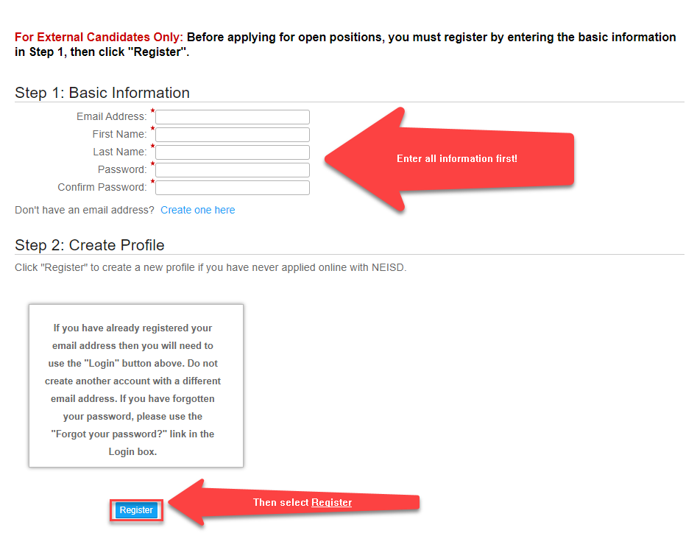
3. Your registration is complete. Double check that your name appears in the upper right hand corner and in the *Contact Information* section of your profile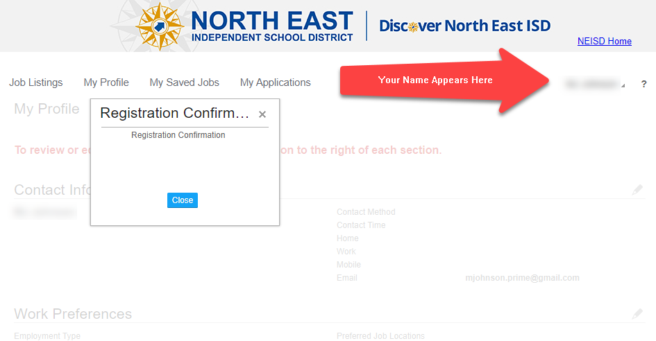

## Resetting Your Password

1. Click the *Login* dropdown menu on the external applicant main page
2. Select the blue *Forgot your password?* link

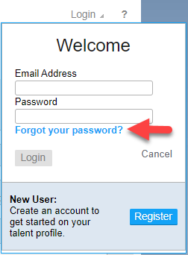

1. In the *User Name* field, enter the **email address** that you registered with.
   1. If you do not remember the email address you registered with,   
      contact the **HR Help Desk, (210) 407-0079** to retrieve it

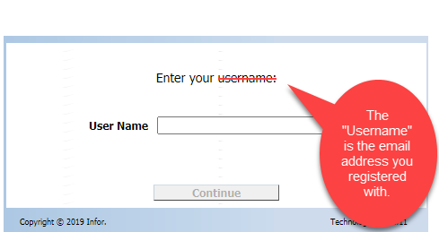

1. If this is your first time resetting your password, you will be emailed a temporary password.
2. Login with the temporary password
3. You will be prompted to fill out security questions. You must fill out **at least one** but do not need to fill out all four.
   1. **Note:** Security questions are **case sensitive**

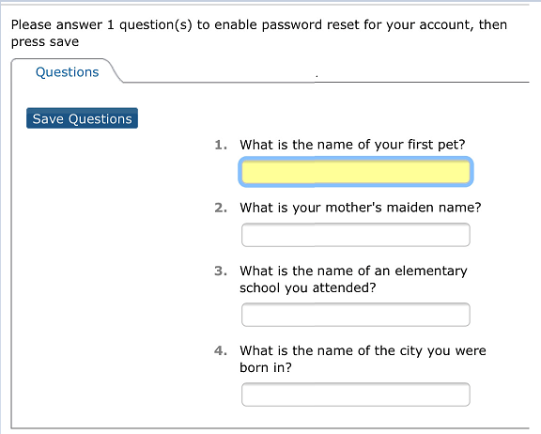

1. Reset your password and click *Save*

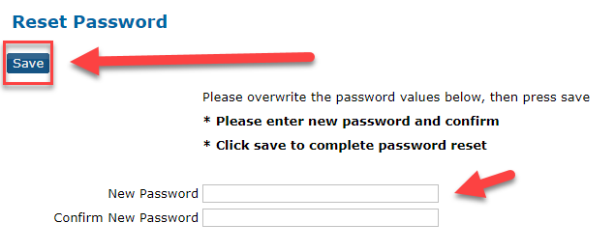

**If you still need assistance resetting your password or if you do not remember the answers to your security questions, contact the HR Help Desk, (210) 407-0079**

# Edit Profile/My Profile

## Updating Your Contact Information

1. Click *My Profile* on the top left of the external applicant home page
2. Under the *Contact Information* section, click the pencil icon on the far right hand side of the screen to add or update this information
3. Fill out all required and preferred information
4. Click *Save* at the bottom of the box

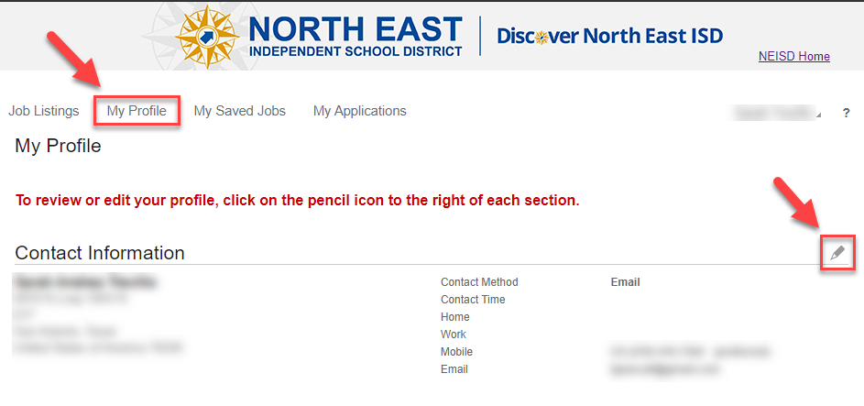

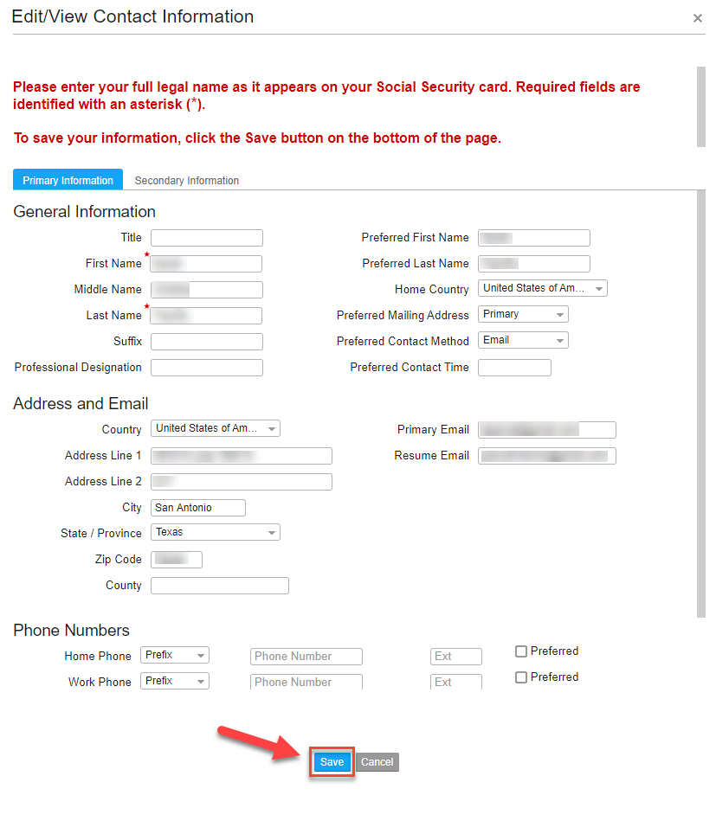

## Updating Your Work Preferences

1. Click *My Profile* on the top left of the external applicant home page
2. Under the *Work Preferences* section, click the pencil icon on the far right hand side of the screen to add or update this information
3. Fill out all preferred information
4. Click *Save* at the bottom of the box

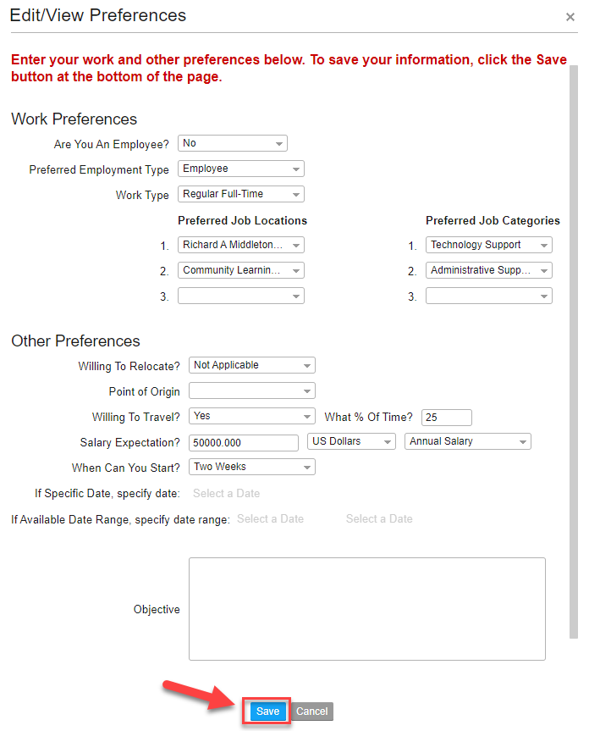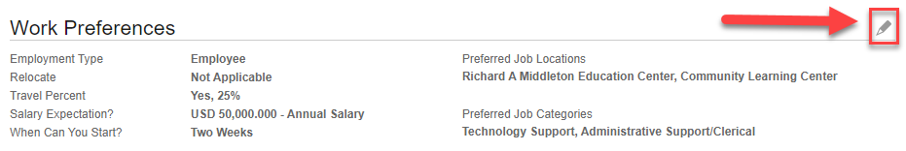

## Answering Required Questions

1. Click *My Profile* on the top left of the external applicant home page
2. Under the *Questions* section, click the pencil icon on the far right hand side of the screen to answer questions that are **required** for all applicants
3. Fill out all required information
4. Click *Save* at the bottom of the box



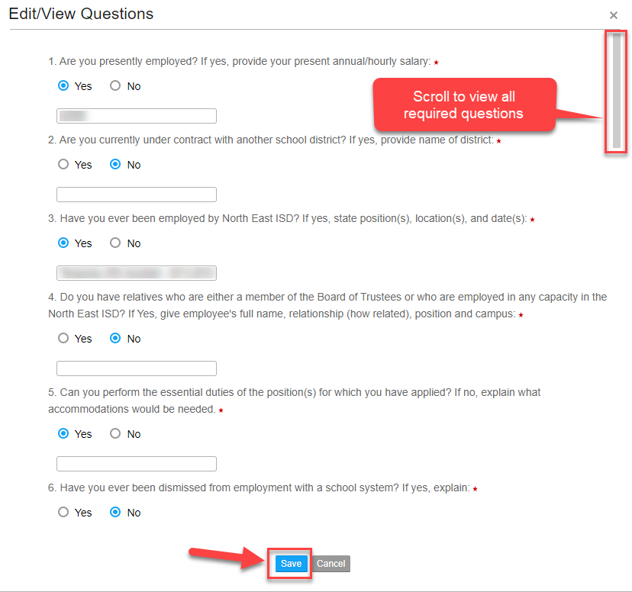

## Filling Out Your Talent Profile

1. Click *My Profile* on the top left of the external applicant home page
2. Navigate down to the *Talent Profile* section
3. Select the section you would like to edit on the left side of the section
4. In the left hand corner of the *Talent Profile*, click *Add (Position/Education/Skill/Credential/Achievements/Reference/Identification Number)* to add **new** information to a section
5. Click the pencil icon on the right side of the box to **edit existing** information within a section
6. Click *Save* after adding or editing any information within a *Talent Profile* section

**Notes:**

* **Identification Number** is your Social Security number and is **required** for all applications
* References **cannot** be deleted or edited, **only** added. Please ensure all information is up to date and accurate before submitting references

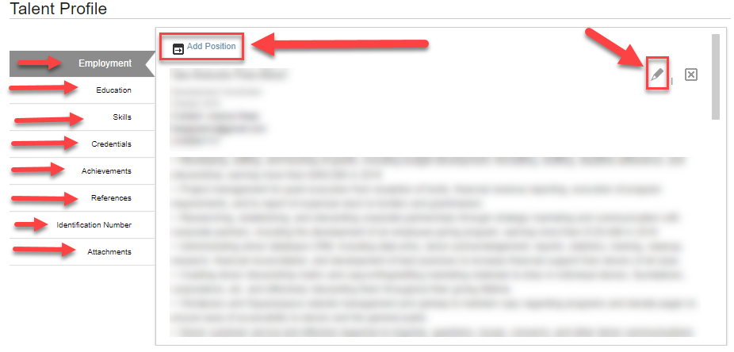

## Uploading Attachments

1. Click *My Profile* on the top left of the external applicant home page
2. Navigate down to the *Talent Profile* section
3. Click on the section labeled *Attachments*
4. Click *Add Attachment* to upload a document
5. Select your *Document Type*
6. Locate the attachment by clicking the small folder icon and double clicking the file in your computer
7. Click the blue *Add* button to complete your upload

**Note:** Uploading a Resume will attach it to all **future** job applications. If a resume is added *after* an application has already been completed, it **will not** attach to those already completed applications.

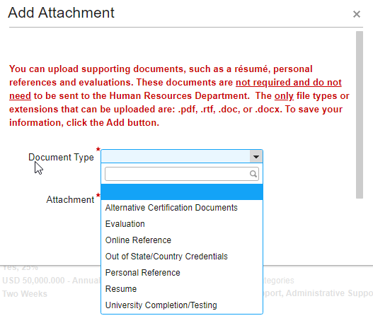



# Job Listings

## Browsing Open Positions

1. Select *Job Listings*in the upper left hand corner of the screen to view current openings
2. Navigate through pages by clicking the arrows at the bottom of the *Job Listings* box
3. Select the starred *Feature Jobs* option to view job listings that are urgently seeking candidates
4. Sort your results on the left hand side of the *Job Listings*box by Date Posted, Location, Category, or Job
5. Search for specific openings on the right hand side in the search boxes
   1. Use the drop-down menus to narrow your results by Location, Work Type, Category, or Date Posted
   2. If you are searching for a specific job, use the Job ID field to enter the posting’s ID number

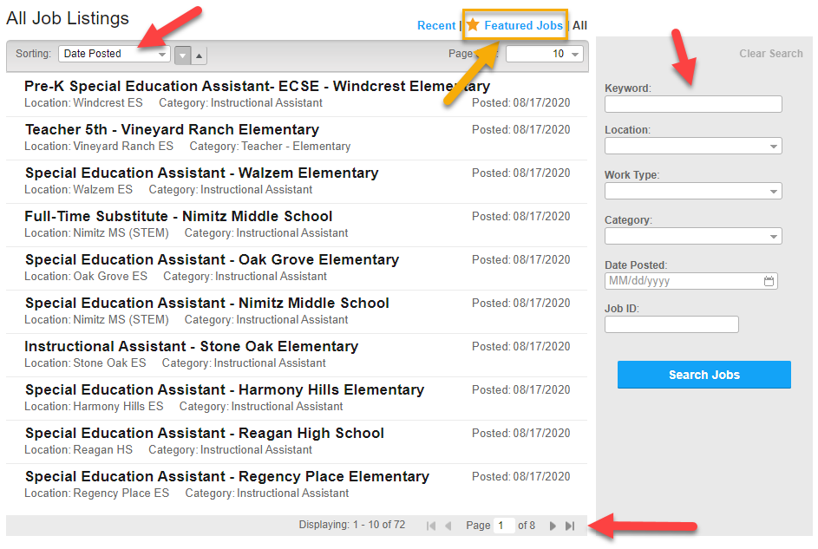

## Viewing a Job Listing

1. On the *Job Listings* page, double click the position you are interested in
2. Click *Save as a PDF* to save the posting to your computer *(this* ***will not*** *save it to your Job Cart)*
3. Scroll through the posting to learn about:
   1. Location
   2. Work Schedule
   3. Work Type
   4. Exemption Status
   5. Pay Grade and Salary Structure information
   6. Required Education, Experience, and Certifications, if applicable
   7. Job Summary
   8. Essential Requirements and Responsibilities
   9. Qualification Requirements
   10. Physical Demands
4. View the posting and close dates on the right-hand side of the screen to determine when that posting will be removed or renewed
5. Click *Back to Job Listing* at the top or bottom of the page to return to the Job Listing main page

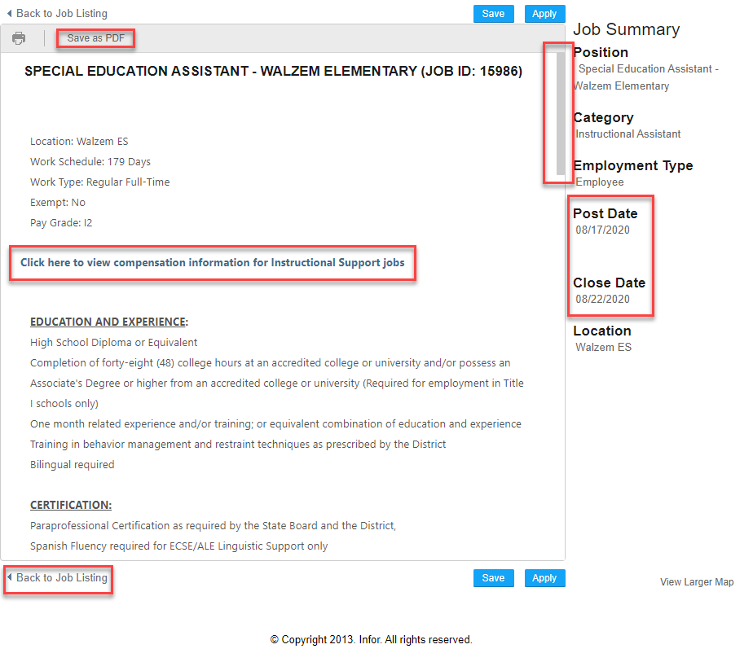

## Saving and Viewing Saved Jobs

1. On the *Job Listings* page, double click the position you are interested in
2. Above the posting, click the *Save* button to save that job to your *Job Cart*
3. Click *My Saved Jobs* at the top of the screen to view and access jobs that you have saved previously
4. Double click a saved job to open up the posting
5. Click *Remove* on the right hand side of a saved job to remove it from your *Job Cart*

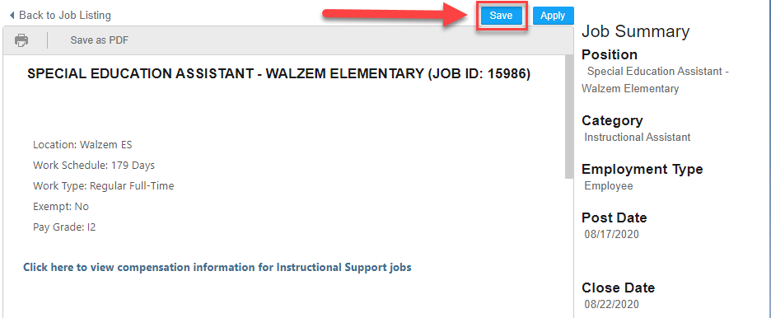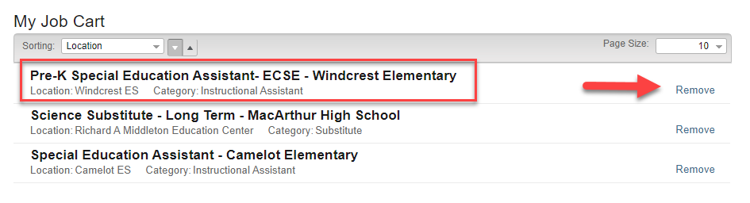

## Applying for a Position

1. On the *Job Listings* page, double click the position you are interested in
2. Click the blue *Apply* button to fill out an application for that position
3. Read and agree to the Consent Agreement by clicking the box that says *I Agree* at the bottom
4. Cancel to return to the job posting or click *Continue* to proceed - the box to continue will **not** be accessible if the agreement box is unchecked
5. Review and answer all required questions
   1. Questions previously answered in your profile will auto-populate answers into the fields
6. Read and agree to the Acknowledgement by clicking the box that says *I Agree* at the bottom and then clicking *Continue* to proceed
7. Provide self identification information and click *Continue* at the bottom to proceed
8. Review your profile information and click *Continue* to proceed
   1. View the section titled *Edit Profile/My Profile* for instructions
   2. If you have a specialized resume for this position, upload it in the *Attachments* section within the application
9. Answer the final question: *How did you hear about us?*
10. Ensure that all information is correct and then click the blue *Submit* button at the bottom to complete your application

**Notes:**

* Navigate between sections using the tabs at the top
* You may close your application and resume it later if it is within the posting dates

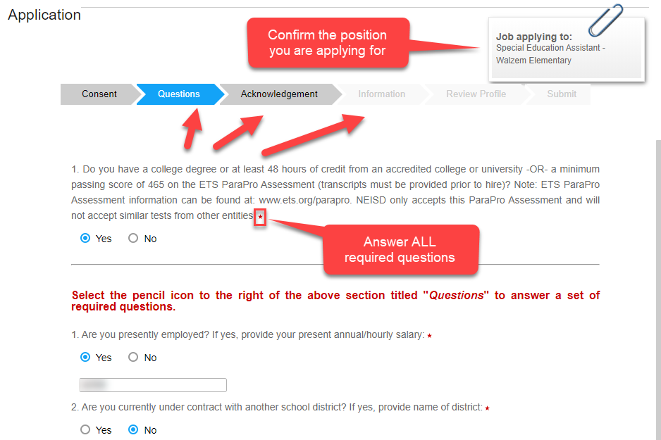

## Finishing Incomplete Applications & Viewing Your Application Status

1. Click *My Applications* in the top banner to view your incomplete and submitted applications
2. To resume an incomplete application, locate the position that is incomplete and click *Continue* on the right hand side
3. Locate the *Status* text beneath the position title to determine where in the process your application is
4. Positions that are no longer available to be applied to will state this information on the right hand side of the posting

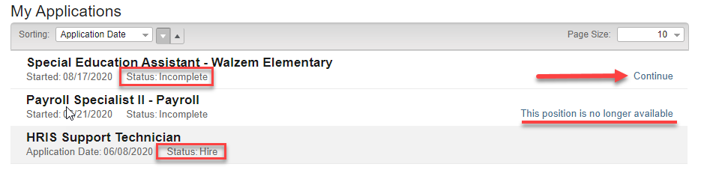

**Note:** Some positions require additional insight and screening information through **Gallup**. Those applying for teaching or principal positions will receive an email with a questionnaire from Gallup **within 24 hours.** For technical issues logging into or completing your Teacher Insight (TI) or Principal Insight (PI) questionnaires, please contact Gallup’s support line at **(877) 425-5872** and provide **District #29512724.**

All questions regarding screening questionnaires or scores must be directed to your specified HR Specialist during the interview process. **The HR Help Desk is not able to provide scores or pass/fail information.**

## Creating and Managing Job Alerts

Candidates can now create and manage Job Alerts which allow them to receive regular emails with new job postings at North East ISD using their selected search criteria.

To add a Job Alert:

1. Register or log into the External Applicant portal
2. At the top of the page, select “My Job Alerts”

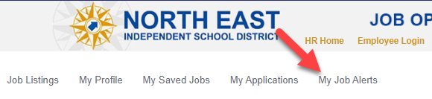

1. Click “Add New Job Alert” to add a new alert
2. Enter either a Description keyword and a location, a category, or a work-type to filter your alert results.
   1. **Note:** For the “description” keyword, the system will search both the job **title** AND job **description** for your chosen keyword and return results.
   2. You **must** enter something into the description box and at least one of the other three boxes.
3. Select “Save” to finish creating the job alert

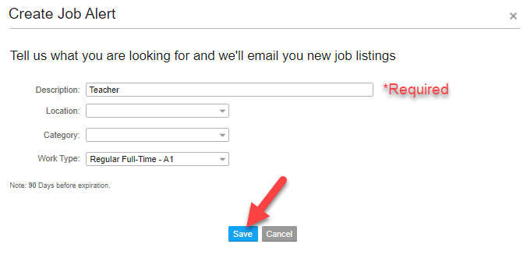

# 

1. Edit or delete your Job Alert by using the buttons on the right-hand side of the “My Job Alerts” screen.

# Applicant Mobile View

Candidates can apply to North East ISD openings through their mobile device or tablet. The following screenshots will provide a walkthrough of the application process on a mobile device. The sample provided is using iPhone’s Safari Browser, but it will look similar on Android devices.

1. Once you select the job posting you would like to apply to, the system will ask you to log in or register. Follow the prompts on the screen to do so.
2. Once registered, you will be asked to fill out the following information on each screen from Step 1 through Step 7

## Contact Information

Enter your contact information, ensuring that the fields with the red asterisk (*) are filled out accurately. You can save your information at any time.

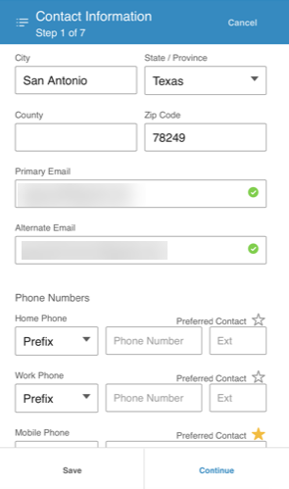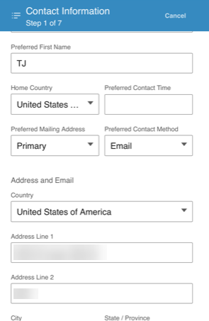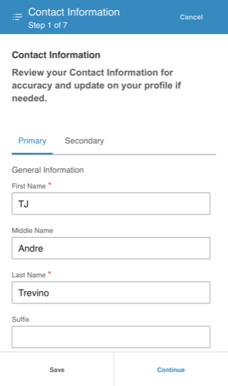

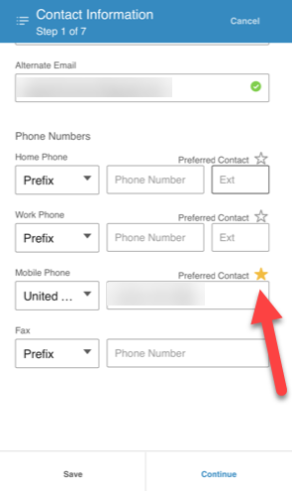

Don’t forget to use the star to mark your preferred phone number!

## Consent Agreement

Read through the consent agreement and check the “I Agree” box to continue.

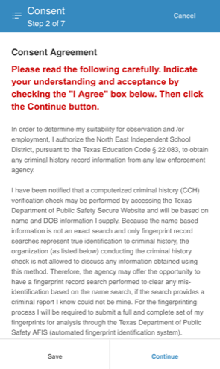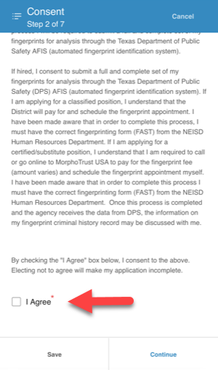

## Questions

Answer the questions provided as they appear - remember that some questions may require you to type in additional information. Ensure that all questions are filled out as necessary. If there is an error, the site will provide you with more information.

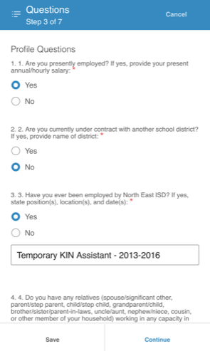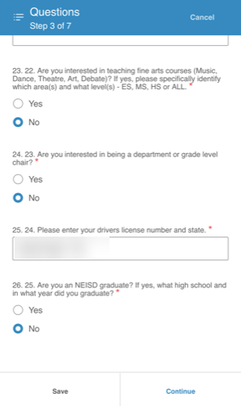

## Acknowledgement

Read through the acknowledgement and check the “I Agree” box to continue.

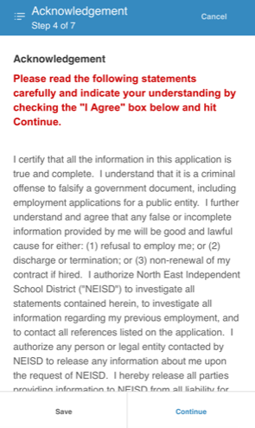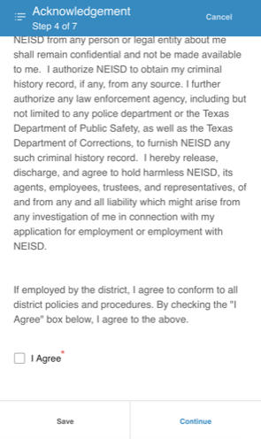

## Information

Read through the information provided and answer the questions provided.

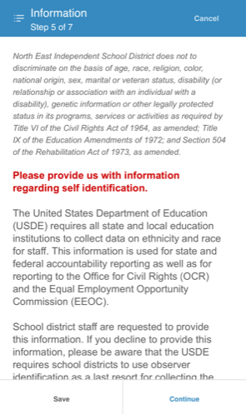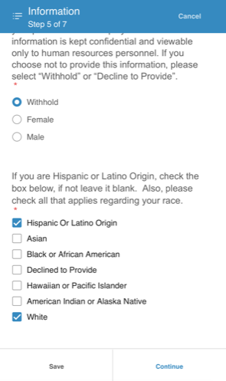

## Preferences

The preference section **is not required**. These preferences apply to your overall profile and **will apply to all current and future** applications. You may change this information at any time.

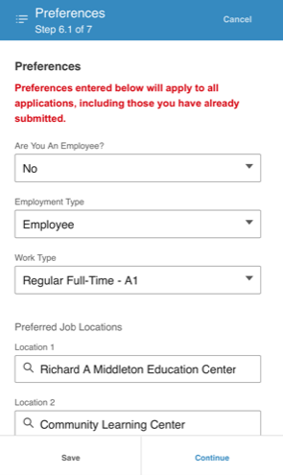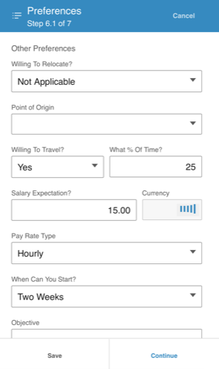

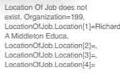

**You may encounter an error with the location preferences. If this occurs, simply delete your Location preferences and re-enter them, as needed.**

## Employment History & Education

Use the plus icon to add your employment history and education as needed. Only certain fields are required (*), others are optional. You can add and delete entries as much as you’d like.

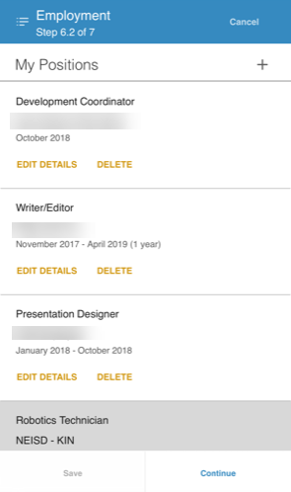 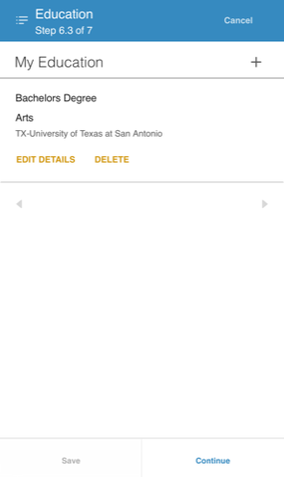

## Skills, Credentials, Achievements

**These sections are all optional**. Skills added can be those that are pre-selected **or** you can add unique skills at the bottom. Credentials are primarily for **non-SBEC** certifications. Select which is applicable and fill out as much information as you’d like. Achievements are typically considered any awards or recognition provided throughout your career. Feel free to add as many or as few as you’d like.

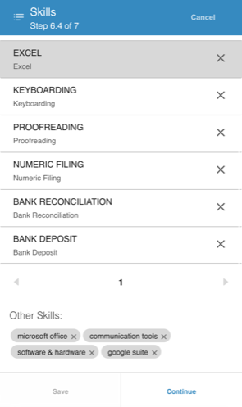 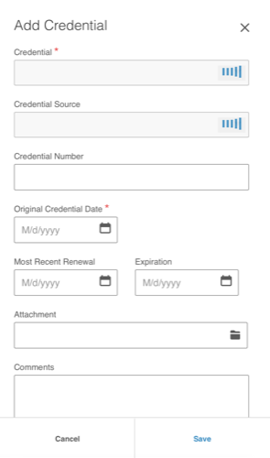

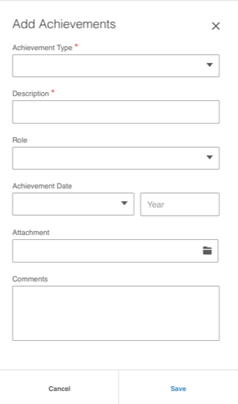

## References

**References should not be added in the application itself.** Instead, they should be entered in your profile which can be accessed using the menu button in the upper left-hand corner (don’t worry, you can return to your in-progress application once you’re done). Follow the screenshots below to navigate to your references. **Note that you cannot edit or delete references. You can add new ones at any time.**

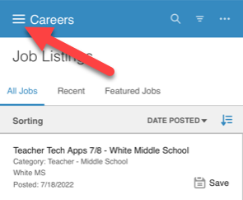

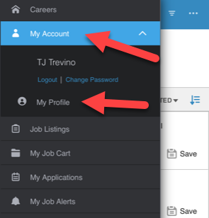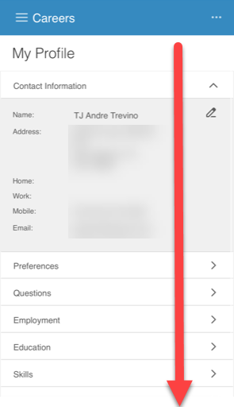

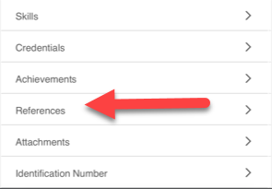

# 

## Attachments & Identification Number

Upload any attachments such as your resume, transcripts, etc. here. Select the closest option for the attachment type. Only certain types of files are accepted. Your identification number is your social security number **or** identification number for your country of origin. This information is encrypted for safety.

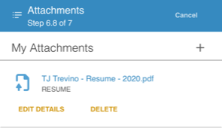 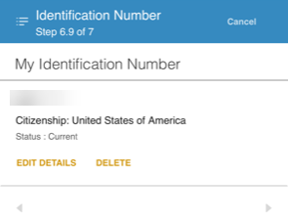

## Finish & Submit

Answer the “How Did You Hear About Us?” question and then select “Submit Application”. You should receive a confirmation pop-up and an email confirming your application was received. You can continue to submit more applications for any positions you are qualified for or interested in.

# 

# 

# Quick Links

[**External Applicant Portal**](https://lmkwebextprod.neisd.net:444/ltmprod/CandidateSelfService/controller.servlet?context.dataarea=ltmprod&context.session.key.HROrganization=199&context.session.key.JobBoard=EXTERNAL&context.session.key.noheader=true#)

[**Teacher Certification Requirements**](https://www.neisd.net/Page/33498)

[**Compensation Plans**](https://www.neisd.net/Page/31282)

[**Work Schedules**](https://www.neisd.net/Page/25597)

[**Accommodations & ADA**](https://www.neisd.net/Page/33713)

[**Substitutes Information**](https://www.neisd.net/Page/25596)

# Need Further Assistance?

If you need assistance with the online application please call **(210) 407-0079.**  
For general questions, contact Human Resource Services at **(210) 407-0188.**