**MEDICAL MAGENT PROGRAM**

**ANDREW HILL HIGH SCHOOL**

**WORK-BASED LEARNING AND COMMUNITY SERVICE HOURS AGREEMENT**

Student Name: _________________________ ID#: _______________ Graduating Year: 20_____

This agreement is between the above-named student, his/her parent(s)/guardian(s), and Andrew Hill High School. This student will perform 40 community service hours or work-based learning hours in the healthcare field as a requirement of the Medical Magnet program at Andrew Hill High School. 30 of the 40 hours must be completed during their junior and senior years.

Examples of ways to earn hours include, but are not limited to: job shadowing, internships, career summer institutes, mentoring by healthcare professionals, medical programs, such as the Stanford STEP programs, FAST, or other research, advocacy, HOSA, and other health-related club activities.

If the above-named student has any limitations to perform their hours, please list them below:

_______________________________________________________________________________

_______________________________________________________________________________

_______________________________________________________________________________

Please note: The requirements for these hours are that they must be unpaid (with the exception of the Career Summer Institute in Mental Health), outside of the school day, and related to the healthcare field.

When hours are completed, please return the completed form to Ms. Winterstein in S200. This form is due by the FRIDAY before spring break of your senior year. See back of page for final signatures and where to keep track of hours.



**MEDICAL MAGENT PROGRAM**

**ANDREW HILL HIGH SCHOOL**

**WORK-BASED LEARNING AND COMMUNITY SERVICE HOURS LOG**



Student Name: ___________________________ ID#: _____________ Phone #: ______________ Grade: _____ # hours:_____

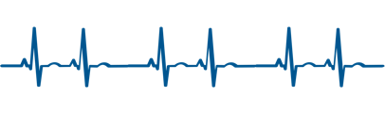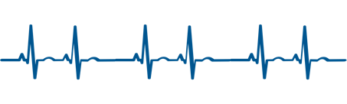

**Example:**

|  |  |  |  |  |
| --- | --- | --- | --- | --- |
| Date (s) | Location | Duties Performed (be specific in what you did) | # of Hours | Signature of Supervisor |
| 8/9/25 | San Jose Jazz Summerfest | Worked at the NMDP table, greeted and checked people in and instructed people how to swab. Took the NMDP sign and walked around the festival to recruit people to sign up for NMDP | 4 |  |

|  |  |  |  |  |
| --- | --- | --- | --- | --- |
| Date (s) | Location | Duties Performed (be specific in what you did) | # of Hours | Signature of Supervisor |
|  |  |  |  |  |
|  |  |  |  |  |
|  |  |  |  |  |
|  |  |  |  |  |
|  |  |  |  |  |
|  |  |  |  |  |
| Date (s) | Location | Duties Performed | # of Hours | Signature of Supervisor |
|  |  |  |  |  |
|  |  |  |  |  |
|  |  |  |  |  |
|  |  |  |  |  |
|  |  |  |  |  |
|  |  |  |  |  |
|  |  |  |  |  |
|  |  |  |  |  |
|  |  |  |  |  |
|  |  |  |  |  |