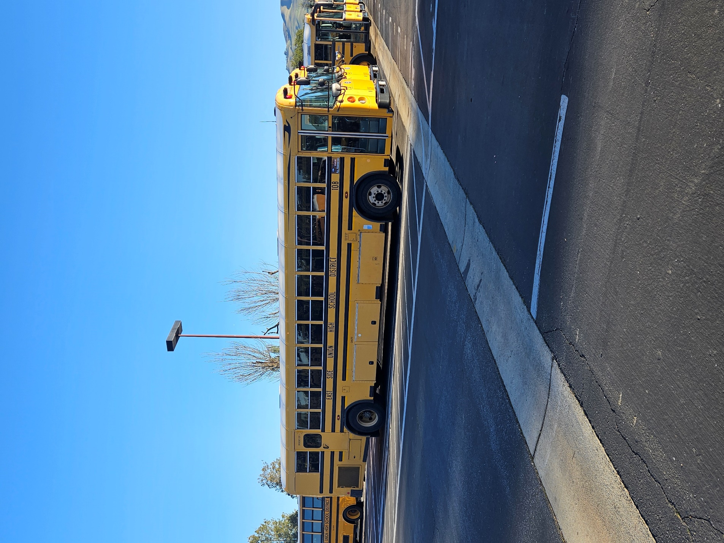
2025 – 2026 School Year Trip Costs
All Trips are estimated prior to the trip
Actual trip costs are after trip is completed

Outside of the District
$75.00 per hour
$85.00 per hour after 2:00 pm
$4.95 per mile

