
NEISD Summer Fun Online Resources
for Parents of Students With IEPs & 504 Associated Needs

Resources for Early Childhood Special Education (ECSE)

NEISD Pre-K Online Learning  NEISD Fun Learning Opportunities   | Summer Activities at Home  100 Fun Things for Kids to Do at Home This Summer (with Printable Checklist)  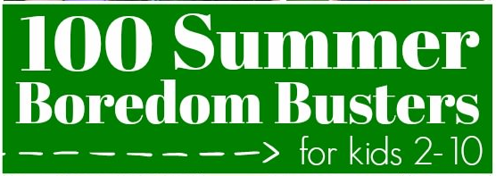 | Outdoor Fun  30+ Fun Activities for Kids to Play in the Dirt  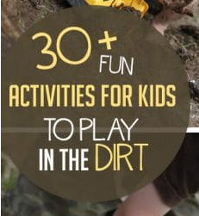
Read Alouds  Author Jan Brett's Free Coloring, Video and Activity Pages  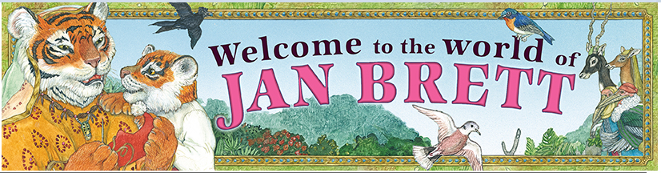  Storyline Online    Spanish Children Stories with English Translations  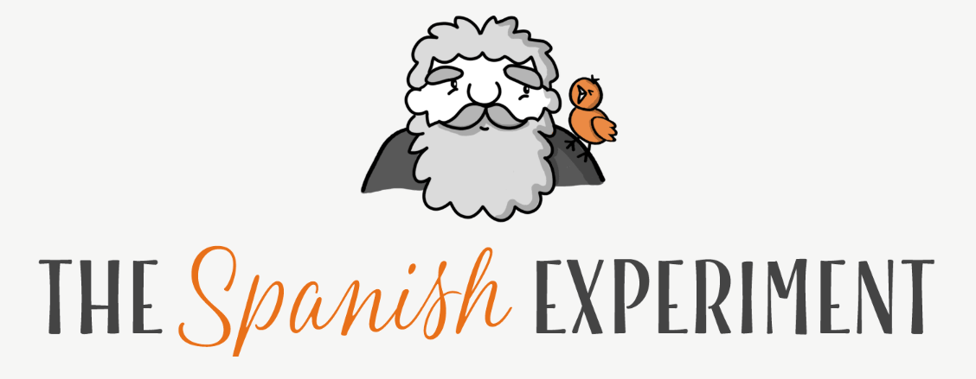 | Interactive Literacy Ideas  ABC home practice  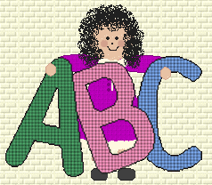  Literacy Apps    Scholastic Learning At Home   | Science Fun  Kids Science Experiments    Recipes for Kids  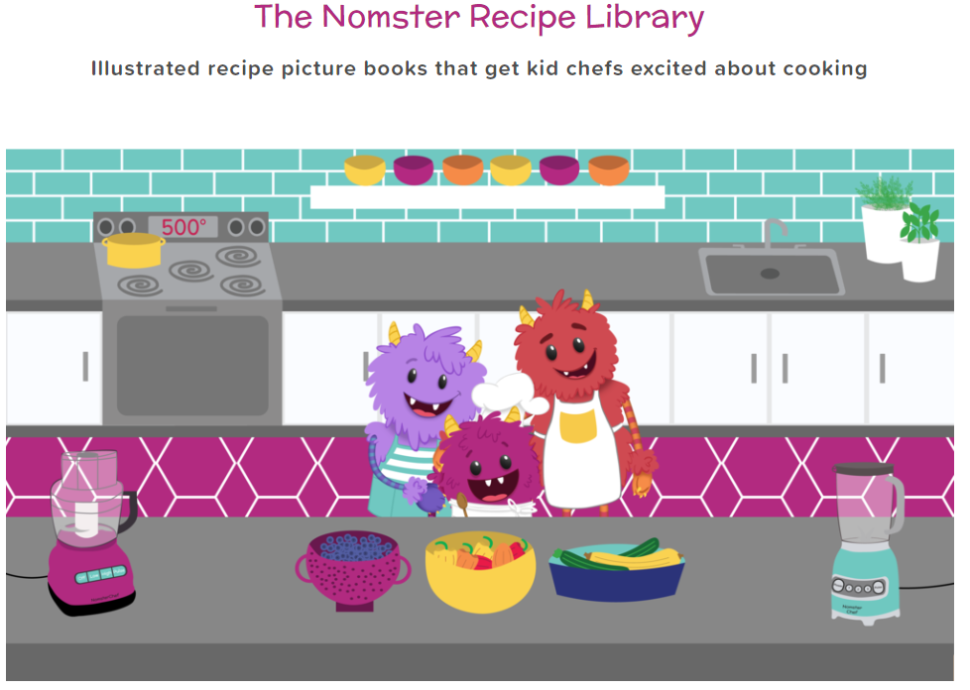  Experiments in Spanish  
Games, Activities, Videos and More  National Geographic Kids    PBS KIDS  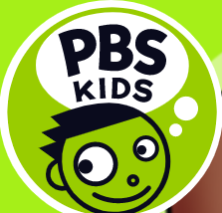  Sesame Street  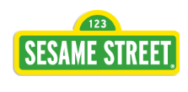  LITTLE CRITTER  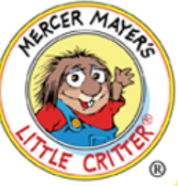  Games in Spanish   | Brain Breaks and Movement Songs  10 Brain Breaks Old School Kinder Style  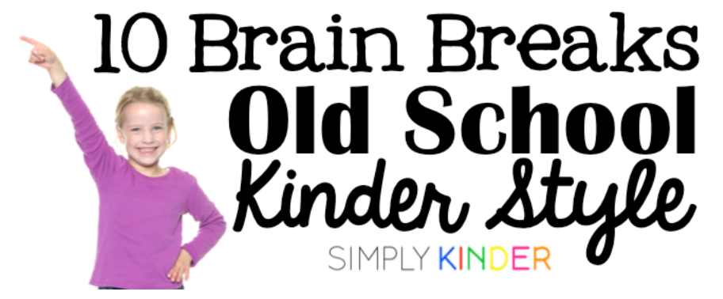  Dr. Jean - Music for Young Children    Cosmic Kids Yoga  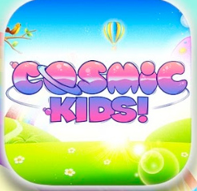  GoNoodle: Home   | Online Games  Games, stories, and printables for preschoolers - FunbrainJr.com    Starfall Education: Kids Games, Movies, & Books K-3  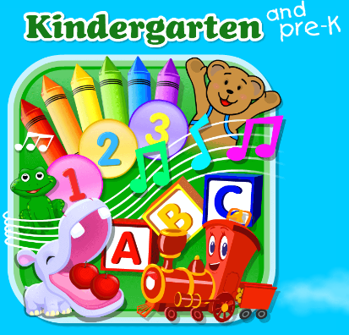  Uptoten - Home    Preschool Learning Games, Ages 3 - 4  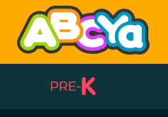  Kinderweb  

Resources for ALE, SLE and HSE

Reading Fun | Math Fun | Experiment Fun
https://www.storylineonline.net/ | https://www.splashlearn.com/math-games | https://www.nomsterchef.com/nomster-recipe-library
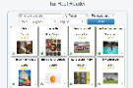https://tarheelreader.org/find/ | https://www.mathplayground.com/index_classic.html | http://www.sciencefun.org/kidszone/experiments/
  Books that can be read aloud that are written in both Spanish and English https://abdodigital.com/?tk=7724458A4EE9A73EE8087AC8D237C57C |  | Experiments in Spanish
Virtual Trips | Move Your Body | Arts & Crafts
https://www.aqua.org/Experience/Blacktip-Reef | https://youtu.be/X655B4ISakg | Paint in a Bag: Similarly to the sensory bag, children with significant tactile defensiveness are more apt to engage with this painting activity because the mess is all contained inside a Ziploc-type bag. Put a blank piece of paper inside of the bag, add a few drops of paint, and zip the bag closed. By pushing on the outside of the bag, your child can move the paint around. Have them explore with mixing colors to decorate a kaleidoscope on the canvas.
  North American Tours https://www.virtualfieldtrips.org/video-library/videos-by-location/north-america-videos/ | https://youtu.be/fpD9kRyBn8o  Get Yo Body Movin'

Resources for Math Resource

  Got Cards? | 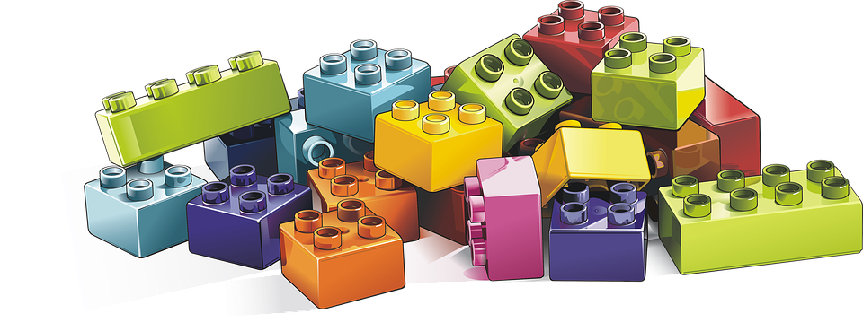  Got Legos? | 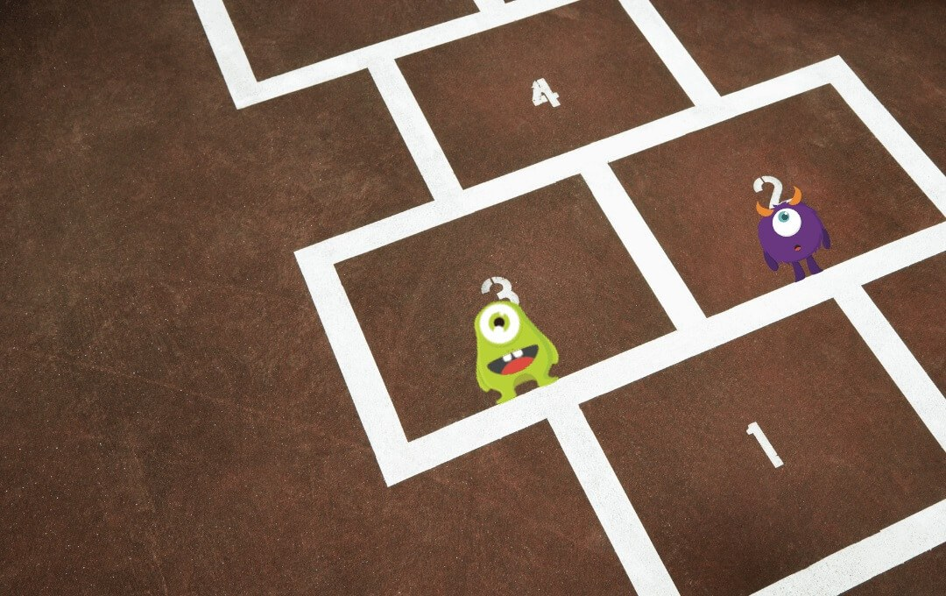  25 Fun Maths Activities And Games For Kids To Do At Home For Free!
  Math Tutorials |   Online Math Games |   Online Math Games
  Coding Website |   Math Games in Spanish | 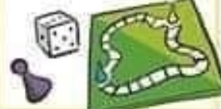  25 Non Screen Activities
 |  | Try a digital escape room from Breakout EDU Fun. Remember to write down all of your clues so that you can go back and pick up where you left off.

Resources for Reading Resource and Dyslexia

  Visit Story Online and select a book to listen to | Reading Tutorials | 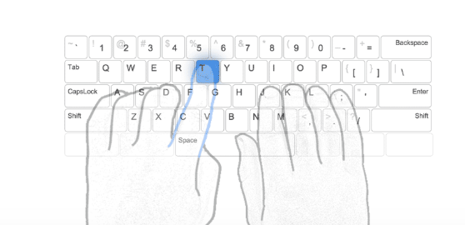  Learn touch typing for free with typing club.
  At home summer learning with scholastic read-a-palooza. |   PBS English Language Arts Resources for all grades |   Print and play games for:  Sight words  Phonemic Awareness
  Digital Library of free Spanish books | Language Arts Games in Spanish |   Free Spanish and English Read Alouds Over the Phone

Resources for English Resource

  Create an online storybook | PBS English Language Arts Resources for all grades

Grammar Tutorials

Resources for Behavior

Social Skills Bingo & Tic Tac Toe Games  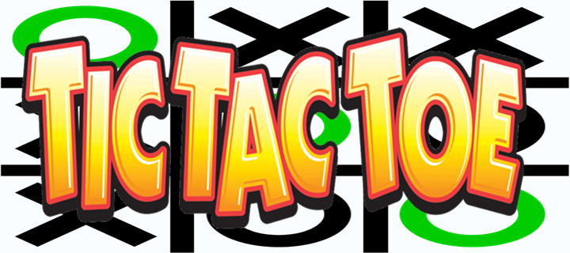 | Coping Skills Wheel Games    Elementary  https://bit.ly/3bhw6QC  Secondary  https://bit.ly/35Lz3Yk
Social Emotional Skills | Fun Summer Activities  
Social Skills Ideas for Home | Benefits of Board Games  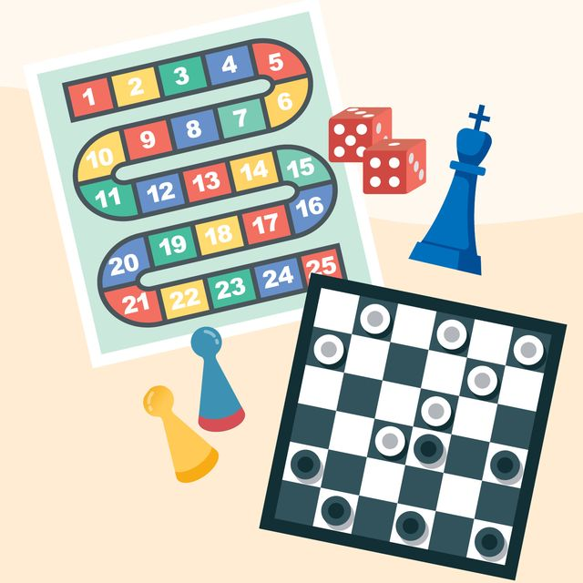

Resources for the Deaf and Hard of Hearing

**Remember to turn on the Closed Captions for all videos**
E-Learning for Deaf Kids  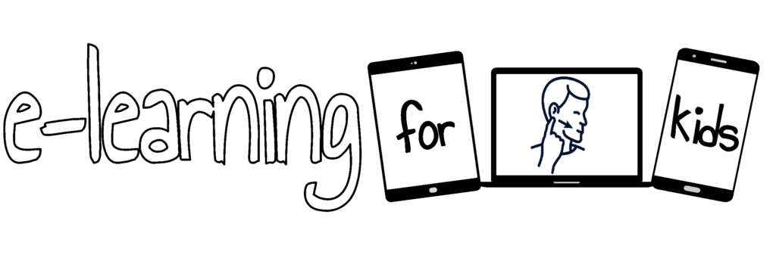  Plus + additional  DHH Accessible eLearning Resources | Self Advocacy    A free, online, interactive training designed for transition-aged students who are deaf or hard of hearing. The training utilizes three questions: Who Am I?, What Do I Want?, and How Do I Get There? https://dcmp.org/learn/465-map-it-what-comes-next-module
Just for fun  With Sign Language Interpretation  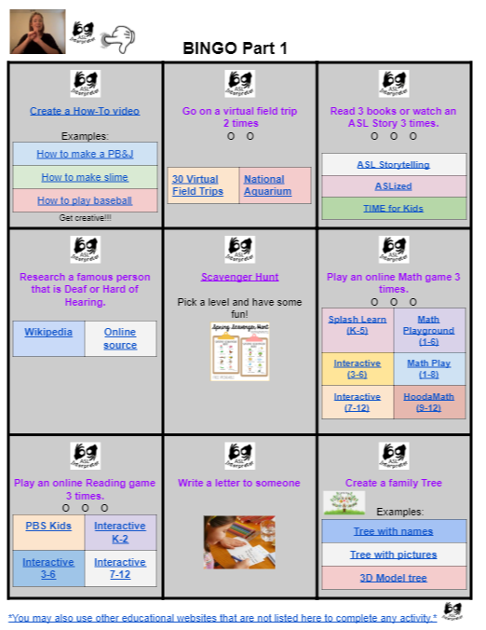  Activity Bingo | ECSE- Early Childhood 3-5yrs  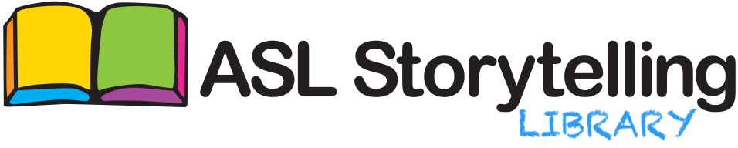  https://www.texasdeafed.org/aslstorytelling  All AGES  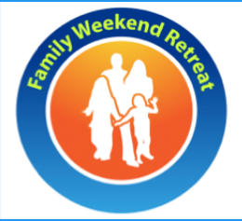  Virtual Family Weekend Retreat
Elementary  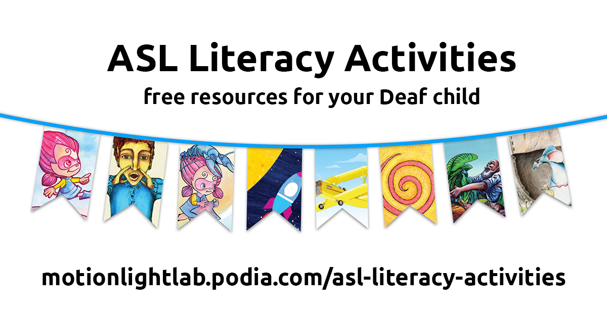  Is your child at home? Do you need more American Sign Language and English related activities? Want to support your child’s literacy development? Create a free account.  https://motionlightlab.podia.com/asl-literacy-activities | Elementary    Gain Fluency and confidence in math. IXL helps students master essential skills at their own pace through fun and interactive questions, built in support and motivating awards.  Contact your elementary DHH teacher for Login information.  https://www.ixl.com/math/
Middle/High School    Summer read: Part 1 Part 2 Part 3  Optional read along activities | Middle/High School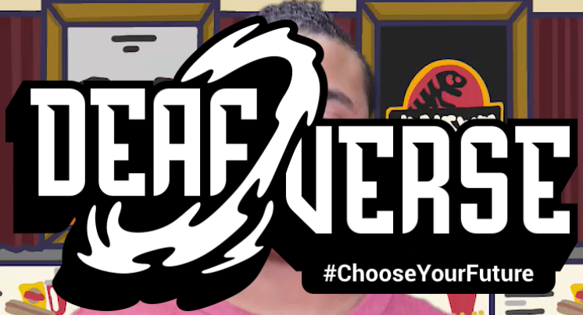  Deafverse is a choose-your-own-adventure game created just for teenagers. In Duel of the Bots, you get to make choices, stand up for yourself, and build confidence and skills you can use in real life.  https://www.nationaldeafcenter.org/deafverse/resources.html
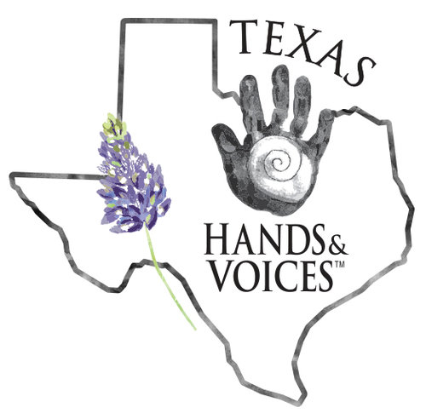  DHH Kids & Teens Zoom Hangouts Texas Hands & Voices  LINK | Reuniones para Niños y Adolecentes via ZOOM Texas Manos & Voces  Enlace

Resources for the Visually Impaired

Elementary and Early Childhood    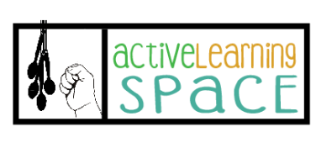  Experience Books: A Tool for Conversation  Peep and the Big Wide World with Video Description  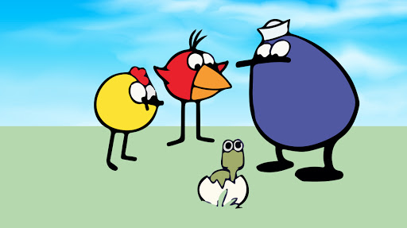 | Cortical Visual Impairment Resources and Activities  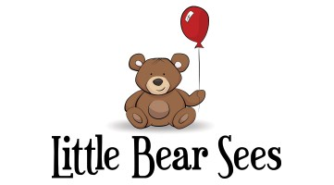  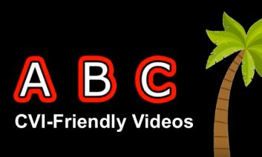  Egg Book  Grandpa Shark book  While You Are Home: Activities for Children with CVI
Middle/High School    Young Heroes: Louis Braille (with Captions and Description)  Video Clips for Daily Living Skills and More  Typer Online: Home Practice Typing Skills  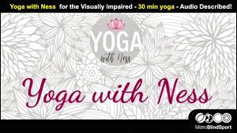 Yoga for VI | Orientation and Mobility  Texture Walk for Sensory Exploration  Follow Your Nose!  Do You Hear That?  Get the Feel Of It!  On-Line Summer Camp  

Resources for Speech and Language

COMMUNICATION
Preschoolers: Speech and Skills with Everyday Interactions and Activities
How Can I Help My Child? - Articulation, Language, Fluency, Voice
Communication Suggestions for Parents Grades K-2 and Grades 3-5

LISTENING
Auditory Bombardment of Specific Sounds Audio clips of individual sounds and words with that sound at the beginning, middle and end of words.
Storyline A free library of read-aloud books read by celebrities!

LANGUAGE
~ posted with permission from the author Creative Speech Lab:
Recipes Picture-based activities that promote speech, language and social communication opportunities.
Scavenger Hunt Indoor and outdoor scavenger hunts that encourage language concepts, such as size, shape, texture, and categories.

LITERACY
Bookmark for Language and Literacy Use this bookmark as a checklist, to enhance language skills, during reading time with your child!

Transition Services - Activities to Prepare for the Future!

Transition-Related Activities:

- Use these great activities to facilitate and guide you through effective communication with your student(s) in discussing his/her future education, employment, and/or independent living goals. If desired, share the results gained by using these tools with your student’s case manager. Ongoing collaboration between school and family will aid in facilitating a positive transition from school to adulthood for your student!
  - Middle School Study Habits Questionnaire
  - Student Led Parent Interview
  - Parent Questionnaire for Students with Significant Support Needs
  - O*NET Interest Profiler
 | 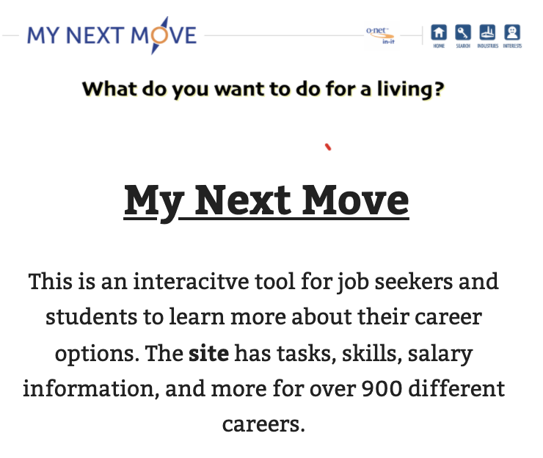 | 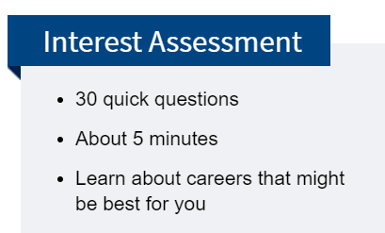

Career Exploration Activities for Elementary School Students
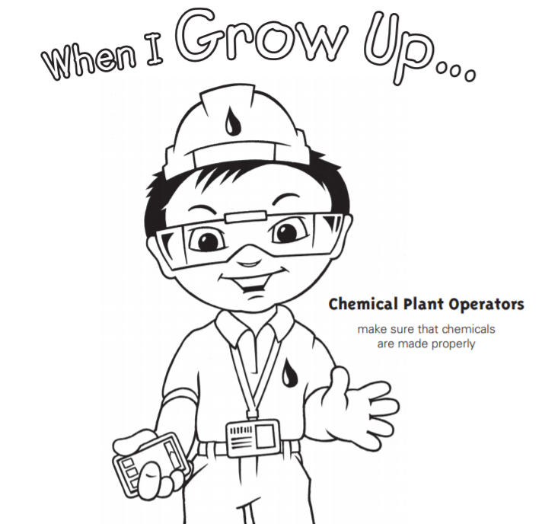  “When I Grow Up” Coloring Pages | 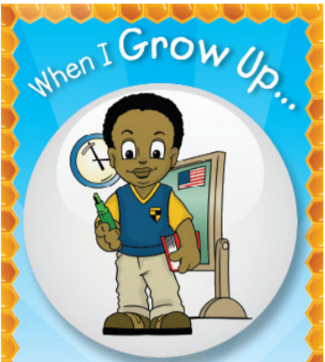  “When I Grow Up” magnet trading cards | 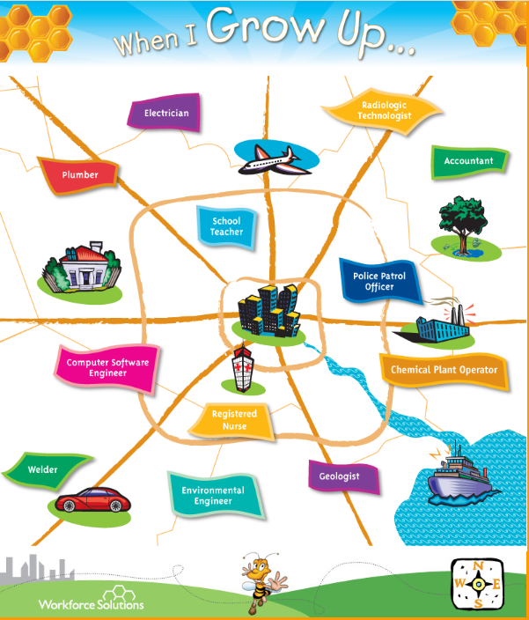  “When I Grow Up” Career Map with Videos | 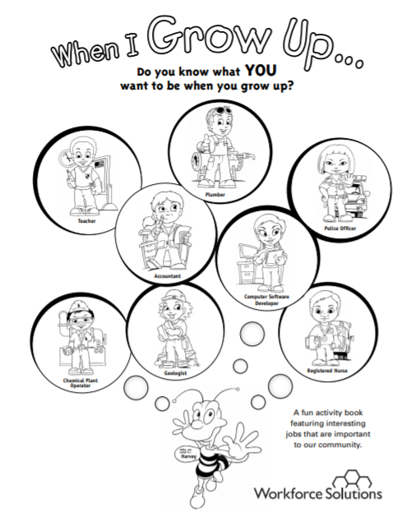  “When I Grow Up” Activity Book

Career & College Readiness Activities for Middle & High School Students
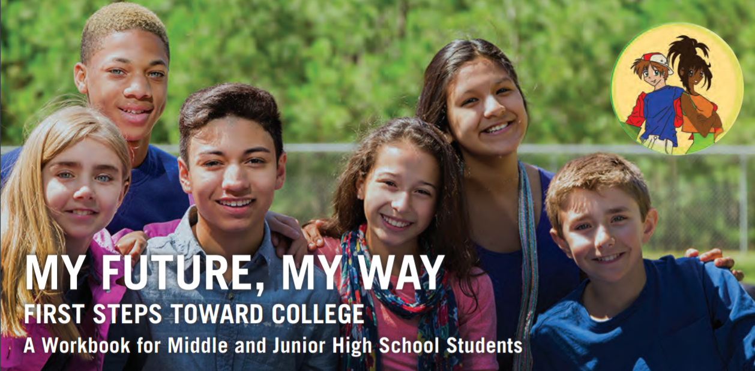  My Future, My Way Workbook | Success in the New Economy  YouTube Video | 

Family Resources

- Transition Tips for Parents/Guardians of Children with IEPs

- "Parent Perusals” Family Resource Blog, hosted by the ESC-20 Family Engagement Specialist

- Have a question(s) about your student’s individual community resource needs?
  - Click here to find the Itinerant Transition Teacher assigned to assist your campus!

Resources for 18+Programs: (NETS & Beyond)

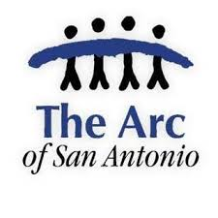  The ARC of San Antonio |   Special Reach | 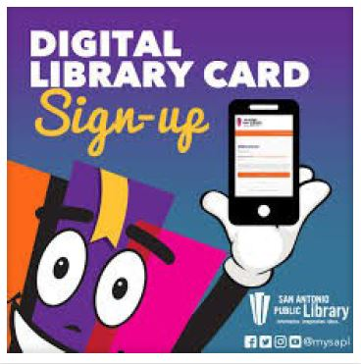  San Antonio Public Library Digital Card
  Tour 33 National Parks | 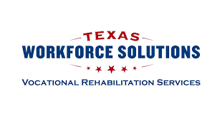  TWS Vocational Rehabilitation | 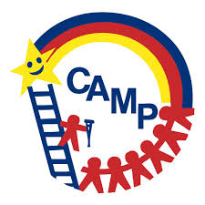  CAMP Family Resources

Choice Board - Transition Skills

Planning for the Future - A Week At-A-Glance

Resources for Related Services (OT, PT, AT, MT, IHCPT & APE)
NEISD Related Services YouTube Channel
(Check this out periodically for information being shared /
Consulte esto periódicamente para obtener nueva información)

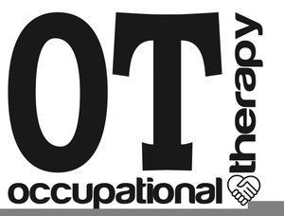  Occupational Therapy Playlist  OT Summer Fun Websites |   Physical Therapy Playlist | 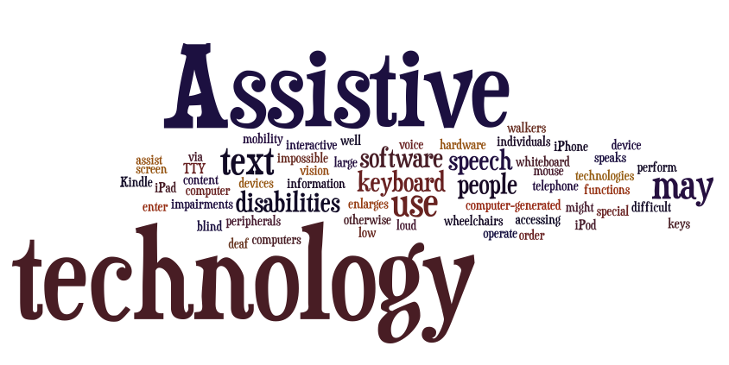  Assistive Technology
  Music Therapy Playlist | 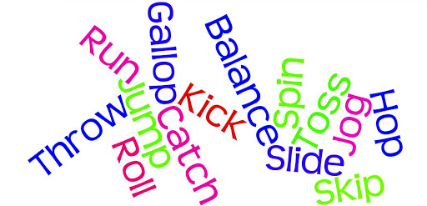  APE K-5 Playlist  APE 6-12 Playlist |   In Home Parent Training

Technology Resources

  How to Use Tutorial  Quick Guide Card  (Reading support - student must currently have an account / Programa que ayuda leer textos - estudiantes ya necesitan estar registrados) |   Google Read & Write Youtube Tutorial  (Reading support - accessible to anyone / Programa que ayuda leer textos - Accesible para todos) | 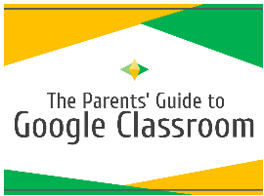  Tutorial for Parents  Guía para padres  (Learn what Google Classroom is all about / Aprende todo sobre Google Classroom)
  Flipgrid Website  (A way to complete assignments/ Un programa que se puede utilizar para completar tareas) |   Sign In  Zoom Directions for Students  Zoom Tutorial  Zoom Tutorial on Youtube  (Zoom is a tool being used to meet with students and/or parents / Zoom es un programa que se puede utilizar para reunirse con estudiantes y / o padres por internet) | 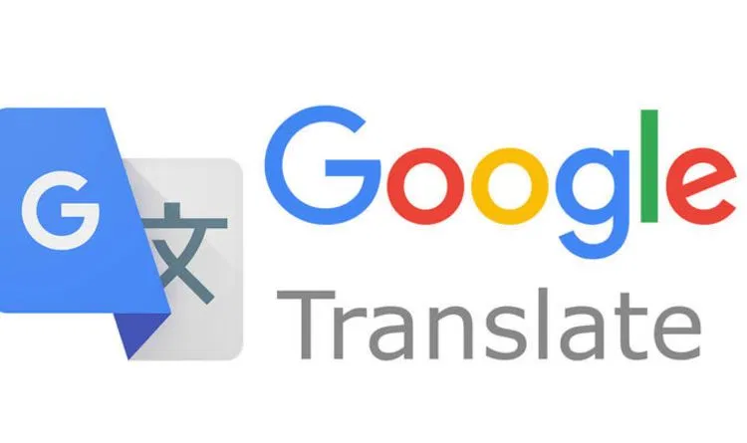  Android Download  iOS Download  (Tool to translate directions for assignments into home language / Manera de traducir las instrucciones de tareas a su idioma)

