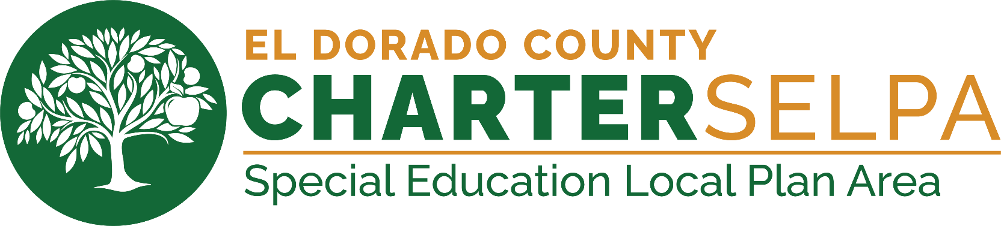
December 2025

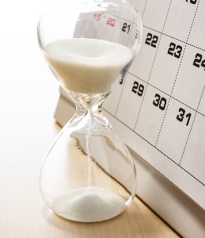
IMPORTANT UPDATES

SELPA Data office will be closed for Winter break,
December 25-26 and January 1-2

Trainings
We offer virtual and in-person training and events throughout the year!
The Events & Training catalog can be found here.
We’re excited to announce that our SEIS Virtual Trainings will be back in January. Sign up now to reserve your place!
SEIS Data Lab for District Level Users
Tuesday, January 13, 2026 | 3:00 PM - 4:00 PM
SEIS for Providers
Monday, January 26, 2026 | 1:00 PM - 2:30 PM
Navigate SEIS for District-Level Users
Thursday, January 29, 2026 | 9:00 AM - 11:00 AM


Fall 1 Key Dates
- CALPADS requested zero errors by November 21, 2025.
- SELPA Requested Fall 1 due date December 5, 2025, to allow for SELPA review.
- Certification Deadline: December 12, 2025 (Annual Determination Data pulled.)
- Amendment Window: December 13, 2025 – January 23, 2026 (SELPA approval required.)
Fall DRDP 2025
- Identify students requiring Fall DRDP and begin assessing now
  - Students with an active IEP and receiving services before November 1st must be assessed in the Fall.
  - Access report in SEIS: Searches > SEIS Searches > Fall DRDP 2025
- Assessment data must be affirmed no later than 12/31/2025
- Find the DRDP Assessor Guide here

Ensure students are assigned to their designated Providers
With the influx of students transferring into and out of LEAs over winter break, now is the ideal time to ensure all students are correctly assigned to their designated Provider.
How to Add and Remove Providers on Student Records
Upcoming IEP meetings
Take some time to review all upcoming IEP meetings that are approaching their due dates. Make sure you verify timelines, confirm any required updates, and prepare the necessary documents. We also ask that you send out all IEP meeting invitations before winter break to ensure families have ample notice.
Postsecondary
Start preparing to gather postsecondary data by reviewing your student list, confirming contact information, and organizing the tools or surveys you’ll use. Here is a helpful letterhead to support this process.

Affirm all meetings and amendments before Winter break.

If using Service Tracker, ensure to log all December Services provided before going on Winter break.



Fall 1 Suggested Milestones

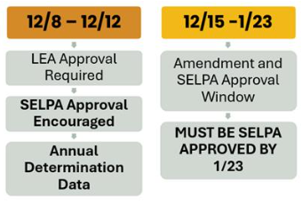
CALPADS Update Flash #317
New Real-Time Version of Report 16.14 – Students with Disabilities – Plan Student List by District of Special Education Accountability. Review the information here.
Timeline Changes for Upcoming IEP Implementation Data Collection 2025-26
For the upcoming 2025-26 AY, there will be a change to the data review/collection schedule as follows:

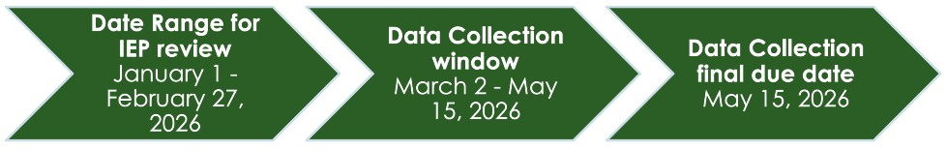
These changes provide a more flexible timeline to ensure the data review and submission process is completed before the end of the school year in June 2026.

QUESTIONS FOR CALPADS?

CALPADS Special Education Data Office Hours- Mondays, 3:00-4:30 pm
Data Stewards are strongly encouraged to attend the weekly Zoom open office hours hosted by the CDE's Special Education Division. Click here to register.

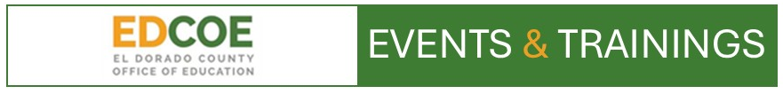


We offer virtual, in-person training
and events throughout the year

Explore our YouTube Video Training Library.
It is filled with valuable tutorials designed to
enhance your skills and knowledge in SEIS and
CALPADS data reporting. Subscribe today!

The SELPA has instituted a Service Request ticketing system. We invite Data Team service requests to be submitted via this email address: selpadata@edcoe.org.

