NUESTRO ELEMENTARY SCHOOL
Parent/Student Handbook
2026-2027
(Revised October 2026)

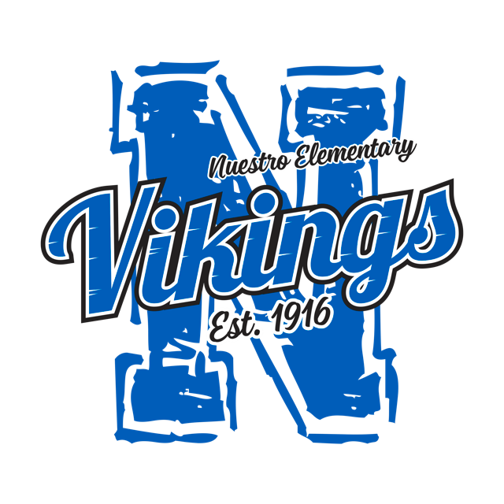

Office Hours:
7:30 a.m.-3:30 p.m. (Monday-Friday)

School Information
3934 Broadway
Live Oak, CA 95953
(530) 822-5100
Fax: (530) 822-5178
www.nuestroschool.org

Nuestro Elementary School District
Governing Board of Trustees

Member Term Expires

Mrs. Amber Brown, President 2027

Mrs. Emily Morton 2026

Mrs. Bethany Schmidl 2026

All meetings held by the Governing Board of the Nuestro Elementary School District are open to the public.

Regular board meetings are generally held on the 3rd Tuesday of each month, at 6:00 p.m. Public notice is posted at least 72 hours prior to the meetings.

As a public meeting, the Nuestro Elementary School District Governing Board extends a cordial welcome to all members of the Nuestro community to attend.

Should you care to leave a message for one of the members of the governing board, please call the school office and we will gladly pass on your message.

____________________________________________________________________

Nuestro Elementary School District Mission Statement

Empowering students to become successful leaders in the 21st century.

Nuestro Elementary School District Vision

Our vision is to inspire the whole child, in a nurturing environment, with a rigorous, innovative educational experience while maintaining high-standards and promote life-long learners in a global society.

Nuestro Elementary School

Staff List 2026–2027

Administration
Karen Villalobos – Superintendent / Principal
karenv@sutter.k12.ca.us
Lori Lindblad – Administrative / Office Secretary
lorit@sutter.k12.ca.us
Susan Gilbert – Administrative Assistant
susang@sutter.k12.ca.us
Michael Sproul – Data Technician / Technology Support
michaels@sutter.k12.ca.us

Teaching Staff – Elementary
Amanda Pauls – Transitional Kindergarten
amandapa@sutter.k12.ca.us
Amber Bozzo – Kindergarten
amberb@sutter.k12.ca.us
Stefanie Wedin – 1st Grade
stefaniew@sutter.k12.ca.us
Jeanna Winters – 2nd Grade
jeannaw@sutter.k12.ca.us
Melisse Roberts – 3rd Grade
melisser@sutter.k12.ca.us
Terri Brady – 4th Grade
terrib@sutter.k12.ca.us
Jeanette Torok – 5th Grade
jtorok@sutter.k12.ca.us

Teaching Staff – Middle School
Brian Coleman – 6th Grade
brianc@sutter.k12.ca.us
Connie Robinson – 7th / 8th Grade
crobinson@sutter.k12.ca.us

Support Staff
Cindy Bohmann – Library / Student Services / Night Custodian
cindyb@sutter.k12.ca.us
Stephanie Hunt – Food Service Specialist / After School Program Aide
stephanieh@sutter.k12.ca.us
Polly Vahniwal – Instructional Aide / After School Program Aide / Yard Supervisor
kulberv@sutter.k12.ca.us
Sonia Takher – Instructional Aide / Yard Supervisor
soniat@sutter.k12.ca.us
Karli Steele – Instructional Aide / Yard Supervisor
karlis@sutter.k12.ca.us
Evie Bird – Instructional Aide
evieb@sutter.k12.ca.us
Lila Rivera – Art Aide
lilar@sutter.k12.ca.us

ELOP/Viking Zone Staff
Jennifer Decker – ELOP Lead
jenniferd@sutter.k12.ca.us

Facilities
Angel Heredia – Custodian / Maintenance
juanh@sutter.k12.ca.us

Student Support & Specialized Services
Ramon Fonseca – Resource Center Teacher
ramonf@sutter.k12.ca.us
Rajvir Johal – Psychologist
rajvirj@sutter.k12.ca.us
Melissa Moore – Speech Therapist
melissam@sutter.k12.ca.us
Patricia Sandoval – Counselor
patricias@sutter.k12.ca.us
Emmalee Tullis – Student Support Specialist
emmaleet@sutter.k12.ca.us

NUESTRO ELEMENTARY SCHOOL DISTRICT
Dr. Karen Villalobos, Superintendent/Principal
3934 Broadway Road
Live Oak, Ca 95953
(530) 822-5100
(530) 822-5178

To Parents/Guardians:

Your child is attending a school receiving Title I federal funds through the Elementary and Secondary Education Act (ESEA). At the beginning of each school year, local educational agencies receiving Title I funds are required to notify parents whose student(s) attend a Title I school that they may request, and the agency will provide the parents on request (and in a timely manner), information regarding the professional qualifications of the student’s classroom teachers, including at a minimum:

- Whether the student’s teacher:

- Has met State qualification and licensing criteria for the grade levels and subject areas in which the teacher provides instruction;

- Is teaching under emergency or other provisional status through which State qualification or licensing criteria have been waived; and

- Is teaching in the field of discipline of the certification of the teacher.

- Whether the child is provided services by paraprofessionals and, if so, their qualifications.

If you would like this information, please contact Dr. Karen Villalobos at 530-822-5100.

Sincerely,

Dr. Karen Villalobos

Bell Schedule Recess/Lunch

7:50 am | School Begins
9:15-9:30 am | TK/Kinder Morning Recess
9:35-9:50 am | 5-8 Morning Recess
9:55-10:10 am | 1-4 Morning Recess
11:10-11:50 am | TK/Kinder Lunch
11:35-12:05 am | 5-8 Lunch
12:00-12:40 pm | 1-4 Lunch
12:50pm | TK/Kinder Dismissal Time
2:30pm | 1-8 Dismissal Time

Minimum Day Schedule

7:50 am | School Begins
9:15-9:30 am | TK/Kinder Morning Recess
9:35-9:50 am | 5-8 Morning Recess
9:55-10:10 am | 1-4 Morning Recess
11:10-11:50 am | TK/Kinder Lunch
11:35-12:05 am | 5-8 Lunch
12:00-12:40 pm | 1-4 Lunch
12:50pm | TK-8 Dismissal Time

After School Program (ASP) Rules / Viking Zone
- Follow all directions the first time they are given.
- Use self-control and have respect for others. Keep hands, feet, and objects to yourself.
- Ask permission before leaving a classroom or designated play area.
- Use equipment properly. Sit on the slide. Jump ropes are for jumping rope only. Students should use balls as they were intended to be used.
- Stop playing when directed or signaled to do so, then follow directions.
- No wearing hats in the buildings.
- Cell phones shall be put away and turned off while on campus.
- Students must not leave the After School Program until they are checked out by a parent/guardian unless other arrangements have been approved by the District and the appropriate paperwork is on file with the After School Program Supervisor.
- For the safety of your children, parents/guardians are required to sign out their children each day from the After School Program. If you are getting your child on or about the 2:30pm dismissal time, park your car in a designated space and then go to the after school program to check out your child. Do not park in the pick-up/drop-off lanes.
ATTENDANCE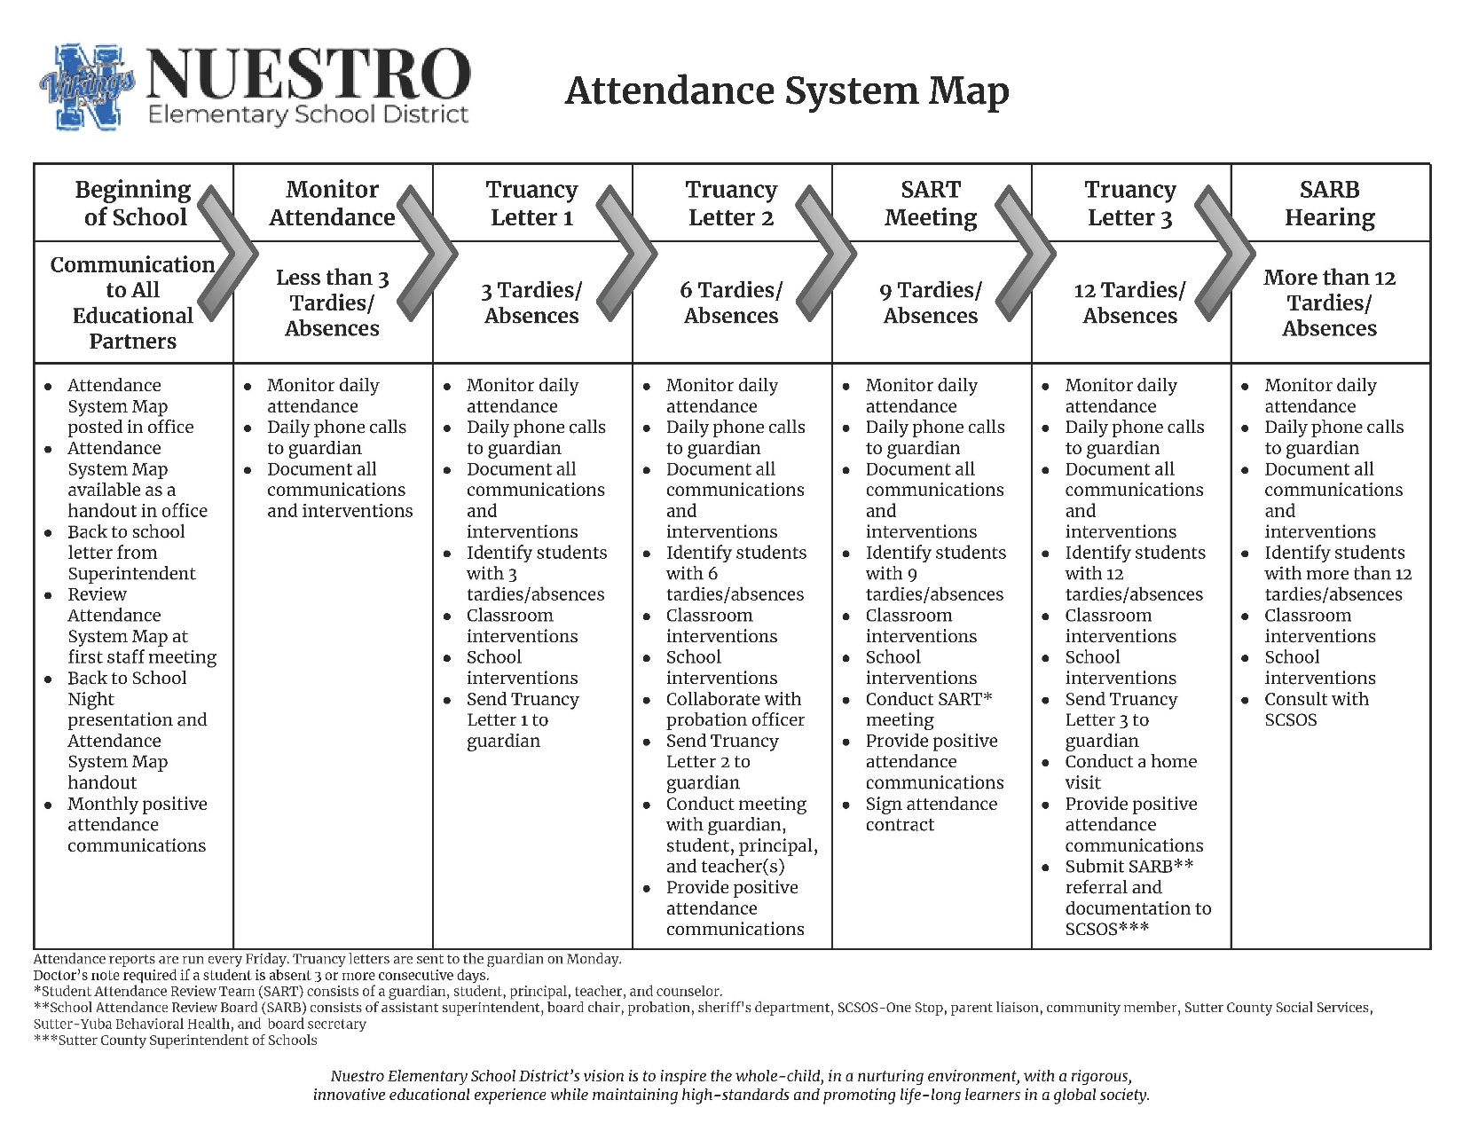
Everyone understands that students need to be in school every day to receive the best possible education. Absenteeism is very costly. It causes long-term problems for students, schools, and our community. California’s Compulsory Attendance Law requires every person between the ages of 6 and 18 years of age to attend school full time every day, unless the student has been legally exempted or has graduated from high school. California’s Attendance Law requires parents/guardians to verify all student absences.
According to the Nuestro Elementary School District Agreement for School Attendance, the student will have no more than two (2) unexcused absences in any one trimester. If there are more than two unexcused absences in any one trimester, it may cause immediate revocation of this Agreement. The Interdistrict Attendance Agreement may also be revoked if a student has excessive tardiness (averaging more than one per week).
The questions and answers below further explain Nuestro’s protocol for attendance:
What must I do if my child is going to be absent from school?
- Call the office no later than 8:20am, so we know your child is safe. If you are leaving a message, leave your child’s name, the reason for the absence, the date of the absence, and your name.

- Then verify your child’s absence by sending a note to the school within 3 days of the student’s return to school. This verification must include:
1. The student’s full name.
2. The date(s) of absence.
3. The specific reason for the absence.
4. The name and relationship of the person providing the information.
5. The date when the verification was made.

Any absences, after failing to follow this procedure, will be considered unexcused.
Below are some frequently asked questions about attendance:
What is considered an Excused Absence?
By law [EC § 48205], excused absences are: illness [fever 100° or more, your child must be fever free for twenty-four hours before returning to school], persistent runny nose with yellow-green mucous discharge, rashes [unless there is a note from your physician stating that your child is not contagious], vomiting [if your child is sent home vomiting he/she needs to be vomit-free for twenty-four hours before returning to school], diarrhea [if your child is sent home from school with diarrhea he/she needs to be diarrhea free for twenty four hours before returning to school], medical/dental appointments [doctor’s note required for verification], death in the family, specific religious reasons, required appearance in court, and exclusion from school for contagious disease.

What if my child’s absences do not fall under any of the Excused Absences categories?
State law [EC § 48260-48273] is very specific about these types of absences. A student who is absent from school without a valid excuse will be marked “unexcused” for the day. These types of absences are also called “Truancies”.

What about coming in late (tardy) or leaving early for an appointment?
According to State Law [EC § 48260-48273], a student that is absent from school in excess of 30 minutes during a school day is also considered “truant”.

What is the process for a child with more than 3 unexcused absences/truancies?
The California legislature responded to the role irregular attendance and poor behavior play in lost learning, school dropout, and juvenile delinquency with a number of laws written in the early 1970s. In 1974, School Attendance Review Boards (SARBs) were introduced in California Education Code [EC] Sections 48320–48325, as a part of a system of interventions intended to make maximum use of school district and community resources to reengage students, improve graduation rates, and divert minors away from the justice system. Nuestro Elementary School District is required to follow the SARB process. This means that you will begin receiving letters from the school upon the 3rd (third) truancy. If your child continues to be truant, you will need to meet with the Superintendent/Principal. Additional instances of truancy will result in a referral to the School Attendance Review Board and possible referral to the District Attorney for prosecution.

What can I do if my child needs to be out of school for a length of time?
If your child must go out of town for five or more days, you may request that your child is signed up for an Independent Study Agreement. Please note that teachers need at least two weeks’ notice in order to prepare
materials without interrupting their instructional time.

Why is attendance such a big issue?
Regular attendance is vital to student’s success in school. The student, who is frequently absent, misses social
interaction and direct instruction from his/her teachers even though written work can be made up. Any day or hour absent is a missed learning opportunity. Attendance is a key predictor of dropouts. Dropouts create economic loss and jeopardize future work force since only 31% of dropouts keep a job more than a year. Also schools lose funding for each absence, regardless of the reason; including illness or excused absences.

What about homework? If my child is absent, can I request homework to be sent home?
Students are given the opportunity to make up schoolwork missed due to illness or a valid excused absence upon their return. As a general policy, a student is allowed one (1) day to complete make-up work for each day of excused absence from school.

BREAKFAST/LUNCH PROGRAM
All students at Nuestro Elementary will have free breakfast and lunch during the school year. Viking Zone students who stay until 4:15pm will receive Supper.

BUS & VEHICLE RULES
The riding of the Sutter Union High School Bus is a privilege allowed to the students of our district by the high school. Violation of the bus & vehicle rules may result in a student’s bus or vehicle riding privilege being revoked. Violation may also result in disciplinary action which may include in the immediate revocation of an interdistrict agreement.
- Keep off the road or street at all times while waiting for the bus or vehicle.
- Line up in single file and remain standing until the bus or vehicle has come to a full stop before trying to board.
- Get a seat as quickly as possible and remain seated.
- Keep head and hands inside the bus or vehicle at all times after entering.
- No loud talking or unnecessary commotion. It may divert the driver's attention and result in an accident.
- Do not throw anything out of the windows. Littering is against the law.
7. Help look after the safety and comfort of smaller children.
- Riders are under the supervision of the driver and are expected to do as he/she instructs.
- Remain seated until the bus or vehicle comes to a complete stop before standing up to get out.
- Unload quietly and quickly from the front of the bus first.
THE ABOVE RULES AND REGULATIONS WILL APPLY TO ANY TRIP UNDER SCHOOL SPONSORSHIP.

CELL PHONES AND OTHER ELECTRONIC DEVICES
To keep our learning environment free from unnecessary disruptions, and for the safety/privacy of other students, cell phones and electronic devices are to be turned off and put away while students are on campus or involved in any school function. Parents who wish to contact their children during the school day should call the office. Any phones or electronic devices (CD players, IPODs, MP3 players, cameras, video cameras, video games, electronic toys, etc.) that are not turned off and kept put away (unseen and unheard) while students are on campus will be confiscated. Confiscated items will require parent/guardian pick-up on the first offense. Discipline associated with a failure to follow this school rule will be handled as a serious safety issue if the device is capable of taking pictures or making a recording. Failing to follow this rule is also a failure to cooperate with the teacher and/or administration of the school.

Students are allowed to have electronic devices such as electronic book readers that do not have the capability of taking pictures or making recordings. Please note that the school will not be responsible for ANY cell phones, electronic devices, other electronic devices, or prohibited items that are lost or stolen. We appreciate your understanding and helping us maintain a safe and secure learning environment for all children.

Under Board Policy, California Education Code, and Assembly Bill 3216, in Nuestro Elementary School District, cell phones and digital recording devices are to remain in the off position during school hours. Unless given explicit directions for instructional purposes by school/district staff, cell phone usage is completely restricted on school grounds. Cell phones, digital recording devices, and headphones must not be visible during class or restroom breaks. Use of a cell phone while on a school bus, going on field trips, during breaks/recess, and passing periods is not allowed.

At no time are cell phones or digital recording devices permitted to be used during class with guest/substitute teachers.

First Offense: Student may pick up the cell phone/digital recording device in the school office after the end of the school day.
Second Offense: Parent/Guardian must pick up the cell phone/digital recording device.
Future Offenses: Parent/Guardian picks up the cell phone/digital recording device and agrees the student will not possess the cell phone/digital recording device during school hours. The student will sign an agreement acknowledging that subsequent offenses may result in further consequences for defiance of school policy.

Smartphones and other mobile communication devices shall not be used in any manner that infringes on any other person's privacy rights. When a student uses a mobile communication device in an unauthorized way, the student may be disciplined, and a district employee may confiscate the device. The employee shall store the device securely until it is returned to the student or turned over to the principal or designee, as appropriate. A student may also be subject to discipline, by the law, Board policy, or administrative regulation, for off-campus use of a mobile communication device that poses a threat or danger to the safety of students, staff, or district property or substantially disrupts school activities.

The Superintendent or designee shall inform students that the district will not be responsible for a student's mobile communication device which is brought on campus or to a school activity and is lost, stolen, or damaged

CLASSROOM PARTIES (INCLUDING BIRTHDAYS)
Because of state laws governing the type of food served at public schools, and the need to ensure student safety, the following is in effect:
l. One party per month to celebrate all birthdays for that month. Only one cupcake or treat, per student, is allowed.
2. Check in advance with your child’s teacher to make sure you do not bring an item that may cause an allergic reaction in a student. No items that could cause an allergic reaction are allowed.
3. Drinks are to contain mostly fruit juice. Low-fat milk may be served. No carbonated drinks may be served.
4. No baked goods from home are allowed.
5. Only healthy foods may be served.

DISCIPLINE
Nuestro Elementary School desires to prepare students for responsible citizenship by fostering self-discipline and personal responsibility. To achieve this, The District provides staff with opportunities for training in classroom management and discipline strategies.

High expectations for student behavior, effective classroom management, and parent/guardian involvement can minimize student misconduct. A continually disruptive student may be assigned to alternative programs or removed from school. Students on interdistrict agreements may have their agreements revoked. Also, if a child is involved in a fight or is causing ongoing disruption, the parent(s)/guardian(s) may be required to spend one full day at school with the child.

A teacher may also direct a student’s recess time when he or she believes that this action is the most effective way to bring about improved behavior, subject to the following conditions:
The student shall be given adequate time to use the restroom and get a drink or eat lunch, as appropriate.
The student shall remain under an employee’s supervision during the period of re-direction.
Teachers shall inform the Superintendent/Principal of any recess restrictions they impose.

The following table provides a guideline for consequences that may be given for different problem areas. However, it is important to note that Education Code provides maximum corrections and allows the Superintendent/Principal to use his or her discretion to provide alternatives to suspension or expulsion that are age appropriate and designed to address and correct the pupil's specific misbehavior. Notwithstanding minimum and maximum corrections provided as a general guide, the minimum and maximum corrections will be those allowed by current Educational Code. (see 48900 et seq.)

PROBLEM AREAS | MINIMUM CORRECTION | MAXIMUM CORRECTION
ARSON  (Fire damage or attempt to damage with inflammables) | One-day suspension  Parent conference  Revocation of Interdistrict Agreement | Three- to five-day suspension  Police notification  Parent conference  Restitution  Expulsion
ASSAULT  (Action with intent to do bodily harm) | Two- to three-day suspension  Parent conference  Revocation of Interdistrict Agreement | Five-day suspension  Police notification  Parent conference  Expulsion
BATTERY  (Willful and unlawful use of force or violence) | Two- to three-day suspension  Parent conference  Revocation of Interdistrict Agreement | Five-day suspension  Police notification  Parent conference  Expulsion
DANGEROUS OBJECTS  (Possession or sale of firearms, *knives, firecrackers, matches, lighters, weapons or replicas) | Possible one-day suspension  Parent conference  Revocation of Interdistrict Agreement | Three- to five-day suspension  Police notification  Parent conference  Expulsion
DRUGS  (Use or possession of marijuana, alcohol, controlled substance or look-alike) | Automatic five-day suspension  Police notification  Parent conference  Revocation of Interdistrict Agreement | Exclusion from all school activities  Expulsion from school district
FIGHTING  (Mutual combat) | Alternative means of correction  and/or possible one- to three-day  suspension  Parent conference  Revocation of Interdistrict Agreement | Five-day suspension  Parent conference  Expulsion
HARASSMENT  (Physical [habitual threats];  sexual [grades 3-8]; racial) | Alternative means of correction  and/or possible one- to three-day  suspension  Parent conference  Revocation of Interdistrict Agreement | Five-day suspension  Police notification  Parent conference  Expulsion
OBSCENE ACTS  (Gestures, verbal, written, drawing, physical contact) | Alternative means of correction  and/or possible one- to three-day  suspension  Parent conference  Revocation of Interdistrict Agreement | Five-day suspension  Parent conference  Expulsion
PROFANITY | Alternative means of correction  other than suspension | Five-day suspension  Parent conference  Revocation of Interdistrict Agreement  Expulsion
RECEIPT OF STOLEN PROPERTY | One-day suspension  Parent conference  Revocation of Interdistrict Agreement | Five-day suspension  Police notification  Parent conference  Expulsion
ROBBERY OR EXTORTION | One-day suspension  Parent conference  Revocation of Interdistrict Agreement | Five-day suspension  Police notification  Parent conference  Expulsion
SMOKING OR CHEWING TOBACCO  (including use of electronic cigarettes or other devices that deliver a vaporized liquid) | Alternative means of correction and/or one-day suspension  Revocation of Interdistrict Agreement | Five-day suspension  Police notification  Parent conference
STEALING | Alternative means of correction and/or one-day suspension  Parent conference  Revocation of Interdistrict Agreement | Five-day suspension  Police notification  Parent conference  Expulsion
TRESPASSING | Alternative means of correction and/or one-day suspension  Parent conference  Revocation of Interdistrict Agreement | Five-day suspension  Police notification  Parent conference
VANDALISM | Alternative means of correction and/or one-day suspension  Revocation of Interdistrict Agreement | Five-day suspension  Police notification  Parent conference  Restitution  Expulsion
WILLFUL DISOBEDIENCE, DISRUPTION OF SCHOOL ACTIVITIES, OR DEFIANCE OF SCHOOL AUTHORITY | Alternative means of correction and/or one-day suspension  Revocation of Interdistrict Agreement | Five-day suspension  Police notification  Parent conference
BULLYING  Please note that bullying includes:  1. Bullying is aggressive behavior that involves unwanted, negative actions.  2. Bullying involves a pattern of behavior repeated over time.  3. Bullying involves an imbalance of power or strength. | Alternative means of correction  and/or possible one- to three-day  suspension  Parent conference  Revocation of Interdistrict Agreement | Five-day suspension  Parent conference  Expulsion
According to the Nuestro Elementary School District Agreement for School Attendance, “The student shall cooperate with the teachers and support staff and will cause no disruption either in the classroom or outside of class. The students shall obey all school rules and have no violation that could normally result in suspension or expulsion. The agreement will automatically be revoked if a student receives two (2) suspensions in one calendar year. (Suspension is defined as being suspended from the classroom for one or more days, either being sent home or staying in the office under the supervision of the Superintendent)”
EARLY RELEASE DAYS (12:50pm)
All students will be released at 12:50pm. Please see calendar for a list of early release days.

FIELD TRIPS AND OTHER SCHOOL ACTIVITIES (STUDENTS)
To participate in a school sponsored field trip or an after-school game/activity, students must turn in all required paperwork by the deadline. This includes permission forms with parent/guardian signatures. A student may not be allowed to participate in a field trip or other activity if he or she has engaged in behavior that causes the teacher or administration to believe the student should not attend the field trip or activity.

FIELD TRIPS AND OTHER SCHOOL ACTIVITIES (PARENTS/GUARDIANS, CHAPERONES, AND COACHES)
We encourage parents and guardians to participate in school activities, including field trips. For the protection of our children, anyone who wishes to chaperone or participate in a field trip or other school sponsored activity with our students must be cleared through our background check, complete the volunteer packet, attend training, and turn in any necessary paperwork by the deadline. No one will be allowed to drive on school functions unless they submit the required documentation for driving on a school sponsored activity and complete the volunteer packet. Also, volunteers and teachers must be able to provide full attention to the supervision of the children placed in their care. Therefore, chaperones may not bring other children (including siblings) on field trips or activities.

While we understand that taking the time to complete the volunteer packet or required documentation for driving on a school sponsored activity may inconvenience someone, we are responsible for the children placed in our care, and we will not make exceptions to these rules.

FOOD ALLERGIES
If your child has any food allergies, please notify the school office and your child’s teacher(s) in writing. This information helps us ensure your child’s safety and make any necessary accommodations.

GRADING PLAN
There are three grading periods in each school year (Trimester 1, Trimester 2, and Trimester 3). Progress reports will also be sent home at about the middle of each trimester for grades 3rd – 8th. Please check the calendar for trimester and progress report dates. Nuestro report cards take into consideration the classroom common core standards set by the State of California, we are continually working to improve our report cards to best communicate your child’s progress.

Any progress notices, assignments, or notes sent home that require a parent/guardian signature must be returned with the appropriate signature within two school days.

GRADING CRITERIA
Teachers at Nuestro Elementary School believe grading should be fair. Standards for assignments are clearly defined, and teachers evaluate work based on the criterion put forth in the assignment.

HEAD LICE
To prevent the spread of head lice infestations, school employees shall report all suspected cases of head lice to the school nurse or administrator as soon as possible. The nurse, administrator, or administrator’s designee shall examine the student and any siblings of affected students or members of the same household. If nits or lice are found, the student shall be excluded from attendance and parents/guardians informed about recommended treatment procedures and sources of further information. If there are two or more students affected in any class, all students in the class shall be examined, and information about head lice shall be sent home to all parents/guardians of those students. Staff shall maintain the privacy of students identified as having head lice and excluded from attendance. Excluded students may return to school when (1) they bring a note from the parent/guardian verifying treatment, and (2) re-examination by the nurse, administrator, or administrator’s designee shows that all nits and lice have been removed.

INDEPENDENT STUDY
Parents/Guardians must make all requests at least two weeks in advance.
Parent must fill out and sign an independent study contract.
Upon the student's return, all work must be attached to the contract and given to the teacher.
Students must be out a minimum of five days to be on independent study. Please make sure your child completes all work as assigned. If a student does not complete the assigned work, he or she will be marked absent for the days, which would most likely create a truancy issue for the child and parent.

INVITATIONS (INCLUDING BIRTHDAYS)
No invitations are to be distributed to classmates at school unless they are given to all students in that particular classroom. This includes distribution in the parking lot.

PARKING LOT RULES
These rules are in place to keep our children safe. We appreciate your being especially careful and cautious while operating a vehicle on school grounds. Please drop-off and pick-up children as safely and efficiently as possible. Drive slowly at all times, being careful to watch for children and other pedestrians. Please be courteous and circle around if traffic is backing up behind you. Nuestro Elementary School employees are on duty in the parking lot to ensure the safety of everyone. Please follow their directions.

Because of the potential for serious harm to others, no vehicle can be left running on campus without a licensed driver sitting in the driver’s seat.

Please do not park or get out of your vehicle if it is in the pick-up lanes during the times set forth below. Parking for an extended amount of time or getting out of your vehicle during the times below will create an unsafe environment for our students and staff. If staff asks you to circle around, do so immediately so we can keep traffic flowing smoothly.

NO PARKING OR GETTING OUT OF YOUR VEHICLE IS ALLOWED IN THE DROP-OFF/PICK-UP LANES DURING THE FOLLOWING TIMES:
Regular Days: 7:30am to 7:55am and 2:25pm to 2:40pm
Minimum Days: 7:30am to 7:55am and 12:10pm to 12:25pm
Early Release Days: 7:30am to 7:55am and 12:50pm to 1:00pm
If you must park or get out of your vehicle for any reason during the times listed above, park in a parking space.

Bikes are to be locked in the bicycle area during school hours and should be walked while on campus. All students must wear helmets when riding bikes. Following CA law, no students under the age of 16 may ride their e-bike to school.

Only use the marked entrance and exits. DO NOT drive across gravel areas in front of the school.

Parent Square
It is essential that all parents and guardians download the Parent Square app to stay informed about important updates, events, and announcements. Please ensure your contact information is current, so you don’t miss any school communications.

PINK EYE
Due to very contagious symptoms, you will receive a phone call in the event that we suspect your child may have pink eye. Your child may not return to school without a note from your doctor.

TRADING CARDS AND COLLECTIBLES AND TOYS
Trading cards and other collectibles are not allowed on school grounds. The school will not be liable for loss or theft of valuables.

VISITORS
Due to security concerns, school districts require all schools use visitor identification. The protocol for visitors at Nuestro is as follows:
- Everyone other than a paid employee who is on duty is considered a visitor.
- Visitors are required to report directly to the school office before going anywhere else on campus.
- All visitors are required to sign in at the office and wear a school visitor’s badge.
- Visitors are not to proceed on campus without first signing in and putting on a visitor’s badge.
- Visitors may only go to the areas that they indicate when they sign in.
- All visitors are to return to the office and sign out before they leave the school.

WEBSITE
The District/School website, www.nuestroschool.org, provides families with important information about school policies, programs, and available resources. You can also find a calendar of events and links to contact school staff

WHOOPING COUGH BOOSTER (Tdap) SB614.
Under state law, all students going into 7th and 8th grades must have proof of having had the Tdap booster shot before starting school.

NUESTRO ELEMENTARY SCHOOL PLAYGROUND SAFETY RULES

- BE KIND AND HAVE FUN
- Students are not permitted on the playground without adult supervision. If an adult is not on the playground, do not go on the playground.
- Listen and respect all staff. Follow their directions the FIRST time they are given.
- Always play safe by being careful and courteous to the people around you.
- Always get permission to leave the playground.
- Only play in the designated areas. If something you are using goes out of that area, ask to retrieve that item.
- Immediately freeze when the bell rings and put away any equipment you are using or see near you. Then walk to your line-up area. Listen for yard duty instructions.
- No yelling or making loud noises near classrooms that are in session.
- Wear proper clothing and shoes to make sure you can properly see, climb, and run in designated areas. No sandals or open-toed shoes are allowed in the bark.
- Make sure no one is in the way when you get off of equipment.
- Be extra careful on days when the weather is hot or wet. Do not play in the bark or on the grass when it is wet. Do not jump in puddles or play in the mud.
- Take turns and get in line if more than one person wants to use a piece of equipment. No cutting or holding places for others is allowed.
- Always use equipment how it is intended to be used.
- Always ask for help when you feel unsafe.
- No running in the bark, on the sidewalk, or on the blacktop. You may only run on the blacktop while playing basketball.
- No destroying property of any kind or hurting our trees and plants.
- No throwing or kicking walnuts.
- No playing any type of tag game.
- No playing in or beside maintenance areas.
- No sitting or standing on tables.
- No standing on benches.
- Only climb on equipment if you are able to get down safely.
- Keep your hands and feet to yourself.
- Only one person may slide at a time. Stay on your bottom while sliding.
- No playing in the bathrooms.
- Throw away your trash in a garbage can.
- No twisting on the swings or jumping off of them.
- No hitting other people.

Student Dress Code
Shoes must be worn at all times. All types of flip-flops or strapless shoes are prohibited because they pose a safety hazard. Sandals must have a manufactured heel strap. Shoes on wheels or roller shoes are not allowed. Students should have footwear that is suitable for outside activities every day.
Clothing and jewelry shall be free of writing, pictures, or any other insignia which are aggressive, vulgar, profane, or sexually suggestive. Clothing should not suggest racial, ethnic, or religious prejudice or promote drug, tobacco, or alcohol use.
Clothing or jewelry deemed to be associated with gang membership will not be allowed.
Hats need to be worn with the brim facing forward. Hats and hoods are not to be worn in the classrooms or in the multi-purpose room during assemblies.
Clothes shall be sufficient to conceal undergarments at all times. No see-through, fish-net fabrics, halter tops, tank tops (K-5 ok as long as tank tops or tank top dresses have a “2 finger width” shoulder), off-the-shoulder, bare midriffs, or spandex as outerwear.
No skirts or shorts are permitted, unless they are longer than fingertip length with the fingers in a relaxed position.
Pants and shorts must stay above the hips at all times. Oversized pants or excessively tight pants that don’t cover the underwear completely are not allowed.
No pajamas, slippers, or any type of loungewear (such as yoga pants) are permitted at school.
Leggings may only be worn with skirts, long sweaters, or shirts that completely cover the person’s front and backside areas.
Clothing with printing across the buttocks is not acceptable.
Students must have appropriate clothing and shoes to fully participate in P.E. activities.
Any hair coloring (spray or otherwise) that would drip or smear when wet is not allowed.
Students may not write on their clothing or skin, or on the clothing or skin of others.

NUESTRO ELEMENTARY SCHOOL DISTRICT
STUDENT COUNCIL
Campaign Rules
Those who are trying for the Student Council positions must follow the following rules. Violation of any rule will result in disqualification of the candidate.
Posters
One banner per person will be displayed in the cafeteria. It may not be any larger than the 4ft x 4ft poster paper given out by the school. Posters must have candidate’s name and position clearly displayed. No unkind or inappropriate communication is permitted. No candidate may mention another candidate by name or by implication.
Smaller posters may be taped in locations approved by Mr. Heredia using tape provided by Mr. Heredia.
Nothing else may be passed out. This will lead to the disqualification of the candidate.
Presentation
1. The candidate’s presentation is to last no more than three minutes.
2. The candidate’s presentation must be pre-approved by the Student Body Advisor.
3. Give it your all and good luck.
Candidates MUST get their presentations and posters approved by the Student Body Advisor. No poster or presentation can be altered after approval.

NUESTRO ELEMENTARY SCHOOL DISTRICT
GRADUATION & END-OF-YEAR GUIDELINES

End-of-Year Trip
The end-of-year trip, including all activities and location, must be approved by the Superintendent/Principal. The class will decide, by a majority vote, where they would like to go for the end-of-year trip. The destination cannot be more than 100 miles from the school. Anyone attending the end-of-year trip with the class must first be cleared through the district’s volunteer & chaperone process. Anyone not meeting the conditions set forth by the District will not be allowed to attend the trip with our students.

Graduation
We will begin holding parent meetings in March/April to determine the specifics of graduation. Below are some general guidelines for the graduation ceremony:
Dress: Gowns will be worn by all graduating students. These gowns will be purchased by parents/guardians. It is the parents’ responsibility to make sure their children’s gowns are wrinkle-free prior to the graduation ceremony. Anyone needing assistance with this must let the Superintendent/Principal or the 8th grade home room teacher know at least 3 days prior to graduation day. We will be happy to help! As with all school sponsored functions, the dress code must be followed.
Music: All music used during the ceremony must be chosen by the class no later than the end of April. The music must be appropriate for an elementary school graduation setting and must be approved by the 8th grade homeroom teacher and student services aide. Music containing any foul language; derogatory terms of any kind; inappropriate innuendos; or lyrics referring to alcohol, drugs, sex, suicide, killing, or any other topic that is inappropriate for an elementary school graduation ceremony will not be considered.
Pictures: All pictures must be appropriate and approved by the 8th grade homeroom teacher.

Valedictorian/Salutatorian
- The valedictorian will be the student with the highest GPA average for grades 6-8.
- If there is no identified valedictorian using criteria in item 1, we will then look at CAASPP scores in each descending grade level. If the students attended different schools, we will compare common assessments. If there is no common assessment, we will declare a tie.
- The criteria above will also be used to determine who becomes salutatorian.
- The valedictorian and salutatorian will be chosen approximately 3-4 weeks before the end of the school year.

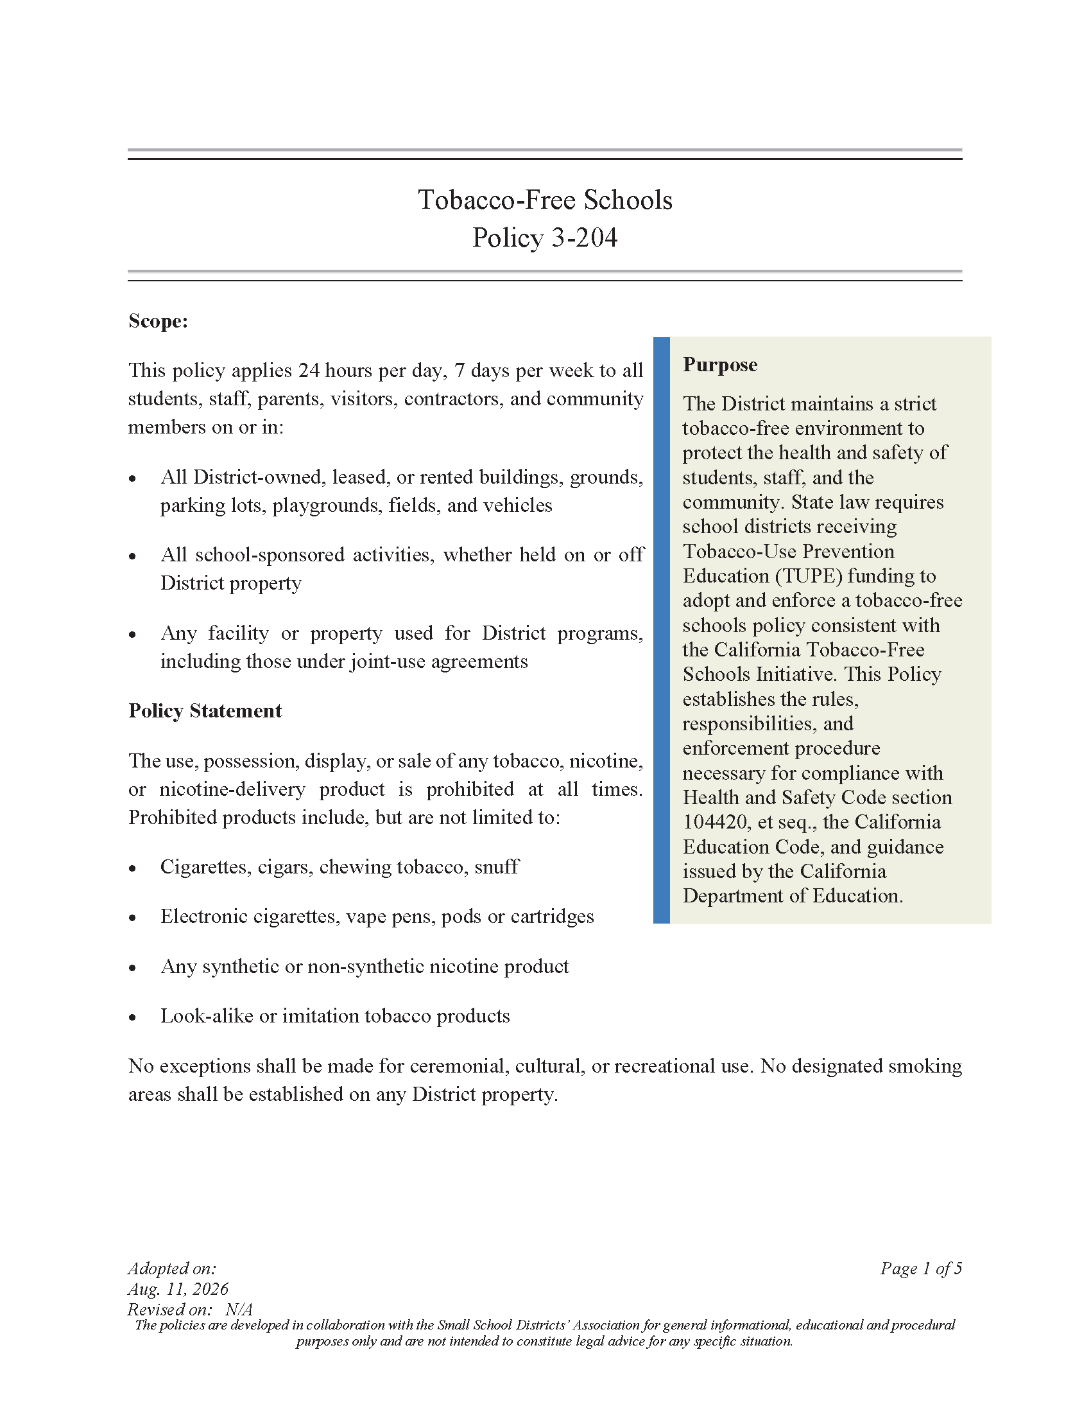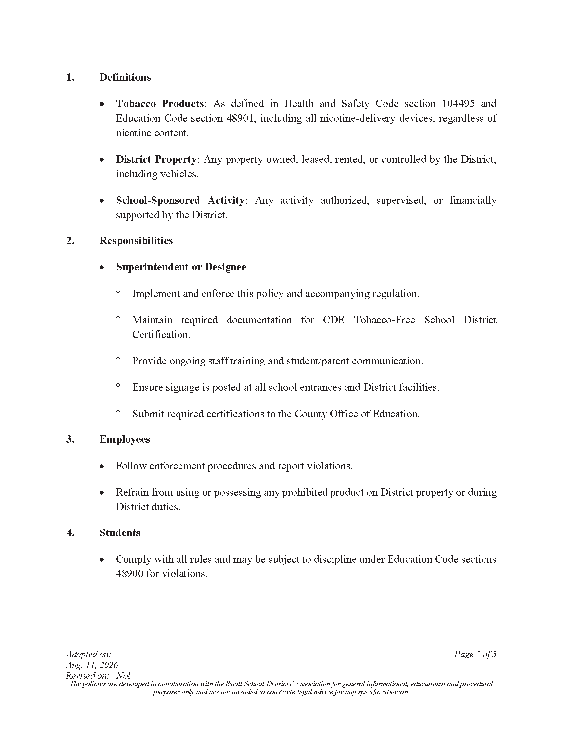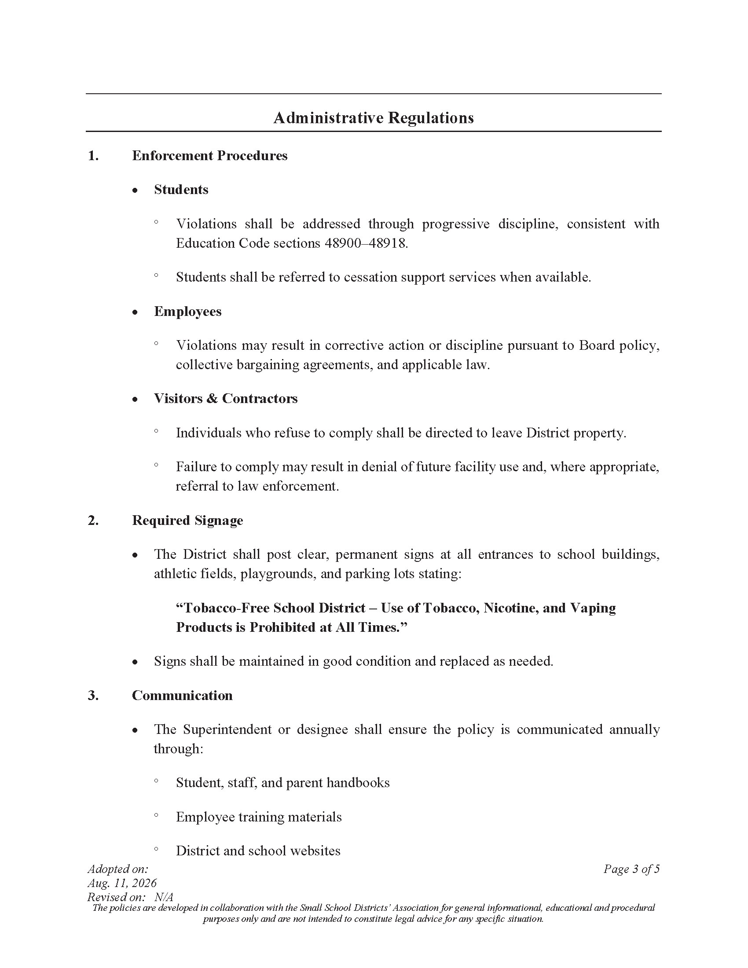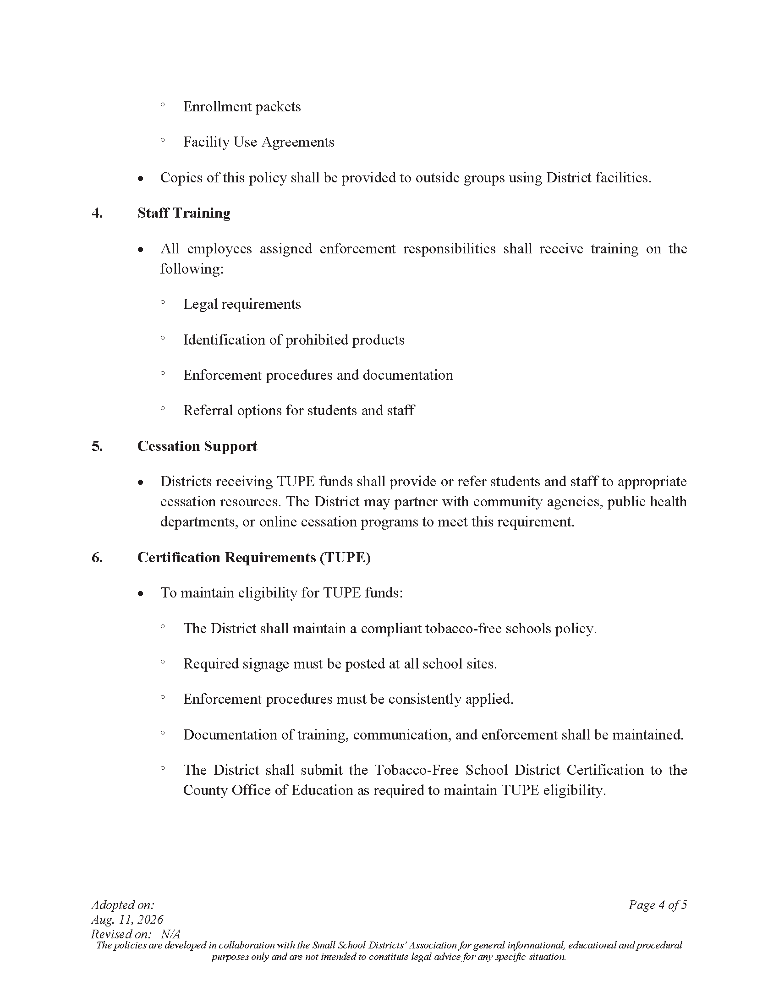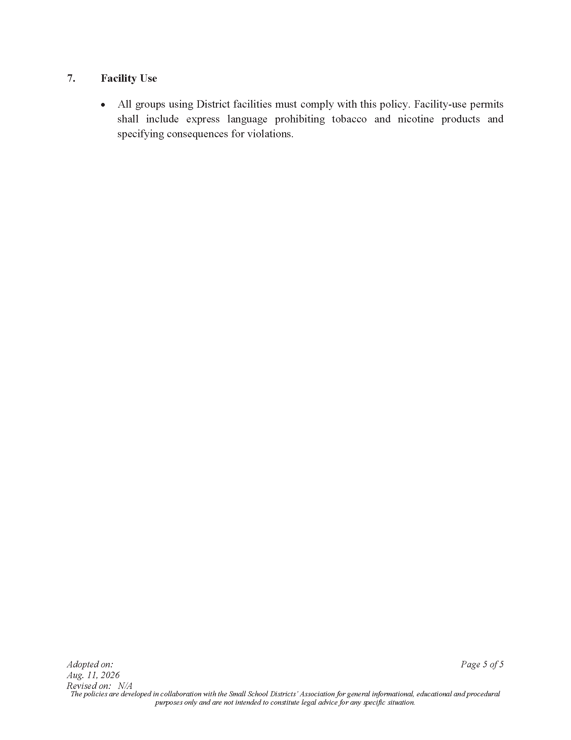
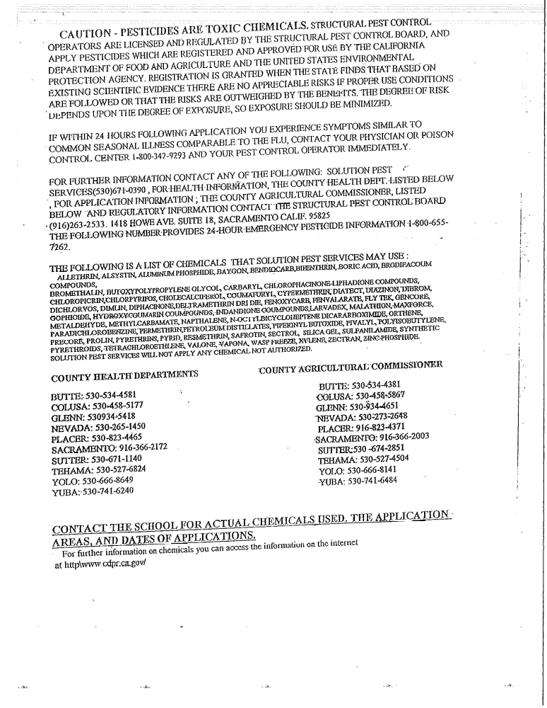
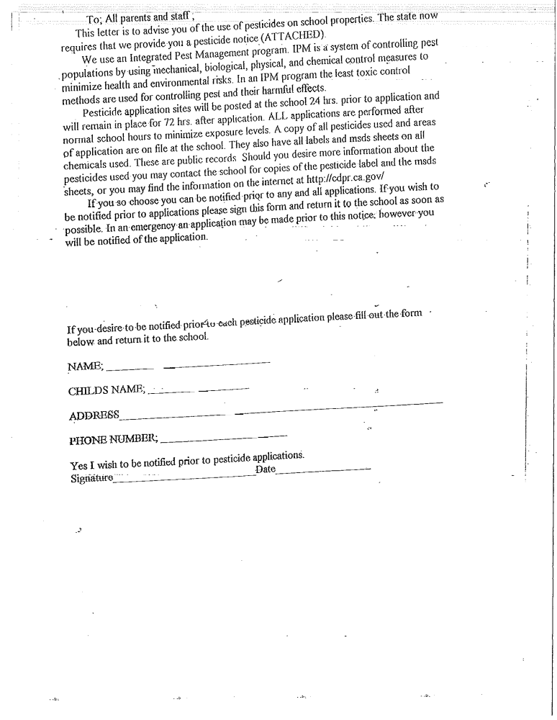
2026-27 PARENT/STUDENT HANDBOOK ACKNOWLEDGMENT FORM

I,__________________________________________________________________, the parent/guardian(s)
(print parent/guardian(s) name(s))

of ____________________________________________, acknowledge receipt of the 2025-2026 Parent/Student
(print student(s) name(s))
Handbook.

________________________ _____________________
Parent/Guardian Signature Date

________________________ _____________________
Parent/Guardian Signature Date

Karen Villalobos
Superintendent/Principal
Nuestro Elementary School District
3934 Broadway
Live Oak, CA 95953
530.822.5100

