Skyward Student Access Online Registration

1. To get to Skyward Student Access, students will go to NEISD.net and click on the Launchpad Tab.

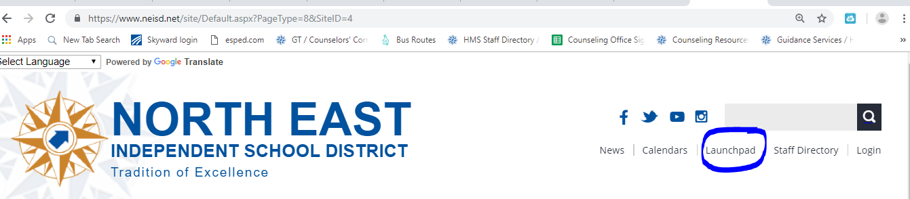

1. Once at Launchpad, Click on the Skyward Application.

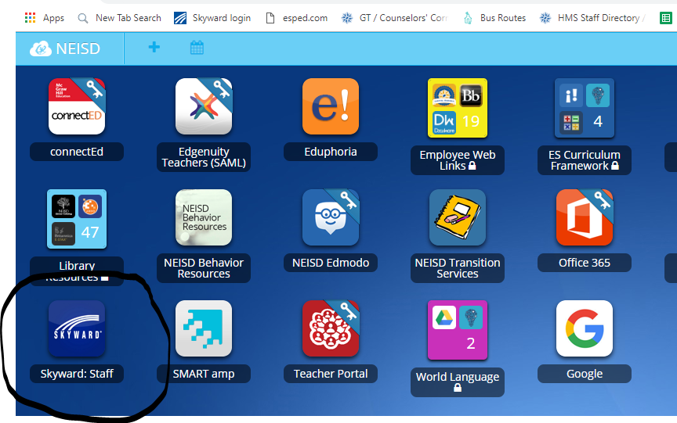

1. Once at the screen below, login just like you would the school computers, except **leave off** the @stu.neisd.net.

Example:

Username:  HHawk1234 (1st initial of your First Name and your whole Last Name, and last 4 digits of your school ID #)

Password: 0931234 (Student ID number)

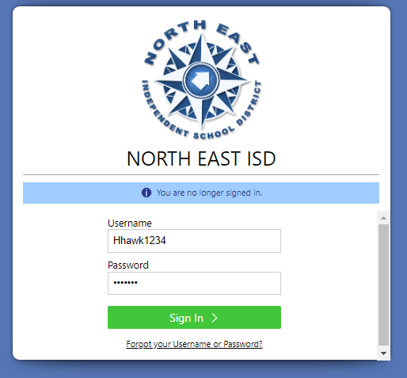

1. Click on the Course Request Ed White Middle School Application.

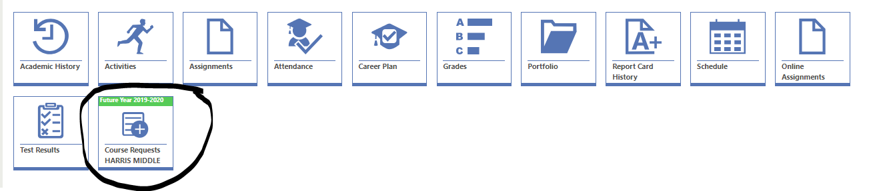



1. Using your Course Selection paper as a guide, enter in your courses by subject, description, or course number. Then click add. All of the courses you ‘added’ will show up on the right hand side.

If you accidently add one you do not want, you will press ‘remove’ and it will take it off of your choices for course requests. You should have a total of 7.0 classes.

Do you have ALL of the classes below?

Math

English/Reading

Science

History

Physical Education (PE) or Athletics

Eagle Hour

Elective

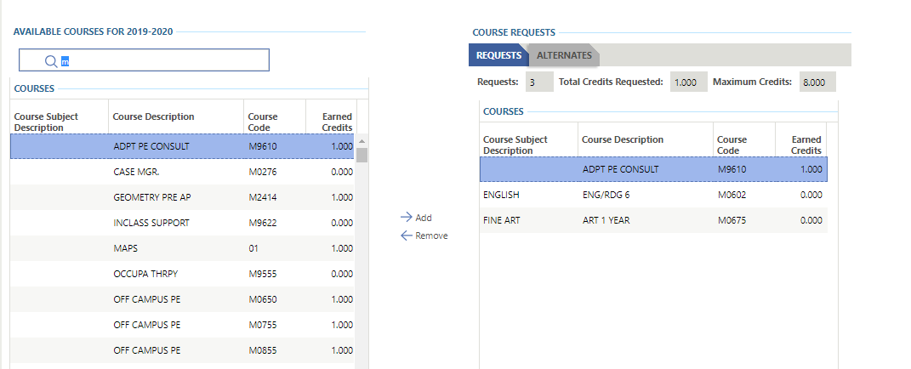

1. You will now enter in alternates, by choosing alternate electives. An alternate class is a class that you would like to take IF you do not get into the classes you chose for some reason (they are full, they wouldn’t fit with your other classes, etc…)

Alternate classes can only be electives like Art, Theatre Arts, Choir, Spanish or Principles of Applied Engineering. Elective classes are NOT required core courses like English, Science or PE.

The maximum number of alternate classes is 3. These choices will be used if the requested elective class is full. Students can put their alternates *in the order of first choice to third choice*.



1. Once students have entered in ALL 7.0 courses and 3 alternates, you MUST SUBMIT your course requests or they will not be saved or sent to the counselor for course registration.

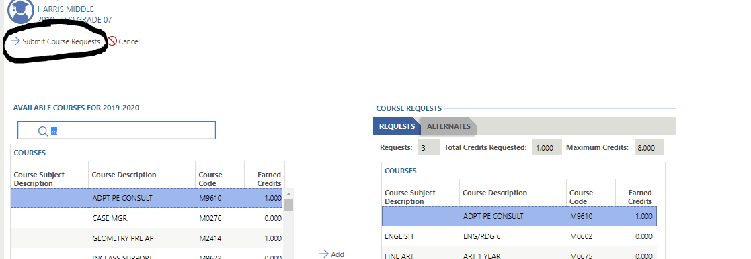

1. You may view your course requests, which includes the alternate choices in your Skyward through Launchpad.

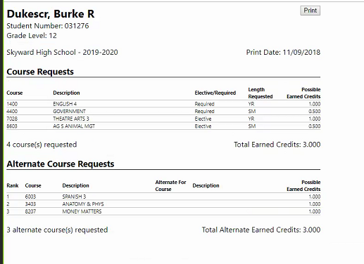

***Parents can login and also select classes for their students. They will simply login to their Parent Portal Skyward account as they would do when checking student grades. Once at the home page an icon will appear like below and classes will be able to added/removed following the directions above.



