

Winship-Robbins School District
2020-2021 Adopted BUDGET REPORT

Dawn Carl Superintendent/Principal

2

Winship-Robbins Elementary School District TABLE OF CONTENTS
2020-21 Adopted Budget Report

Budget Introduction Page 3
General Fund Revenue Assumptions Page 4 State Priorities Page 5
General Fund Revenues Pages 6 - 7 General Fund Expenditures Pages 8 - 10 General Fund Balance Page 11 Revenues Versus Expenditures Page 12 Other Funds Page 13
Multi-Year Assumptions and MYP Pages 14 - 15 Enrollment- ADA Trend Page 16

3

Winship-Robbins Elementary School District INTRODUCTION
2020-2021 Adopted Budget Report

- The County Office, under AB1200, requires districts to document and include written budget assumptions in the budget package submitted for approval to the district Board of Trustees. Each district should advise the Board, by way of budget documents, accompanied by a brief narrative, of the financial condition of the district. This report will provide the required information for the Board to certify the district’s ability to meet its financial obligations.

- The Adopted Budget Report is presented by fund and major object account classification, reflecting 2019-2020 “Estimated Actuals” in columns A-C and the Proposed 2020-2021 “Budget” in columns
D-F. The final column reflects the percentage of variance between the 2019-2020 Estimated Actuals
and the proposed 2020-2021 Budget.

- This report contains information and estimates that reflect the information contained in the Governor’s May Revision State Budget proposal.

4

Winship-Robbins Elementary School District General Fund Revenue Assumptions 2020-2021 Adopted Budget Report

Local Control Funding Formula
- Based on Projected 2020-2021 ADA of 115.37 (which includes 1.84 County Operated ADA)
- Property Taxes = $833,566– $759,949 In-Lieu = $73,617
- State Aid = $940,253

Other State and Federal Funding
  - Unrestricted Lottery = $153 per Annual ADA
  - Restricted Lottery = $54 per Annual ADA
  - Federal No Child Left Behind (Title I $19,632 & Title II $1,934)
  - REAP funding is projected at $23,092

5
Eight State Priorities
2020-2021 ADOPTED BUDGET REPORT

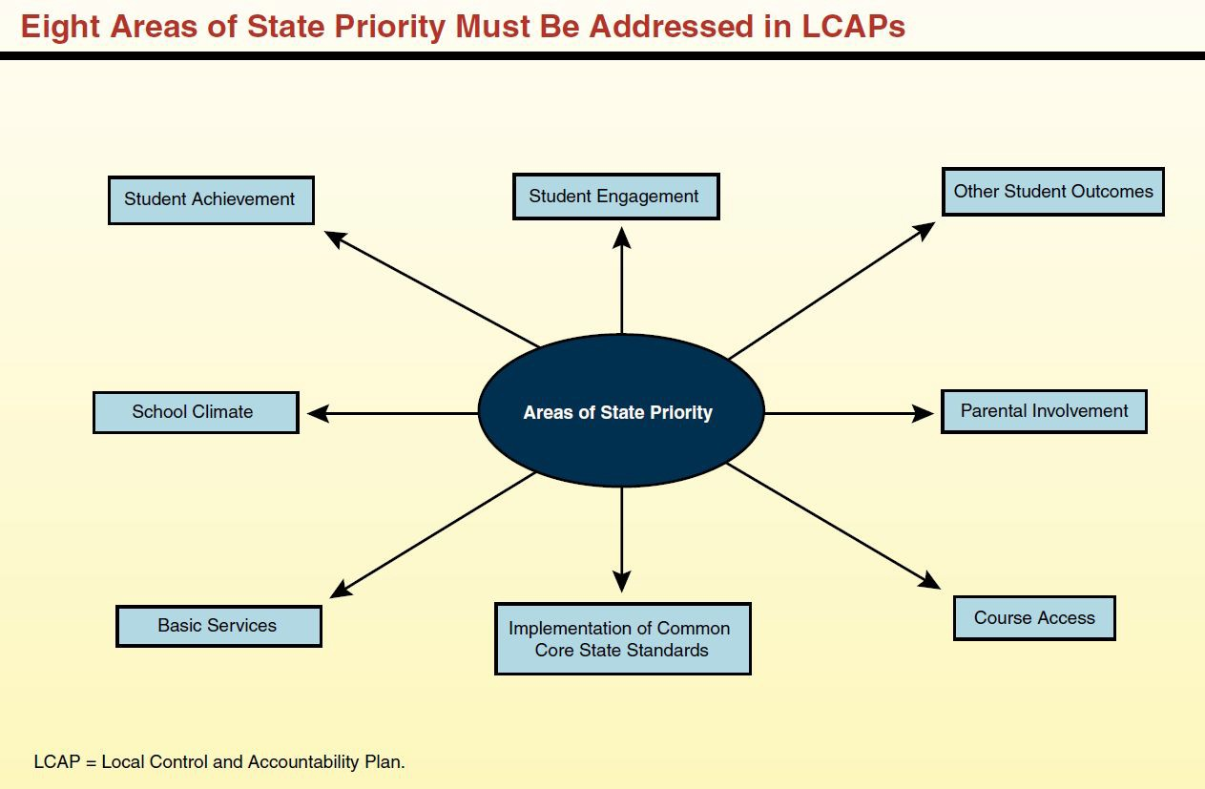
Schools Services of California

6

Winship-Robbins Elementary School District GENERAL FUND REVENUE SOURCES
2020-2021 Adopted Budget Report

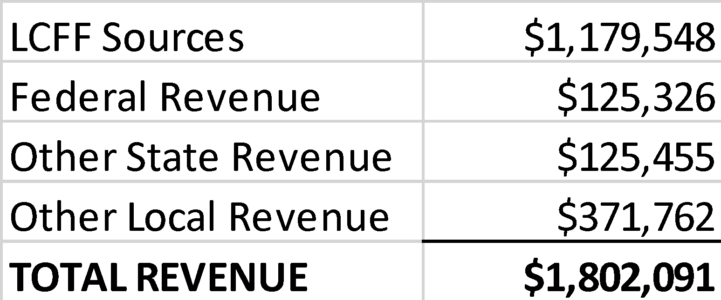
The largest part of the revenue (65%) comes from Local Control Funding and is to be aligned to meet the eight state priorities. These priorities are on the previous slide.

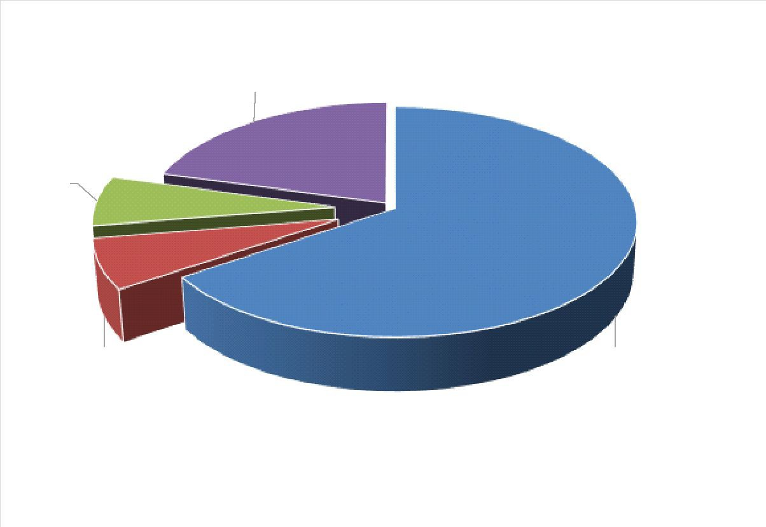
The district will continue to receive federal funds for specific purposes and must continue to follow federal regulations.

Other state funds consist of child nutrition, mandated costs, lottery and miscellaneous other awards.

Local resources include interest, donations, local grants, special education funds, and charter fiscal oversight fees.

7

Winship-Robbins Elementary School District GENERAL FUND REVENUE SOURCES
2020-2021 Adopted Budget Report

Local Control Funding Formula $1,179,548
This budget source is based on 20/21 projected ADA of 113.57 plus 1.84 of County Operated ADA. The LCFF calculator reflects a 0% COLA and a 7.92% decrease in base funding, based on the Governor’s May Revision.

Federal Revenues $125,326
This revenue source includes Title I, Title II, REAP, and Child Nutrition funding.

Other State Revenues $125,455
This revenue includes Unrestricted and Restricted Lottery, Mandated Costs, and Child Nutrition.

Other Local Revenue $371,762
This revenue includes Interest, Rental Income, and Charter Fiscal Oversight revenue. There is a reduction of $55,000 primarily due to the removal of one-time funds received by the charter for an indemnification clause in their MOU for 19/20.

8

Winship-Robbins Elementary School District GENERAL FUND EXPENDITURES
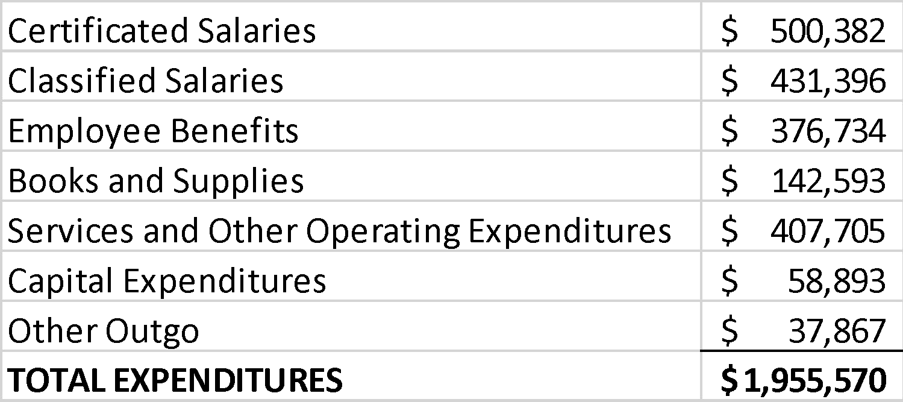
2020-2021 Adopted Budget Report

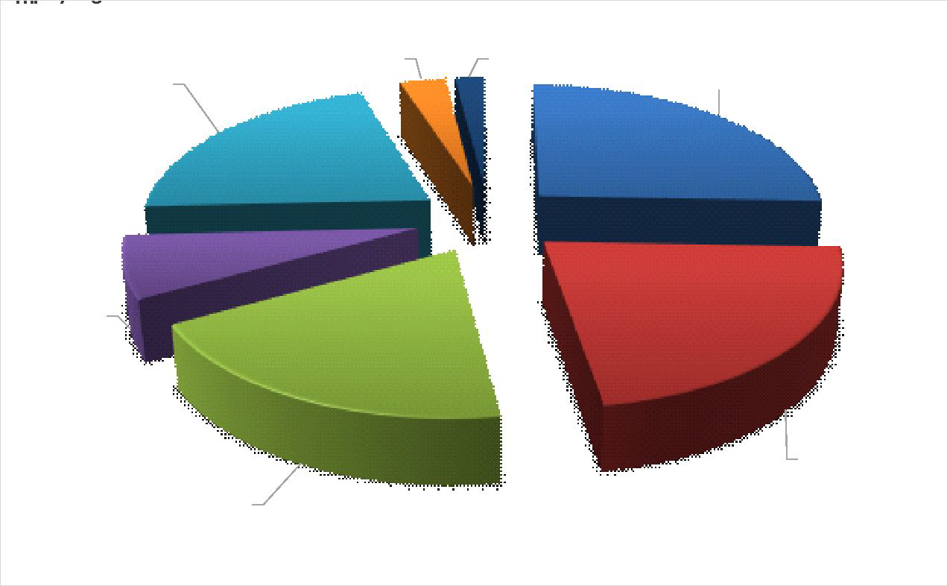
Salaries and benefits represent 67% of the District’s total budget.

9

Winship-Robbins Elementary School District GENERAL FUND EXPENDITURES
2020-2021 Adopted Budget Report
CERTIFICATED SALARIES - $500,382
Salary projections are based on 6.2 certificated FTE; and 1 management FTE, (.7 FTE Principal; .3 FTE Superintendent). There is a decrease in FTE and certificated salaries due to the retirement of one teacher effective 6/30/20, as well as a second retirement of one teacher effective October 2020.

CLASSIFIED SALARIES - $431,396
Salary projections are based on 11.0 FTEs and known staffing needs, including extra-duty and overtime.
.
EMPLOYEE BENEFITS - $376,734
Benefits are based on projections that reflect a increase in salary expenditures. 2020-2021 STRS rate is 16.15%. 2020-2021 PERS rate is 20.70%.
BOOKS AND SUPPLIES - $142,593
Projected instructional materials and supplies expenses include core and supplemental instructional materials, custodial and maintenance supplies, and technology related expenditures. This expenditure is reduced by $34,612 primarily due to the reduction of food and supply budgets in the cafeteria program. These reductions are due to a restructuring of the program.

SERVICES, OTHER OPERATING EXPENSES - $407,705
Projected services and other operating expenses include professional development for classroom staff, classroom on-line instructional and intervention programs, maintenance, custodial repair, drinking water delivery, and servicing expenses and utilities. This expenditure is reduced by $17,493 primarily due to the removal of several one-time, service expenditures related to maintenance and repairs, reductions in REAP, Classified Employee Professional Development grant, and MTSS expenditures.

10

Winship-Robbins Elementary School District GENERAL FUND EXPENDITURES
2020-2021 Adopted Budget Report

CAPITAL OUTLAY - $58,893
This includes budget for the Winship water well construction project, electricity for the corporation yard, and new windows. The decrease of $224,084 is due primarily to the reduction of the solar project. The district also removed the fence project.

OTHER OUTGO - $37,867
Includes Special Education Excess Cost.

INTERFUND TRANSFERS IN/OUT - $0
No change.

CONTRIBUTIONS TO RESTRICTED PROGRAMS $328,078
Contributions to restricted programs are projected to total $328,078 and include contributions to Child Nutrition, Special Education, Routine Restricted Maintenance, and Preschool.

11
Winship-Robbins Elementary School District GENERAL FUND BALANCE
2020-2021 Adopted Budget Report

The estimated ending balance for the 2020-2021 year is $2,096,381. Of this amount, $97,778.51 has been designated for economic uncertainties as required by the State of California.
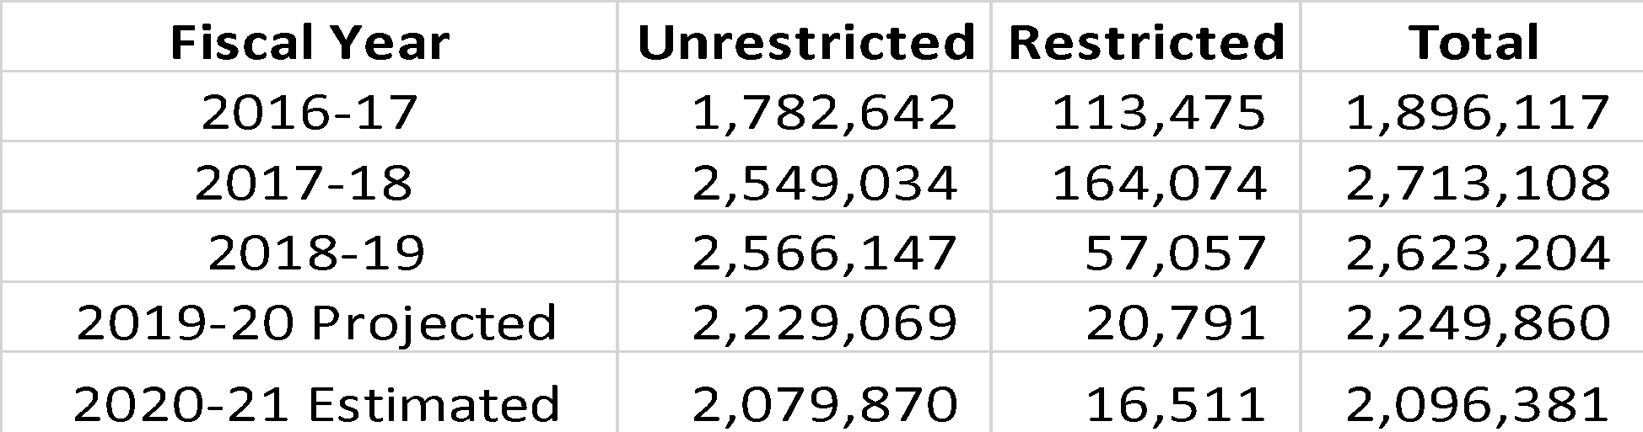
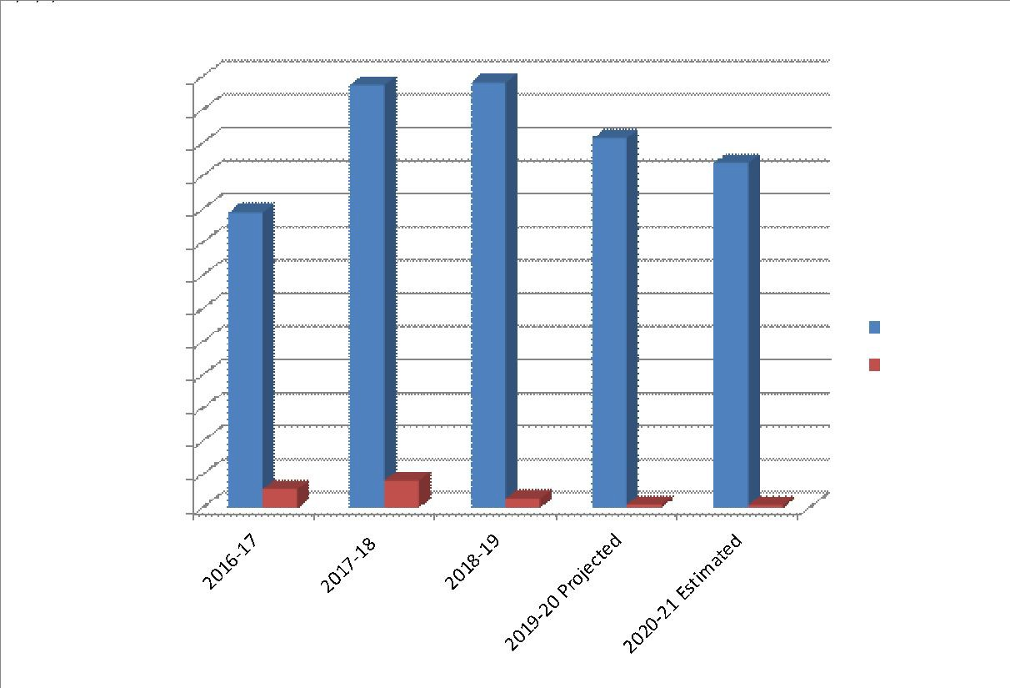

12

Winship-Robbins Elementary School District REVENUES vs. EXPENDITURES
2020-2021 Adopted Budget Report

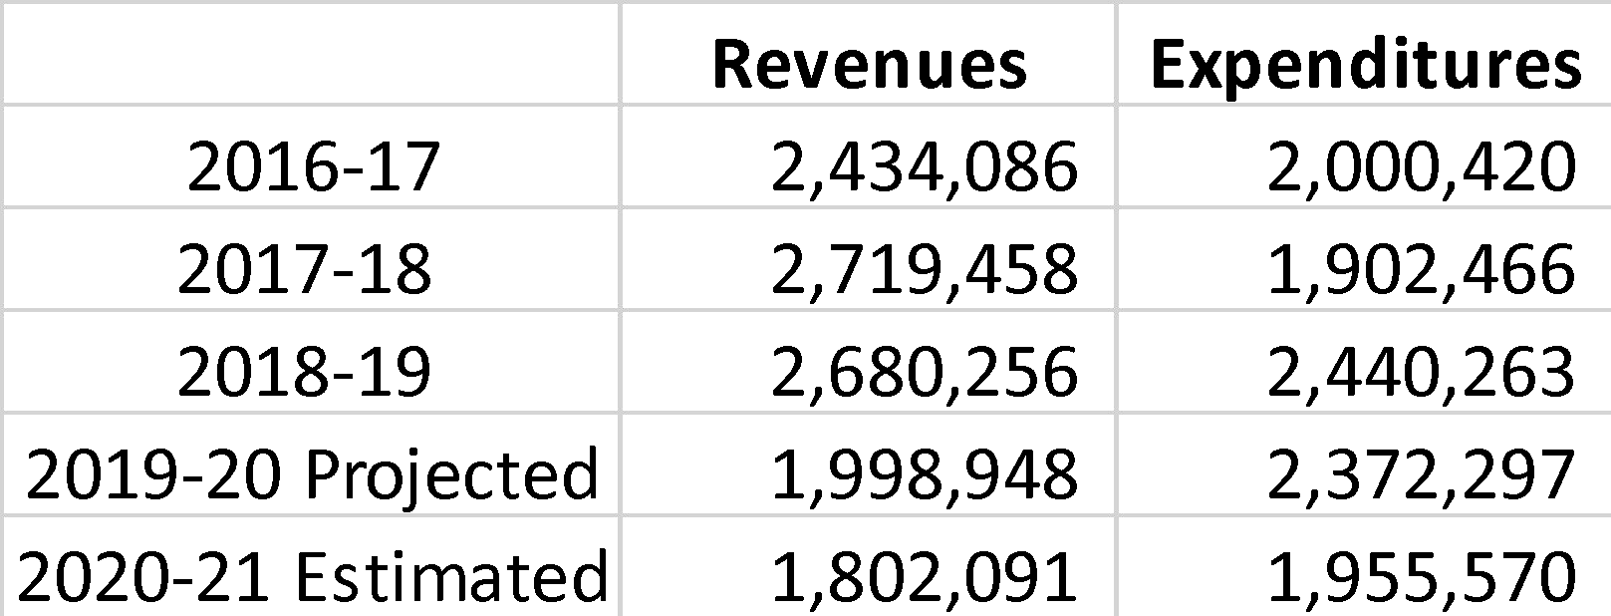
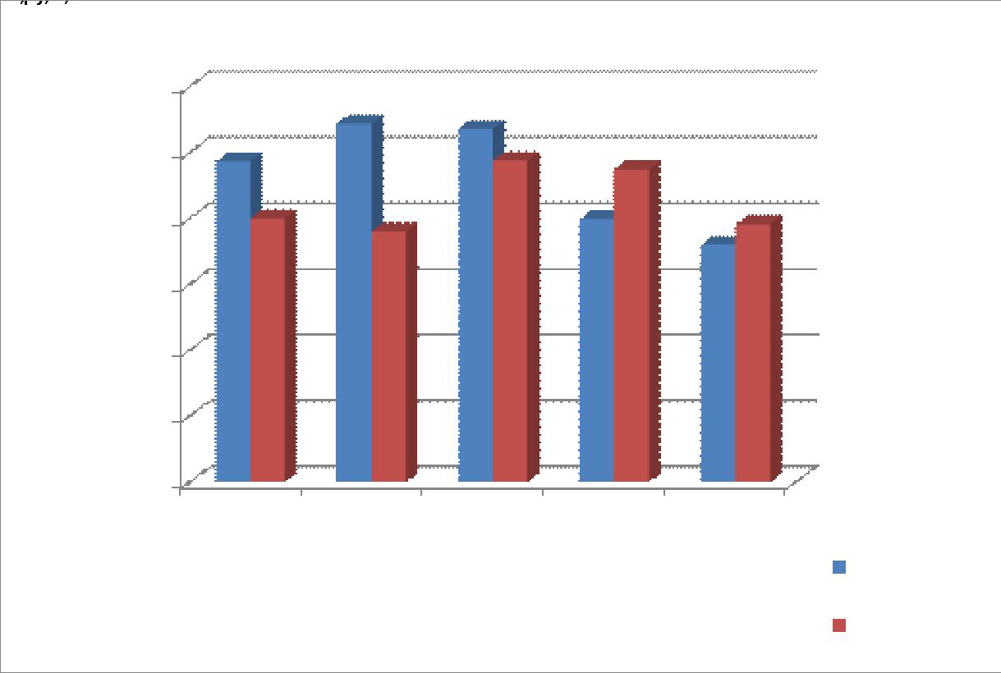

13

Winship-Robbins Elementary School District OTHER FUNDS
2020-2021 Adopted Budget Report

- Student Activities Fund – 2020-2021 ending fund balance is projected to be $240.00

- Child Development Fund – 2020-2021 ending fund balance is projected to be $5,065.00

- Deferred Maintenance Fund – 2020-2021 ending fund balance is projected to be $19,297.00

- Special Reserve Fund - 2020-2021 ending fund balance is projected to be $403,786.00

- Capital Facilities Fund (Developer Fees) - 2020-2021 ending fund balance is projected to be
$12,934.00

- County Schools Facilities Fund - 2020-2021 ending fund balance is projected to be $1,819.00

14

Winship-Robbins Elementary School District MULTI-YEAR PROJECTION (MYP) ASSUMPTIONS
2020-2021 Adopted Budget Report
□Winship-Robbins Local Control Funding for the future two years has been calculated using projected ADA of 115.41 in 21/22 and 22/23 (which includes 1.84 of County Operated ADA in each year). All one-time revenues and expenditures have been removed.
□Expenditure adjustments are as follows:
□Certificated 21/22 decreased due to the full reduction of one teacher salary that retired October 2020. Step & Column increases are projected for 21/22 and 22/23.
□Classified Step and Column were projected for both 21/22 & 22/23.
□Benefits Increased to cover the above salary adjustments, and increased to cover the increases in PERS & STRS in 21/22 & 22/23. STRS rates are projected to be 16.02% and 18.10 %, respectively.
PERS rates are projected to be 22.84% and 25.50%, respectively.
□Supplies Fiscal year 21/22 increased with CPI rate of 1.73%. Fiscal year 22/23 increased with CPI rate of 2.12%.
□Services Removed one-time 20/21 expenditures. Fiscal year 21/22 increased with CPI rate of 1.73%.
Fiscal year 22/23 increased with CPI rate of 2.12%.
□Capital Outlay Removed one-time capital projects expected to be completed in 20/21. Budgeted land improvements in 21/22 and estimated costs for capital projects in 22/23.
□Other Outgo No adjustments.
□Transfers-Out No adjustments.
□Contributions Contribution to Routine Restrict Maintenance; contribution to balance special education and contribution to balance child nutrition services.
□Other Sources/Uses No adjustments.

2020-21 Bud11et Development
Winship-Robbins Elen,entary School Di-ict

PROJECTED 2020121

COMPONENTS OF ENDING FUND BALANCE
Reservedtcr Econorric Uncettairties s 97,778.51 s 96,378.07 s 98.870.93 ASSIGNMENTS
Assig,edfor Te:dbook Adoptions s s s
Assig"ledfor DeferredMairtenance s <100.000 (roof.flootinc:1.mairt shed,HVAC s 300.000 (roof.flooril""IA.mairt shed,HVACetc. s
Assig,edtor a.as Pu-chase s 100.000 s 100.000 s 100.000
Assig,edtor NewOassroorns/Portables s s s
Assig,edtor 2 ),ears of R.tu-e Chuter Reverues s 5"2.910 s 5"2.910 s 5"2.910
Assig,edtor Restroom Rehab s s s
Assig,,edtor Metal BUldng s s s
OiildNl.trition s s s
Prop39 s s s
s 4.323 s 4.324 s 4,324

RestrictedLottel')I
Special Ed..Jcation
s s s

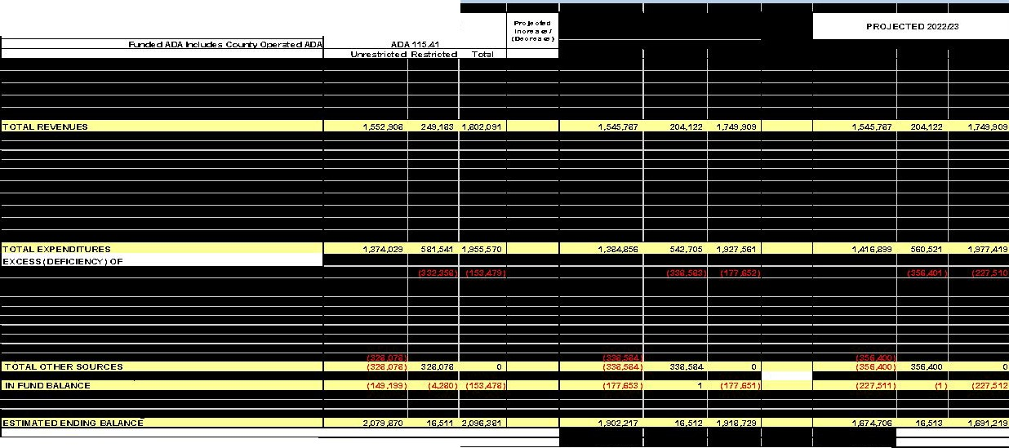Wnship Vll:rter "'-ell &Drinking\Nater Grarts s 11.584 s 11.584 s 11.584
Low Pertorn-ing stl.lCS!rt Block Grart s s s
REAP s s s
s 151 s s 151
s 455 s s 455
U'"lassi 933 180

Winship-Robbins Elementary School District Enrollment – ADA TRENDS
16
2020-2021 Adopted Budget Report

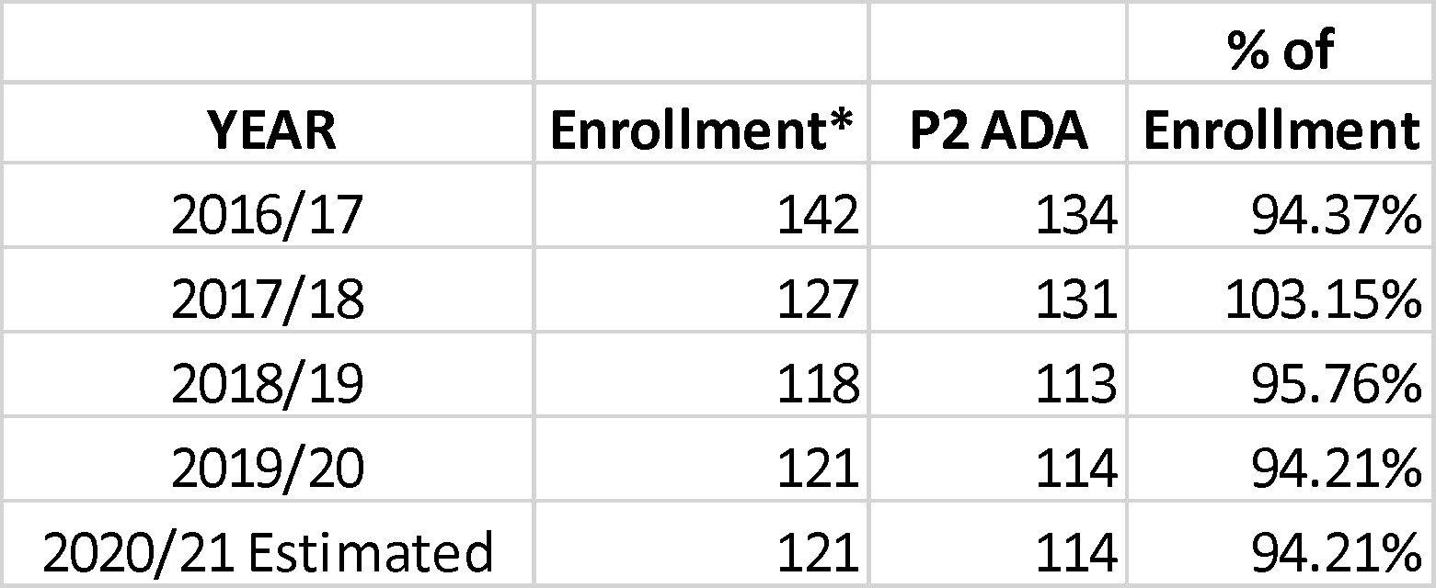

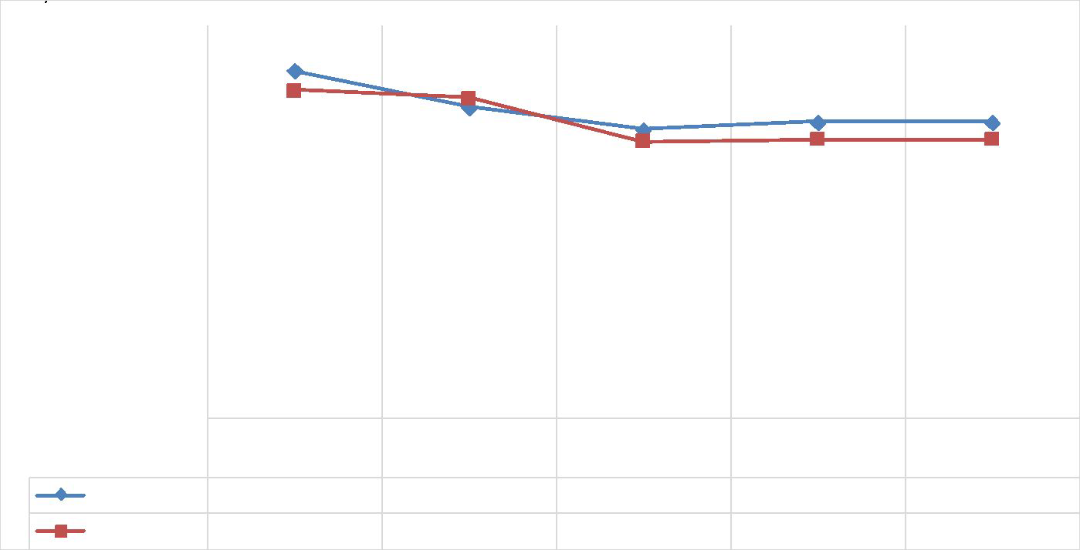

*For the first four years, CBEDS enrollment is used. For the current year, projected enrollment is used.

