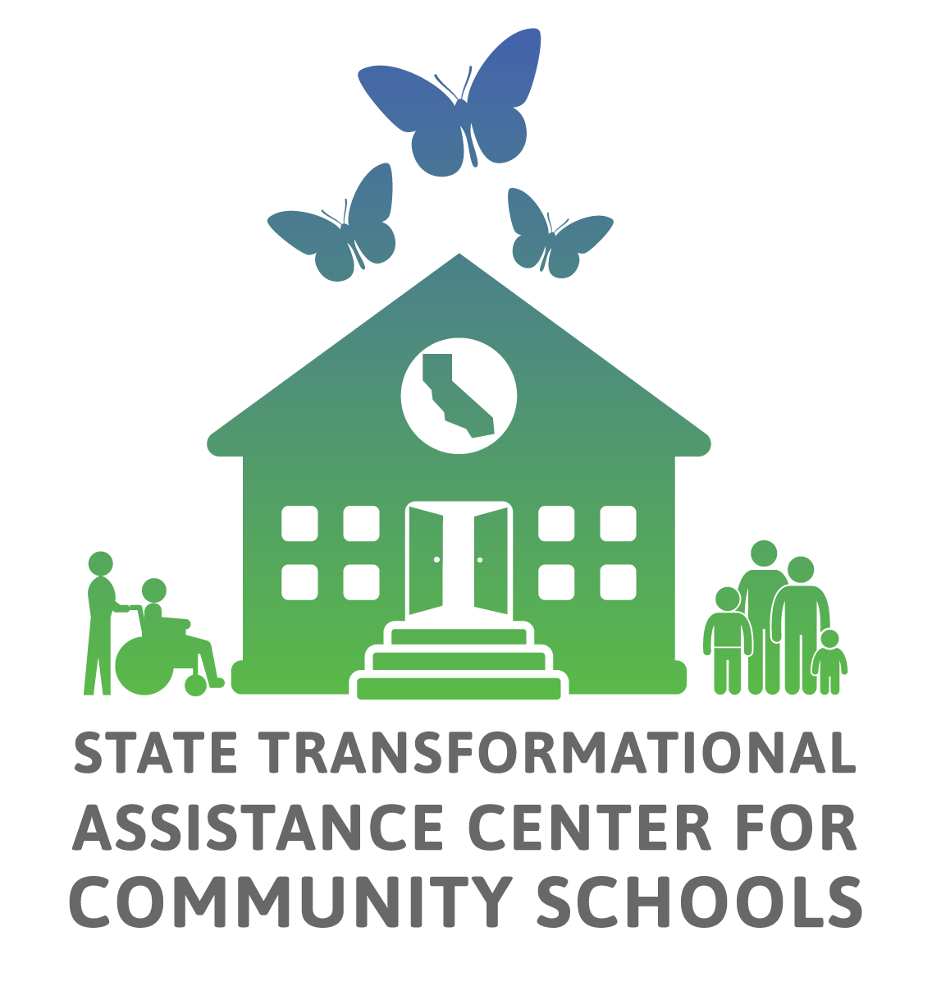

California Community School Partnership Program

Annual Progress Report

Implementation- School Sites-

2025-2026

Introduction 2
1. Site-level Program Narrative 4
1.1. CCSPP Capacity-Building Strategies 6
Shared Commitment, Understanding, and Priorities 6
Centering Community-Based Learning 7
Collaborative Leadership 8
Sustaining Staff and Resources 9
Strategic Community Partnerships 10
1.2. CCSPP Engaging Educational Partners 12
1.3. CCSPP Whole Child and Family Supports Inventory 17
1.4. CCSPP Goals and Actions 22
Goals and Actions 22
Measuring and Reporting Results 23
Goal Analysis 25
School Climate Measure 25
1.5. CCSPP Feedback and Improvement 26
2. Site Level Additional Documents and Evidence 29

Introduction

Welcome to the California Community Schools Partnership Program (CCSPP) Annual Progress Report (APR). The APR:
- Serves as a tool to assess implementation efforts, and to encourage reflection as part of an ongoing continuous improvement process.
- Is designed to inform implementation, guide support, and strengthen sustainability efforts across the state.
The information submitted will be reported to the California Department of Education (CDE) and incorporated into reporting about the CCSPP grant for the California State Legislature.

Data for learning
The data collected through the APR helps Local Educational Agencies (LEAs), Consortia, County Offices of Education (COEs), Regional Technical Assistance Centers (RTACs), and state partners understand how community schools are progressing, where additional resources or supports are needed, and what promising practices are emerging. The APR encourages local teams/councils to identify and reflect on areas for growth, learning and evidence of progress. An APR Visualization tool and a summative report are developed and posted each year with APR findings for LEAs and RTACs.

Who should prepare the APR
The site-level report should be developed by each school’s CCSPP shared decision-making team or council to ensure participation from students, staff, families and community partners. Keep in mind:
- Only one report is required per school site.
- If you are a single-school LEA grantee, you will need to complete both the site-level APR and the LEA-level APR.

Process to prepare the APR
We strongly recommend using the Google Doc version to COLLABORATIVELY draft your responses before completing in Qualtrics. Once your draft is complete, copy and paste your final responses into Qualtrics to submit. This helps prevent potential data loss if internet or browser issues cause progress not to save correctly. Keep in mind:
- In Qualtrics, you can complete the report over multiple sessions if needed, however, please use the same device and browser to pick up where you left off.
- All questions in this report have to be answered unless marked as [Optional].
- The APR is intended to align with the required annual update presentations on community school planning, including data and outcomes from the prior year at each school site.

If you need a copy of your site’s APR response from last year, you may submit a request using this link. Please note that access to APR data is limited to authorized school personnel, and requests may only be made for your own site’s data.

Resources to reference in the APR
Please reference the following resources:
- CA School Dashboard as you consider and reflect upon your progress and CCSPP outcomes.
- Resources provided by the State Transformational Assistance Center (S-TAC) including the Community Schools Implementation Plan Template, the Community Schools Needs and Assets Assessment (NAA) Guide, the Whole Child and Family Supports Inventory and the Capacity Building Strategies: A Developmental Rubric.
- We have also provided links to the Capacity-Building Strategies self-assessment (Google Doc version here) – an optional tool aimed to assist grantees in identifying their phase of growth and development for each strategy.

Seeking support for the APR process
Please contact your Regional Technical Assistance Center (RTAC). If you do not know the region you are assigned to, please visit the Tracker spreadsheet on the "School tab (or click here). Or visit our AI-powered chatbot "APRil".

Suggested timeline
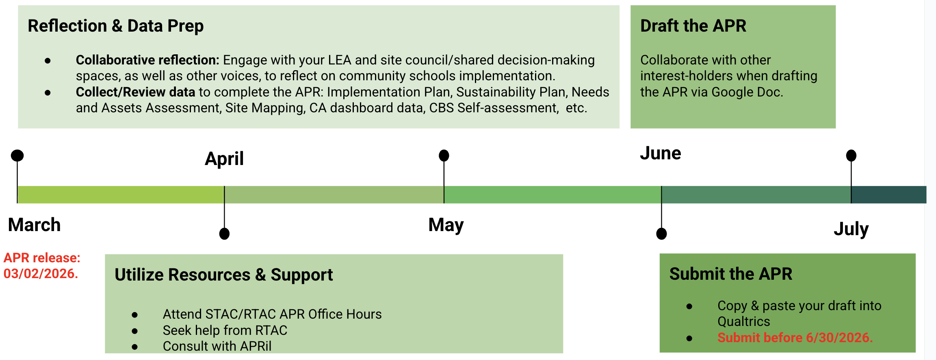

1. Site-level Program Narrative
School sites implementing the CCSPP must respond to the following prompts. This information will inform the completion of the LEA/Consortium-level APR, particularly their LEA/Consortium Program Narrative.

For support on how to respond to the APR or any part of its process, please visit our AI-powered chatbot "APRil" (click here). For additional support, please contact your Regional Technical Assistance Center (RTAC).

Here’s a visual of the reflective process for schools:
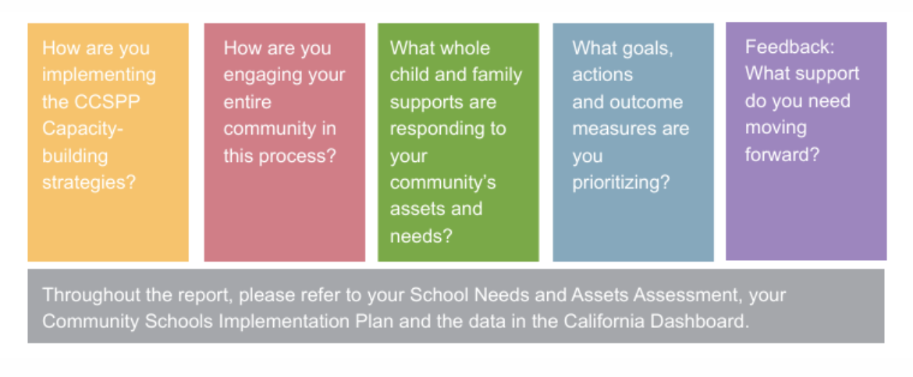

Please provide your school name using the options below. Start by selecting your Region, Cohort, and LEA. If you do not know your region or cohort, please visit the Tracker spreadsheet and check the "Schools" tab (click here).

Region ▼_____Capitol Region_____________________________
Cohort ▼___Cohort 2________________________________
LEA/Fiscal Agent ▼_Marysville Joint Unified School District______________
School Name (CDS Code) ▼_____Yuba Feather Elementary________________________

If your LEA Name, School Name and CDS code is not in the dropdown list, please enter them here. If you do not know your CDS Code please find it here. If you are a School District or a County Office of Education, your School Code is seven zeros (0000000).

58 72736 6056782
Please provide contact information for someone familiar with your school's community school practices in case clarification about APR responses is needed.

Name: Traci Piatt
Job Title: Community School Site Coordinator
Email: tpiatt@mjusd.k12.ca.us
Phone number: 530-675-2382

1.1. CCSPP Capacity-Building Strategies

Please reflect on your team's progress for the 2025-2026 school year in strengthening and building the capacity of all interest-holders in implementing the community schools approach.

To answer this section about the five Capacity-Building Strategies we suggest that you:
- Review the Capacity-Building Strategies (CBS) Rubric and the Site-Level CBS Self-Assessment Tool to understand the phases of growth and development.
- Engage all interest-holders (e.g., staff, families, students, and partners) in discussion and completion of the self-assessment to determine your site’s current phase for each strategy.
- Complete this APR section using the assessment results from your self-assessment.
- Identify the artifacts or evidence used to assess your current phase of growth and development, drawing from the lists provided below. Use the “Other” option to describe additional evidence or artifacts not listed. You are not required to attach any of the artifacts or evidence identified in this question
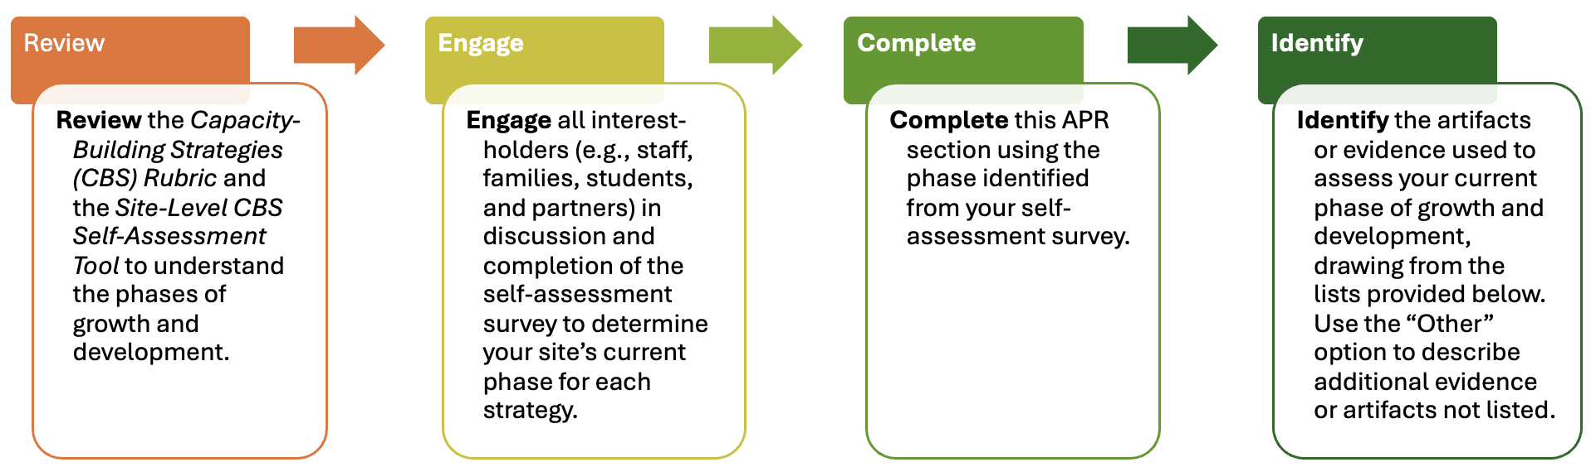

Shared Commitment, Understanding, and Priorities
Please indicate your current phase of growth and development for "Shared Commitment, Understanding and Priorities". (Select one.)

- Visioning: We are beginning to develop a shared community schools vision at our site, with early efforts to involve students, families, staff, and partners and align plans.
- Engaging: We have engaged our school community in co-developing and communicating shared priorities, with stronger alignment between our CCSPP plan, SPSA, and needs and assets data.
- Transforming: We have established a widely shared and publicly communicated vision that guides our school’s priorities, planning, and continuous improvement efforts, allowing us to celebrate growth and accomplishments together.
Please identify the artifacts or evidence you may have referenced to gauge your current phase of growth and development for "Shared Commitment, Understanding and Priorities". (Select all that apply.)

- Outreach materials
- Surveys
- Interview/focus groups data from school staff
- Interview/focus groups data from students and/or families
- Councils or Committee meeting minutes (School Site Council, English Learner Advisory Committee, Steering, etc.)
- Protocols used to create vision/graphic representation of vision
- Needs and Assets Assessment tools/participation rates
- SPSA alignment crosswalk (shows integration).
- Findings Report and presentation materials from the needs and assets assessment (slides, summaries shared publicly).
- Baseline data dashboard or data snapshot showing initial metrics tied to priorities.
- Capacity-Building Strategies Self-Assessment Tool
- Other (Please specify):

Centering Community-Based Learning
Please indicate your current phase of growth and development in "Centering Community-Based Learning". (Select one.)
- Visioning: We are beginning to explore community-based learning, with early professional learning and limited integration of community knowledge into instruction.
- Engaging: We have engaged educators and partners in designing and implementing community-based learning experiences supported by collaborative planning and varied assessments.
- Transforming: We have embedded community-based learning into daily instruction, with culturally affirming practices, meaningful assessments, and regular public sharing of student work.

Please identify the artifacts or evidence you may have referenced to gauge your current phase of growth and development for "Centering Community-Based Learning". (Select all that apply.)

- Needs and Assets Assessment results
- A site-specific framework for community-based teaching that elevate community assets
- School climate surveys
- Unit plans, lesson plans
- Performance assessments that highlight classroom-community connections
- Student engagement or attendance rates
- Family and community engagement or attendance
- Community learning tours and/or home visits
- Professional development or training sessions
- Student exhibition rubrics or portfolios showing authentic assessments tied to community-based learning.
- Family or community feedback forms on learning exhibitions or showcases (evidence of reciprocity).
- Capacity-Building Strategies Self-Assessment tool
- Other (Write-In):

Collaborative Leadership

Please indicate your current phase of growth and development for "Collaborative Leadership". (Select one.)
- Visioning: We are establishing site-level leadership structures, with emerging representation and early steps toward shared decision-making.
- Engaging: We have engaged diverse interest-holders in regular collaborative leadership, with clearer roles, improved accessibility, and growing influence over school decisions.
- Transforming: We embed shared decision-making across all structures, ensuring students, staff, families, and partners hold real influence in shaping school directions.

Please identify the artifacts or evidence you may have referenced to gauge your current phase of growth and development "Collaborative Leadership". (Select all that apply.)
- Committee by-laws
- Team mapping
- Formal agreements
- Guiding documents, vision statements, decision-making protocols
- Team work plans and agendas
- Planning documents
- Survey data
- Councils or Committee meeting minutes (School Site Council, English Learner Advisory Committee, Steering, etc.)
- School staff direct input (Interview/focus groups)
- Students and/or families direct input (Interview/focus groups)
- Engagement with policymakers or external partners (e.g., LEA leaders, local government, advocacy groups)
- Capacity-Building Strategies Self-Assessment tool
- Other (Write-In):

Sustaining Staff and Resources
Please indicate your current phase of growth and development for "Sustaining Staff and Resources." (Select one.)
- Visioning: We identify the mindsets, staffing, and resources needed for effective community school implementation and long-term success.
- Engaging: We recruit and support diverse staff through professional learning, improved working conditions, and planning for sustainable funding.
- Transforming: We sustain and grow our workforce by monitoring climate and retention data, securing ongoing funding, and aligning community school strategies across all site plans.
Please identify the artifacts or evidence you may have referenced to gauge your current phase of growth and development for "Sustaining Staff and Resources". (Select all that apply.)

- Community school-aligned job descriptions
- Roles and responsibilities document that includes a process for ongoing revision
- Processes for budget transparency
- Staff visioning documents (e.g., graphic representations, protocols for design)
- Data examining staff/teacher retention/vacancy rates
- Councils or Committee meeting minutes (School Site Council, English Learner Advisory Committee, Steering, etc.)
- Professional development or training sessions
- Teachers and staff surveys (e.g., school climate surveys)
- Long-term funding plan or sustainability roadmap developed with LEA.
- Professional learning calendar and participation records specific to community school practices.
- Cross-plan alignment chart showing how the community school plan integrates into SPSA, MTSS, and LCAP.
- Capacity-Building Strategies Self-Assessment tool
- Other (Write-In):

Strategic Community Partnerships
Please indicate your current phase of growth and development in "Strategic Community Partnerships". (Select one.)
- Visioning: We are identifying and documenting partnerships, with early efforts to align services to student and family needs.
- Engaging: We align partnerships with needs and assets findings, vet partners for quality and fit, and collaborate to improve coordination and access to services.
- Transforming: We have established strong, well-aligned partnerships that expand access to services, improve experiences for students and families, and are regularly reviewed for impact.

Please identify the artifacts or evidence you may have referenced to gauge your current phase of growth and development for "Strategic Community Partnerships". (Select all that apply.)

- Contract agreements/MOUs/Service Delivery Applications
- Service utilization rates
- School climate surveys
- Feedback from existing service providers and partners
- Partnership evaluations
- Partners participation in school events
- Partnership impact summaries or evaluation reports (showing service utilization, outcomes, satisfaction).
- Annual partnership reflection reports or improvement plans based on review data.
- Increased reports of student and family wellbeing
- Capacity-Building Strategies Self-Assessment tool
- Other (Write-In):

Please reflect on what you have accomplished, learned, or initiated this year with respect to one or more of the Capacity-Building Strategies and how that progress was made possible through the CCSPP. Please make sure to reference which of the five strategies your reflection relates to. We suggest you provide a narrative of up to 300 words.
Your word count is: 0

This year, our progress has been most strongly connected to Strategy 3: Collaborative Leadership and Practices for Educators and Administrators and Strategy 4: Community-Based Learning and Family and Community Engagement.
Through CCSPP funding, we were able to intentionally create spaces and opportunities that strengthen both student learning and family engagement. One of our major accomplishments was the development of a makerspace room that supports STEM nights, reading nights, after-school enrichment, and family engagement events. This space has become a central hub where students, staff, and families can learn together through hands-on activities that promote creativity, problem-solving, and collaboration.
In addition, we initiated the rehabilitation of our school gardens to establish a stronger “community garden” experience. This project encourages students, staff, and community members to work side by side while also connecting classroom learning to real-world science standards. Students are learning about plant life cycles, sustainability, and responsibility, while families and community members feel more connected to the school environment.
This progress was made possible through CCSPP because the funding allowed us to purchase the materials and supplies needed to turn these ideas into meaningful, lasting programs. It also gave us the flexibility to cost-share with other funding sources, such as ELOP, maximizing our impact.
Most importantly, these efforts have helped us build stronger relationships with families and create more welcoming opportunities for community involvement. CCSPP has supported our vision of making school a place where students and families feel connected, engaged, and empowered to learn together.

1.2. CCSPP Engaging Educational Partners

As part of establishing collective priorities for the CCSPP, schools engage the entire community in identifying their top community school priorities and vision. A community school is a “whole-child” school improvement strategy where the LEA and school(s) work closely with staff, students, and families.

Please reflect on your school’s level of engagement this past year with various groups in developing your community school. We understand this is a difficult task and we are asking you to take a bird’s eye view to estimate engagement across groups. Your estimation should consider the seven types of engagement processes in the table below along with other ways you support engagement. We know that not all processes are always appropriate for every context and it is not the expectation that all processes are used in engaging the different school community groups.

 | Estimate the percentage of individuals engaged in developing your community school at any time during the implementation process. | Which of the following processes did you use to engage each of the following school community groups? (Select all that apply) |  |  |  |  |  |  | If you selected other processes, please specify:  Other (Write-In)
 |  | Surveys | One-on-one interviews | Focus groups | School council/steering committee meetings | Other meetings and forums | School events | Other
Administrators | - 0%  - 1-24%  - 25-49%  - 50-74%  - 75-100%
Certificated staff | - 0%  - 1-24%  - 25-49%  - 50-74%  - 75-100%
Classified staff | - 0%  - 1-24%  - 25-49%  - 50-74%  - 75-100%
Students | - 0%  - 1-24%  - 25-49%  - 50-74%  - 75-100%
Family members | - 0%  - 1-24%  - 25-49%  - 50-74%  - 75-100%
Community partners (school partners with an MOU or any other formal agreement to provide support or services.) | - 0%  - 1-24%  - 25-49%  - 50-74%  - 75-100%

[Optional] Please use this space to provide any additional information regarding your engagement of educational partners.
Your word count is: 0

Please reflect on your school’s level of engagement this past year with the perspectives, assets, and needs of historically marginalized students. We understand this is a difficult task and we are asking you to take a bird’s eye view to estimate engagement across student groups. Your estimation should consider the types of engagement processes in the previous item along with other ways you support engagement. We know that not all processes are always appropriate for every context and it is not the expectation that all processes are used in engaging the different student groups.

Note that you do not need to report on all of the groups listed below as they may not be applicable to your context. Also note that there might be overlap between groups.

 | Percentage of individuals engaged in developing your community school in the past year.
English language learners | - 0%  - 1-24%  - 25-49%  - 50-74%  - 75-100%
Students with disabilities | - 0%  - 1-24%  - 25-49%  - 50-74%  - 75-100%
Socioeconomically disadvantaged students | - 0%  - 1-24%  - 25-49%  - 50-74%  - 75-100%
Racially marginalized populations | - 0%  - 1-24%  - 25-49%  - 50-74%  - 75-100%
Homeless youth | - 0%  - 1-24%  - 25-49%  - 50-74%  - 75-100%
Foster Youth | - 0%  - 1-24%  - 25-49%  - 50-74%  - 75-100%
Chronically absent students (students who were absent for 10 percent or more of the instructional days) | - 0%  - 1-24%  - 25-49%  - 50-74%  - 75-100%

How are you engaging individuals within the groups identified above?
We are engaging students experiencing chronic absenteeism and those who are socioeconomically disadvantaged by creating stronger school-to-home connections, increasing access to supportive resources, and providing meaningful opportunities for involvement.
For students with chronic absenteeism, we focus on building positive relationships with families through regular communication, attendance outreach, and personalized support. Staff work closely with families to identify barriers to attendance, whether they involve transportation, health concerns, family responsibilities, or school connectedness. We also create engaging school experiences through after-school enrichment programs, STEM nights, reading nights, assemblies, and community events that help students feel excited about coming to school and strengthen their sense of belonging.
For socioeconomically disadvantaged students and families, we work to remove barriers that may limit participation and access. Through partnerships with community organizations, food distributions, family resource events, and school-based support services, we help connect families to essential resources. We have also had the opportunity to provide enriching activities, assemblies, and field trips such as wildlife refuge hikes, Wild Things assemblies, Farm Day, visits to the Railroad Museum, and a social-emotional learning ventriloquist assembly. These experiences allow our disadvantaged students access to learning opportunities and memorable experiences they may not otherwise have outside of school.
In addition, our makerspace activities, community garden projects, and family engagement nights provide free, inclusive opportunities for students and families to participate in learning together without financial burden.
CCSPP funding has made this work possible by allowing us to create welcoming spaces, provide hands-on learning opportunities, and strengthen partnerships between school, families, and the community. These efforts help ensure that all students, regardless of circumstance, feel supported, connected, and successful in their school experience.

1.3. CCSPP Whole Child and Family Supports Inventory
To make progress towards achieving CCSPP goals, grantees may offer a variety of supports that address the holistic needs of students and families (see Whole Child and Family Supports inventory).

For each potential support below, please identify if the support was part of your community schools implementation.
 | Are these whole-child and family supports part of your Community Schools Implementation? (Select as many services that apply)
 | Yes | No
Health Screening and Services (vision, dental, hearing, neurological, physical health)
Mental Health Screening and Services
Nutrition Services and Support
Academic Support (tutoring, specialist, etc.)
Counseling Center
Multi-Tiered System of Support
Coordination of Services Team (e.g., COST team)
Before School (times/services)
After School (times/services)
Summer Programs
During School (learning pathways, differentiated instruction, lab times, etc.)
Teacher Leadership Development and Opportunities
Parent Leadership Development and Opportunities
Student Leadership Development and Opportunities
Shared Decision-Making Bodies that center the voices of students, families, and community
Multiple Modes of Family Communication & Involvement (e.g. student-teacher-family conferences, regular class information & outreach)
Home Visits
Adult Education (GED, ESL, Job Training, Financial Literacy, etc.)
Positive Behavioral Supports
Practices that help prevent, reduce, and eliminate exclusionary discipline (restorative practices, peer mediation, etc.)
Programs and practices that teach social-emotional skills (e.g., SEL curriculum, mindfulness practices)
Project-Based Learning
Culturally-Sustaining and Responsive Curriculum and Pedagogy
Community-Based Curriculum, Pedagogy, and Projects
Personalized Learning Plans
Performance Assessments (e.g., capstones, portfolios, etc.)
Advisory System to ensure every student has a home base / family group and an advisor who knows them well.

For each support you identified as part of your community schools implementation, please provide the following information:

1. Indicate when you started implementing this support: whether it is newly implemented as a result of CCSPP funding, or if it existed prior and was later integrated into your community schools' work.
2. Estimate how many students, educators, families, or other community members were served by this support over the past year. Please enter a number only in the applicable categories (e.g., number of staff members in professional development; number of students in after-school programs, etc.)
3. List the main funding source you are currently using in addition to CCSPP, to sustain this support long term.
4. (Optional) Provide brief examples of key activities conducted as part of implementing this support.

 | When did you start implementing this support? | In the past year, how many individuals were served? Please enter an estimate number only in the applicable categories . |  |  |  | In addition to CCSPP, please select the main funding source you are using for this support. | If you selected "other" for the funding source, please specify: | OPTIONAL: Please list 2-3 examples of the types of activities that you conducted as part of your implementation of this support.
 | When did you start implementing this support? | Students | Staff | Parents/ Family members | Other individuals |  | Other (Write-In)
Health Fair for community | Previously implemented and now integrated into the community schools work | 30 | 2 | 18 | 4 | Children and Youth Behavioral Health Initiative (CYBHI) |  | - Tooth Mobile  - Peach Tree Mobile  - First 5
Mobile Access Hub for Mental Health Services | Previously implemented and now integrated into the community schools work | 6 |  | 6 |  | Local bond measures |  | YCOE support
Nutritional Services - Fresh Fruit | Previously implemented and now integrated into the community schools work | 79 |  |  |  | Local Control Funding Formula (LCFF)/LCAP |  | MJUSD food service program and fruit program
Academic Supports | Previously implemented and now integrated into the community schools work | 79 |  |  |  | Local Control Funding Formula (LCFF)/LCAP |  | Intervention - School wide for Reading and small group for Math
MTSS | Previously implemented and now integrated into the community schools work | 32 |  |  |  | General Funds |  | Tier 1, 2, and 3 supports for academics and behaviors
COST | Previously implemented and now integrated into the community schools work | 22 |  | 15 |  | Local Control Funding Formula (LCFF)/LCAP |  | Monitor student progress, attendance, and academic success
Before School | Previously implemented and now integrated into the community schools work | 24 | 1 | 14 |  | Expanded Learning Opportunities Program |  | STARS
After School | Previously implemented and now integrated into the community schools work | 40 | 1 | 15 |  | Expanded Learning Opportunities Program |  | STARS
Shared Decision-Making Bodies that center the voices of students, families, and community | Started implementing this support exclusively as a result of CCSPP funding | 12 | 25 | 15 | 4 | General Funds |  | Site council meetings, Pizza with the Principal
Multiple Modes of Family Communication & Involvement | Previously implemented and now integrated into the community schools work | 79 | 4 | 67 |  | General Funds |  | Newsletter, parent square, emails, phone calls, social media
Home Visits | Previously implemented and now integrated into the community schools work | 7 |  | 4 |  | Local Control Funding Formula (LCFF)/LCAP |  | For families needing extra support, or students with attendance concerns
Positive Behavioral Supports | Previously implemented and now integrated into the community schools work | 79 | 18 |  |  | Title I |  | PBIS rewards, school wide expectations, data monitoring
Practices that help prevent, reduce, and eliminate exclusionary discipline (restorative practices, peer mediation, etc.) | Started implementing this support exclusively as a result of CCSPP funding | 15 | 3 |  |  | Title I |  | Restorative justice training, lessons, and circles.
Community-Based Curriculum, Pedagogy, and Projects | Started implementing this support exclusively as a result of CCSPP funding | 30 | 3 |  |  | Title I |  | Students engage in classroom projects as a fundraiser - building somethings, and gardening
Note: *please add rows as needed

1.4. CCSPP Goals and Actions
As part of the CCSPP application and implementation process, your school’s shared leadership structure is expected to prioritize the key topics, goals, and challenges identified in the Needs and Assets Assessment. These areas should guide the initial focus of your community schools transformation work.

We recognize that for many grantees, this is still an early stage of implementation. It's natural for current efforts to focus on building processes, with measurable outcomes taking shape over time. Please respond honestly to help reflect on your school’s progress and growth throughout the grant period.

In identifying goals and actions, consider the major components of the community schools approach, as outlined in the California Community Schools Framework and identified in the Whole Child and Family Supports Inventory in the previous page (e.g., integrated student supports, authentic family and community engagement, collaborative leadership, extended learning time and opportunities, positive and restorative school climate, community-based curriculum and pedagogy, etc.), and your site-level implementation plan.

Goals and Actions
Please describe the top three goals for your community schools’ initiative and their associated actions. At least one goal should be identified from the Whole Child and Family Inventory, in section 1.3 above.

 | Cohorts 1-3 only: Was this goal submitted with the previous APR? | Select the category that is most closely related to your goal: | Describe the goal and explain how the school has developed it, particularly as it relates to your Needs and Assets Assessment. | Explain the action(s) you took in the SY 2025-2026 to meet this goal
Goal 1:. | - Yes  - No | - Social-Emotional Well-Being & Mental Health  - Attendance & Absenteeism Reduction  - Family & Community Engagement  - Academic Achievement & Student Learning  - School Climate  - Collaborative Leadership and practices  - Community School Framework & Whole-School Implementation  - Integrated Student Supports  - Student Behavior & Discipline  - Data, Monitoring & Accountability  - Health & Wellness Services  - College & Career Readiness  - Expanded Learning & After School  - Professional Development & Staff Capacity  - Parent Education & Resources  - Equity & Inclusion  - Community-based Curriculum and Pedagogy  - Other (Write-in) | Increase student attendance rates and decrease students that are chronically absent. | During the 2025–2026 school year, we implemented several actions to increase student attendance rates and reduce chronic absenteeism by focusing on student engagement, family connection, and early intervention.  We strengthened communication with families through regular attendance outreach, phone calls, meetings, and personalized support when attendance concerns arose. Staff worked closely with families to identify barriers such as transportation challenges, health concerns, family responsibilities, or lack of school connectedness. By addressing these concerns early, we were able to provide support before attendance issues became long-term patterns.  We also made family engagement a priority by inviting families to monthly school gatherings where they could celebrate and witness their students receiving awards for attendance and academic achievements. These events helped strengthen the connection between home and school, encouraged positive attendance habits, and created opportunities for families to feel more involved and invested in their child’s success.  To further increase student motivation and school connectedness, we created more engaging and meaningful school experiences. Through CCSPP funding, students were provided opportunities to participate in after-school enrichment programs, STEM nights, reading nights, assemblies, and family engagement events that helped build excitement around school. Students also participated in enriching field trips and activities such as wildlife refuge hikes, Wild Things assemblies, Farm Day, visits to the Railroad Museum, and a social-emotional learning ventriloquist assembly. These opportunities helped students feel more connected to school and increased motivation to attend regularly.  In addition, our makerspace room and community garden projects created hands-on learning opportunities that promoted student belonging and engagement during the school day and beyond. Families were invited to participate in these activities, strengthening the partnership between home and school.  These combined efforts helped create a more positive school climate where students felt welcomed, supported, and excited to be present, contributing to improved attendance rates and a reduction in chronic absenteeism.
Goal 2: | - Yes  - No | - Social-Emotional Well-Being & Mental Health  - Attendance & Absenteeism Reduction  - Family & Community Engagement  - Academic Achievement & Student Learning  - School Climate  - Collaborative Leadership and practices  - Community School Framework & Whole-School Implementation  - Integrated Student Supports  - Student Behavior & Discipline  - Data, Monitoring & Accountability  - Health & Wellness Services  - College & Career Readiness  - Expanded Learning & After School  - Professional Development & Staff Capacity  - Parent Education & Resources  - Equity & Inclusion  - Community-based Curriculum and Pedagogy  - Other (Write-in) | Increase parent and family engagement. There is a strong relationship between home and school that is an indicator of student success. The goal is that by engaging more families in academic and extracurricular activities, we will develop higher attendance rates and greater academic achievement. | During the 2025–2026 school year, we implemented several actions to increase parent and family engagement by strengthening the connection between home and school and creating meaningful opportunities for families to be involved in both academic and extracurricular activities.  We made family engagement a priority by inviting families to monthly school gatherings where they could celebrate and witness their students receiving awards for attendance and academic achievements. These events created a positive and welcoming environment for families, encouraged regular school involvement, and helped families feel more connected to their child’s educational experience.  Through CCSPP funding, we were also able to host family-centered events such as Back to School Night, Spring Open House, school assemblies, after-school enrichment activities, and a Help Me Grow event cohosted with First 5 Yuba County. These events brought students, staff, and families together while providing opportunities for families to connect with school staff, access community resources, and actively participate in their child’s learning experience.  Our makerspace room became a central space for collaboration, allowing families to engage in creative learning activities and school events in an inviting environment. In addition, our community garden project encouraged students, staff, families, and community members to work together while supporting science-based learning and promoting shared responsibility and pride in our school campus.  We also provided enriching activities and field trips such as wildlife refuge hikes, Wild Things assemblies, Farm Day, visits to the Railroad Museum, and a social-emotional learning ventriloquist assembly, which created shared experiences for students and families to celebrate and discuss at home.  These efforts helped strengthen the partnership between families and the school community, creating a culture where families feel welcomed, valued, and actively involved. As a result, we continue to see stronger family participation, improved student engagement, and greater support for student success both academically and socially.
Goal 3: | - Yes  - No | - Social-Emotional Well-Being & Mental Health  - Attendance & Absenteeism Reduction  - Family & Community Engagement  - Academic Achievement & Student Learning  - School Climate  - Collaborative Leadership and practices  - Community School Framework & Whole-School Implementation  - Integrated Student Supports  - Student Behavior & Discipline  - Data, Monitoring & Accountability  - Health & Wellness Services  - College & Career Readiness  - Expanded Learning & After School  - Professional Development & Staff Capacity  - Parent Education & Resources  - Equity & Inclusion  - Community-based Curriculum and Pedagogy  - Other (Write-in) | Decrease out of school suspensions and major referrals; while decreasing the intensity of major behavior issues by reteaching and supporting students through an MTSS approach. | During the 2025–2026 school year, we made a strong effort to improve student behavior and discipline by creating a more positive, supportive, and proactive school environment. Our focus was on prevention, relationship-building, and providing students with the social-emotional tools needed to be successful both academically and behaviorally.  We strengthened our schoolwide PBIS (Positive Behavioral Interventions and Supports) system to clearly teach expectations, recognize positive choices, and provide consistent support for students who needed additional guidance. We also implemented a Check-In/Check-Out process for students needing more individualized support, allowing them to build daily connections with trusted staff members, receive encouragement, and monitor progress toward behavioral goals.  In addition, students participated in both whole-group and individualized Social-Emotional Learning (SEL) lessons to help develop skills such as self-regulation, problem-solving, conflict resolution, and emotional awareness. Staff also participated in restorative practices training, which helped shift our approach from reactive discipline to relationship-centered problem solving and accountability.  These efforts have led to a noticeable decrease in the intensity of student behaviors on campus. In previous years, we addressed serious incidents involving physical altercations and even situations involving knives on campus. This school year, we have not had to address those types of severe behaviors, showing significant progress in creating a safer and more positive school climate.  As student behavior improved, we also saw stronger school connectedness and a more positive school culture. Students feel more supported, families are more engaged, and our campus environment has become more focused on growth, accountability, and success for all students.

Measuring and Reporting Results

CCSPP metrics are the performance and outcome measures you intend to use to assess your progress as it relates to your goals in the CCSPP implementation.

As you fill in this question, please identify how each goal and action influences the CCSPP outcome areas listed in the Request for Applications. Please reference the CA School Dashboard and/or DataQuest in filling out this section.

- School attendance rates
- Chronic absenteeism rates
- Middle school dropout rates
- High school dropout rates
- Proficiency scores, English Language Arts and Mathematics, if available
- High school graduation rates
- Pupil suspension rates
- Pupil expulsion rates
- School climate measures (e.g., survey results)
- Other locally determined measures

Please provide baseline data for each year of CCSPP implementation, as applicable, and your desired outcome(s) for the SY 2025-2026 on the indicators that are relevant to each of your developed goals. If/when utilizing a local outcome measure that responds to your local needs and assets (e.g., performance assessments, seal of biliteracy rates, etc.) please identify and describe the local measure. School-level outcomes can be reported per school site, as well as disaggregated by student group.
 | Metric(s) | Please provide a description or definition of the metric you are using (e.g., % increase in graduation rate for English Learners) | SY 2023-2024 (report numeric values only) | SY 2024-2025 (report numeric values only) | SY 2025-2026 (report numeric values only) | Desired Outcome (SY 2026-2027)
Goal 1: | - Chronic absenteeism rates | 140 day data from Aeries | 35.2% | 39.6% | 23.1% | 20%
Goal 2: | - School climate measures (e.g., survey results) | Overall participation in family engagements/school activities | No data tracked | No data tracked | ~60% families attending one or more school events. | ~65% families attending one or more school events.
Goal 3: | School climate measures (e.g., survey results) | Using the PBIS Rewards program and Aeries Analytics, determine suspension rates, and % of major referrals. | No data | Suspensions: 14.5 Total Days  K- 7.5 days  1- 2 days  2- 0 days  3- 3 days  4- 2 days  5- 0 days  Major Referrals:  Fighting - 17  Defiance/Disrespect - 12  Inappropriate Language/Behavior - 9  Other - 7  Bullying/Harassment - 2 | Suspensions: 10 Total Days  K- 0 days  1- 1 days  2- 0 days  3- 1 days  4- 4 days  5- 4 days  Major Referrals:  Inappropriate Language/Behavior - 5  Fighting - 3  Threat - 2  Bullying/Harassment - 2  Repeated Warnings - 2 | Suspensions: 7 Total Days  K- 0 days  1- 0 days  2- 0 days  3- 1 days  4- 3 days  5- 3 days  Major Referrals:  Inappropriate Language/Behavior - 4  Fighting - 1  Threat - 0  Bullying/Harassment - 1  Repeated Warnings - 3

Goal Analysis
Describe any changes you made to your planned goals, metrics, desired outcomes, or actions for the upcoming school year (SY 2026-2027) based on reflections on prior practice. Your response may include:
1. Adjustments made in response to differences between planned and actual implementation
2. Insights into the effectiveness of specific actions in advancing your goals
3. Identified areas for growth and the strategies you’ve developed to address them

Please reference the three goals you entered above and provide a narrative of up to 300 words.

Your word count is: 0

Based on reflections from the 2025–2026 school year, we made adjustments to our planned goals, actions, and supports for the upcoming 2026–2027 school year to continue building on our progress.
As the year progressed, we recognized the need for additional Tier 2 behavioral and social-emotional supports for students who required more targeted intervention. In response, we added larger small-group meetings for Tier 2 students, providing increased opportunities for peer connection, problem-solving, and skill-building in a supportive setting. We also increased Social-Emotional Learning (SEL) support throughout the year by expanding both whole-group and individualized SEL lessons to better address student needs related to behavior, self-regulation, and school connectedness.
For the 2026–2027 school year, decreasing absenteeism will remain a major goal. While we saw significant improvement in attendance during the 2025–2026 school year, we recognize there is still important work to be done. Chronic absenteeism continues to impact student success, and we believe improving attendance requires consistent, ongoing effort through family outreach, student engagement, and meaningful school connections. Because of this, attendance improvement will remain a continued focus rather than a one-time goal.
Family engagement will also remain a high priority. As students are promoted to higher grade levels and new students and families enter our school community, building strong home-to-school relationships must be an ongoing effort. We will continue to prioritize family events, recognition opportunities, community partnerships, and inclusive school activities to ensure all families feel welcomed, connected, and involved.
These reflections have helped us refine our goals to ensure continued growth in student attendance, behavior, and family engagement while maintaining a positive and supportive school climate.

School Climate Measure
As part of the CCSPP implementation process, grantees are asked to elevate the assets and meet the needs of students by building a positive school climate through trusting relationships, combined with rich learning opportunities that prepare all students to succeed in life. Establishing a positive and nurturing school climate is one of the long-term program outcomes of the CCSPP and it is expected to result in improved student outcomes. To understand how grantees are tracking school climate, please answer the following questions.

Does your school currently collect data and track progress on school climate?

- Yes
- No

Please rate your agreement with the following statement:
“Our school climate has improved since we started implementing the CCSPP “

Strongly Disagree | Disagree | Neither disagree nor agree | Agree | Strongly Agree

[If Agree or Strongly Agree above] What improvements in school climate have you observed since the implementation of your CCSPP grant that you believe are connected to CCSPP activities? Please describe. Provide a narrative of up to 300 words.

Your word count is: 0
Since the implementation of our CCSPP grant, we have observed significant improvements in our overall school climate, particularly in student behavior, student engagement, family involvement, and the sense of connection between home and school.
One of the most noticeable improvements has been in student behavior and discipline. Through the strengthening of our PBIS (Positive Behavioral Interventions and Supports) system, Check-In/Check-Out supports, increased Social-Emotional Learning (SEL) lessons, and restorative practices training for staff, students are demonstrating stronger self-regulation, conflict resolution, and positive decision-making skills. The intensity of student behaviors has significantly decreased. In previous years, we addressed serious incidents involving physical altercations and even situations involving knives on campus. This school year, we have not had to address those types of severe incidents, reflecting a much safer and more positive campus environment.
Student engagement has also improved through hands-on learning opportunities such as our makerspace room, community garden projects, after-school enrichment programs, assemblies, and educational field trips including wildlife refuge hikes, Farm Day, Wild Things assemblies, visits to the Railroad Museum, and a social-emotional learning ventriloquist assembly. These experiences have helped students feel more connected and excited about school.
Family engagement has also grown through monthly recognition assemblies, Back to School Night, Spring Open House, and our Help Me Grow event co-hosted with First 5 Yuba County. Families are more involved, visible on campus, and connected to student success.
CCSPP has allowed us to create a more welcoming, supportive, and relationship-centered school culture where students feel safe, families feel valued, and staff are better equipped to meet student needs.

1.5. CCSPP Feedback and Improvement
To inform the improvement of the CCSPP grant program and inform future technical assistance priorities, please select the three areas below you would be most interested in receiving technical assistance on to support your CCSPP goals and activities.
- Strategic Partnerships and Cross-Systems Coordination
- Community School Planning and Implementation
- Integrated Student Supports and Services
- Student Learning Supports and Environment
- Centering Community-based Learning
- Monitoring Progress and Developing Data Collection Tools
- Family and Community Engagement
- Collaborative Leadership Practices for Educators and Administrators
- Community Schools Sustainability
- Engaging Communities, Policymakers & Educators in Shared Understanding
- Other instrument or process: __________________________________________________

[Optional] Please use this space to share how your LEA has assisted you in implementing your community schools strategy. Describe specific LEA policies, practices, structures, or resources/supports that have enabled implementation. How can LEA support be strengthened to better support your site’s implementation efforts?
We suggest you provide a narrative of up to 300 words.

Note: This question is designed to better understand the role of LEA-level leadership, policies, and systems in supporting site-level community school implementation. Your response will help identify effective district practices and areas for growth, informing technical assistance and continuous improvement efforts statewide.
Your word count is: 0

[Optional] Please use this space to share your effective practices and subsequent successes related to any of the sections above (capacity-building strategies, engaging educational partners, whole child and family supports inventory or CCSPP goals). We suggest you provide a narrative of up to 300 words.
Your word count is: 0
Please check the box to indicate interest-holders that have been involved in preparing your Annual Progress Report. (check all that apply)

- Principal
- Assistant Principal (if applicable)
- Community Schools Coordinator(s)
- School Counselor/Social Worker/Psychologist
- Teacher(s)
- Instructional Coach(es) (if applicable)
- Other staff
- Student(s)
- Parent/guardians(s)
- Community partner(s) (school partners with an MOU or any other formal agreement to provide supports or services)
- Other (please specify):
- ______________

[Optional] Please add any additional details about the involvement of the community school groups listed above in your APR preparation process.
Your word count is: 0

How useful was the APR process in assessing your CCSPP implementation and outcomes?
- Very useful
- Useful
- Somewhat Useful
- Not Useful
- Not at all useful

[Optional] What suggestions do you have for improving the APR process to make it a more meaningful and useful reflection tool for your CCSPP implementation?
Your word count is: 0

2. Site Level Additional Documents and Evidence
The following documents were added in the 2022 Legislative Update about the CCSPP.
CCSPP implementation plan (2025-2026) for your school site

Please submit or resubmit your most current implementation plan as a PDF using this link to a Box folder. You can use the CCSPP Implementation Plan template. Include your school name and CDS code in the name of the file. (Example: ShadowUSD_12123451234567.pdf.) This is a required upload for all grantees.

Evidence that the CCSPP implementation plan was posted to share with your school community.
Please include the online link (URL) where the plan was posted on your school website below.

https://yubafeather.mjusd.com/

Was your CCSPP Implementation plan presented to your school community in 2025-2026?
- Yes
- No

Was your CCSPP Implementation plan presented to a meeting of the governing board of the school district, county board of education, or the governing body of the charter school in 2025-2026?
- Yes
- No
Cohort 1, Cohort 2 and Cohort 3 ONLY: Sustainability plan
Please submit your sustainability plan by clicking this link. This plan is a required submission starting in year two of your implementation grant cycle. It is designed to assist in planning and implementing strategies to ensure the long-term sustainability of your efforts. Additionally, it encourages reflection as part of an ongoing process of continuous improvement. The online survey will remain open through 11:59 p.m. (Pacific Daylight Time) on Tuesday, June 30, 2026. A google doc version of the sustainability survey is available here.
If you have questions regarding the survey, please contact CDE staff at CCSPP@cde.ca.gov for assistance.

