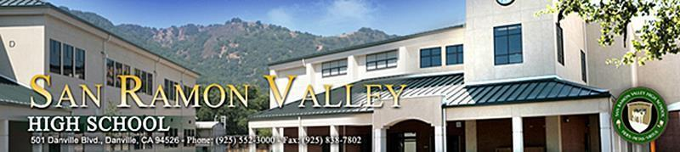

# School Site Council Agenda

**September 18, 2025**

1. Call to order

1. Review of minutes from May 2025.
2. New Business
   1. Introductions and purpose of Site Council.
   2. School Safety Plan

1. Principal’s Report
2. Student Leadership Report
3. Public Comment
4. Adjourn

Next Meeting: October 16, 2025 at 3:30 pm