Winship-Robbins Elementary School District’s Universal Prekindergarten Plan (UPK)

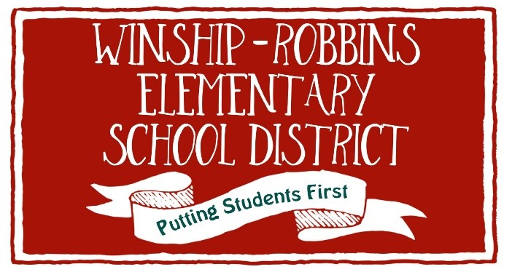

Board Adopted June 8, 2022

