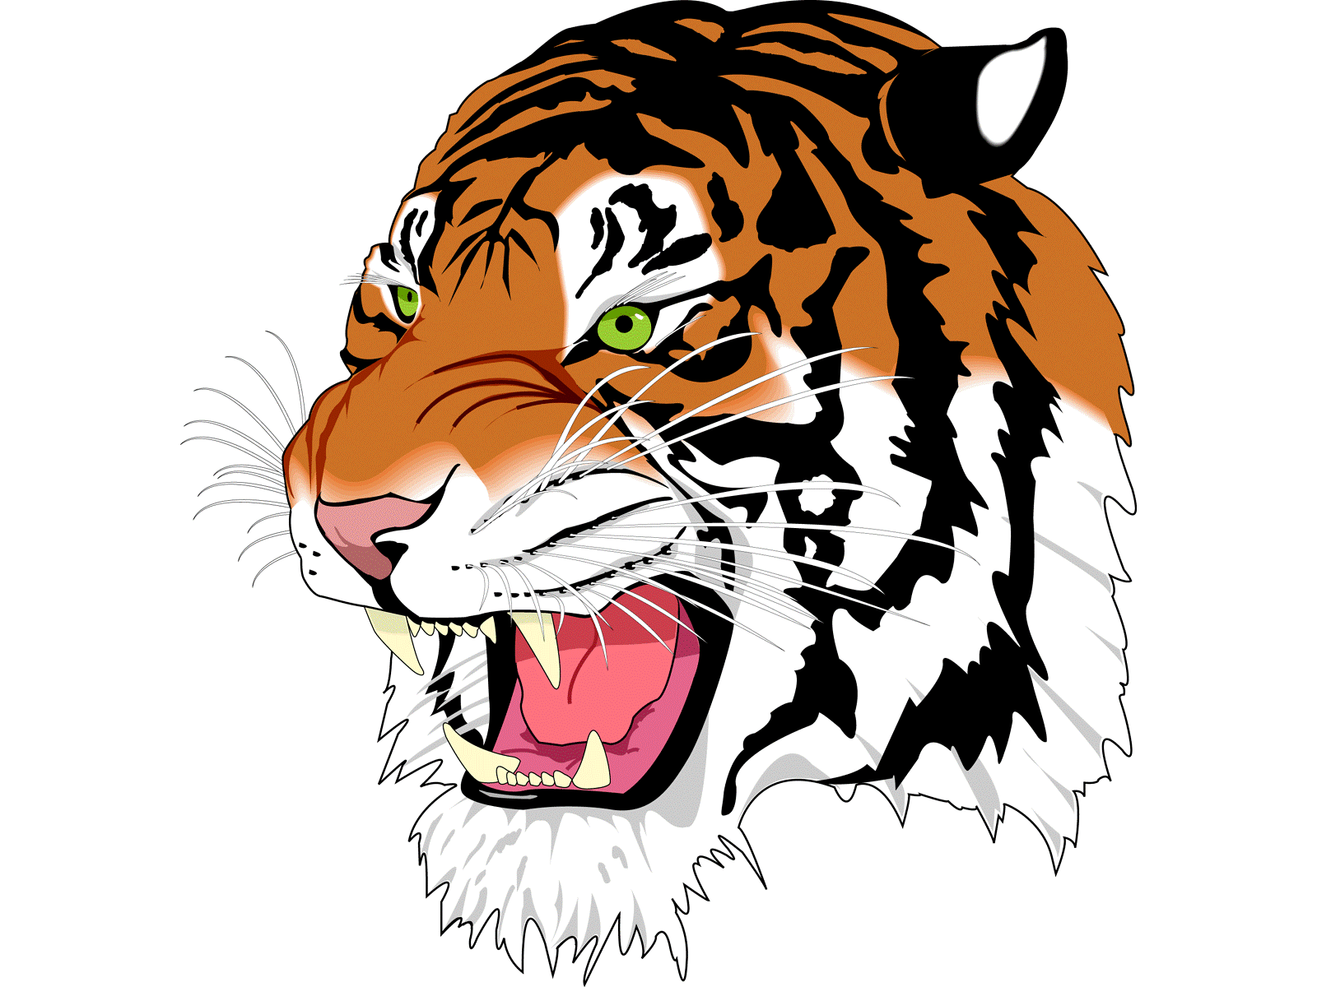
DAILY BULLETIN
Wednesday October 29th, 2025
Lunch Menu

Philly Cheese Steak
Fries
Peanut Butter & Jelly (PB&J)
Salad Bar
Fruit
Milk

Servers
Trenton
Jaime

School Announcements:
- Tomorrow, we will have our annual ASB Halloween carnival in the gym for the elementary school from 9-10 am.
- Tomorrow, we will have our Halloween pep rally. Come dressed up for our costume contest. The winner will receive a gift card!
- Halloween doors need to be completed today. The winner will be announced at the pep rally.
- The pumpkin carving contest has begun. The pumpkins will be in the art room. Each class needs to carve their own pumpkin and clean up their own mess. Pumpkins need to be done by tomorrow. They will be judged at the pep rally.
- There is no school on Friday.

Athletics:
- On Friday, the Cross Country Team will travel to Fall River for a meet.

Extra-Curricular:

- Chess club will be in Mrs. Howard’s room today.

