
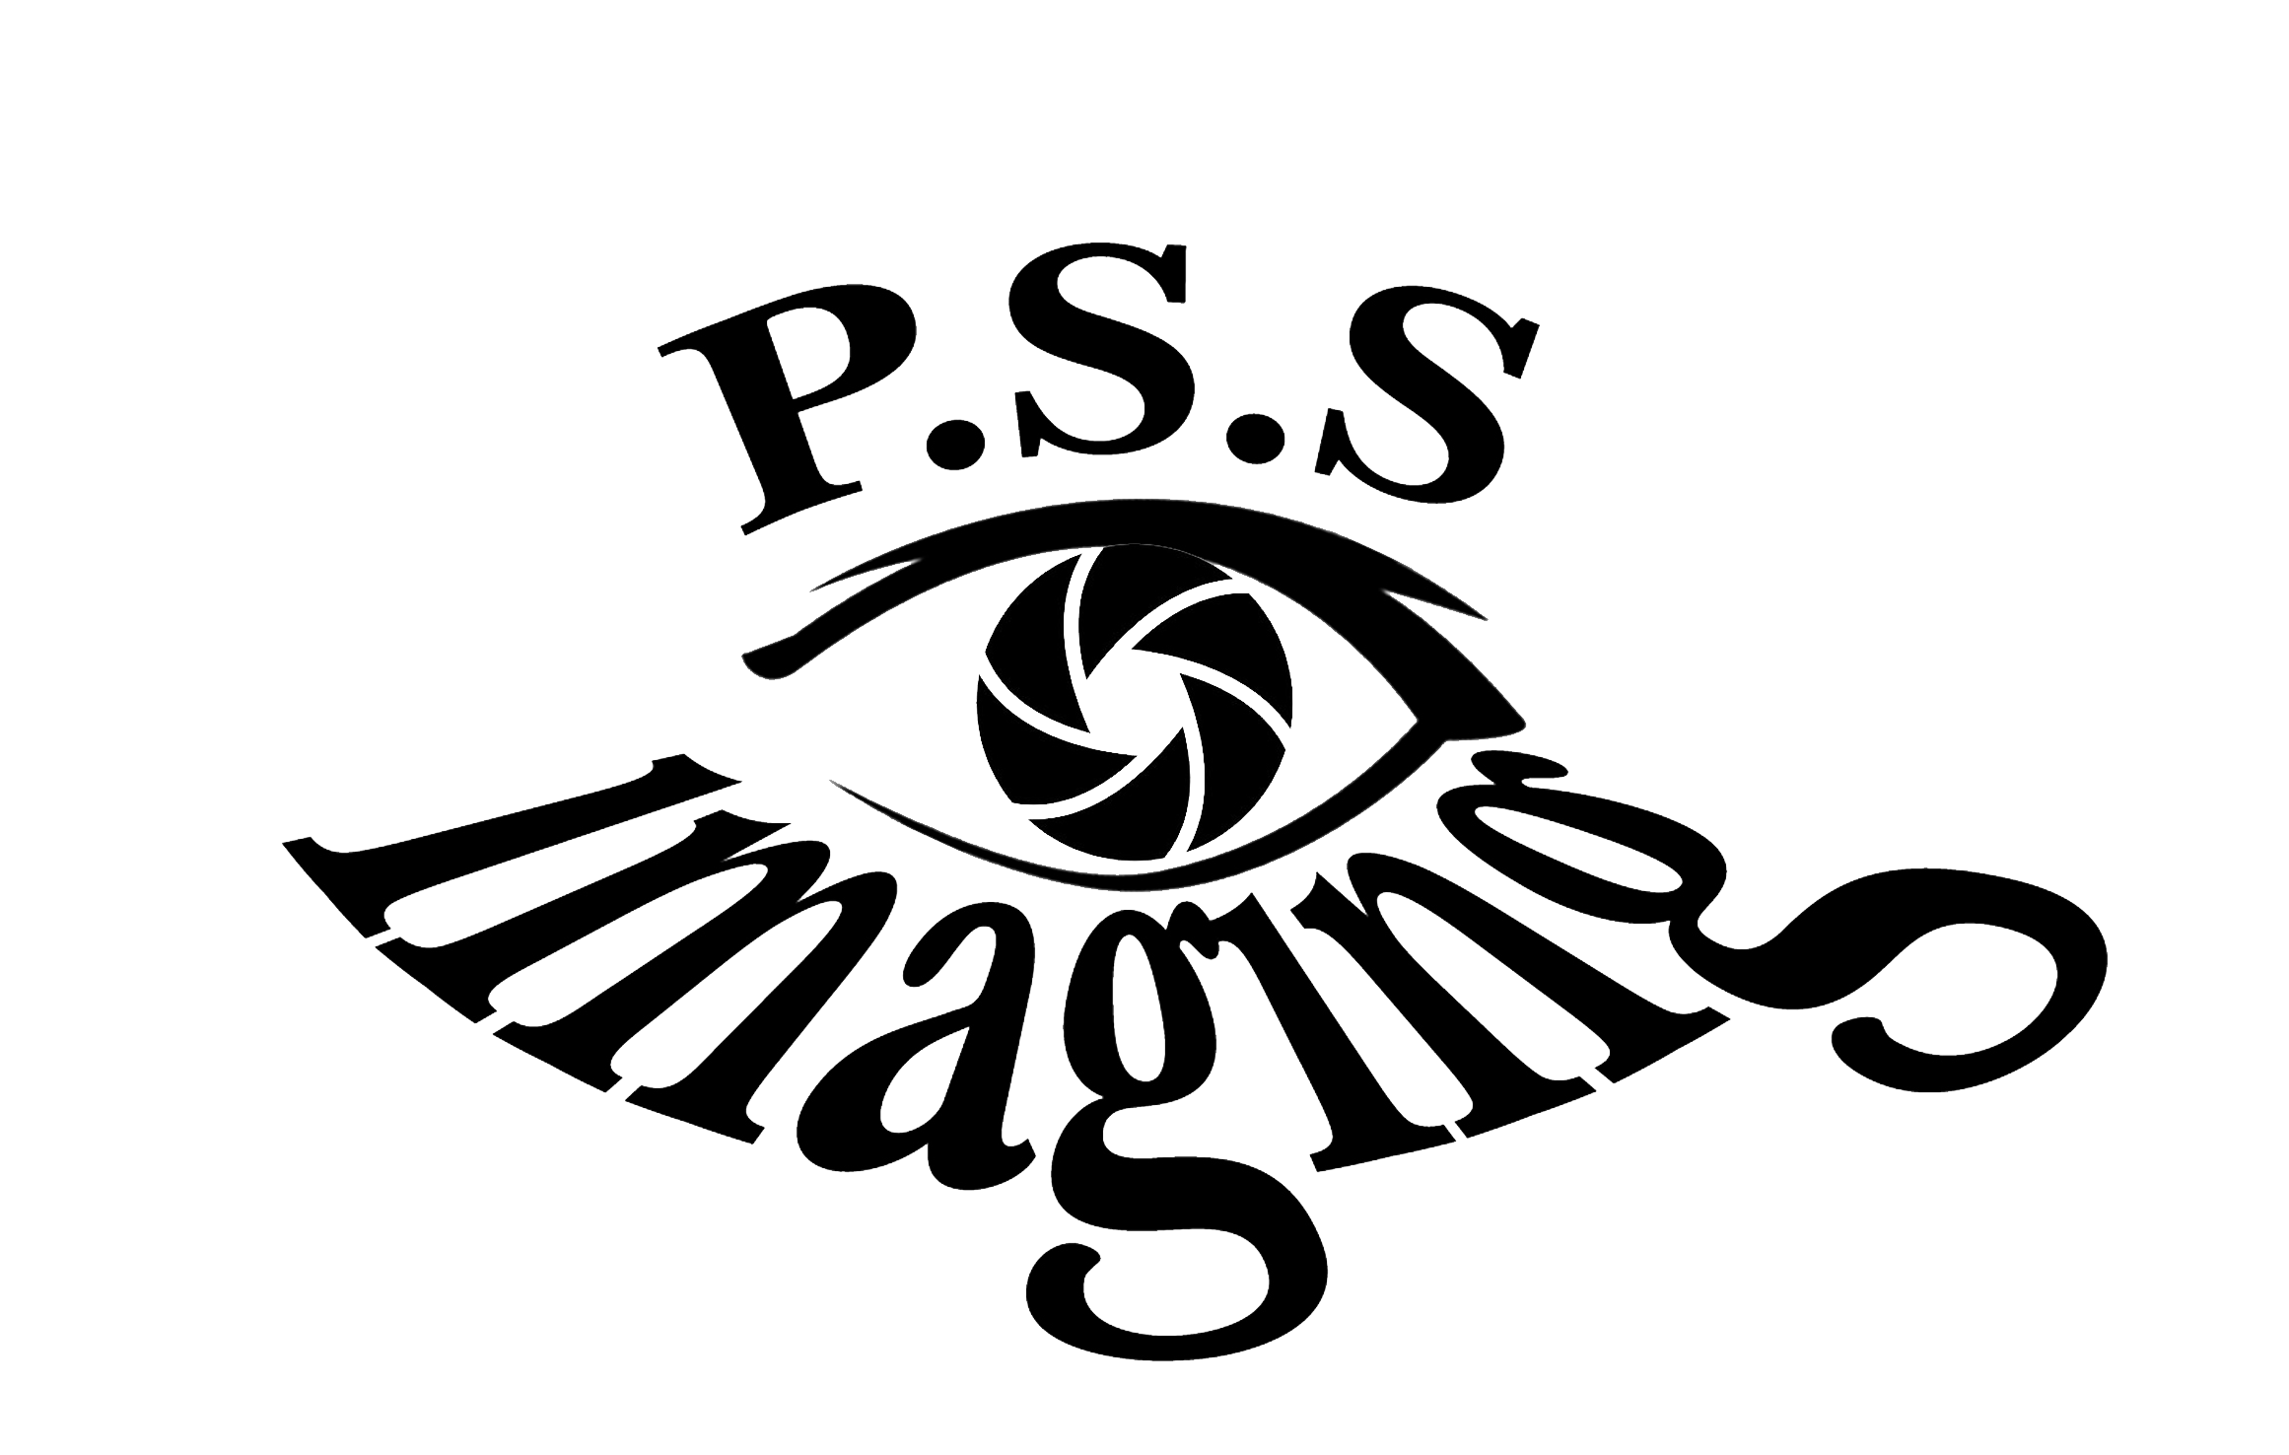
Welcome 2027 Seniors!

Dear Parents & Seniors,
PSS Imaging, Inc. is excited to offer Senior Sessions for the 2026-2027 school year! Senior Sessions will be offered on campus from June 8th to June 22nd. Sessions will fill up quickly so please schedule at your soonest convenience! We will also have sessions available at our Anaheim Studio located at 1240 N Jefferson St, Ste K, Anaheim, CA 92807. Seniors must make and appointment to have their photos taken no later
than November 20th.

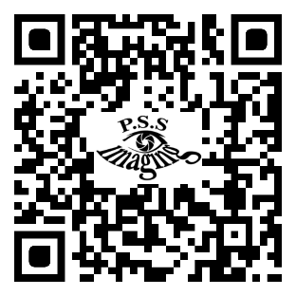
How to Schedule:
1. Please visit pssimaging.net and select “Schedule Session” or scan the QR Code.
2. From the drop-down menu select "Senior". Here you will find additional information on how to schedule and what to expect during your senior session.
Important Session Information:
Exciting News! You can now purchase your Senior Session at the time of scheduling. When you arrive at your senior session you can relax and enjoy time with your senior.
Your school's yearbook staff will only accept yearbook poses from PSS Imaging Inc. Sessions need to be paid in full at the time of your scheduling. Session fees are mandatory for the time and talent of our photographers, retouching on selected yearbook images, and timely submission of your yearbook selection to your yearbook staff. All sessions are non-refundable. At least 24-hour notice for cancellations or change of appointment must be provided. If you do not show up or cancel after the given window your session fee will be forfeited (no refund will be available and will not apply to a new session). We ask only one parent or guardian to be present for the senior sessions, we are unable to accommodate multiple family members or children in our photography area. Please arrive 10 minutes before your session time to enjoy accommodation and prepare for your session. We ask your student to arrive ready with clothing, hair, and make-up done if needed. Please visit the "View and Order Galleries"- Seniors for after-session Information.
For additional information regarding senior sessions, contact us by e-mail at pssimaging@msn.com or by phone at (714) 630-7785.

We look forward to providing you with outstanding portraits!

