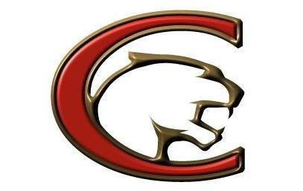

CHS Football important dates

Physical night May 13th

Spring Ball May 11th - May 27th JV & V only
4pm -6:30pm
(no practice on 15th,22nd,25th)

Summer Weights start June 9th
(We start Tuesday June 9th but after that Mon - Thur)

Frosh: Mon - Thur 9am - 10am
(additional time may be added by JV/Frosh Coach for practice over summer)
JV: Mon - Thur 2:30pm - 4pm

Varsity: Mon - Thur 4pm - 6pm, Mon & Wed practice 6pm - 8pm

Big Red July 20th Frosh/JV/Varsity
(Times to be announced)

Athletes must be enrolled at CHS, have online clearance complete and a current Physical on file for football activities.

