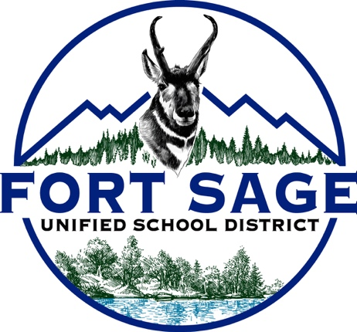
NOTICE OF PUBLIC HEARING
Adoption of Instructional Materials/Curriculum
July 8, 2026
5:30 p.m.
Fort Sage Unified School District Board Room
100 D.S. Hall Street
Herlong, CA 96113
NOTICE IS HEREBY GIVEN that the Governing Board of the Fort Sage Unified School District will hold a Public Hearing to receive input from parents, guardians, teachers, staff, community members, and interested parties regarding the proposed adoption of instructional materials/curriculum.
The proposed adoption includes McGraw Hill California Reveal Math instructional materials for Mathematics, Transitional Kindergarten through 12th Grade (TK–12).
Instructional materials are available for public review at Sierra Primary TK-6, and Herlong High School 7-12 Offices during regular business hours.
Questions should be directed to:
Derek Cooper, Superintendent
(530) 827-2101
Posted: 6/25/2026

