HMS Track Shoe Report
Track Parents,
As you are aware, track is an inexpensive sport compared to other sports, however, your young athlete will need a good pair of running shoes. All running shoes are not the same. Try not to purchase running shoes at department stores. Stores such as Running Lab, Nike, or Adidas outlet stores will be of great help in purchasing running shoes. If you have concerns with your child’s foot, or if your child has lower body pain when they run, Runnin’Gear in Brighton may be able to help by custom fitting a shoe for your child. Running Lab has cutting edge high speed camera fit process. An observed treadmill run, and measurement with excellent customer service. Running Lab offers 10% off for shoes or spikes, or 15% off both and running classes are offered. Runnin’ Gear will also personally fit a shoe to your child and offer 10% off shoes and 20% off spikes.
Nike Lunar Fly
- $90
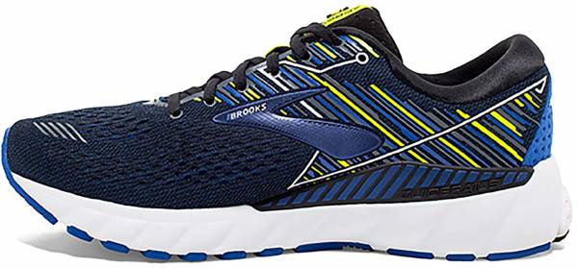
Listed here are locations of stores and price point suggestions for a few very good running shoes.

- Running Lab
328 W.Main Street
Brighton ,MI 48116
Web: www.runninglabstore.com
Phone: 810-225-9123
Brookes Adrenaline 23
- $140
Owner: Ken Larscheid
Store Manager: Tony Reese
  - Cutting edge high speed camera fit process.
  - Treadmill run and measurement with excellent customer service.
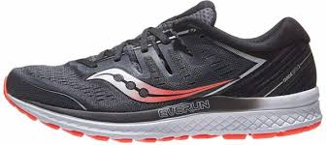
  - 10% off for shoes or spikes, or 15% off both.
  - Good Form Running classes offered.
  - Clearance items possible
Saucony Guide 16
- $140

- Nike Outlet Stores
Tanger Outlet Mall
1475 N Burkhart Rd. Howell, MI
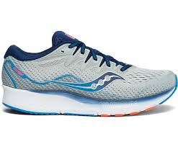
Phone: 517- 552-6453

- Adidas Outlet Stores
Saucony Ride 16
- $140
Tanger Outlet Mall
1475 N Burkhart Rd.
Howell, MI
Phone: (517) 552-3337
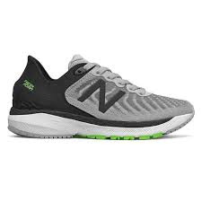
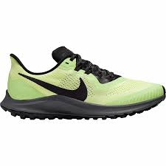
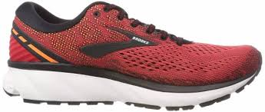
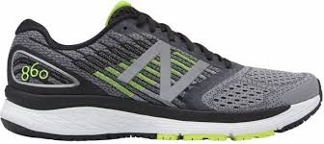
New Balance 860-V13
- $140
New Balance 880-V13
- $140
Nike Pegasus 40
- $140
Brookes Ghost 15
- $140

