San Pasqual Valley Elementary
Student/Parent Handbook
2026-2027




San Pasqual Valley Unified School District
Board of Trustees
Cody Hartt, President
Keahna Owl, Vice President
Karla Delgadillo, Clerk
Angelo Derma, Trustee
Sofia Dominguez, Trustee

Superintendent
Mr. Richard Cordero

Elementary School Principal
Tamy Durham

San Pasqual Valley Elementary School Vision and Mission
Vision:
San Pasqual Valley Elementary Staff will provide a safe and nurturing learning environment in which our students will gain the skills necessary to be successful in their education, careers, and society.
Mission:
San Pasqual Valley Elementary School provides a safe and orderly environment where mutual respect is modeled and fostered. Individual academic needs are met and challenged through the implementation of a California Common Core standards-based curriculum. Every student will be given the opportunity to master the state approved standards.

San Pasqual Valley Unified School District
676 Baseline Road
Winterhaven, CA 92283
760-572-0222
www.spvusd.org
 Find and like us on Facebook: San Pasqual Valley Elementary School

Principal’s Message
Dear Students, Parents, and Guardians,

It is with great pleasure that I welcome you to our elementary school community. As the principal of this wonderful institution, I am honored to guide and support this exciting educational journey.

At our school, we believe that education is the key to unlocking the limitless potential within each child. Our dedicated team of educators is committed to providing a safe, nurturing, and inclusive environment that fosters academic excellence, personal growth, and character development.

We strive to create a learning atmosphere that celebrates diversity and encourages students to embrace their individuality. Our goal is to empower our students to become confident, compassionate, and resilient individuals, equipped with the skills necessary to succeed in an ever-changing world.

We have designed our curriculum to be engaging, challenging, and well-rounded, catering to the diverse needs and interests of our students. Through a combination of rigorous academics, creative arts, physical education, and extracurricular activities, we aim to provide a holistic education that promotes intellectual curiosity, critical thinking, and a lifelong love of learning.

We encourage parents and guardians to actively participate in their child's academic journey, attend school events, and maintain regular communication with teachers. Together, we can create a strong support network that ensures each student's success.

We have implemented comprehensive safety measures to safeguard the well-being of our students, staff, and visitors. We believe that when children feel secure, respected, and valued, they can flourish academically and socially.

This handbook serves as a valuable resource and I encourage you to familiarize yourself with its contents, as it will help ensure a smooth and productive school year for everyone.

Finally, I would like to express my gratitude to all the parents and guardians for entrusting us with the education of your precious children. It is a responsibility we do not take lightly, and we are honored to be partners in their academic and personal growth.

Please do not hesitate to reach out to me or any member of our team if you have any questions, concerns, or suggestions. Together, let us create a supportive and enriching environment where every child can thrive.

Wishing you all a warm welcome to our elementary school community!

Sincerely,
Ms. Durham
SPVE Principal

Principal’s Message 1
2026-2027 SAN PASQUAL VALLEY UNIFIED SCHOOL DISTRICT 1
BOARD MEETING SCHEDULE 1
2026-2027 MANAGEMENT STAFF 1
2026-2027 SAN PASQUAL VALLEY ELEMENTARY SCHOOL CALENDAR 2
2026-2027 PROGRESS/REPORT CARD SCHEDULE 3
2026-2027 ELEMENTARY STAFF ASSIGNMENTS 4
Attendance Policy 5
Attendance Incentives 5
Excused Absences 5
Unexcused Absences 6
Tardiness 6
Truancy 6
Intervention and Support 6
Student Attendance Review Board (SARB) 6
Social and Emotional Learning 7
Peacebuilder Pledge 9
Classroom Behavior Management: A Plan for Success 10
The Social Contract 10
Schoolwide Classroom Rules 10
Positive Rewards/Incentives 10
Consequences 10
The Rule of 5 11
Toys and games 14
Drug and Weapon Free Zone 14
Search and Seizure 14
Smoke-Free Zone 14
Prohibited Items and Practices 14
Dress Code Policy 15
Dress Code Violations 15
Bullying Prevention Policy 16
Definition of Bullying: 16
Reporting and Investigation: 16
Discipline: 16
Prevention and Education: 16
PEACEBUILDERS© PROGRAM AND PEACE AMBASSADORS 21
PEACE AMBASSADORS 21
Academic Program 22
Curriculum 22
Transitional Kindergarten (TK) 22
Expanded Learning Opportunities Program (ELO-P) 22
Progress Monitoring Assessments 22
State Testing Notification 22
California Assessment of Student Performance and Progress (CAASPP) 22
Smarter Balanced Assessment Consortium Assessments 22
California Science Tests (CAST) 23
California Alternate Assessments (CAA) 23
Standards-based Tests in Spanish (STS) for Reading/Language Arts 23
English Language Proﬁciency Assessments for California 23
Physical Fitness Test 23
Grade-level Standards for Promotion 23
Parent Conferences 24
Parent Involvement and Volunteers 24
Stress-less Homework Policy 24
Make-up Work 25
Student Study Team (SST) 25
School Visitors 26
Visitors to Classrooms or Other Instructional Areas 26
Daily and Emergency Safety Procedures 27
Bus Riding Procedures 27
Consequences for Misbehavior on the Bus Behavior 27
“Bus Note” Procedures 27
Parent Drop-off Procedures 28
Food and Drink on Campus 28
Birthday Celebrations 28
Cafeteria Procedure 30
Library and Media Center 30
Computer and Internet Usage 31
Student Health at School 31
Emergency Information 31
Sick Children 31
Head Lice 34
Prevention: 34
Control: 34
Medications 34
Immunizations 35
Pets on Campus 35
Teacher Pledge: 36

2026-2027 SAN PASQUAL VALLEY UNIFIED SCHOOL DISTRICT

BOARD MEETING SCHEDULE

All meetings begin at 5:30pm in the High School Library. Board will immediately enter closed session and return to general session no later than 6:00pm.

August 11, 2026 February 9, 2027
September 8, 2026 March 9, 2027
October 13, 2026 April 13, 2027
November 10, 2026 May 11, 2027
December 15, 2026 June 17, 2027
January 12, 2027 June 22, 2027
A copy of the San Pasqual Valley Unified School District Policies, Procedures and Regulations is available at each school office and in the District Office. Students, parents, and members of the community may review them upon request.

2026-2027 MANAGEMENT STAFF

Richard Cordero Superintendent
Anastasia Noriega San Pasqual Valley High School Principal
Richard Cordero San Pasqual Valley Alternative Education Principal
Erin Grande San Pasqual Valley Middle School Principal
Tamy Durham San Pasqual Valley Elementary Principal
Johna Meek San Pasqual Valley Special Education Director

2026-2027 SAN PASQUAL VALLEY ELEMENTARY SCHOOL CALENDAR

August  11 - Ice Cream Social  12 -First Student Day of School  25– Back to School Night  September  7-Labor Day  11-Progress Reports Sent Home  12-ELO-P Super Saturday  26-ELO-P Super Saturday  October  9- Native American Day  17 - ELO-P Super Saturday  29 - Fall Festival  24 - ELO-P Super Saturday  26-30-Red Ribbon Week/Spirit Week  14-16 -Report cards sent home and Parent Conferences/Early Release @ 1:15  November  7- ELO-P Super Saturday  11 -Veteran’s Day  13 - Progress Reports Sent Home  14- ELO-P Super Saturday  23-27-Thanksgiving Break  December  9- Winter Program  5-ELO-P Super Saturday  12-ELO-P Super Saturday  18- Report Cards Sent Home  21-31 Winter Break  21 &22- ELO-P Bonus Days  January 2026  1 - New Year’s Day (observed)  1-8- Winter Break  7&8- Staff Development  11- Students back to school  18- ML King Jr. Day  30- ELO-P Super Saturday | February  8- Lincoln’s B-day  12- Progress Reports Sent Home  15 - President’s Day  20- ELO-P Super Saturday  24- Around The World Day  March  1-5 Read Across America  18- SEL Night  17-19 Parent Conferences Early Release 1:15  19- Report Cards Sent Home  26- Good Friday  28- Easter  29-31 -Spring Break  April  1-2 -Spring Break  10- ELO-P Super Saturday  23 - Progress Reports  24- ELO-P Super Saturday  18-30- SBAC Testing  May  8-ELO-P Super Saturday  22- ELO-P Super Saturday  28- Field Day  31 -Memorial Day  June  3- Kinder Promotion Ceremony  2-4 Early Release - 1:15  4 -Last of school  7-25- ELO-P Summer School  19-Juneteenth-No Summer School

2026-2027 PROGRESS/REPORT CARD SCHEDULE

First Quarter
Grading period: August 11, 2026 – October 7, 2026
Progress Reports sent home: September 11, 2026
Parent Conferences: October 15, 2026 (1:30pm – 7:00pm)
Parent Conferences: October 16, 2026 (1:30pm – 3:15pm)
Report Cards sent home: October 16, 2026
Awards Assemblies: October 23, 2026 – 1st & 2nd 8:30-9:00; 3rd, 4th, & 5th 9:15 – 10:00

Second Quarter
Grading period: October 8, 2026 – December 18, 2026
Progress Reports sent home: November 13, 2026
Report Cards sent home: December 18, 2026
Awards Assemblies: January 22, 2027– 1st & 2nd 8:30-9:00; 3rd, 4th, & 5th 9:15 – 10:00

Third Quarter
Grading Period: January 11, 2027 – March 12, 2027
Progress Reports sent home: February 10, 2027
Parent Conferences: March 18, 2027 (1:30pm – 7:00pm)
Parent Conferences: March 19, 2027 (1:30pm – 3:15pm)
Report Cards sent home: March 19, 2027
Awards Assemblies: March 25, 2027 – TBD

Fourth Quarter
Grading Period: March 15, 2027 – June 04, 2027
Progress Reports sent home: April 23, 2027
Report Cards sent home: June 4, 2027
Awards Assemblies: June 4, 2027 – TBD

Emergency Response Protocols - Safety Drill Schedule 2026-2027
August (Fire) January (Fire)
September (Lockdown and Fire) February (Lockdown and Fire)
October (Fire & The Great Shake-Out - Earthquake) March (Fire)
November (Fire) April (Fire)
December (Fire) May (Fire)

2026-2027 ELEMENTARY STAFF ASSIGNMENTS
113A and 113B | Larissa Bouts | Pre-K Teacher
113A and 113B | Morales, Alba | Pre-K Teaching Assistant
111A | Larissa Bouts | Transitional Kinder (TK)
112A | Rodriguez, Yukeiry | Kindergarten
112B | Zaragoza, Clarissa | Kindergarten
108A | Rutledge, Sarah | 1st
108B | Hartman, Margie | 1st
106C | Polk, Lucia | 2nd
106B | Pappin, Bonnie | 2nd
106D | De La Teja, Vivian | 3rd
106E | Castro, Francisco | 3rd
114D | Smith, Taune | 4th
114B | Castillo, Alma | 4th
114C | Arredondo, Vanessa | 5th
114A | Turner, Shelley | 5th
110C | Copeland, Leah | Teacher on Special Assignment (TOSA)
109B | Beck, Amanda | PE/ EEL/ THRIVE Coordinator
102A | Ruiz, Brenda | Librarian
107D | Thrower, Jahan | Art
108C | Diaz, Damaris | Outreach Consultant
111A | Miller, Alysha | SDC K-2
111C | Goodrich, Dalilah | SDC 3-5
111A | Miranda, Ingrid | Special Ed. Paraprofessional
111A | Canedo-Zamudio, Karime | Special Ed. Paraprofessional
111C | Gonzalez, Rosa | Special Ed. Paraprofessional
111C | Dominguez, Melissa | Special Ed. Paraprofessional
107A | TBD | ASES Clerk
107B | Montgomery, Jeanette | TK-4th grade Counselor
107C | Meraz, Rosa | 5th grade Counselor
106A | Dornstadter, Kerri | RSP
106A | Flores, Hailey | Special Ed. Paraprofessional
101 – Office | Mendenhall, Lisa | Secretary to the Principal
101 – Office | Gallardo, Veronica | Attendance Clerk
 | Josue Mejia | Custodian
 | Lopez, Martin | Custodian
104A | Rodriguez, Andrea | Student Health Care Specialist
111D | Miller, Cyndee | Title VI Paraprofessional  AI Coordinator
101-- Office | Durham, Tamy | Principal

Attendance Policy

Regular school attendance is important for academic success. California Education Code requires all children between the ages of 6 and 18 to attend school regularly. Students are expected to attend school every day, on time, and for the entire school day, unless they are sick or have a valid excuse. Please make every effort to adjust doctor appointments and family schedules to minimize time away from school.

Attendance Incentives
Regular attendance is crucial to your child’s school success. Students who display good and perfect attendance habits will be recognized, and when the school is able, rewarded. Attendance incentives are offered to encourage good attendance and build necessary life skills such as responsibility, reliability, and commitment.

- Perfect Attendance* - Zero (0) absences with two or less tardies.
*Absences with a doctor’s note are still considered absences and do not qualify students for Perfect Attendance incentives.

- Excellent Attendance - 95% or higher attendance rate.

- Various other individual, class, grade-level, and school incentives for reaching attendance goals.

Excused Absences
California State law requires that students will be in attendance during the school day unless officially excused. Excused absences include illness, medical appointments, bereavement, family emergencies, and religious holidays. If a child is absent for 3 (three) or more consecutive days due to illness, a note from a physician is required to excuse the absence. A physician note is also required if a child misses more than 9 days during the school year for medical appointments. Independent Study is a viable option for students with severe long-term medical conditions. Please contact the elementary office at 572-0222 extension 2101 for more information.
Parents or guardians are required to notify the school in advance of any planned absences or provide a written excuse within three (3) school days of an absence. Parents may call the school 24 hours a day. If contact is not made by phone, a written note, signed by the parent/guardian, must be sent to the school upon the child’s return. Call Mrs. Veronica Gallardo at 572-0222 extension 2101.

Unexcused Absences
Absences that are not excused are considered unexcused. Students with unexcused absences may be subject to disciplinary action, including loss of privilege, detention, suspension, or referral to the Student Attendance Review Board (SARB). After the 10th consecutive unexcused absence, the student will be withdrawn from school and authorities will be notified.

Tardiness
Instruction begins at 8:00AM. Students are expected to arrive at school on time. Students who are late to school or to class miss important instructional time and disrupt the learning environment. Guardians of students who are consistently tardy will be offered support and intervention before involving the authorities.

Truancy
California Education Code defines a truant as a student who has three (3) or more unexcused absences in a school year or who is tardy or absent for more than 30 minutes during the school day without a valid excuse. Guardians of students who are truant may be subject to disciplinary action, including referral to the Student Attendance Review Board (SARB).

Intervention and Support
Our school has a system of interventions and support to help students who are struggling with attendance. Parents or guardians of students who are absent or tardy will be notified by the school within two (2) school days. Students who have excessive absences or are at risk of becoming habitually truant may be referred to the Student Attendance Review Board.

Student Attendance Review Board (SARB)

The Student Attendance Review Board (SARB) is a team of school officials, parents, and community members who work together to address attendance issues and develop plans to support students in improving their attendance.

Parents will be notified by a letter or a phone call on the 3rd, 6^{th,} and 9th absences. After the 3rd unexcused absence, parents will receive the first letter from the School Attendance Review Board (SARB) notifying them of California compulsory school attendance. After the 6th absence parents will receive a second letter from the SARB outlining their requirement to attend a Student Attendance Review Team (SART) meeting.

The SART team is designed to identify the reasons for the students’ attendance issues and develop a plan to address them. The SART may meet with the students and their parents or guardians to discuss the attendance issues and develop a plan of action.

The plan may include interventions such as counseling, mentoring, academic support, and family services. The SART will monitor the students’ attendance and progress and may make recommendations for additional support or services if needed.

If the students’ attendance does not improve, the SART may recommend further action, such as a referral to the District Attorney's Office or the Department of Children and Family Services.

Parents or guardians are encouraged to participate in the SARB process and to work closely with the school to support their child's attendance. If your child is referred to the SARB, please contact the school office for more information and to schedule a meeting with the SART.

Please contact the school office for more information on our attendance policy and procedures.

Social and Emotional Learning

At our school, we recognize the importance of supporting the whole child, which includes their social and emotional development. This section outlines our approach to promoting social and emotional well-being, and our commitment to creating a safe, supportive, and inclusive learning environment. We believe that developing social and emotional skills is key to helping our students become responsible, respectful, and empathetic individuals who are equipped to succeed in school and beyond. This section of the handbook is designed to provide parents and guardians with an understanding of our approach to SEL, as well as resources and tools to support their child's social and emotional growth.
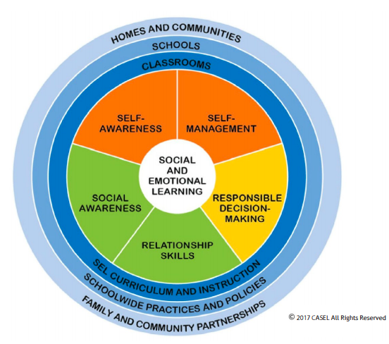
We encourage families to work with us as partners in promoting positive social and emotional development, both in and out of the classroom.

The goal of SEL is to help students develop the skills and competencies they need to succeed in school and in life. These skills include self-awareness, self-management, social awareness, relationship skills, and responsible decision-making. By teaching students to recognize and regulate their emotions, empathize with others, communicate effectively, and make responsible decisions, SEL can improve academic performance, reduce behavioral problems, and increase positive social outcomes.
SEL is typically taught through a combination of direct instruction, modeling, and practice. Teachers may use a variety of strategies, such as role-playing, group discussions, and cooperative learning activities, to help students develop these skills.
Overall, SEL is an important component of a well-rounded education that can help students become more resilient, responsible, and successful individuals.
A multi-tiered system of supports has been adopted to address a variety of SEL needs. The diagram below outlines the supports integrated at San Pasqual Valley Elementary School. All supports listed below in Tier I and Tier II are automatically integrated to each student’s educational experience. If parents/guardians DO NOT want their child to receive the support in Tier I or II listed below, they must notify the school in writing. Individual Student Planning/Individual School Counseling in Tier 3 requires parent/guardian approval.
Tier I: Universal Intervention  (All Students) | Tier II: Secondary Intervention (Small Group Based) | Tier III: Tertiary Intervention (Individually Based)
PeaceBuilder Program: Evidence based program that promotes a positive school culture  Classroom Guidance Lessons: classroom lessons facilitated by School Counselors to address academic, college and career, and personal/social topics.  Daily SEL Lessons with Classroom Teacher: Digital character education and social emotional learning program.  Minute Meetings/Check-Ins: brief meetings with individual students to build connections, offer guidance when experiencing short-term situations, and/or determine if more support is needed. | Student Success Groups: Students meet in small groups with counselors or designated support staff to address personal growth topics such as: positive school behaviors, bullying prevention, friendship skills, coping skills, healthy habits, stress management, resiliency, career exploration, leadership skills, etc. Various group topics are offered throughout the school year and identified students are selected to participate in the group that best addresses their needs/area of interest  Conflict Resolution: Students who are involved in a friendship problem or mutual conflict with another peer(s) are offered the opportunity to meet with school counselors or designated support staff to communicate respectfully and work together to solve the problem effectively and peacefully. This intervention is not utilized to address bullying.  Suite 360 Intervention/Restorative Practices: Students who have been identified due to repeated discipline referral infractions will participate in lessons or restorative practices to enhance and teach appropriate behavior and redirect inappropriate behavior.  Safe School Ambassadors: Selected students are invited to participate in a two-day training that teaches students how to identify and respond to mistreatment. Students meet in groups throughout the year to continue practicing the learned skills and empower them to continue enhancing school culture. | Individual Student Planning/Individual School Counseling: on-going meetings between student and school counselor to address specific academic, college/career, and personal/social areas of need (parent approval required).  Suite 360 Intervention/Restorative Practices: Students who have been identified due to repeated discipline referral infractions will participate in lessons . to teach appropriate behavior and redirect inappropriate behavior.

PeaceBuilder Expectations:

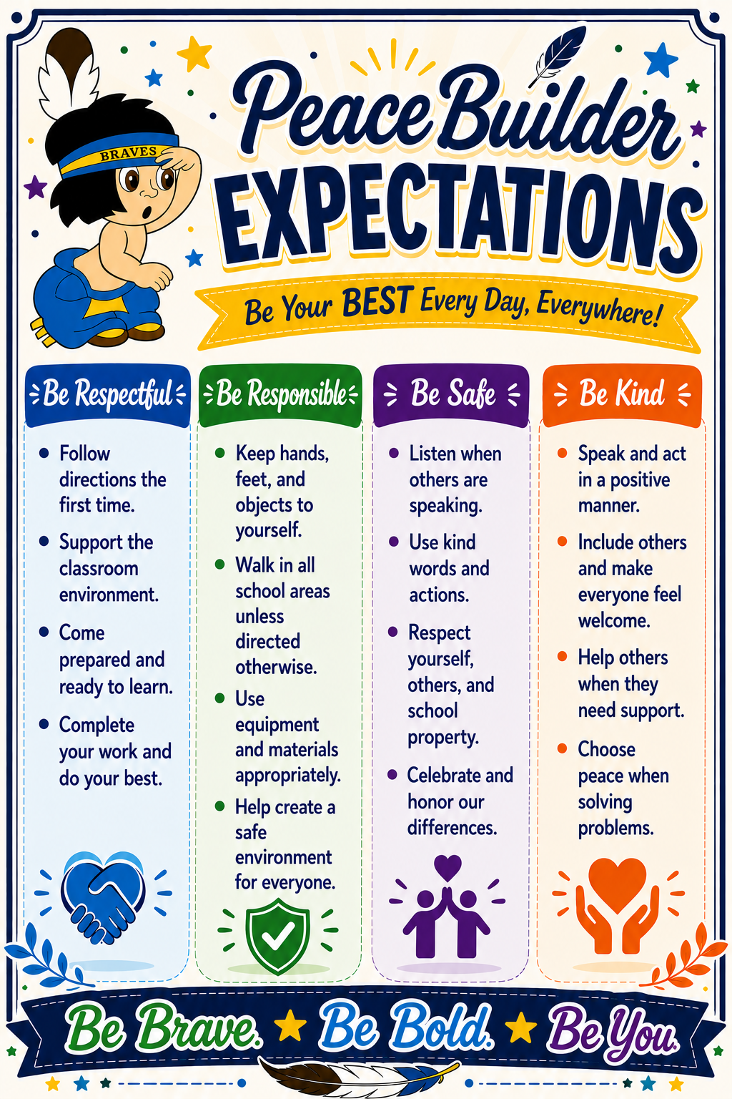

Classroom Behavior Management: A Plan for Success

The Social Contract
Each classroom will work together to develop a Social Contract. Working collaboratively, Teachers and students will articulate the elements that make a safe and engaging learning environment by answering the following questions:
- How do you want the teacher to treat you? How do you want to feel?
- How do you want the students to treat each other? How do we want to feel?
- How do you think the teacher wants to be treated? How does she want to feel?
- How will we handle violations to our contract?
Each student and the teacher will sign and post the social contract and refer to it daily to help students regulate their own behavior and build and strengthen positive classroom relationships.

Positive Rewards/Incentives
- Verbal Praise
- Positive notes/stamps/stickers
- Classroom and school incentives
- Phone calls home
- Praise Notes (at teacher discretion)
- Peace Preferral to Administration for a peace prize.

Consequences
- Warning
- Sign behavior log.
- Phone call home.
- Loss of privilege.
- Buddy Room or Office Detention (if Buddy Room is not available).
- Upon 5th signature, referral to administration, assigned In-school Restorative Room (ISR) (ISR) detention and reflection

The Rule of 5
Students that have five (5) or more behavior log signatures for disruptive behaviors during the week (in class and at recess combined) will be assigned one (1) session of in-school Restorative Room (ISR) and reflection. Attempts will be made to notify parents/guardians before students are assigned a date for detention/reflection. Each Rule of 5 offense resulting in detention/reflection in the Restorative Room (ISR) is due to five broken rules in one week.
There will be plenty of redirection, warnings and opportunities for students to change their behavior and avoid consequences. Rule of 5 interventions include:
- Redirection
- Reteach the behavior
- Intentional Proximity
- Student Conference
- Modification of Privileges
- Seating Change
- Mental/Physical Break (Peace Corner)
- Buddy Room
- Note Home
- OTHER
Teachers and administration will explore alternate consequences for students who repeatedly receive Rule of 5.

Progressive Consequences:
1st set of 5 signatures - Partial day in Restorative Room (ISR) room.
2nd set of 5 signatures - Half Day in Restorative Room (ISR) room to include lunch time.
3rd set of 5 signatures - Full day in Restorative Room (ISR) and Parent Conference.
4th set of 5 signatures - Full day in Restorative Room (ISR) room to include lunchtime.
5th set or more of 5 signatures - Out of school suspension.

Severe Behaviors - Automatic referral to Administration, with possible in-school suspension (ISR), out of school suspension, or expulsion.
Not limited to: fighting, vandalism, profanity, dangerous objects, prohibited articles, threatening students or staff, severe disrespect/defiance, nicotine/vapes/alcohol/drugs, bullying.

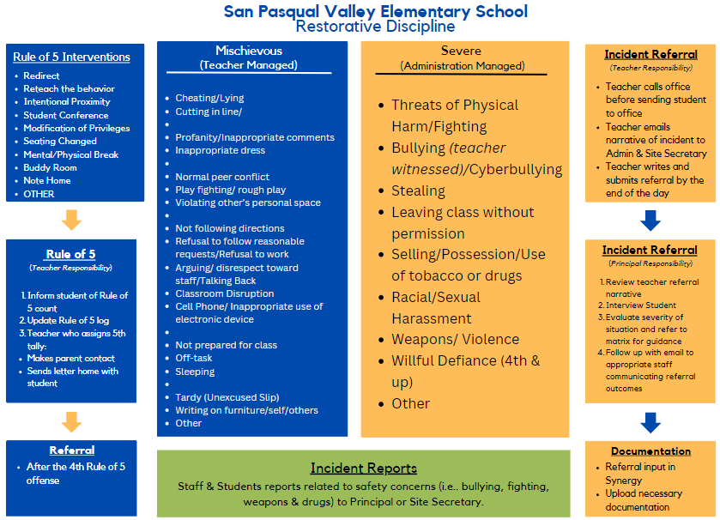
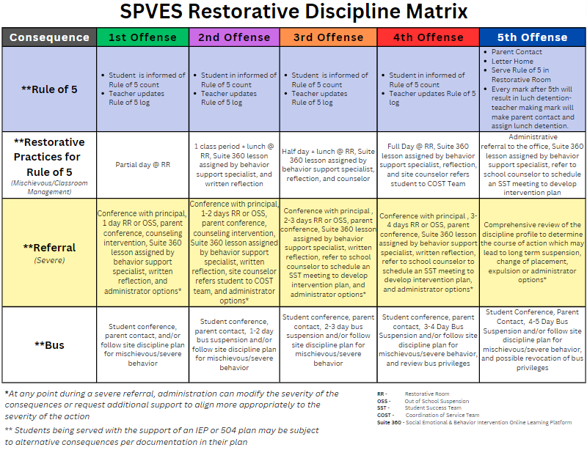
Personal Electronic devices: Use of electronic devices, such as cell phones, tablets, or laptops, is restricted during instructional time and other school-related activities. The school is not responsible for items lost, stolen, or damaged.
Students in possession of an electronic device are subject to disciplinary action.

School Internet Account and Internet Searches: SPVUSD uses software that sends an alert (“red flag”) when there has been an inappropriate internet search (eg. violence, adult content) from a school-issued account.
In this case the alert will be forward to the teacher and they will take the following actions:
- The teacher speaks to the student to correct behavior and issues a behavior log signature.
- After 3 red flags, the teacher contacts the parent, as well as prints and sends home the “red flag” emails. Consequence: Student loses device privileges for 1-2 weeks.

Toys and games
Toys and games, such as video games, trading cards, or other items that can cause disruption or distract from learning, are not allowed in the classroom or on the playground. The school is not responsible for items lost, stolen, or damaged.

Drug and Weapon Free Zone
Unlawful use, possession, distribution, or sale of weapons and drugs, alcohol, other illegal contraband on school district property, or at school sponsored events are not allowed and will be referred to legal authorities. In addition, the school administrative disciplinary plan will be enforced. School personnel will contact legal authorities in the event they suspect any person to be under the influence of drugs or alcohol.

Search and Seizure
School administration reserves the right to search and seize when there is reason to believe that material or matter detrimental to the safety, health, and welfare of students or staff exists. A safe and orderly campus is of vital importance to all. School administration also reserves the right to include law enforcement presence to assist in search and seizure if deemed appropriate. Parents will be notified immediately.

Smoke-Free Zone
Unlawful possession of tobacco, marijuana, paraphernalia, or any related products is cause for disciplinary action.

Prohibited Items and Practices
Our school is committed to providing a safe and secure environment for all students, staff, and visitors. To ensure the safety of everyone on campus, the following items are prohibited:

Weapons: Firearms, knives, explosives, or any other dangerous weapons or objects that can cause harm or injury.

Illegal drugs and alcohol: Possession, use, or distribution of any illegal substances or alcohol is strictly prohibited.

Tobacco products: Smoking, vaping, or using any other tobacco products is prohibited on school grounds.
Inappropriate materials: Materials that are inappropriate for an elementary school setting, such as explicit magazines or books, are not allowed on campus.

Students who violate this policy may face disciplinary action, including suspension or expulsion. Parents are responsible for ensuring that their children do not bring prohibited items to school. The school is not responsible for items lost, stolen, or damaged. We appreciate your cooperation in helping to keep our school safe and secure for everyone.

Dress Code Policy
The purpose of the dress code at San Pasqual Valley Elementary is to help create a learning environment where students can focus on their studies and feel comfortable expressing themselves without disrupting the learning environment. When implemented fairly, a school dress code can:
- help minimize distractions in the classroom and reduce peer pressure to wear certain types of clothing.
- promote safety, reduce social pressures, and promote inclusivity.
- promote equality by allowing all students to wear clothing that is appropriate, affordable, and culturally sensitive.
- A dress code can help prepare students for future academic and professional environments where dress codes may be required.

SPVE Dress Code
- Clothing items that promote or depict hate speech, violence, drugs, or alcohol are prohibited.
- Clothing should be appropriate for the weather and should not interfere with the student's ability to participate in school activities.
- Students are allowed to wear hats or head coverings for religious or cultural reasons.
- Clothing should not expose undergarments or private body parts, and should not be excessively revealing or form-fitting.
- Students are allowed to wear any color or pattern, regardless of gender or cultural norms.
- Students are allowed to wear jewelry and accessories that do not pose a safety hazard.
- Shoes should be worn at all times and should be safe and appropriate for school activities.

Dress Code Violations
When students fail to adhere to the dress code, staff may 1) refer students to the nurse to borrow more appropriate items, 2) turn clothing items inside out, or 3) call parent/guardian for a change of clothes.

Bullying Prevention Policy
The San Pasqual Valley Unified School District believes that all students have a right to a safe and healthy school environment. The district, schools, and community have an obligation to promote mutual respect, tolerance, and acceptance.

The school district is committed to providing a safe and welcoming environment for all students. Bullying, harassment, or discrimination based on any protected characteristic, including but not limited to race, color, religion, national origin, sex, sexual orientation, gender identity, disability, or age, are prohibited and will not be tolerated.

Definition of Bullying:
Bullying is defined as any repeated and intentional behavior directed toward another person or group of people that involves physical, verbal, electronic, or written expression or gesture, that causes physical or emotional harm to the targeted person or group, places the targeted person or group in reasonable fear of harm, or creates a hostile environment that interferes with the educational process. Cyberbullying is defined as bullying that occurs through the use of technology or electronic communication, including but not limited to cell phones, computers, social media sites, and other similar means.

Reporting and Investigation:
Any student who believes they have been the victim of bullying, harassment, or discrimination, or who witnesses such behavior, should report it immediately to the principal, a teacher, counselor, or other school staff member. The school will promptly investigate all reports of bullying, harassment, and discrimination and will take appropriate disciplinary action as needed.

Discipline:
Any student found to have engaged in bullying, harassment, or discrimination will be subject to disciplinary action following the SPVE Restorative Discipline matrix which may include loss of privilege, suspension, expulsion, or other consequences as deemed appropriate by the school administration. In addition to disciplinary action, students who engage in bullying, harassment, or discrimination may be required to participate in counseling or other programs designed to address the behavior.

Prevention and Education:
The school will provide ongoing education and training to students, staff, and parents/guardians on bullying prevention and intervention strategies. This may include classroom instruction, assemblies, and other school-wide events focused on promoting empathy, respect, and positive behavior. Bullying, harassment, and discrimination have no place in our school community. We are committed to providing a safe and welcoming environment where all students can learn and grow. By working together, we can prevent and address incidents of bullying and create a positive and respectful school culture for everyone.

If you’re thinking about hurting yourself, are worried about a friend or loved one, or would like emotional support, please call any of the numbers below:

Imperial County Mental Health Crisis Number: 1-800-817-5292

National Suicide Prevention Lifeline: 1-800-273-TALK or Dial 988

Crisis TEXT Line: Text “HELP” to 741741
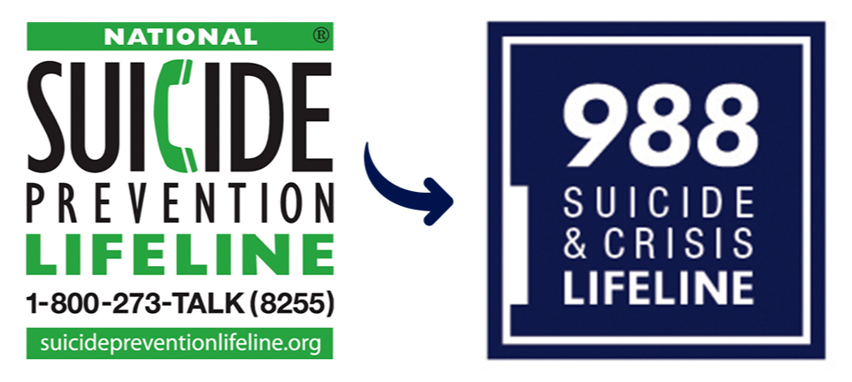

(Samples)
CONFLICT RESOLUTION CONTRACT

As a member of the San Pasqual Valley Elementary School community, I understand that conflicts can arise from time to time. I am committed to resolving conflicts in a peaceful and respectful manner. To support this commitment, I agree to:

- Treat others with respect and kindness, even when I disagree with them.
- Listen carefully to the other person's point of view.
- Speak in a calm and respectful tone of voice.
- Seek to understand the other person's feelings and needs.
- Focus on finding a solution that works for everyone involved.
- Work with my teacher or other school staff to resolve any conflicts that cannot be resolved between myself and the other person involved.

If I am involved in a conflict, I understand that I have the right to:

- Speak with my teacher or another school staff member about the conflict.
- Bring a friend or family member to help me communicate my thoughts and feelings.
- Request that a mediator be present to help facilitate the discussion.

I understand that if I violate this conflict resolution contract, I may be subject to disciplinary action.

ANTI-BULLYING CONTRACT

Our goal at San Pasqual Valley Elementary School is to provide each student with a safe learning environment.
Bullying is defined as any repeated and intentional behavior directed toward another person or group of people that involves physical, verbal, electronic, or written expression or gesture, that causes physical or emotional harm to the targeted person or group, places the targeted person or group in reasonable fear of harm, or creates a hostile environment that interferes with the educational process. It often involves an imbalance of power and is often repeated over time.
Cyberbullying is defined as bullying that occurs through the use of technology or electronic communication, including but not limited to cell phones, computers, social media sites, and other similar means.

As a member of the San Pasqual Valley Elementary School community, I, __________________ understand that bullying is not acceptable behavior. I am committed to treating others with kindness and respect. To support this commitment, I agree to:
- Not engage in any form of bullying, including physical, verbal, or social bullying.
- Not participate in any activity that is intended to harm or embarrass others.
- Speak up if I witness bullying behavior and report it to a teacher or other school staff member.
- Treat others the way I would like to be treated, including those who may be different from me.
- Respect others' personal space and belongings.
- Understand that using technology to bully others, including cyberbullying, is also not acceptable.
- Refuse to pass along any harmful or hurtful messages or rumors.
- Work with my teacher or other school staff to promote a positive and inclusive school culture.
I understand that if I violate this anti-bullying contract, I may be subject to disciplinary action.

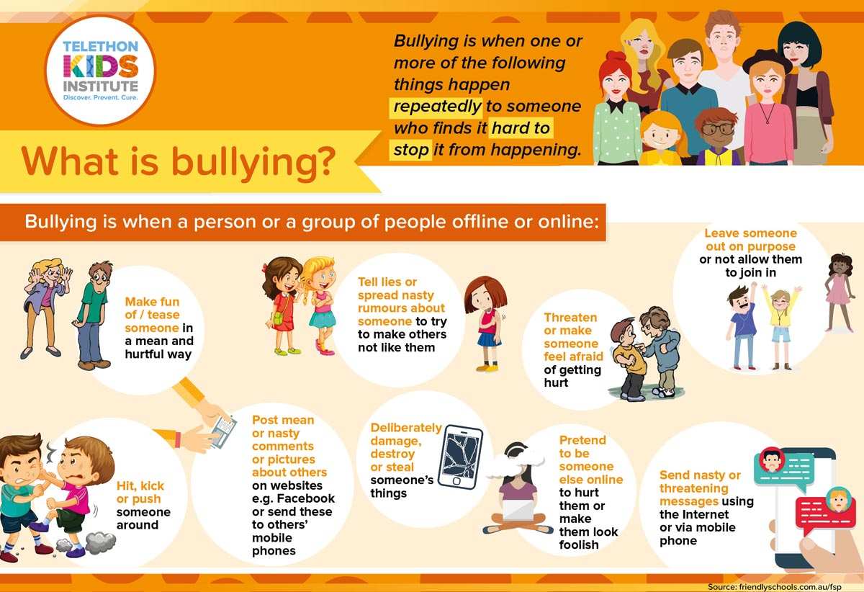
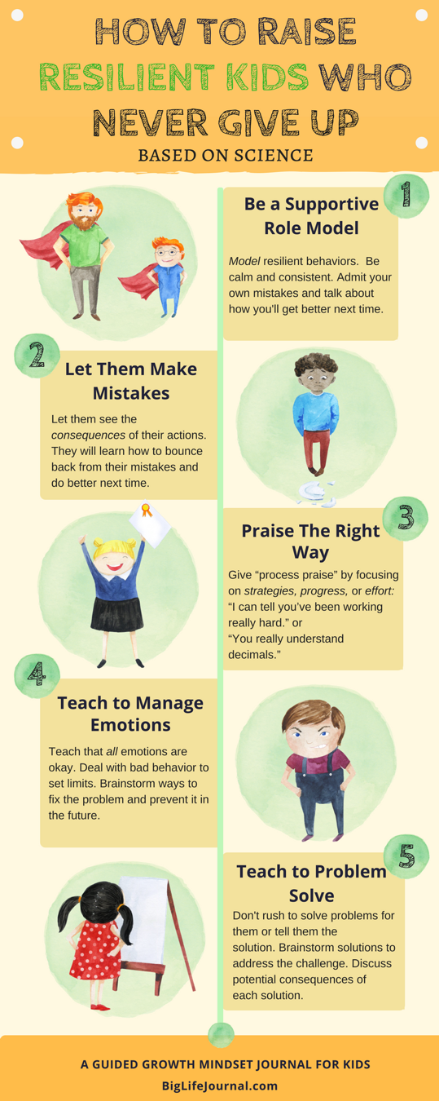



PEACEBUILDERS© PROGRAM AND PEACE AMBASSADORS
San Pasqual Valley Unified School District is a PeaceBuilder District. PeaceBuilders is a research-validated violence prevention youth program. It is a comprehensive program that shifts the entire climate of a school or district to a peaceful, productive, and safe place for children, parents, and staff.

In the school setting, PeaceBuilders increase academic achievement by allowing teachers to spend more time teaching and less time disciplining. In all settings, the program creates a peaceful environment by increasing positive, respectful, thoughtful behavior, while decreasing violence and disruptive behavior. Children who are in a positive, peaceful environment, feel positive, ready to learn, and are able to process abstract concepts more easily.

Each morning the elementary students and staff recite the PeaceBuilders Pledge. The staff prepares PeaceBuilders Assemblies for the students to help them understand the PeaceBuilders Principles. Teachers teach weekly PeaceBuilders lessons in their classrooms. The PeaceBuilders Program affects the whole school by increasing cooperation, achievement, and individual success. We encourage families to memorize the PeaceBuilders Pledge or talk about what the PeaceBuilders principles mean to them.

PEACE AMBASSADORS
Students in grade three through five are eligible to participate in the Peace Ambassador program. Peace Ambassadors are considered role models for other students and at times will miss class time to participate in Peace Builder events. Therefore, good behavior and passing grades are a requirement of all Peace Ambassadors. Students interested in being a Peace Ambassador must submit an application and meet the following requirements:
- Models the PeaceBuilder Principles
- Has no missing assignments
- Maintains 90% attendance
Students who meet the above criteria will also be required to do the following:
- Attend 2 training days consisting of:
- Introduction and Team Building
- Opening Statements/Empathy/Listening/Restating
- Steps of Peer Mediation
- Role Play Peer Mediation

Academic Program

Curriculum
San Pasqual Valley Elementary uses California state-adopted instructional materials to provide rigorous, standards-aligned instruction in each core subject.
The following is a list of the publisher series in use:

TK
Scholastic Big Day
Kindergarten - 5th Grade
Language Arts – HMH Journeys
Mathematics – EnVision – Pearson California
History/Social Science – Studies Weekly (K-1st) McGraw Hill (2nd-5th)
Science – Amplify

Transitional Kindergarten (TK)
Designed as the first year of a two-year kindergarten program, TK is meant to foster enthusiasm about learning and ignite creativity. Families with four-year-old children have a choice between a traditional preschool (PK) or a Transitional Kindergarten (TK) program. The ratio of adults to TK students is 12 to 1.
To qualify for TK children must turn five between Sept. 2, 2026, and June 2, 2027.
Next school year, TK will be open to children who will have their fourth birthday by September 1 of the school year.

Expanded Learning Opportunities Program (ELO-P)
ELO-P offers extended learning opportunities for students in grades TK-6th grade. In addition to 3 weeks of summer school, we are required to provide 16 additional days of learning on Saturdays. All Super Saturday School sessions run from 8am to 5pm and are filled with arts and crafts, science and engineering challenges, and field trips.

Progress Monitoring Assessments

State Testing Notification
California students take several mandated statewide tests. These tests provide parents/guardians, teachers, and educators with information about how well students are learning and becoming college and career ready. The test results may be used for local, state, and federal accountability purposes.

California Assessment of Student Performance and Progress (CAASPP)

Smarter Balanced Assessment Consortium Assessments
The California Assessment of Student Performance and Progress (CAASPP) computer adaptive assessments are aligned with the Common Core State Standards (CCSS). English language arts/literacy (ELA) and mathematics tests are administered in grades three through eight and grade eleven to measure whether students are on track to college and career readiness. In grade eleven, results from the ELA and math assessments can be used as an indicator of college readiness.

California Science Tests (CAST)
The new, computer-based CAST measures student acquisition of the California Next Generation Science Standards. It is administered in grades five and eight, and once in high school. The new computer-based CAST replaces the California Standards Tests (CST) for Science.

California Alternate Assessments (CAA)
The computer-based CAA for ELA and CAA for mathematics is administered to students with the most significant cognitive disabilities in grades three through eight and grade eleven. Test items are aligned with the CCSS and are based on the Core Content Connectors. The instructionally embedded CAA for Science is administered in grades five and eight, and once in high school.

Standards-based Tests in Spanish (STS) for Reading/Language Arts
California offers the optional STS for Reading/Language Arts, which are multiple-choice tests that allow Spanish-speaking English learners to demonstrate their knowledge of the California content standards. The California Spanish Assessment (CSA) will replace the optional STS. The CSA will be a computer-based assessment that is aligned with the California CCSS en Español.
Pursuant to California Education Code Section 60615, parents/guardians may annually submit to the school a written request to excuse their child from any or all of the CAASPP assessments.

English Language Proﬁciency Assessments for California
The ELPAC is aligned with the 2012 California English Language Development Standards. It consists of two separate English Language Proﬁciency (ELP) assessments: one for the initial identiﬁcation of students as English learners and the other for the annual summative assessment to identify students’ English language proﬁciency level and to measure their progress in learning English.

Physical Fitness Test
The physical fitness test (PFT) for students in California schools is the Fitness Gram®. The main goal of the test is to help students in starting lifelong habits of regular physical activity. Students in grades five, seven, and nine take the fitness test

Grade-level Standards for Promotion
As per SPVUSD, Elementary Multiple Grade Level Standards for Promotion, students must achieve two of the three benchmarks to be promoted to the next grade level:
- Students must be in attendance at school for 90% of the school year.
- Students must score at “Nearly Met” or above on the California Assessment of Student Performance and Progress (CAASPP)
- Students must demonstrate progress toward grade-level standards on two or more measures including: STAR Reading/Math, DIBELs progress monitoring, IXL Reading/Math, writing samples with rubric scores.
Students not meeting the above criteria can only be promoted if:
- They receive an exception letter based on the criteria outlined by the California Education Code.
- They scored “Met Standards” or “Exceeds Standards” on the current year California Assessment of Student Performance and Progress (CAASPP) in the areas of Language Arts or Math. Scores for these tests do not arrive until August.
PROGRESS/REPORT CARDS
At the midpoint of each grading period, parents are notified of student progress in all subject areas. These written reports are to keep students and parents informed. Report cards are issued 4 times per year. If you do not receive a report card, please contact the classroom teacher, or school office. Parents are encouraged to contact the classroom teacher if there are any concerns.

Parent Conferences
Parent conference nights will be held in conjunction with the release of the 1st quarter Report Card and the 3rd quarter Report Card. Individual parent conferences may be scheduled with the teacher at any time throughout the school-year.

Parent Involvement and Volunteers
San Pasqual Valley Unified School District encourages parents to be involved in their child’s education. If you would like to volunteer or to help in any way, please stop by the elementary or district administrative office for more information. In some cases, volunteers may be required to get fingerprint clearance and pass a drug test.

Stress-less Homework Policy
At SPVE, we believe that learning should not end when students leave the classroom. However, we also believe that children need time to play, read, and spend quality time with their families. Therefore, we have adopted a stress-less homework policy.
We encourage students to read for pleasure and practice basic skills, such as math facts and spelling, at home. However, we do not assign traditional homework such as worksheet packets, projects, or assignments that require significant time and effort outside of the classroom.
Instead, we ask that parents and caregivers support their child's learning by engaging in meaningful conversations, exploring the world around them, and pursuing their interests outside of school. We believe that by fostering a love of learning and curiosity, students will be more engaged in the classroom and develop a lifelong passion for education.

Here are activities the teachers might assign or recommend for stress-less homework:
Read together: 20 minutes of reading per day can make a significant positive impact on a child’s vocabulary and reading fluency skills. Reading together is a great way for families to spend time together and promote literacy skills. Take turns reading aloud or snuggle up and enjoy a good book together.
Play games: Playing games together can be a fun and educational way to spend time as a family. Games like Scrabble, chess, and Settlers of Catan can help build critical thinking and problem-solving skills.
Explore the outdoors: Take a walk in the park, visit a nature center, or go on a hike. Spending time in nature can help reduce stress and improve overall well-being.
Cook a meal together: Cooking is a valuable life skill and can be a fun way to bond with family members. Encourage children to help with meal planning, shopping, and preparing the meal.
Pursue interests: Encourage children to pursue their interests outside of school. This could include hobbies like drawing, writing, or playing music.
Volunteer: Volunteering in the community is a great way to give back and teach children about the importance of civic engagement.
Remember, there are many valuable activities that families can do together instead of homework. The most important thing is to spend quality time together and promote a love of learning.

Make-up Work
It is the responsibility of the student returning from an absence to ask for assignments missed. Students may ask for future assignments for known upcoming absences.

Requesting a Teacher for Your Child
Parents are able to request teachers for their children during an appointed window at the end of the year, which will be the first two weeks of May. The requests must be in writing. Every effort will be made to grant each request; however, it is important to remember that due to many factors, we may not be able to grant all requests.

Student Study Team (SST)
Our school is committed to providing all students with the support they need to succeed academically, socially, and emotionally. To ensure that every student has the opportunity to thrive, we have established a Student Study Team (SST) process.

The SST is a collaborative team that includes parents/guardians, teacher, administrator, counselor and other support staff that has knowledge of the student’s strengths and struggles. The team meets regularly to identify students who may be struggling academically, socially, or emotionally, and to develop individualized plans to support those students.

If your child is identified as a candidate for the SST process, you will be notified by the school. You will be invited to participate in the SST meetings and to share information about your child's strengths, challenges, and needs.

The SST process is designed to be supportive and collaborative, and to ensure that every student receives the individualized attention and support they need to succeed. If you have any questions or concerns about the SST process, please contact the school office for more information.

Daily and Emergency Safety Procedures

The safety and well-being of our students is our top priority at our school. This section outlines our policies, procedures, and guidelines to ensure a safe learning environment for all students, staff, and visitors. We believe that a safe school environment promotes student learning, growth, and success. This section covers a wide range of topics, including emergency procedures, school security, playground rules, transportation safety, and more. It is important for parents and guardians to review this section with their child to ensure they understand the expectations and guidelines for staying safe while at school. Our goal is to work collaboratively with families to create a culture of safety, where everyone feels supported and informed. We encourage you to reach out to us with any questions or concerns related to school safety.

School Visitors
A visitor is defined as any person seeking to enter a school building who is not an employee of the school district, or a student currently enrolled in that building. School visitors, under no circumstances, are permitted to be left alone with students for any reason. School visitors must be under the supervision of a school employee at all times while on any school campus.
- All visitors shall report to the school office when arriving or leaving the school premises.
- All visitors shall be requested to wear a visitor’s pass when on school premises.
- It is possible that visits may not be allowed at certain times of the school year or school day, such as, but not limited to, the first and last weeks of school, immediately before or after vacations or other breaks, while standardized testing or other student assessments are being conducted, or for any other reason deemed necessary by school personnel.

Visitors to Classrooms or Other Instructional Areas
Access to particular classrooms or other instructional areas of the school may not be allowed upon the recommendation of the classroom teacher or as otherwise deemed necessary by the principal. Visitors wishing to conference with teachers or administrators need to contact the elementary office to speak to their child’s teacher to schedule a time in advance.

Because classrooms and other instructional areas are the most vulnerable to disruption, specific conditions may be required of visitors, including but not limited to:
- remaining in a designated area or seat
- refraining from speaking to students while the class or activity is in session
- refraining from entering or leaving the area while an activity is underway
- requiring that the visitor be chaperoned
- limiting the duration of the visit to particular times or length of time
- limiting the activities of the visitor to a particular purpose(s)

Bus Riding Procedures

Your child’s safety is our priority. Students and parents must understand that bus transportation to and from school is a privilege, not a right. All school rules apply while on the bus and all other district vehicles. Depending on the bus infraction, students can lose the privilege to ride the bus if bus procedures are not followed.

- Arrive at the bus stop early: Students should arrive at the bus stop at least five minutes before the scheduled pickup time.
- Stand back from the road: Students should stand back from the road and wait for the bus to come to a complete stop before approaching it.
- Board the bus in a single file: Students should board the bus in a single file, using the handrail to climb the steps.
- Find assigned seat: Drivers use a seating chart on the bus. Students should find their assigned seat quickly and remain seated for the duration of the ride.
- Keep the aisle clear: Students should keep the aisle clear of bags, backpacks, and other items.
- Talk quietly: Students should talk quietly while on the bus, as loud noises can distract the driver and make it difficult for them to hear traffic.
- Follow the driver's instructions: Students should follow the driver's instructions at all times and avoid distracting the driver.
- Exit the bus safely: Students should wait for the bus to come to a complete stop before exiting and should use the handrail when exiting.
- Cross the street safely: Students should always look both ways before crossing the street and cross in front of the bus, never behind it.
- Report any issues: Students should report any issues or concerns to the driver or the school as soon as possible.

Consequences for Misbehavior on the Bus Behavior
Driver stops the bus and investigates: Name in driver’s book, student placed in front of bus, last one off the bus stop, parent contacted.

1st Bus Referral - Student Conference, Parent Contact, Site Discipline Plan
2nd Bus Referral - Student Conference, Parent Contact, Site Discipline Plan AND three (3) Day Bus Suspension.
3rd Bus Referral - Student Conference, Parent Contact, Site Discipline Plan AND five to ten (5 - 10) Day Bus Suspension.
4th Bus Referral - Student Conference, Parent contact, Site Discipline Plan AND revoke bus privileges for the rest of the year.

“Bus Note” Procedures
Having a consistent pick up and drop off location on file is essential for keeping all students safe. Students are to board and disembark only at their designated stops. There is a limit of FIVE “Change in Transportation Request/Change in Student Dismissal Procedure” per year. This request can only be accepted in written form.
We understand that at times emergencies arise and parents/guardians must make a request by phone. In this case and for the safety of your child, all requests must be made prior to 11:00 AM each day.
If you would like your child to walk home, please send a note with your child to school and submit it to the teacher.

Parent Drop-off Procedures
Drop off: All students should enter through the cafeteria doors in the morning until 7:55AM.
- Please KEEP THE BUS LANE CLEAR for all buses during the morning from 7:15 – 7:55AM.
- If a bus is in the lane, please DO NOT ENTER.
- Students should walk along the paved sidewalks to avoid crossing the lane of traffic when entering the cafeteria.
- Students that arrive after 7:55AM should go to the Elementary office to obtain a tardy slip.
Pick Up: Students who are picked up by their parent/guardian each day will wait in the cafeteria until the buses clear. Parents will line up after buses clear and staff will walk your student to your car.

Food and Drink on Campus
Students are encouraged to bring a water bottle each day. Colored and flavored drinks are not allowed and will be confiscated. Students are to follow the teacher’s classroom food and drink rules. All cafeteria food and drink are to be consumed in the cafeteria unless otherwise authorized. Snacks may be given to students as an incentive. Gum is not allowed, unless it is a part of a child’s classroom educational modification plan.

PLEASE REFRAIN FROM PACKING THE FOLLOWING ITEMS:
- Candy
- Carbonated drinks; Caffeinated/Energy Drinks
- Full sized bags of chips
- Peanuts
Students will be made to throw these items away.

Birthday Celebrations
In an effort to maximize class time and minimize interruptions, SPVE will have 1 class birthday celebration per month, on a date and time to be determined and communicated by the teacher. All summer birthdays will be celebrated in August.

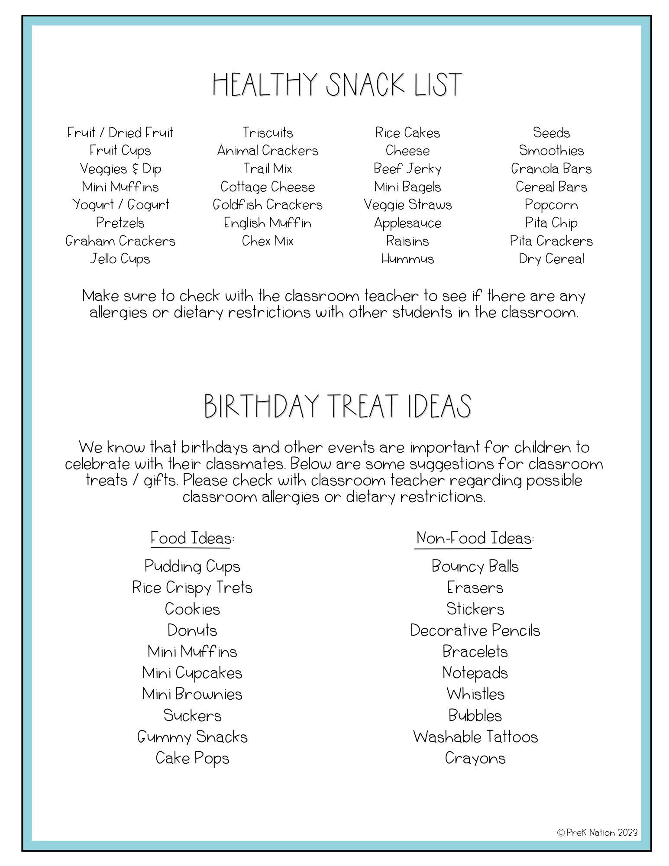

Cafeteria Procedure

Students should follow the school-wide behavior expectations as well as these procedures to ensure a safe and efficient lunch period for everyone involved.

- Entering the Cafeteria: Students usually enter the cafeteria in an orderly and quiet manner, usually in a single-file line then make their lunch choice by getting in the corresponding line. Teachers or cafeteria staff members may lead students to their designated tables or sections.

- Obtaining Meals: Students are required to pick up their meals from the designated area. All students are eligible to receive breakfast and lunch at no cost.

- Seating: Once students have their meals, they will proceed to their designated tables or sections. Students have the privilege of choosing their own seat, however, Staff may assign seats, if necessary.

- Eating: Students are expected to follow basic table manners and eat quietly, disposing of their trash properly. Students may not share or trade food.

- Cleaning Up: Once students are finished eating, they are expected to clean up their table or area, placing trash in designated bins.

- Dismissal: After the designated lunch period, students will be dismissed from the cafeteria in an orderly and quiet manner. Students are not allowed to remove food from the cafeteria unless it is in a lunch box or bag.

Library and Media Center
SPVE is thrilled to provide access to our school library on a weekly basis! We are committed to creating a safe and enriching environment for learning and reading. Please review our library policies below:

Library Hours: Our library is open during school hours, and students may visit during their scheduled library time or with their teacher's permission.

Borrowing Materials: Students may check out books for up to two weeks. Students are responsible for returning books on time and in good condition. Students may renew a book if they need more time to finish reading it.

Lost or Damaged Books: Students are responsible for the books they borrow. If a book is lost or damaged, students' parents or guardians will be responsible for paying the replacement cost of the book.

Behavior: Students are expected to follow the school-wide rules and use library materials and equipment appropriately and with respect. Talking, eating, drinking, and running are not allowed in the library. Students who cannot follow library rules may lose library privileges.

Selection of Materials: Our library offers a wide variety of books and other materials that support the curriculum and encourage reading for pleasure. We make every effort to ensure that materials are age-appropriate and aligned with our school's values and beliefs.

Parent Involvement: We encourage parents to visit our library and to talk with their child about the books they are reading. Parents are also welcome to volunteer during various school library events during the school year.

We hope that your child enjoys using our library and develops a love of reading that will last a lifetime. If you have any questions or concerns, please do not hesitate to contact us.

Computer and Internet Usage
Students may have access to the internet if they and their parent/guardian complete the Internet Usage License Agreement Contract. They must abide by the rules governing student access and use. No trade may be conducted through the school and inappropriate subjects, (i.e., Facebook, YouTube, and other social networking sites) may not be accessed. Students who abuse the privilege will lose their right to access the internet. Signing the Internet Usage License Agreement is considered the student’s first warning.

Student Health at School

Emergency Information
Emergency information obtained from the parent/guardian is used to contact a parent/guardian if your child is ill or an emergency arises. Please make sure that information in the office is accurate and current. Your child’s health is important, please call the school office (760-572-0222 ext. 2101) if your child’s health status changes.

Sick Children
Children with a contagious disease, such as a virus, impetigo, conjunctivitis (pink eye), or Covid-19 should not come to school until disease is no longer transmittable. Students with contagious conditions will be sent home. Any student who has had diarrhea or has been vomiting may not return to school until he/she has been symptom free for 24 hours. A doctor’s note may be required if the absence is more than 3 days. Please contact the attendance clerk when your child needs to stay home due to illness (760-572-0222). Ext. 2101.
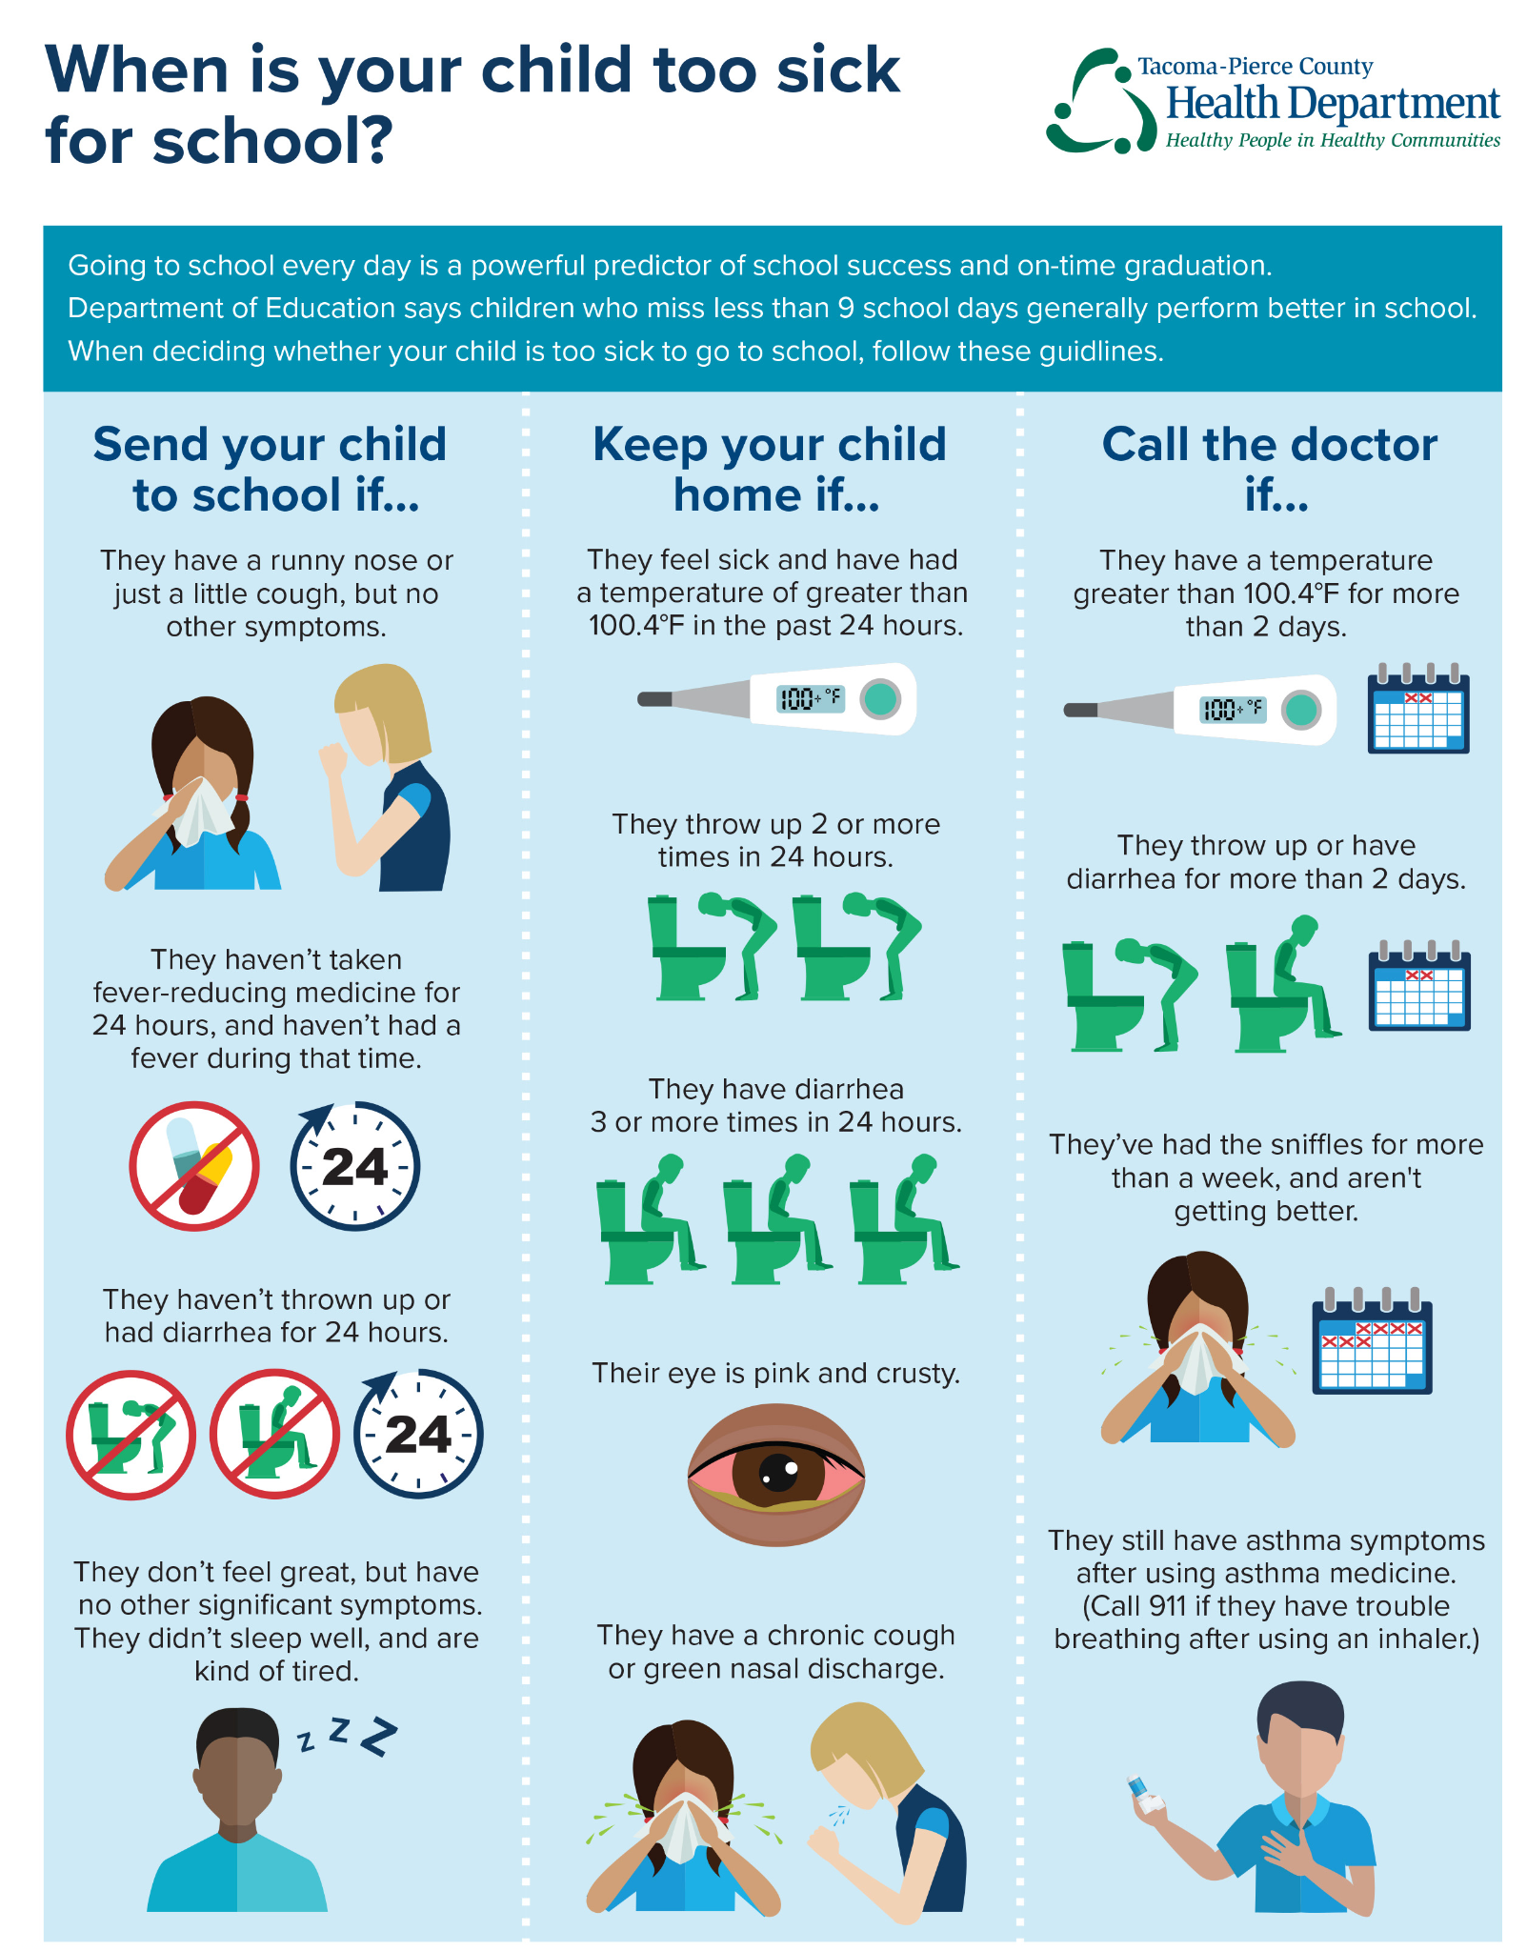

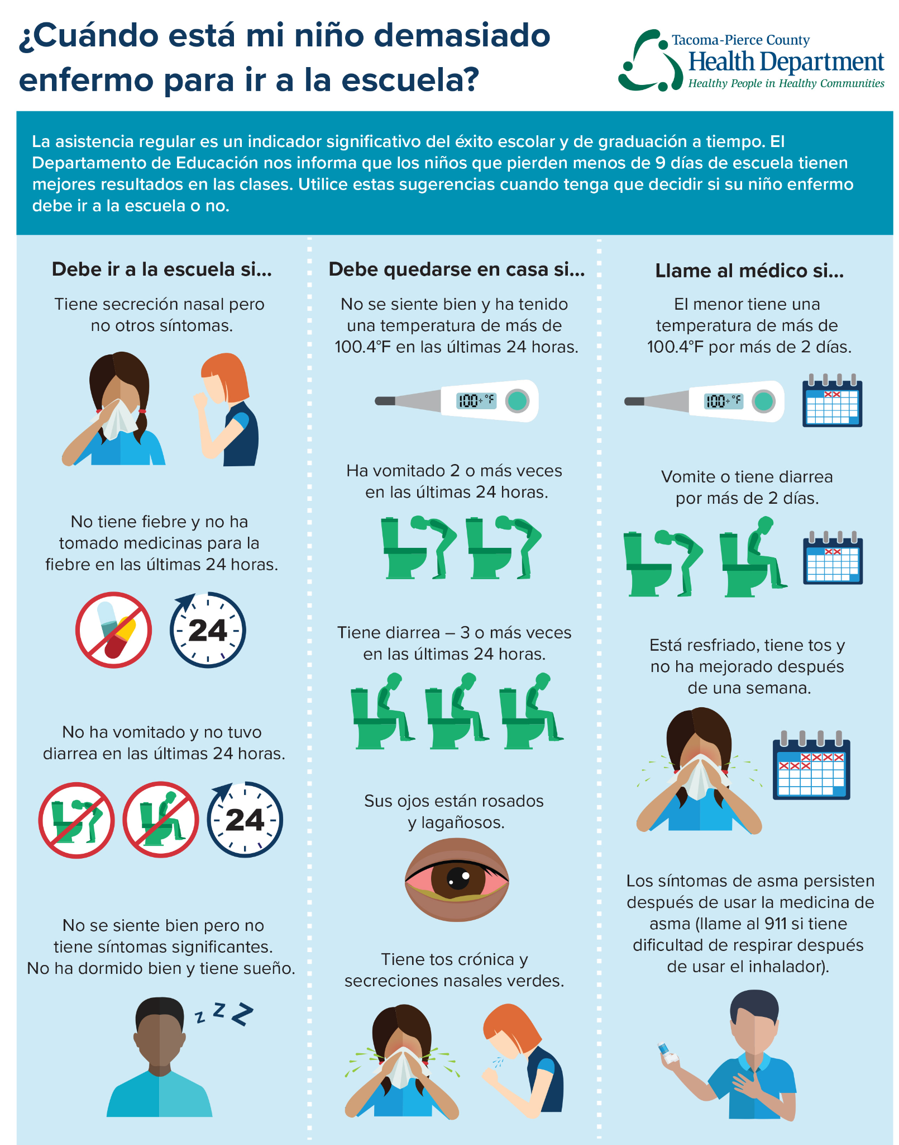

Head Lice
Our school is committed to maintaining a healthy environment for all students, and head lice can be a common problem among children. We ask that all parents take the necessary steps to help prevent the spread of head lice and to work with the school to control outbreaks.

Prevention:
- Teach your child to avoid head-to-head contact with other children.
- Instruct your child not to share combs, brushes, hats, or other personal items with other children.
- Check your child's head regularly for signs of head lice and treat it promptly if you detect any signs.

Control:
- If a child is found to have head lice, his/her parents will be notified, the child will finish out the school day before being sent home for treatment.
- The child may return to school after being treated and having no live lice.
- The school nurse will conduct follow-up checks to ensure that the lice have been eliminated.
- We encourage parents to seek guidance from healthcare professionals regarding treatment options.
- We will respect the privacy of students and families dealing with head lice.

The parent/guardian of any such student shall be given information about the treatment of head lice and encouraged to begin treatment of the student immediately and to check all members of the family.

If a student is found consistently infested with head lice, he/she may be referred to a multidisciplinary team, which may consist of the school nurse, representatives from the local health department and social services, and other appropriate individuals, to determine the best approach for identifying and resolving problems contributing to the student's head lice infestations.

Medications
Students are not permitted to have medication of any kind in their possession while on campus.
- Whenever possible, we encourage parents and students to work out the dosage schedule with the doctor so that medication is not given during school hours.
- Only medication prescribed by a licensed physician in the United States may be administered at school.
- The licensed physician must include the name of the medication, method, dosage, and time schedule by which the medication is to be dispensed.
- The school will not dispense medication without a Medical Release Form completed and signed by the parent and a licensed United States physician.
- All medications must be submitted to the school office in their original container with the original label attached and will remain locked in the school nurse’s office.
- Please contact the site office for a copy of the Medical Release Form.

Immunizations
To protect those in educational settings and communities from communicable disease outbreaks, the State of California requires documentation of complete immunizations of students before entering school. Annual review of student health records are mandated by State law. Parents are required to supply updated immunization records on any students who have deficient records. These records must be one of the following:

- A copy of the hospital, clinic, or doctor’s office record
- The California (or other state or county) immunization card (baby shot book)
- Records from previous school

Immunizations needed for student registration are listed below:
Polio 1st, 2nd, 3rd & 4th
Dtp 1st, 2nd, 3rd, 4th & 5th
MMR 1st, 2nd
Hep-B 1st, 2nd, 3rd
Varicella 1st (or history of chickenpox disease)
Hep A is not required for entry

In addition, new Kindergarten and First grade students must have a health physical and oral exam with the results completed on the school’s Health Physical Examination and the Oral Health Assessment form.

Pets on Campus
For the safety and well-being of our students, faculty, and staff, pets are not allowed on campus. This includes dogs, cats, birds, reptiles, and any other animals that may be considered pets. Pets carry harmful germs and can activate allergies for some. We appreciate your understanding and cooperation in helping to keep our campus safe and comfortable for everyone. If you have any questions or concerns, please contact the school office for more information.

Student Withdraw from School
State law requires that a student, who is withdrawing, must have the school’s Withdrawal Form signed by the parent/ guardian and the attendance clerk. A withdrawal is complete when a student has cleared with the library, classroom teacher, and the attendance clerk. Transcripts and records will not be forwarded until all materials are returned and/or fines paid.

It is important that families and schools work together to help students succeed academically, socially, and emotionally. The following are roles and responsibilities that we, as partners, will carry out to support student success in school and in life.
San Pasqual Valley Elementary School
Student-Parent-Teacher Pledge

Please sign and return to your child’s teacher. Thank you.

Student Pledge:
I agree to carry out the following responsibilities to the best of my ability:
- Come to school each day on time and ready to learn.
- Follow school and bus rules.
- Do my best work at school and home every day.
- Take responsibility for my education by listening and participating in class, doing my homework and seeking help when I need it.
- Read daily outside of school (20 minutes K-3, and 30 minutes for grades 4-5).
- Demonstrate positive character traits by not feeding into bullying behavior.
- Respect the school, classmates, staff, and families and follow the PeaceBuilders© Principles.
Student Signature _________________________________________

Parent/Guardian Pledge:
I agree to carry out the following responsibilities to the best of my ability:
- Provide the school with current phone numbers and home address (update as needed).
- Provide a quiet time and place for reading and monitor TV viewing.
- Read to my child or encourage my child to read every day (20 minutes K-3, and 30 minutes for grades 4-5).
- Communicate with the teacher/school and regularly monitor my child’s progress (agenda, email, phone, conferences).
- Monitor and initial my child’s agenda daily.
- Ensure that my child is in school each day, on time and gets adequate sleep.
- Respect the school, students, staff, and families and encourage my child to follow the PeaceBuilders© Principles.
Parent/Guardian Signature ________________________________________

Teacher Pledge:
I agree to carry out the following responsibilities to the best of my ability:
- Provide motivating learning activities (high student engagement).
- Provide high-quality curriculum and instruction to meet the state’s academic standards.
- Provide a safe and positive classroom environment for all.
- Communicate with parents/guardians regularly regarding student progress (agenda, email, phone, conferences).
- Participate in professional growth activities.
- Respect the school, students, staff, and families and model and teach the PeaceBuilders Principles.
Teacher Signature _________________________________________

