Instructional Trip Request (ITR) Packet (Day Trip Only)
- Instructional Trip Request Instructions (3 pages) Step by step instructions on how to complete the Instructional Trip Request Sample Itinerary

Instructional or Athletic Trip Request Form (3 pages)

- Instructional Trip Expectations Checklist
AP and Trip Organizer to review and sign

Parent/Guardian Instructional Trip Authorization and Emergency Procedure
To be completed and signed by parent and teachers Emergency Procedure & Insurance Verification
Medication in School Form – to be completed if medication will be taken on the trip

Instructional Trip Request Chaperone Clearance
Process on how to become an approved chaperone

Student Alternate Transportation Form: Designation of Adult Driver
Use when a parent/guardian designates an adult driver to drive their student to/from a school sponsored activity

Volunteer Personal Automobile Use Form
Use when volunteering to transport students in your vehicle

Charter Bus Use
If using a Charter Bus this Google Form must be completed

Instructional Trip Request Instructions (Day Trip Only)

Pre-Approval & Compliance
  - Contact the Principal/Designee before making arrangements
  - Submit trip request at least 21 days before activity
  - If over 300 miles, overnight, or out of state/country, submit 2 months prior for Board approval
  - No student excluded due to lack of funds - complete the "Other Support" section (p.2)
  - Attach detailed itinerary, including hotel/airline details, and detailed daily activities and timeframes (p.2 or
an attached document)
  - Outline educational objectives (p.2)

Completing the Form

  - School Name (Check: EDHS, IHS, ORHS, PHS, UMHS, PCA)
  - Activity Name & Location (City, State)
  - Sponsoring Teacher/Organization
  - Trip Dates & Times
  - Pickup & Return Details
  - Estimated Total Hours & Missed Instructional Days
  - Trip Miles (Check one: □ Within 300 miles □ Beyond 300 miles □ Out of State/Country)

Transportation:
  - Select method(□District□ Commercial□ Private□ Other□ Van)
  - If under 300 miles & over 24 students, Transportation Office must be given a quote opportunity
  - Submit Request for Transportation Form (if needed)
  - Collect and Approve all Volunteer Driver & Student Driver forms as needed

Supervision:
  - List all supervising staff/adults (certificated, classified, coaches, parents, volunteers)
  - Required ratio 20 students: 1 adult (must include at least one certificated staff member)
  - All non-EDHUSD staff must be cleared by HR to chaperone

Trip Costs & Budgeting
  - Identify funding sources:
  - Fundraising
  - Sponsored Organization
  - Budget Allocation
  - Other (explain)
  - Enter all costs (No blank spaces, so enter $0 or NA if necessary):
  - Transportation & Driver Time
  - Lodging & Meals
  - Entry/Registration Fees
  - Cost per Student
  - Substitute Teacher Costs
  - Enter Budget codes or Funding Sources
  - Budget codes verified & initialed by site's Accounting Specialist

Final Approvals
  - Department Chairperson Signature (if department funds are being spent)
  - Principal Signature
  - Principal/Designee Signature on Instructional Trip Expectations Checklist

- Supervision & Safety (Instructional Trip Expectations Checklist)
  - Meet with Principal/Designee to review & sign Instructional Trip Expectations Checklist
  - Adequate supervision (20:1 student-to-adult ratio)
  - Supervisor/Chaperone roles & responsibilities clearly communicated
  - Any student taking medication on this trip MUST submit a Medication-in-School form, completely
filled out with all required signatures.
  - All chaperones must be cleared as Staff/Coach/Advisor/Volunteer (Admin should check with HR)

Submission & Final Steps
  - Submit completed forms to site's Administrative Assistant for final verification
  - Obtain Principal’s approval

6/26:
7:00 am: Meet at Ponderosa High School
Ponderosa Football 2025 Football Camp Itinerary


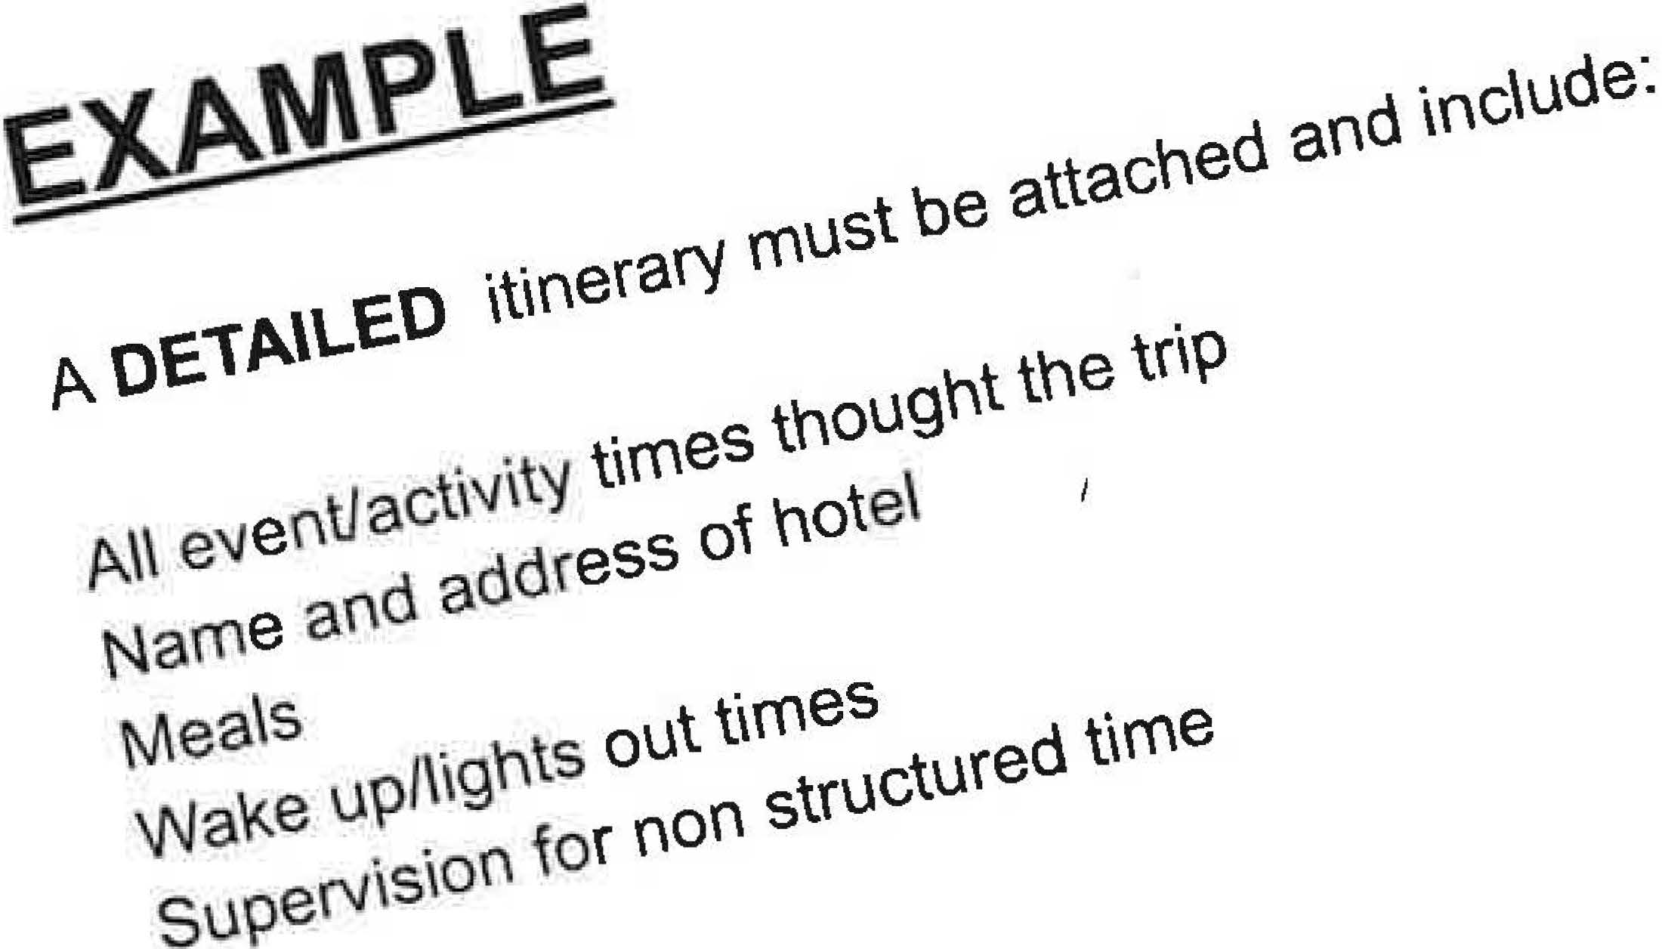
7:30 am: Load vans and depart for Phoenix., Oregon 10:30 am: Stop in Redding, CA for brunch
l l :30 am: Leave Redding and depart for Phoenix
2:00 pm: Check in at hotel (America's Best Inn Phoenix, OR) 3:00 pm: Load Vans for Phoenix High School
3:30pm: Practice I 5:30 pm: Dinner
7:30 pm: 7 on 7 / Lineman Challenge 9:00 pm: Back to hotel
I 0:30 pm: Bed Check I Lights Out 6/27 and 6/28:
7:00 am: Wake up 7:15 am: Breakfast 8:30 am: Practice l
11 :00 am: Back to hotel
11 :30 am: Lunch
3:00 pm: Practice 2
5:00 pm: Dinner
7:30 pm: 7 on 7 / Lineman Challenge 9:00 pm: Back to hotel
10:30 pm: Bed Check/ Lights Out 6/29:
7:00 am: Wake Up
7:30 am: Room Check/ Load Vans
8:00 am: Depart for Ponderosa High School I 0:30 am: Stop in Redding, CA for bmnch 11 :30 am: Depart from Redding
3: 15-3 :30 pm: Arrive at Ponderosa High School

EL DORADO UNION HIGH SCHOOL DISTRICT
Instructional/Athletic Trip Request (Day trip only)
1. In accordance with BP/AR 6153, was a conference held with the Principal/Designee to discuss the feasibility of the trip BEFORE any arrangements were made? Yes No
2. This request must be submitted to the appropriate school administrator at least 21 CALENDAR DAYS prior to activity.
3. No student in a class or group may be excluded because of lack of funds (EC 35330). No group may go on an outing if any member is excluded because of lack of funds.
4. Trips more than 300 miles, overnight, or out of state or country require 2 MONTHS PRIOR NOTICE and approval by the Board.
5. Upon approval, teacher must execute Form 6153-7, Parent/Guardian Instructional Trip Authorization.

TRIP INFORMATION
^{DATE SUBMITTED} |  | SCHOOL (Check) |  | EDHS IHS ORHS PHS UMHS PCA
^{ACTIVITY} |  |  |  |  |  | ^{ACTIVITY LOCATION ADDRESS:}
SPONSORING TEACHER(s) / ORGANIZATION |  |  |  |  |  | DATES OF TRIP | DATE | TIME | LOCATION
 |  |  |  |  |  | PICKUP
^{EST. TOTAL TRIP MILES}  Within 300-mile radius of transportation Out of State  Beyond 300-mile radius of transportation Out of Country  Describe trip itinerary on reverse side. |  |  |  |  |  | RETURN
 |  |  |  |  |  | EST. TOTAL HOURS: |  | NO. INSTRUCTIONAL DAYS/HOURS MISSED
CERTIFICATED STAFF |  |  |  |  |  | ALL OTHER ADULTS |  |  | PHONE
Staff | Classes Covered by
TRANSPORTATION INFORMATION
APPROX. NO. OF STUDENTS (Provide final list of students to Attendance Office and Transportation no later than day before trip.) |  |  |  |  | NO. OF ADULTS SUPERVISING
^{TRANSPORTATION REQUESTED}  (Be specific, specify arrangements being made)  District (See AR 6153, '4.2.2 and 4.3) Commercial  Private (See AR 6153, '4.7) School Van: |  |  |  |  | AR 3541.1 and AR 6153 state: Transportation to and from all district-sponsored field trips within a radius of 300 miles of Placerville will be performed by district employees. All other trips may be contracted out; however, Transportation shall be contacted and given an opportunity to submit a quote on all trips.
(REQUIRED) Transportation has been given an
opportunity to submit a quote on this trip. X
Director of Transportation’s Signature Date Estimate No.
TRIP COSTS (THIS SECTION MUST BE COMPLETED REGARDLESS OF FUNDING SOURCE.)
Funding Sources Fund-raising activities (Describe on reverse side) Sponsored organization
Budget allocation Other (Briefly explain):
 |  |  | BUDGET CODE OR FUNDING SOURCE |  |  |  |  |  | VERIFIED BY
Transportation Cost | $
Driver Time | $
Lodging Cost | $
Meal Cost | $
Entry Fees / Registration | $
Personal Costs Per Student:  $ x # of students | $
Substitute | $
TOTAL | $ |  | TOTAL MUST BE CALCULATED BEFORE SUBMITTING FORM.

INSTRUCTIONAL TRIP REQUEST (continued)
EDUCATIONAL OBJECTIVES OF THE TRIP:
DETAILED ITINERARY (Attach full itinerary - Include number and length of instructional activities with times, place and address students will stay, number and grade levels of students participating, other pertinent information):
FUND-RAISING:
OTHER SUPPORT (Include plan (list below or attach) to support students unable to contribute all or part of the personal costs of the field trip):
No. Students | Plan:

ADMINISTRATION USE ONLY / APPROVALS

APPROVALS:
Approved as submitted | Board Approval Needed
Not Approved | Board Approval Needed

Department Chairperson________________________________________________ Department__________________________

Principal ____________________________________________________________ Date______________________

TRACKING:
DATE | ITEM | COMMENT
 | Transportation called | Contact: Hours Verified
Request for Transportation form submitted
(see Form 3541.1A or 3541.1B)
 | Activity added to Master Contract
 | Sent to Principal for approval
 | Returned to teacher
Final list of students submitted to Attendance
Office and Transportation

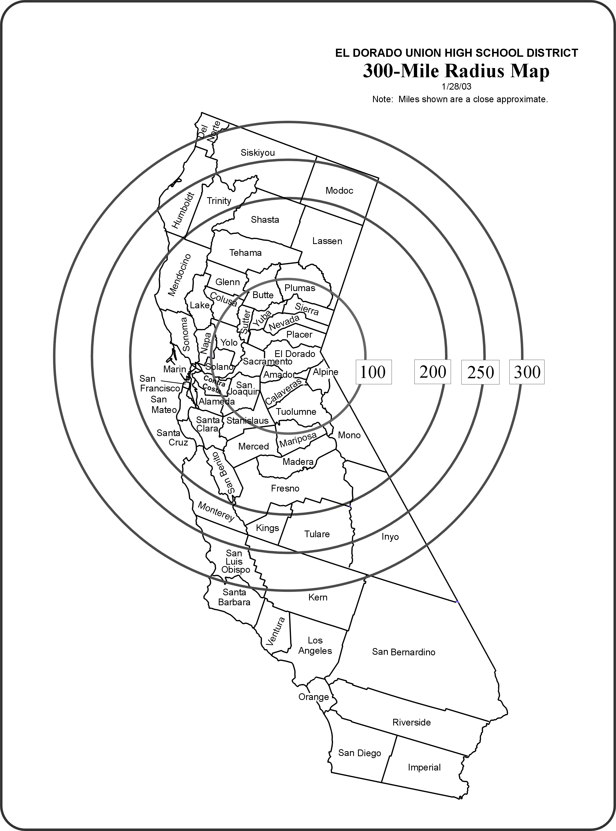
NOTE: Even though trips to Nevada or to the southern portion of Oregon are within 300 miles, they are still out-of-state trips and require Board approval.
Consult a map or on-line map service to determine a more accurate mileage.

EL DORADO UNION HIGH SCHOOL DISTRICT
Instructional/Athletic Trip Expectations Checklist (Day Trip)
School: Sport/Event:
Dates of Trip: Organizer/Leader:

- A detailed itinerary of activities/events will be developed and submitted to the Principal’s Office for approval.

- Behavioral expectations for students will be communicated to students and parents.

- Every student will provide a signed Student Field Trip Authorization Form.

- Medical/Nutritional special needs of students will be reviewed and accommodated.
  - 5141.21H Extended/Overnight /Field Trip Medication Form signed and submitted.

- A first aid kit will be available during the trip.

- Student list and emergency contacts.

- Event/Activity is in compliance with all CIF and/or District Rules and Regulations.

- Students will be directed/reminded not to bring anything with them that would not be allowed at school.

- Searches may be conducted if there is reasonable suspicion to do so.

- Expectations for supervisor, staff and volunteer roles and responsibilities must be clearly communicated.

- All adults who are chaperoning trips must be cleared through the EDUHSD Office.

- Parameters for when students are not in direct visual supervision are to be developed and communicated.

- Adequate supervision has been arranged for given gender and special needs of students.

- Adequate student to adult ratio has been established that is appropriate for the activity/events planned - 20 students to 1 adult for daytime trips (including at least 1 certificated staff member)

- It is understood by all that supervisory responsibility for students is for the duration of the trip.

- It is understood that under no circumstances are any adults participating in the event to engage in the use of alcohol, marijuana, other legal recreational substances, or illegal substances

- If a student misses the bus for a field trip, the trip leader must immediately notify the Attendance Office. Students who drive themselves to the event after missing the bus may not participate; the trip leader must contact the Assistant Principal and the student’s parent/guardian immediately, and follow the parent’s instructions for the student’s return (either driving back to school or leaving the car and returning on the bus). If a student does not report to the bus for the return trip, the trip leader must contact the Assistant Principal and parent before leaving; after all reasonable efforts to locate the student have been made, the bus may depart, and the Assistant Principal will coordinate with the parent or guardian to ensure the student’s safe return home.

We have reviewed, understood and agree to the expectations above:
_________________________ _________________________
School Administrator Signature Organizer/Leader Signature

EL DORADO UNION HIGH SCHOOL DISTRICT
Parent/Guardian Instructional Trip Authorization and
Emergency Procedure/Insurance Verification

STUDENT LAST NAME |  | FIRST NAME |  |  | SCHOOL |  | GRADE
ACTIVITY |  |  |  |  | ACTIVITY SPONSOR
LOCATION |  |  |  |  | DEPARTURE DATE/TIME
TYPE OF TRANSPORTATION |  |  |  |  | ANTICIPATED RETURN DATE/TIME
To Parent/Guardian:

1. Your son/daughter has an opportunity to participate with a group from this school on the activity indicated above. One or more teachers will accompany the group. Signature below signifies that student and parent/guardian agree that the student is to go and return on the school-sponsored transportation indicated above. Privately arranged rides, even with parents, cannot be permitted.

2. Anticipated return time indicates the time at which we expect to arrive back to the starting point. If necessary, parents should arrange to meet their child at this time. Teachers accompanying the group cannot be responsible for seeing that every student has a means of getting home from the starting point.

3. It is the student’s responsibility to communicate with each teacher about potential missed schoolwork. A student absent due to school-sponsored activities may be required by a teacher to complete work before the absence including tests and quizzes.

4. A student attending a school sponsored activity is expected to notify their teachers of their planned absence at least 48 hours in advance and make arrangements to complete all missed assignments in a reasonable period of time. Advanced notice is required to ensure teachers and students have sufficient time to make arrangements.

5. Student shall have satisfactory attendance and be current in his/her academic work in order to participate in the trip.

6. A student will not be permitted to accompany the group unless this form is signed by the parent or guardian, such signature to signify parental approval and completion of the health insurance information (see reverse side).

7. If your student will be taking medication on the trip, a Medication in School form MUST be completed, signed and submitted to the school nurse at least 48 hours before the trip.

8. If your student misses the bus, they must report to the attendance office immediately. Students may not drive themselves to the event and must attend their scheduled classes for that day.

I, as parent/guardian, understand that by permitting my son/daughter to participate in this trip, I have waived all claims against the District (its employees) or the State of California for injury, accident, illness, or death occurring during or by reason of the trip. (Education Code 35330)

My signature below indicates that the above-named student has our permission to attend the field trip as outlined above and per the aforementioned conditions stated above.
 | Parent or Guardian Signature |  |  | Date
To Student: While you are participating in school-related business, you are required to communicate and pre-arrange for make-up work in missed classes with all of your teachers. 48-hour notice is required.

Teachers of said student: Please sign below to verify student/teacher contact prior to the field trip. Teacher signature indicates acknowledgement the student will be missing class.

PERIOD | TEACHER | COMMENT | PERIOD | TEACHER | COMMENT
0 |  |  | 4
1 |  |  | 5
2 |  |  | 6
3 |  |  | 7

Parent/Guardian Instruction Trip Authorization
Emergency Procedure/Insurance Verification
(continued)

EMERGENCY PROCEDURE AND INSURANCE VERIFICATION

The undersigned parent/guardian of |  |  |  |  |  |  |  |  |  |  |  | ,
a minor, do hereby authorize the EL DORADO UNION HIGH SCHOOL DISTRICT, representative as agent(s) for the undersigned in our absence, to consent to X-ray examination, anesthetic, medical or surgical diagnosis or treatment, and/or hospital care which is deemed advisable by, and is to be rendered under the general or special supervision of any physician or surgeon licensed under the Medicine Act, whether such diagnosis or treatment is rendered at the office of said physician or at any duly licensed medical facility.

It is understood this authorization is given in advance of any specific diagnosis treatment, or hospital care required, but is given to provide authority and power on the part of our aforesaid agent(s) to give specific consent in any medical emergency to any and all such diagnosis, treatment, or hospital care which the aforementioned physician in the exercise of best judgment may deem advisable. This authorization is given pursuant to the provisions of Section 25.8 of the CIVIL CODE OF CALIFORNIA.

The undersigned agrees to bear all costs incurred as a result of the foregoing. This authorization shall remain in effect for the duration of this school-sponsored trip.

Father or  Guardian |  |  |  |  |  |  |  | Date
Home/Cell Phone |  |  |  |  |  |  |  | Business Phone
Mother or  Guardian |  |  |  |  |  |  |  | Date
Home/Cell Phone |  |  |  |  |  |  |  | Business Phone
Allergies/Medical Conditions
Medical/Accident Insurance Company
Insurance Policy/Group #
Doctors Name |  |  |  |  |  |  |  |  | Phone
Special Instructions:

Will your student take medication on this trip? Yes No

If yes, a Medication in School form MUST be completed, signed and submitted to the school nurse at least 48 hours before the trip departure.

PAGE2 OF 2 PLEASE COMPLETE BOTH SIDES OF THIS FORM F6153-7 1/87; Revised 5/17/17, 7/21/25

Please return this form to  the School Nurse at least 48  hours before an overnight trip. | EL DORADO UNION HIGH SCHOOL DISTRICT  Medication in School

1. ADMINISTRATIVE STATEMENT

Medication may be dispensed to students by designated school personnel whenever a health care provider finds it necessary to prescribe medication to be taken during the regular school day.
2. MEDICATION PROCEDURE

The form below or similar authorization must be completed by the parent or guardian AND health care provider for any medication that is to be taken during the regular school day. All medication administered at school, even if sold over the counter, must be prescribed by a health care provider.

The parent/guardian must provide all medication, including over-the-counter medication, in the original container. For prescription medication, the pharmacist can provide a second labeled bottle so that one bottle can be brought to school and one bottle can be left at home.

3. PARENT REQUEST

I request that designated school personnel assist my child by giving him/her the medication as set forth in the health care provider’s instructions below and give consent for the designated school personnel and health care provider signing below to exchange medication information. If the medication is an asthma inhaler or an EpiPen, I consent to my child self-administering the medication if designated to do so by the health care provider below. I release the district and school personnel from civil liability in the event my child has an adverse reaction to the asthma inhaler or EpiPen. I may terminate consent for administration of medicine at any time.

Student’s Name: |  | Birth Date: |  | Grade:

Parent’s Signature: X______________________________________________________ Date: __________________

4. HEALTH CARE PROVIDER’S INSTRUCTIONS
MEDICATION | DOSE | METHOD OF ADMINISTRATION | HOW OFTEN  (e.g. EVERY 4 HRS) | DURATION  (e.g., SCHOOL YEAR)
#1
#2

Indication for Medication: | #1: |  |  | #2:
Special Instructions/Precautions | #1: |  |  | #2:

This student is able to carry and self-administer his/her asthma inhaler |  | Yes |  | No
This student is able to carry and self-administer his/her EpiPen |  | Yes |  | No

Health Care Provider Signature: X_______________________________________________ Date: ____________________

Health Care Provider Name (PRINT): ____________________________________________ Phone: ___________________

BASIC LEGAL PROVISION: 49423. Notwithstanding the provision of Section 49422, any pupil who is required to take, during the regular school day, medication prescribed for him by a physician, may be assisted by the school nurse or other designated school personnel if the school district receives (1) a written statement from such physician detailing the method, amount, and time schedules by which such medication is to be taken, and (2) a written statement from the parent or guardian of the pupil indicating the desire that the school district assist the pupil in the matters set forth in the physician's statement.

EL DORADO UNION HIGH SCHOOL DISTRICT
Student Alternate Transportation Form:
Designation of Adult Driver

Students participating in off-campus school-sponsored activities, including, but not limited to, practices, games, meetings, competitions, and conferences (“events”), are required to travel on school buses or by other school-designated methods of transportation. Under special circumstances, with the school’s prior written approval, students may be transported to and from events by: (1) himself/herself, (2) his/her parent/guardian, or (3) a designated adult driver. Under no circumstances may students be transported in a vehicle driven by another student or other person under 21 years of age.

This form is required when a parent/guardian designates an adult driver to drive his/her son/daughter to and from a school-sponsored activity. The driver designated must have completed a Volunteer Personal Automobile Use Form that has been signed and maintained by the school. The parent/guardian may designate/authorize the entire list of adult drivers the school has identified for the activities listed or designate specific drivers that are on the list.

This form must be completed and accepted at least ten (10) days before an activity/event in order for the student to be transported to and/or from a school-sponsored activity by a designated driver.

REQUIRED INFORMATION

Name of Student
List Activity or Series of Activities: |  |  | Date of Activity
1)
2)
3)
4)
5)

Check the box below that applies:
I designate the list of drivers the school has identified as adult drivers for the listed activities by their completion of the Volunteer Personal Automobile Use Form.
I designate only the following specific adult drivers who have a Volunteer Personal Automobile Use Form on file with the school.

Specified Adult Drivers:
1)
2)
3)

 |  | X
Printed Student Name |  | Signature Date  X
Printed Parent/Guardian Name |  | Signature Date  X
Printed Name of Employee Arranging Transportation |  | Signature Date
Principal or Designee Signature |  | Date
F6153-3E1 5/3/13; Rev 2/9/15

EL DORADO UNION HIGH SCHOOL DISTRICT

Volunteer Personal Automobile Use Form

Thank you for volunteering your time, and your automobile, to help transport our Students to off-site events or activities. To protect the health and safety of our Students, our District requires that anyone (employee or volunteer) using their personal automobile to transport students, in addition to their own child/children, to and from sanctioned activities must receive prior authorization. Before we can issue such authorization, certain information must be obtained at least 10 days before you transport our Students. You must also agree to abide by certain rules regarding the operation of the vehicle as set forth below.

REQUIRED INFORMATION

Name of Driver:
Driver’s Email Address:
Driver’s Phone Number: |  | Home Cell
CA Driver’s License No. & Expiration Date:
Vehicle(s) Year–Make–Model(s):
Vehicle(s) License Plate Number(s):
Insurance Carrier:
Policy Number & Expiration Date:
Liability Coverage Limits:
SPORT(s) / EVENT(s) | SEASON / DATES(s) |  | SPORT(s) / EVENT(s) | SEASON / DATES(s)
1. |  |  | 3.
2. |  |  | 4.

We also require a photocopy of your driver’s license and your insurance policy declarations page. Should your driver’s license or insurance policy expire during the school year, updated photocopies showing their renewal are required before you will again be eligible to transport Students. By signing below, you are also authorizing the District to: (a) obtain a copy of your Driver Record History and status of your driver’s license, (b) conduct a criminal background check, and (c) contact your insurance company to confirm your insurance status. Also, please be advised that, pursuant to Insurance Code Section 11580.9(d), in the case of an accident, your insurance will provide the primary coverage for any resulting bodily injury or property damage. The District’s automobile liability coverage will apply, if at all, only after your insurance coverage is exhausted through the payment of covered claims. The District does not cover, nor is the District responsible for comprehensive, uninsured motorists, or collision coverage for your vehicle.
Vehicle Safety and Transportation  Procedures & Requirements  For the safety of our Students, in signing below you are also agreeing to the following rules and requirements as listed on this page and on the reverse side of this page.  1. I will not operate an automobile while impaired, whether due to alcohol, drugs (prescription or nonprescription), lack of sleep, or distraction of any kind. I will at all times comply with California law regarding proper operation of the Vehicle, including compliance with all speed limits and posted signs and placards. | 2. I will not transport Students in a Vehicle I have reason to believe may be mechanically unsafe or that may become unsafe due to weather or other natural conditions. I will not transport Students unless I have a working seatbelt for each Student, with seatbelts to be used at all times by myself and all transported Students. The Vehicle(s) may be inspected by District representatives.  3. I am at least 21 years of age and will be the sole driver of the Vehicle for any given activity, event, or competition. I will not let anyone other than myself, my child/children, and authorized Students ride in the Vehicle.

 |  | X
Printed Name of Driver |  | Signature Date  X
Printed Name of Employee Arranging Transportation |  | Signature Date
Principal or Designee Signature |  | Date Received

CONDITIONS AND INSTRUCTIONS

As volunteer driver providing transportation to students involved in an authorized school activity, I have read, understood and will meet the conditions noted below. I further agree to provide the required information and to abide by these conditions and instructions while acting as a volunteer driver.

1. I understand that my own automobile liability insurance will always be considered as primary coverage. Check the adequacy of your liability insurance (see item 1, page 1 of this form). You are liable in the event of accident, injury, or death resulting from such use of your vehicle.

State law states that "all persons making any field trip or excursion shall be deemed to have waived all claims against the district (its employees) or the State of California for injury, accident, illness, or death occurring during or by reason of the field trip or excursion." (Ed Code 35330)

Current minimum requirement for insurance coverage is as follows:

Liability Coverage: $100,000 / $300,000
Property Damage: $25,000

2. I understand that all travel by private car requires prior approval by the principal.

3. I understand that I must be at least 21 years of age in order to be a volunteer driver and certify that fact by my signature on this form.

4. I understand that I must submit a signed Volunteer Auto Use Statement annually to the principal so that my volunteer driving status remains in force.

5. I understand that by signing this form I waive and release the district from any and all claims for reimbursement for any such transportation, unless otherwise permissible by District policy.

6. Vehicles volunteered cannot be designed to carry more than nine passengers and a driver. The vehicle must carry only the number of passengers for which it was designed. Each passenger is required to use a safety restraint. (VC 27360-27360.5, 27363)

7. The number of occupants in a pickup or motortruck may not exceed more persons than can safely sit in the passenger compartment. Motorhomes and open Jeep-type vehicles may not be used to transport students. Students are expressly forbidden to ride in the cargo area of pickups or motortrucks whether or not these areas are enclosed by camper shells or other protective covering.

8. I certify that the vehicle is in safe operating condition, and that I have checked or had a mechanical check prior to the trip, including, but not limited to: tires (including spare), brakes, lights, turn signals, horn, suspension, seat belts, emergency tools and equipment (such as a jack and chains), and that said vehicle is mechanically sound.

9. I certify that the vehicle possesses emergency warning devices, such as flares and/or reflectors.

10. In the event of an accident notify California Highway Patrol and request that they contact the Principal in addition to normal procedure.

11. I will assume supervisory responsibilities for student control to and from activities.

12. I promise not to drive with any alcohol/illegal substances in my system while acting as a volunteer driver.

13. I understand that students, other than my own children, will not be released at any location other than school or as instructed by school staff

Charter Bus Information for

Instructional Trips

Please complete this form if you are using a Charter Bus for an EDUHSD Instructional Trip or Athletic Event.

The Charter Bus Company MUST be SPAB Certified in order to drive our students. Please complete this form as soon as possible when planning a trip.
A representative from the EDUHSD Transportation Department will meet the Charter Bus at the school site to inspect the bus before they are allowed to drive our students.

* Indicates required question

- Charter Bus Company Name *

- Charter Bus Company Phone Number *

- Is the Charter Bus Company SPAB Certified *

Mark only one oval.

 Yes  No

- Date of Trip *

https://docs.google.com/forms/d/1o7sxWnbYNybRG8-8YK4cew3_BvflrhlAz0k3crQecj4/edit 1/3

- School Site *

- Time Charter Bus will arrive at School Site *

Example: 8:30 AM

- Destination *

- Purpose of Trip *

- EDUHSD Staff Member Organizing this Trip (with phone number) *

- Other

Forms

