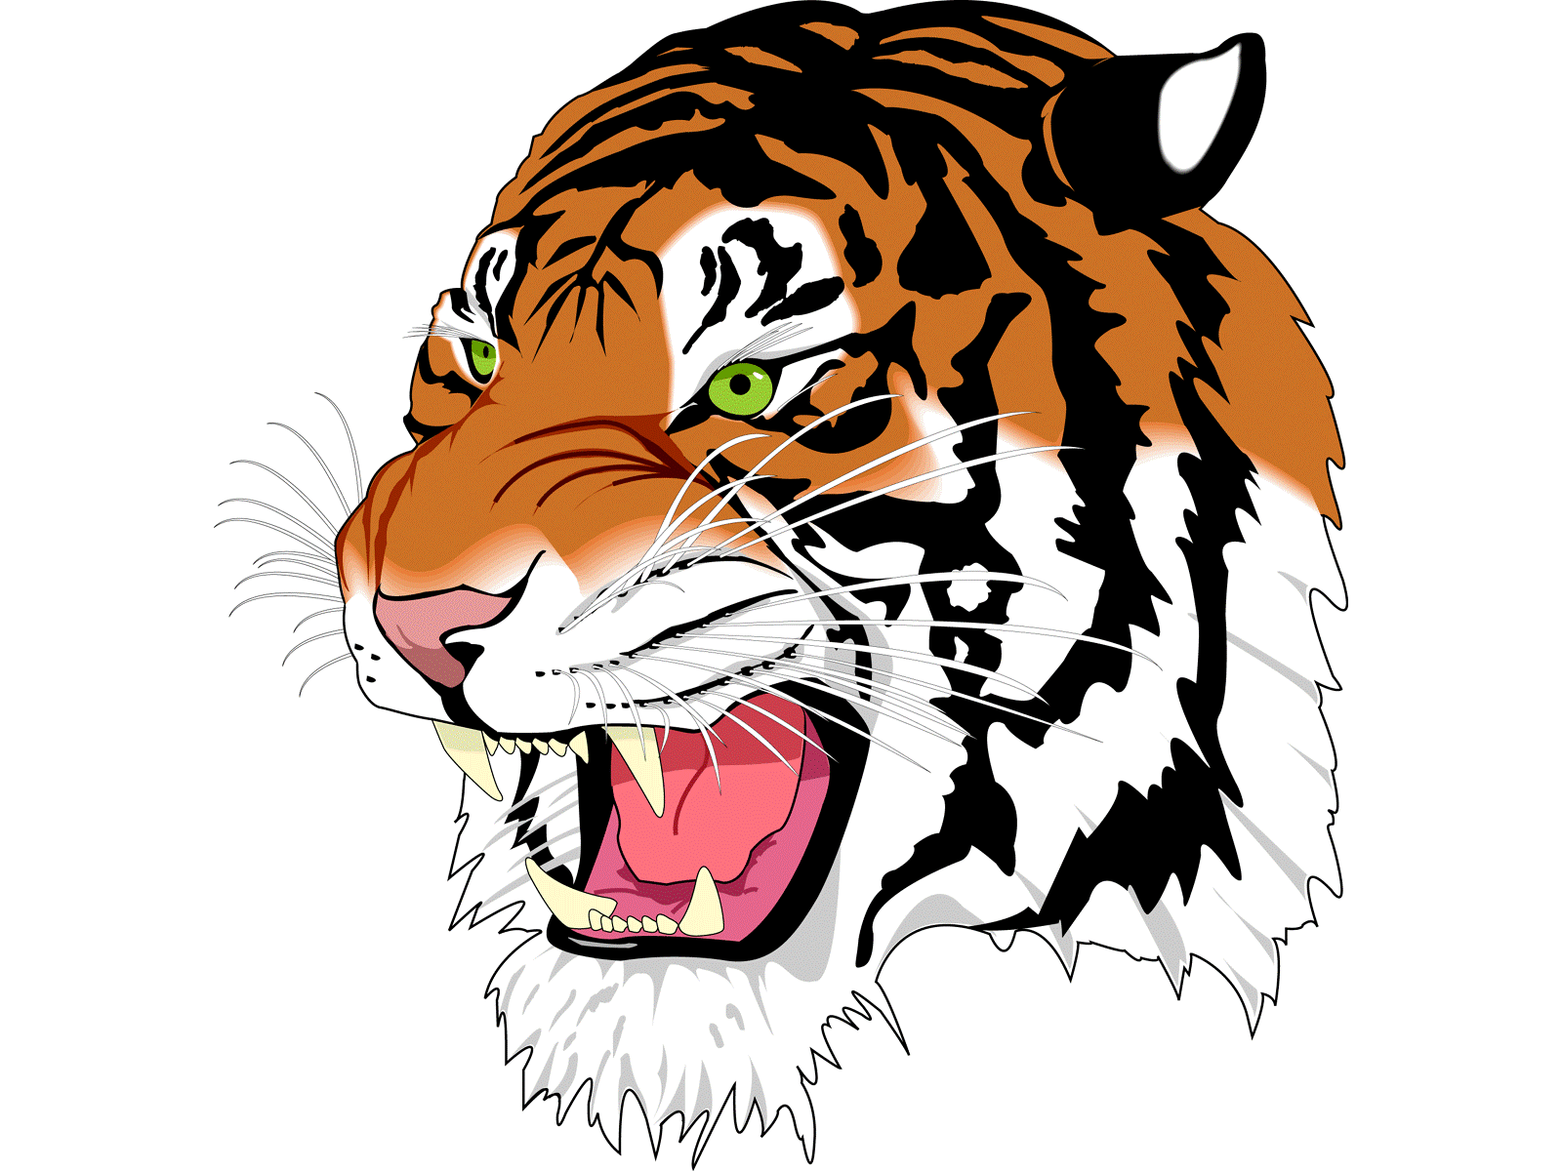
DAILY BULLETIN
Monday October 27th, 2025
Lunch Menu

Chili Dogs
Chips
Peanut Butter & Jelly (PB&J)
Salad Bar
Fruit
Milk

Servers
Trenton
Jaime

School Announcements:
- On Thursday, we will have our annual ASB Halloween carnival in the gym for the elementary school from 9-10 am.
- On Thursday, we will have our Halloween pep rally. Come dressed up for our costume contest. The winner will receive a gift card!
- Halloween doors need to be completed before Thursday.
- Pumpkin carving will begin tomorrow. The pumpkins will be in the art room. Each class needs to carve their own pumpkin and clean up their own mess.
- There is no school on Friday.

Athletics:
- On Tuesday, Dunsmuir will host Princeton for a playoff game beginning at 5:30 pm.
- On Friday, the Cross Country Team will travel to Fall River for a meet.

Extra-Curricular:

