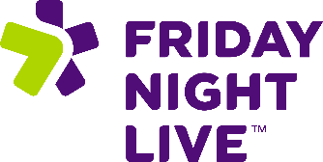 **Friday Night Live (FNL) builds partnerships for positive and**

**healthy youth development which engage youth as active leaders**

**and resources in their communities**

**FNL’s Pillars**

* Positive Youth Development
* Youth & Adult Partnerships
* Leadership & Advocacy
* Community Engagement & Collaboration
* Alcohol, Tobacco, and Other Drug Prevention
* Youth-Driven Campaigns & Skill Building

**FNL’s Activities**

* Red Ribbon Week
* Vaping Prevention Week
* Problem Gambling Prevention: Betting On Our Future
* Underage Drinking Prevention
* Cannabis Use Prevention
* Third hand Smoke Data Collection
* Friday Night Live Mentoring
* Reading Pals - High School FNL Only

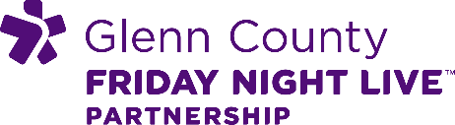 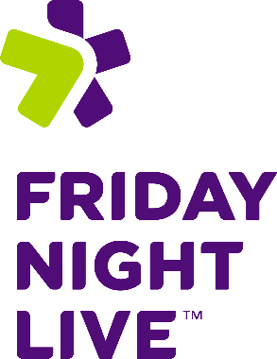 



Links to FNL Resources: [www.glenncoe.org](http://www.glenncoe.org) and

<https://fridaynightlive.tcoe.org/our-programs/friday-night-live>

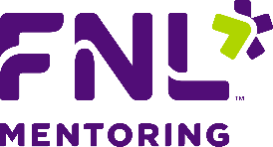

**Friday Night Live Mentoring (FNLM) provides young people with meaningful, supportive relationships that strengthen their resilience and empower them to navigate life’s challenges. FNLM pairs high school mentors with middle school protégés in a year-long, peer-to-peer partnership designed to cultivate leadership, personal growth, and mutual engagement.**

**FNL Mentoring’s Benefits**

* Provides leadership opportunities
* Increases civic engagement
* Supports social emotional learning
* Eases transition from middle school to high school
* Provides academic support
* Increases healthy behaviors
* Increases self-esteem
* Expands involvement in positive extracurricular activities

**FNLM Components:**

* **Matches a high school mentor with a middle school protégé.**
* **Uses a recruitment, application, screening, and training process for mentors.**
* **Includes mutually beneficial, structured, weekly mentoring sessions.**
* **Provides rigorous evaluation, documenting participant development.**
* **Provides lessons on preventing drug, alcohol, and tobacco use and peer pressure**