To make our absence reporting process more efficient for everyone, we encourage all parents to report student absences using the Infinite Campus Parent Portal or the Campus Parent mobile app. This is the fastest and most accurate way to get information to our attendance office, saving you time and helping our staff focus on what matters most - supporting our students and families. As a reminder, the Parent Portal is also the official source for your child's grades, so we encourage you to log in regularly. Please take a moment to download the Campus Parent app or bookmark the website to stay connected.
Download the App
To enter absences on your mobile device, be sure to download the "Campus Parent" app on your smartphone (links below).
- Download from the Apple App Store
- Download from Google Play

How to Report an Absence in Infinite Campus:
- Log in to your Infinite Campus Parent Portal account.
- Navigate to the main menu and select "More," then click on "Absence Requests."
- Choose the student you are reporting an absence for.
- Select the type of absence: whether it is for the full day, a late arrival, or an early departure.
- Enter the date(s) and, if necessary, the specific times for the absence.
- In the "Comments" section, please provide a brief reason for the absence (e.g., illness, doctor's appointment).
- Click "Submit." You will see a confirmation that your request has been sent to the school.
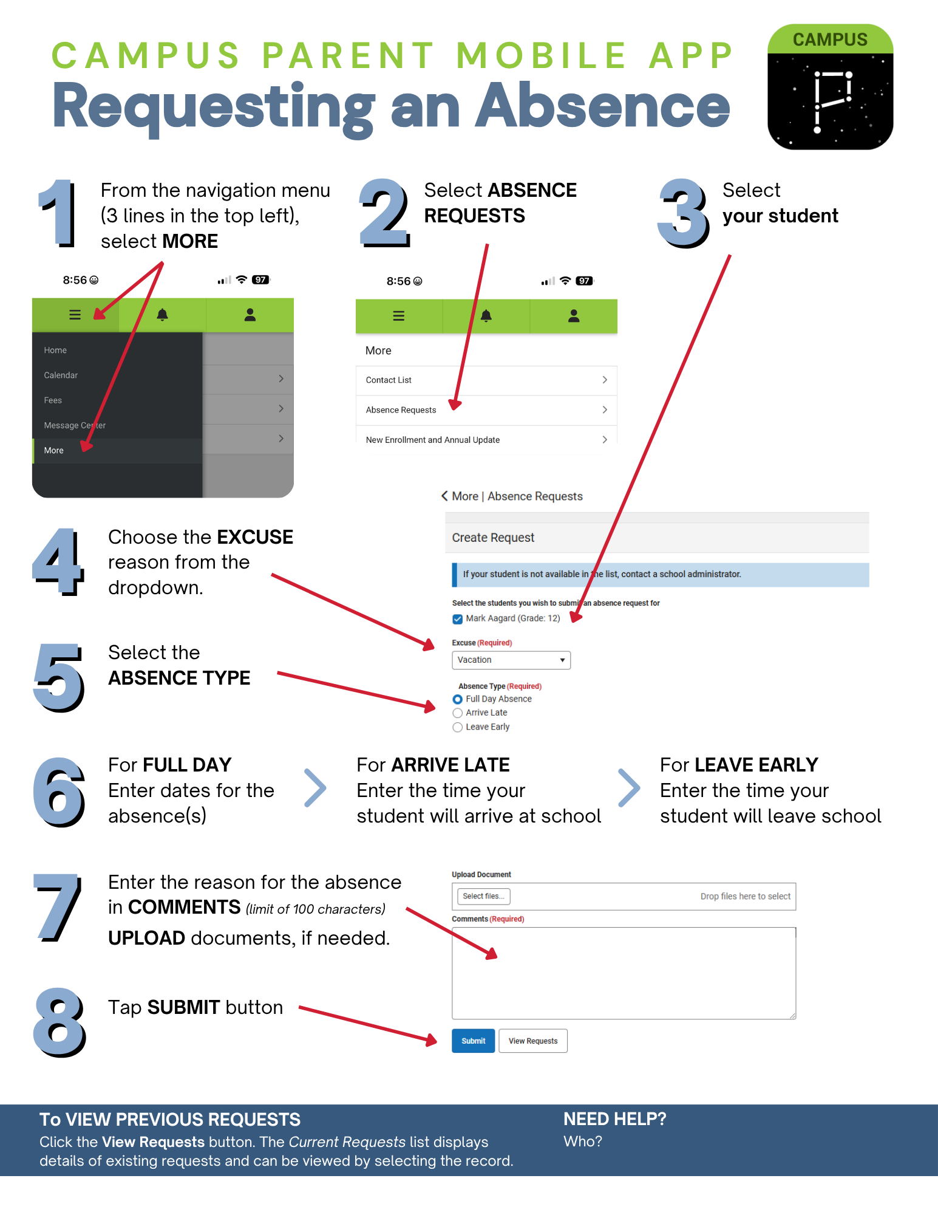
Other Absence Reporting Methods
While the Infinite Campus Parent Portal or Campus Parent mobile app is the preferred method, you may still report an absence by calling the attendance line at (925) 479 - 7700

