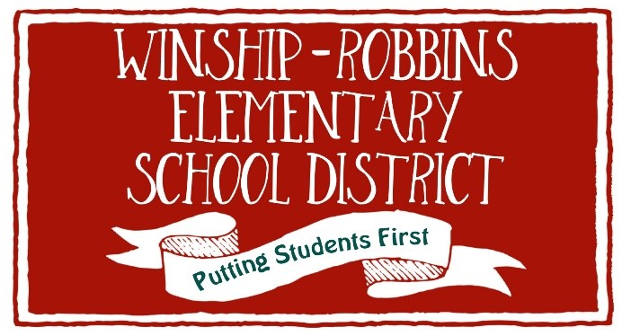
WINSHIP-ROBBINS ELEMENTARY SCHOOL DISTRICT
NOTICE OF VACANCY
Governing Board Member
The Winship-Robbins Elementary School District Board of Trustees is seeking qualified community members to fill a vacancy on the District’s Governing Board.
The vacancy was created by the resignation of a sitting Governing Board member, effective October 1, 2026. Pursuant to California Education Code § 5091, the Board of Trustees must, within 60 days of the vacancy, either order an election or make a provisional appointment to fill the vacancy.
POSITION
Governing Board Member — Trustee Seat:
Term expires: November 30, 2028
WHO MAY APPLY
• Be at least 18 years of age;
• Be a registered voter;
• Be a resident of the school district;
• Not be disqualified from holding a civil office under applicable law; and
• Meet all other applicable requirements of California law.
HOW TO APPLY
Interested community members should submit the following:
• A letter of interest stating why they would like to serve on the Winship-Robbins Elementary School District Board of Trustees;
• A brief statement describing their experience and/or qualifications; and
• Contact information, including name, address, telephone number, and email address.
Applications should be submitted to:
Winship-Robbins Elementary School District
Attn: Superintendent
17451 Pepper Street
Robbins, CA 95676
Email: dawnc@sutter.k12.ca.us
APPLICATION DEADLINE
Applications must be received by:
Statutory deadline for the Board to make a provisional appointment or order an election: November 30, 2026.
Date: November 20, 2026
Time: 4:00 p.m.
APPOINTMENT PROCESS
Following the application period, the Board of Trustees will review the applications and consider making a provisional appointment at a regularly scheduled or specially called public meeting.
The appointment will be made in accordance with California Education Code § 5091 and applicable provisions of the Brown Act.
The appointed trustee will serve for the remainder of the unexpired term, subject to applicable California law.
Anticipated Board appointment date: December 15, 2026
QUESTIONS
Questions regarding the vacancy or application process may be directed to the District Office at:
Phone: 530-738-4386
Email: milagrosr@sutter.k12.ca.us
Posted: October 7, 2026
Winship-Robbins Elementary School District
P.O. Box 100
Robbins, CA 95676

