Skyward Family/Student Access to Enter Course Requests for 2021-2022

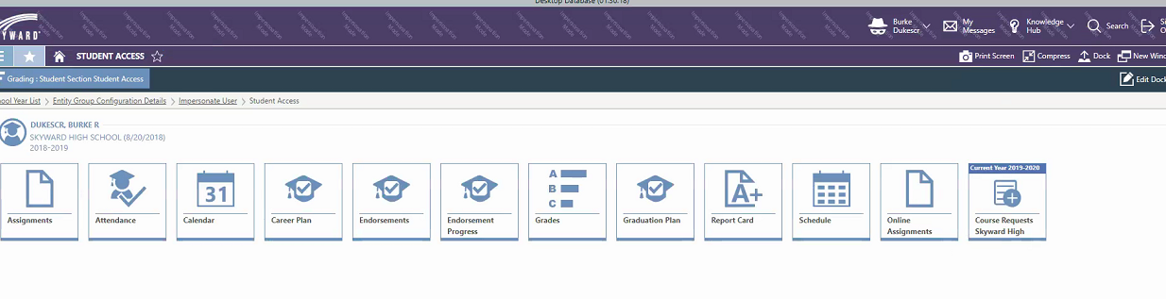
Click on Course Requests and the screenshot below opens. Students enter their courses by subject, description, or course number. Then click add. Students are only able to earn a maximum number of credits. For example: high school students can earn 7 credits.
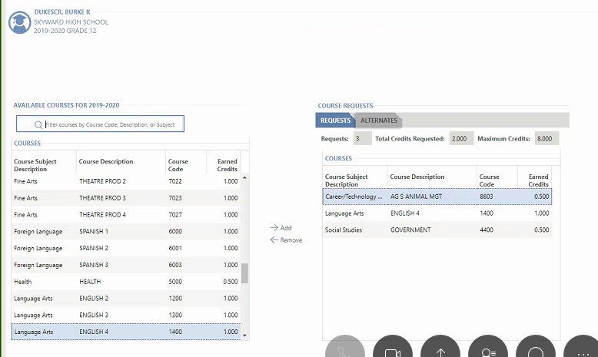

Student can enter alternates, by choosing alternates. The maximum number of classes is 3.

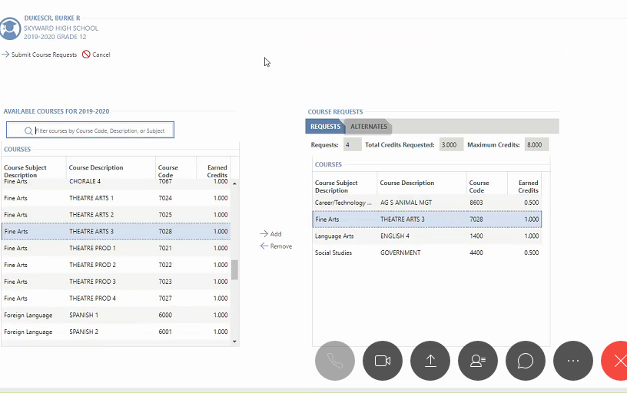
Students can put their alternates in the order of first choice to third choice. 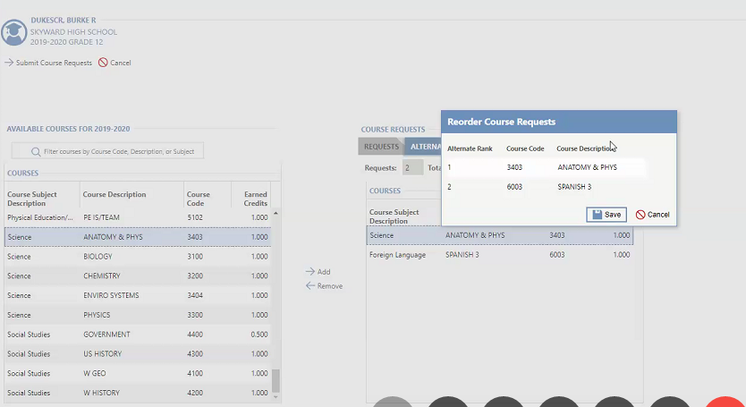
The students can print their course requests, which includes the alternate choices.
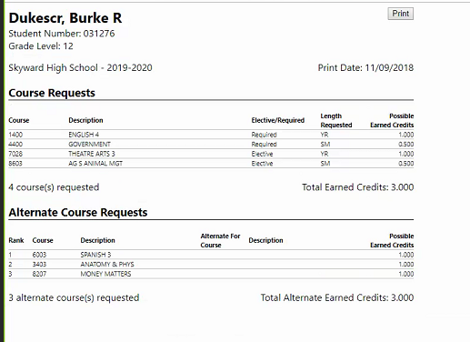
After the students enter their courses, the counselor can view or change the courses - Student Profile>Scheduling>Course Requests. 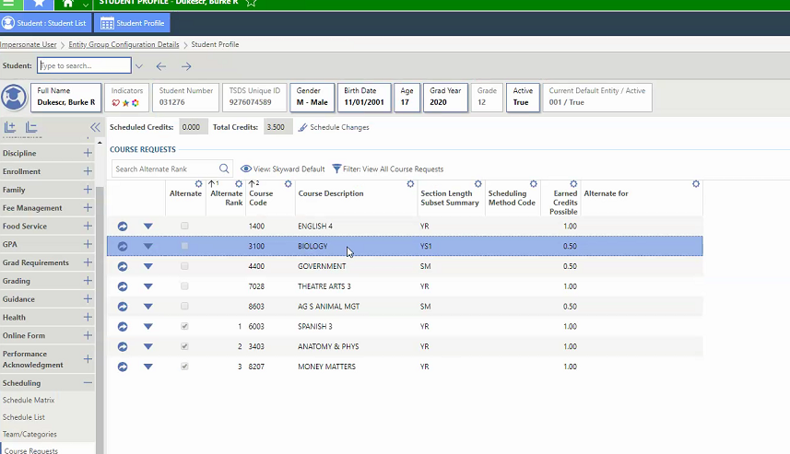
If a student only needs a semester of a full year course, this will be adjusted in this screen by the counselor.

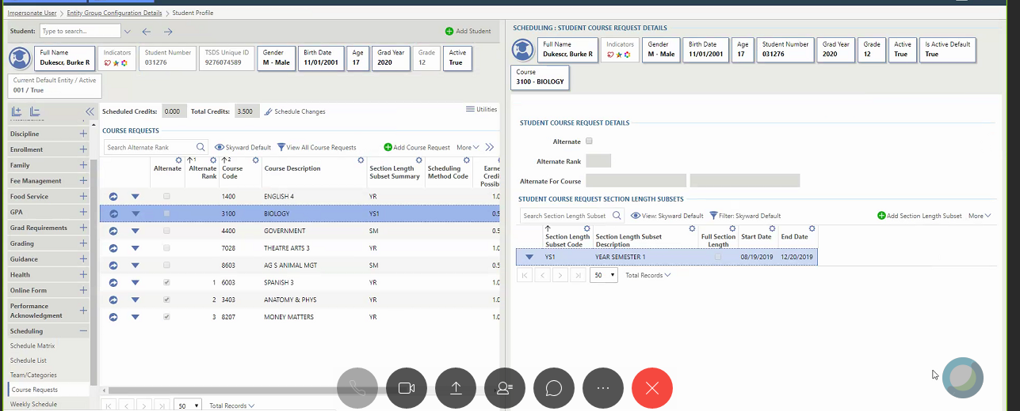

If you have any questions, please contact your child’s counselor.

