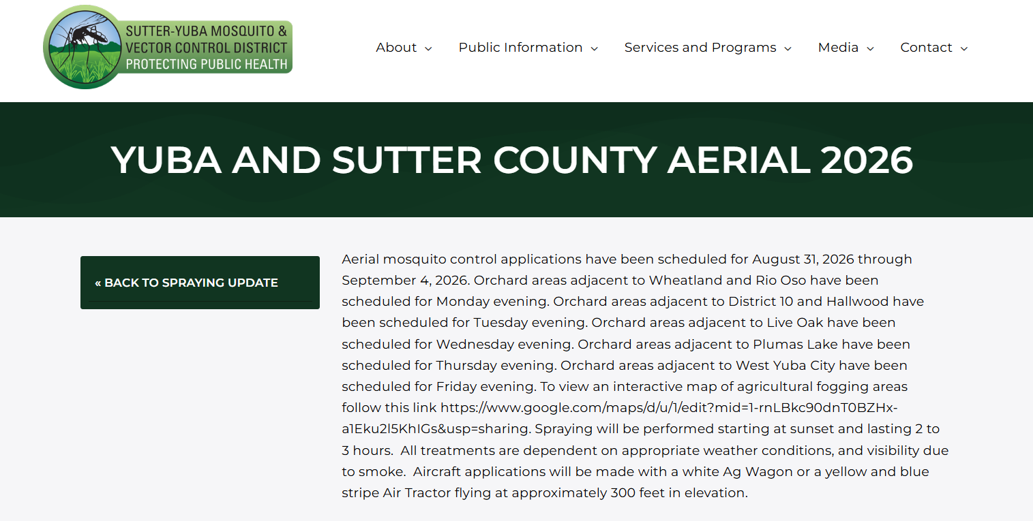

Mosquito abatement will occur on Friday, September 4th, 2026, 5:30pm
