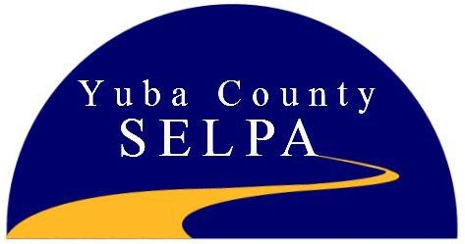

Yuba County
Special Education Local Plan Area Superintendents’ Council

NOTICE OF PUBLIC HEARING

Per California Education Code §56205(b)(2), the Yuba County SELPA Superintendents’ Council hereby gives notice that a Public Hearing will be held as follows:

Topic of Hearing
Yuba County SELPA Annual Budget Plan Yuba County SELPA Annual Services Plan

Date: Time: Location:
May 27, 2026
10:30 A.M.
111 Main Street Wheatland, Ca 95692

For additional accommodations and information: Please contact the SELPA Office at (530) 749-4871

