Butte Science & History Trip
Fifth-Grade Class

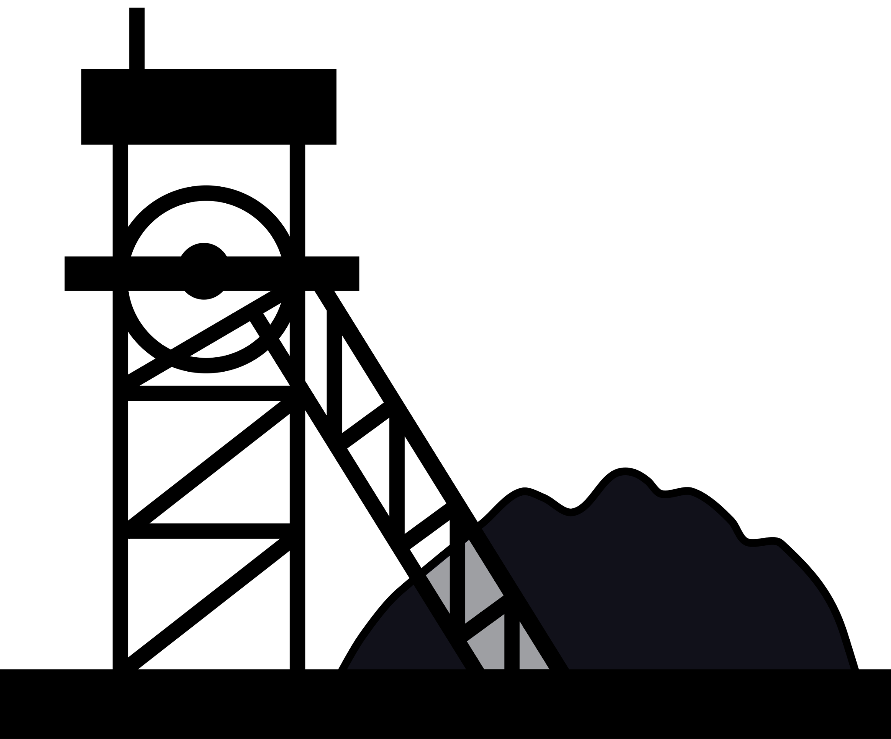

Gallatin Gateway School

Butte Science & History Trip
Purpose 3
Science Standards and Content 7
Social Studies Standards and Content 5
Sample Itinerary 6
Sightseeing and Tour Locations 8
Accommodations and Restaurants 9
Budgets and Funding 10
Chaperone Questionnaire 11
Parent Communication 12
Student Forms and Requirements for Participation 13
Standard Behavior Expectations Acknowledgement 14
Behavioral Expectations, Consequences, and Contract 15
Packing List for 5th-grade Butte Science & History Trip 17
Room Assignments 18
Butte Trip Journal 19
Student Questions for Learning 21
Trip Follow-up 23

The purpose of the Butte Science and History Trip is to have a firsthand experience of student learning in both earth and physical science and social studies. By leaving the classroom, students have the opportunity to enhance their knowledge for a deeper understanding of concepts featured in the state standards. The trip encompasses opportunities to explore geography, economics, history, and the developing culture and industry of Montana.

5-PS1-2- The amount of total matter is conserved no matter the process (heating, cooling, etc.)

- Continental Pit- How much is mined today? Percentages of the actual tonnage used and what’s done with the slag? (Slag is identified as the “leftovers” of the mined content. Slag
+ actual used amount = conserved total amount.)
- WMM- How much copper was mined from the pit? vs How much was actually used? What tonnage of the earth was moved and where did it all go?

5- PS1-3- Identify materials/substances based on their properties

- WMM- Identify certain minerals in class. What are the properties of copper and specific rocks? What did they use to identify the minerals? Cleavage, hardness, opacity, luster, etc.?)

5-ESS2-1- Ways that the hydrosphere, lithosphere, atmosphere, and biosphere interact

- Class- Study or lessons on the interactions of the -spheres in Butte (Ex: The biosphere mined the lithosphere. [What effects did that have on other parts of the biosphere like plants, animals, and hydrosphere? The hydrosphere was altered by the lithosphere in the pit. (Lithosphere brought in minerals that made the biosphere unusable and dangerous.) The biosphere digging up the lithosphere puts toxic chemicals into the atmosphere that could someday taint the biosphere and lead to acid rain.)
- Seeing these examples- WMM, Continental Pit, Walking Tour)

5- ESS3-1- Ways that individuals and communities are using science to protect and conserve their environment, natural resources, and systems (How Native Americans use scientific knowledge to maintain relationships with the world)

- Continental Pit- What current practices help preserve and protect the environment?

- E.5.3 identify resources and labor that are used to produce goods and services
  - WMM/Walking Tour- Why was the copper in Butte so important to the growing economy? What is copper used for? How was copper distributed to the rest of the world? How much copper was produced or mined from Butte? What was the production or refinery process like for copper?
- E.5.5 describe the role of manufacturing and agriculture in the economy of the United States
  - Continental Pit- What is mined now? How much of it? What is it used for? Is there a lot of supply? What is the demand for the ore?
- H.5.1 interpret data presented in timelines
  - Walking Tour of Butte: Comparing then and now. Events in Butte history.
- H.5.2 understand the inter-relationship of chronological historical events
  - Children of the Hill- comparing Butte to today.
- H.5.3 identify roles of individuals and groups and their impact on United States and tribal historical events
  - William Clark- how did he demonstrate civic duty? (responsibility to the mines, creating the Columbia Gardens, orphanage, workers funds for deceased)
  - WMM: Labor unions in Butte- what were the conditions of the miners? Why was it important for them to establish labor unions? What is a labor union? What conditions drove laborers to form a union?
- G.5.2 create, organize, and present geographic information to show settlement patterns in the United States, including impacts on tribal lands
  - Map Butte- where are the major mines? Where is Butte on a map? Where is the mine relative to Butte’s water sources? Where else did Butte need to send ore or work with in order to efficiently mine?
- G.5.3 analyze environmental and technological events and conditions and how humans and the environment impact each other with relation to settlements and migration
  - Walking Tour of Butte- How was Butte a major influencer in the modernization of America? What things did Butte have first? What major contributions did the city or lifestyle that Butte pioneered affected the rest of America/world? What things were relatively new in Butte (toilet, double sidewalks, electricity)?

Day 1
Time | Event | Address | Description
7:45 am | Arrive at GGS |  | Students and chaperones need to be at the school, ready to start loading the cars.
8:00 am | Leave GGS
9:30 am | Arrive at World Museum of Mining |  | Arrive at the campus. Students will have time to get out, walk around, use the restroom, and get into boots for the tour.
10:00-11:30  am | Mining Museum Tour | 155  Museum Way, Butte, MT, 59701 | Bring muck/rainboots boots (will be touring in mineshaft). It will be cold in the mine, bring a coat. Absolutley no running. One group will go to mine. One group will go to scavenger hunt. (Rotate)
11:30-12:00  pm | Lunch |  | Eat cold lunch before the second tour goes into the mine.
12:00-1:30  pm | Mining Museum Tour |  | Rotate, One group will go to mine. One group will go scavenger hunt.
2:30-4:30  pm | Science Mine | 36 E Granite St. Butte, MT, 59701 | Hands-on activities, Chaperones with small groups to supervise. About 2 hours
5:30-7:30  pm | Silver Bow Pizza and Arcade | 3500  Harrison Ave. Butte, MT, 59701 | Dinner, $15/person Appx. 2 hours.
7:45 pm | Ramada Hotel | 2100  Cornell Ave, Butte, Montana 59701 | Check into hotel rooms.

Day 2
Time | Event | Address | Details
8:30-9:15 am | Breakfast at Hotel |  | Should be packed and ready to go before eating breakfast
9:30-10:30 am | Mineral Museum Tour | 1300 West Park Street  Butte, MT 59701 | 1 hour Scavenger Hunt
10:50-11:20 am | Granite Mountain Memorial Overlook | Cora Terrace Butte, MT 59701
11:50-12:30 pm | Lunch at Joe’s Pasties | 1641 Grand Ave. Butte, MT, 59701 | Pasties contain meat, pie crust, onions, gravy, and potatoes. Other options as well.
1:00-2:45 pm | Trolley Tour/ Berkeley Pit | 1000 George Street Butte Chamber of Commerce Building | Hour and a half. Bathrooms available. We will get a tour on the trolley.
3:00 pm | Leave to go to Gallatin Gateway | 100 Mill Street
4:30 pm | Arrive at Gallatin Gateway |  | Parents pick up students from school.

World Mining Museum and Underground Mining Tour 155 Museum Way, Butte, MT 59701 Admission Fee
http://miningmuseum.org/

Copper King Mansion
219 W Granite St, Butte, MT 59701 Admission Fee http://thecopperkingmansion.com/

Science Mine
36 E Granite St, Butte, MT 59701 Admission Fee
http://www.sciencemine.org/about-the-science-mine

Granite Mountain Memorial Overlook Cora Terrace Butte, MT 59701 https://www.granitemine.org/

Mineral Museum
1300 West Park Street Butte, MT 59701 https://www.mbmg.mtech.edu/MineralMuseum/main.asp#gsc.tab=0
Old Butte Walking Tour
117 North Main Street Butte, MT 59701 Admission Fee
https://buttetour.info/

Berkeley Pit Mining Tour
600 Shields Ave Butte, MT 59701 https://pitwatch.org/visit/

Trolley Tour at Chamber of Commerce Building 1000 George Street Butte, MT 59701 https://www.buttechambersite.org/the-trolley/

Joe's Pasties
1641 Grand Ave, Butte, MT 59701 https://ilovepasties.com/

Silver Bow Pizza and Arcade
3500 Harrison Ave, Butte, MT 59701 http://silverbowpizza.com/

Holiday Inn Express
2609 Harrison Ave, Butte, MT 59701 https://www.ihg.com/holidayinnexpress/hotels/us/en/butte/btmhw/hoteldetail

Ramada Inn
2100 Cornell Ave, Butte, Montana 59701 https://www.wyndhamhotels.com/ramada/butte-montana/ramada-butte/overview

Budget and Funding
The Butte Science and History Trip is funded by the Gallatin Gateway School Foundation fundraising programs. The teacher will make reservations and make purchases during the trip with the school credit card. Following the completion of the trip, all receipts must be submitted to the superintendent to invoice the GGS Foundation. Costs of chaperones may be excluded from GGS Foundation reimbursement depending on funds available.

Day 1: Lunch school sack lunch. Dinner night is Silverbow Pizza
Day 2 Breakfast: continental breakfast at the hotel. Lunch is pasties from the restaurant. Estimate of costs:
Item | Cost/ person | Number Attending | Total
Mineral Museum | Free
Science Mine | $3 per child, adults free, $50 fee | 14 | 92
Trolley Tour/ Berkeley Pit | Kid $8 Adult $25? | 7 adults, 14 kids | 187
Silver Bow Pizza | $20 | 21 | 420
Pasty Shop | $15 | 21 | $315
Pit Mine Tour | Child $4 Adult $12.50 | 7 adults, 14 kids | 143.5
Gas |  |  | 275
Hotel Rooms | $108 each | 6 rooms | $648
 |  |  |  | Grand Total
 |  |  |  | $2,081

Joining us on the Butte Science & History Trip is a great privilege to share with your child. Ideally, chaperones should be experienced with children. Additionally, chaperones MUST be in good physical condition. We walk, stand, and sit for long periods of time.

The chaperones are responsible for the safety of the students, for setting an example, and for furthering the goals of the teacher and trip experience. Chaperones will be expected to follow and enforce all rules and expectations. Chaperones are expected to participate in and facilitate activities as requested. The adults are an integral part of the group, and their willingness to participate and support the expectations is vital to the trip’s success.

Please return this form as soon as possible.

- Name:

- Are you willing to supervise a small group of students in your hotel room?

- Are you in good physical condition? Are you able to walk on uneven surfaces?

- Are you First Aid or CPR certified or willing to complete the course by ? (First Aid is required)

- Do you have auto insurance and are an approved driver for the school? (You need to have a $300,000 liability to transport students)

- How many people (not including yourself) do you have seatbelts for? Or do you have a truck that we could haul all the luggage and supplies in?

Hello 5th-grade families,

In fifth grade, students travel to Butte, MT for the Butte Science & History Trip. This year, the trip will take place on May . A mandatory parent meeting will be held to share details and sign forms on at pm in the classroom. For each student to attend the trip, at least one parent must be present.

Attached is a fact sheet with more information about the trip and details about the upcoming parent meeting. Please contact me with any questions or concerns. I am excited for your students to share this experience!

Hello, everyone!

Our Butte field trip is Thursday, 5/25. We will be leaving the school at 8:30 am. Please plan to arrive by 8:00 am so we can start loading the cars. The packing list includes the necessary items for the trip.

Meals and activities for students are paid for by the GGS Foundation. Students will need personal money if they choose to play in the arcade attached to Silverbow Pizza. If you would like to send your child with money for the arcade or for a souvenir, he/she will be responsible for keeping track of it. No more than $20 is suggested.

If you have ordered your child sack lunch through the school for Thursday, they will be ready to go by the time we leave that morning. Please remember that if you did not opt to purchase a school lunch, students will need to bring a sack lunch from home.

Should the need arise to contact your child while we are on the field trip, I have left contact information and lodging information on the next page.

Please let me know if you have any questions. We are very excited to visit historic Butte!

In order to attend the Butte Science & History Trip, each student must have the following forms completed, all work must be submitted to teachers and must be passing, and behavior record must be reviewed and approved.

Field Trip Permission Slip (Drive)
Behavior Acknowledgement
Behavior Contract
Emergency Medical Care (Drive)
Student Transportation Liability Release (Drive)
Academic Eligibility (Confirm with Office)
Behavior Record (Confirm with Superintendent)
Meal Payment (Confirm with Office)

Attending the Butte Science & History Trip requires maturity, a commitment to meeting schoolwide expectations, motivation to fundraise, and consistent school attendance and work completion. Without the ability to maintain these expectations, traveling with a student who has behavior challenges can become a liability and threatens to impact the experience of the trip for other students.
This trip is a tremendous opportunity for our students, and we expect them to maintain socially appropriate behavior, attend school, and complete their classroom assignments for the duration of the school year in order to demonstrate the maturity and motivation to participate in the trip. Students failing to meet expectations will have their trip privileges revoked pending the successful completion of a field trip participation plan. This plan will specify behavior concerns, address remediation opportunities, state completion criteria, and provide a timeline for completion. A field trip participation plan will be written by school personnel and provided to parents in order to assist student success.
Additionally, any student who has been placed on a behavior intervention plan at any time during the fourth or fifth-grade year will automatically begin with a field trip participation plan in order to demonstrate the importance of school attendance, academic achievement, appropriate conduct, and respect for adults and peers. Any and all expectations are in accordance with the GGS Handbooks.

I acknowledge that I have received notification of school expectations in order for my child to travel on field trips. If requested, I will participate in the field trip participation plan process.

Signature Date

Signature Date

Students will be expected to maintain the highest standard of conduct and behavior from the moment we meet at the school, to the moment we return and say goodbye. Students will be representing not only themselves as individuals, but also the school and the community. The teacher will enforce a “zero tolerance” policy as detailed in the following list of expectations for this field trip. Of course, considering circumstances that may or may not be detailed in this contract, the teacher will make any and all behavioral judgments.
Learning is the primary focus of this trip. Coupled with the fun aspects of this experience, students are expected to be involved with, engaged in, and enthusiastic about the academic and scholarly nature of this journey. This includes asking thoughtful questions; completing any and all work assigned by the teacher; focusing energy and attention on learning; and participating consistently in the programs.
Students agree to the following:
- I will be entirely respectful of others. This means that I will not gossip, make any disparaging or mean remarks, or engage in any other types of rude, hurtful, disrespectful, excluding, or unkind behavior to anyone.
- I will make every attempt to resolve any conflicts maturely, swiftly, and responsibly with adult support if necessary.
- I understand that I will be expected to help with cooking and cleaning. I will take the initiative to be useful and productive.
- I will not impose “bad travel attitudes” on others. More specifically, this means that I will make every effort to maintain a consistent, pleasant disposition, even in the face of unpleasant challenges that may come up. I understand that fatigue, hunger, interpersonal differences, temperature extremes, and so on are not excuses for complaining, whining or being pessimistic. I will instead take responsibility for myself and my needs to ensure that a good time is had by all, including me! I agree to voice concerns in a respectful and constructive manner, and to express concerns about those situations that might be remedied. Obviously, some situations (such as temperatures) cannot be “fixed” by anyone

and complaining will not change anything, except to dampen others’ moods! Adults are ready to help students with challenges as much as possible to improve any situation.
- I will be honest, will “say what I mean, and mean what I say”, and will make good overall choices about behavior, attitude, relations with others, and learning.
- I will not cause physical harm to myself or to others.
- I will not be physically intrusive to anyone’s personal space in any fashion, and will also be respectful of all property.
- I will be respectful of all places and objects in every way. This means that I will use extreme caution and heed guidance and authority with regard to touching and interacting with any objects or structures.
- I will respond to behavioral warnings respectfully and with swift self-reflection, using respect and responsibility as my guiding concepts.
- I agree to respect the curfew set by the teacher and the chaperones. This means I will be in my room and ready for lights out at the expressed time. I understand that curfew violations are serious matters and will result in consequences.
- I agree that I will not enter other rooms without express permission of the chaperone. I will not leave the groups without express permission of the group adults. I agree to check in with chaperones as required
- In addition to the above listed expectations, I agree to honor all GGS Handbook Rules.
As a student, if I violate any of the expectations or rules as listed above, I know the consequence will be to call my parents and have them pick me up immediately.

Signature of Student Date

Signature of Parent/Guardian Date

Packing List for 5th-grade Butte Science & History Trip
Students will need to dress for any weather as it can greatly vary. In mine tour
- Hiking Shoes/Boots (for uneven terrain and muddy conditions)
- Jacket
- Sweatshirt
- Pants
- Gloves
- Hat

General activities & tours:
- Comfortable walking and hiking shoes
- A Backpack to carry:
  - Water bottle
  - Snacks (peanut-free)
- Sunscreen
- Compact umbrella (suggested)
- Rain jacket
- About $20 of spending money for any souvenirs or vending machines

Overnight needs
- Toothbrush
- Toothpaste
- Deodorant
- Any other toiletries you need daily
- Swimsuit
- Flip Flops or shoes for the pool area
- Two changes of clothes
- Pajamas
- 3 pairs of socks (1 pair for mansion tour)
- Undergarments

Dress code standards of the school apply: Closed-toe/comfortable shoes and any offensive language or images on clothing are not allowed. Use your best judgment to make mature and responsible decisions regarding your clothing.

*Students are not allowed to use phones or phone watches. Students can bring snacks, please make sure they abide by the school wellness policy.

This is the students’ first experience in traveling overnight for a school trip. It is extremely important that students understand what is expected of them in staying at a hotel in a room with peers. After carefully considering personalities, relationships, and behavior needs, the teacher makes the ultimate decision in room assignments.

When booking accommodations, rooms with two double or queen beds should be reserved. In choosing chaperones, mothers of daughters in the class or fathers of sons in the class are ideal for assigning chaperones to rooms with their own child to maximize bed space and the budget. Book a hotel with a swimming pool and continental breakfast.

Teacher | Student 1 | Student 2
Parent & Child | Student 3 | Student 4 | Student 5
Parent & Child | Student 6 | Student 7 | Student 8
Parent & Child | Student 9 | Student 10 | Student 11
Parent & Child | Student 12 | Student 13 | Student 14

What are we learning in Butte?
In full sentences, write one thing that you learned next to each bullet point.

World Mining Museum
- ​

- ​

- ​

Questions?

Science Mine
- ​

- ​

- ​

Questions?

Mineral Museum
- ​

- ​

- ​

Questions?

Trolley Tour
- ​

- ​

- ​

Questions?

Berkeley Pit
- ​

- ​

- ​

Questions?

Pasty Restaurant
- ​

- ​

- ​

Questions?

Berkeley Pit & Montana Resources Mine
- Why did the Berkeley Pit fill with water?
- How did the water get contaminated?
- How did the water get into the pit? Rain, flood?
- What is in the water that makes it so toxic?
- How deep is the Berkeley Pit?
- How many birds have died in the Berkeley Pit?
- How did the water turn colors?
- Is there any wildlife around the Berkeley Pit?
- Are there microbes living in the water in the Pit?
- How often do animals die in the Pit?
- How big is the Pit?
- How many mines did the Pit absorb?
- Can you save animals when they get into the water?
- How long was the Berkeley mine working before it started filling with water in 1981?

Copper King Mansion
- How many rooms are in it?
- Was William A. Clark the only copper king?
- How many people could live in the house at once?
- How many copper kings are there?
- How many square feet is the house?
- When was the mansion built?
- Did he have dances or parties at his house?
- How old was he when the mansion was built?
- What was the purpose of building the mansion?

Mining Museum
- How old is the mine?
- What types of minerals did they mine?
- Why is it called the Orphan Girl Mine?
- When was the last mining incident?
- How many people have died in mining accidents?
- How cold does it get in the mine?
- Who was Sammy Keith?
- Was the mine a successful mine?
- Why are there only a few open mines that we can go into?
- What’s the biggest mine in Butte?
- When did they stop mining this mine?
- When were the doll clothes made?
- Can you go deeper than 100 feet into the mine?
- Did they mine other things besides copper and silver?
- How many miners worked in the Orphan Girl?
- Who founded the mine?
- When was Butte founded?
- Was Hell Roaring Gulch the first community with schoolhouses in Butte?
- When did they find minerals and copper?
- How many mine entrances are there?
- Who founded the Pegasus Gold Corporation?
- How much gold has been found since they started mining it?
- What’s the biggest piece of gold that came out of the mine?
- How did they get the machinery down in the mines?
- What’s the deepest mine?
- How long did it take to dig out the Berkeley Pit?
- How deep does the Orphan Girl Mine go?
- Did any of the mines connect?
- What was the most common cause of death?
- What machinery did they use?
- What’s the most famous mine?
- Who decided to open pit mine the Berkeley Pit and why?
- Were there any famous miners in Butte?
- Who owned/owns the Berkeley Pit when they started it?
- How much copper did the mine per day?

Following the field trip experience, students must produce evidence of their learning through the notes taken during the tours. Additionally, these tasks must be completed:

Email sent to parents with trip summary and photos Thank you notes for chaperones
Thank you notes for tour guides/coordinators and hotel manager Thank you note to GGS Foundation for funding
Receipts and credit card reconciliation submitted to superintendent Submit all student forms to the secretary
Return and/or restock first aid supplies

