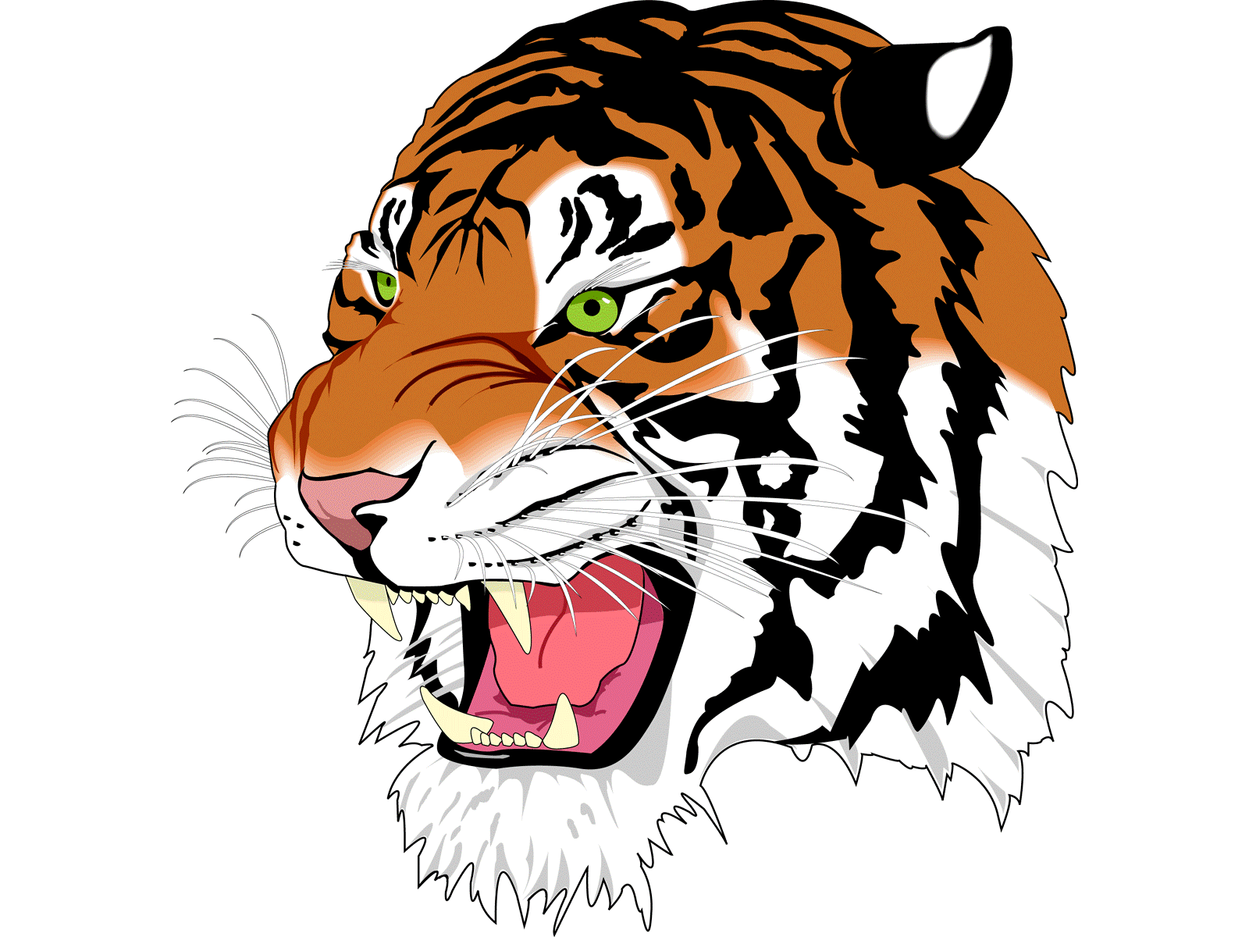
DAILY BULLETIN
Tuesday October 28th, 2025
Lunch Menu

Orange Chicken
Rice Eggs Rolls
Peanut Butter & Jelly (PB&J)
Salad Bar
Fruit
Milk

Servers
Trenton
Jaime

School Announcements:
- On Thursday, we will have our annual ASB Halloween carnival in the gym for the elementary school from 9-10 am.
- On Thursday, we will have our Halloween pep rally. Come dressed up for our costume contest. The winner will receive a gift card!
- Halloween doors need to be completed before Thursday.
- The pumpkin carving contest has begun. The pumpkins will be in the art room. Each class needs to carve their own pumpkin and clean up their own mess.
- There is no school on Friday.

Athletics:
- Today, Dunsmuir will host Princeton for a playoff game beginning at 5:30 pm.
- On Friday, the Cross Country Team will travel to Fall River for a meet.

Extra-Curricular:

- Music club will be after school today.

