
2025-2026
STUDENT-PARENT HANDBOOK

4701 Brookfield Drive
Sacramento, CA 95823
Phone 916-422-5524 Fax 916-422-2673
www.egusd.net/mack

Samantha Moorer, Principal
Latonia Walton-Jenkins, Vice Principal
Mike Mangonon, Vice Principal
TABLE OF CONTENTS

 | Page
Elk Grove Unified School District Mission and Goals | 3
Charles Mack Elementary School Vision, Mission, and Motto | 4
Daily Schedule | 5
Principal’s Letter | 6
Accelerated Reader Golden Horseshoe Matrix | 8
Dress Code | 9
Student Support Policies, Programs and Services: | 10
Academic Improvement/LCAP | 10
ExL After School Education | 10
Arrival and Dismissal: Grades 1 through Grades 6 | 10
Arrival and Dismissal: Kindergarten | 11
Attendance | 11
California Assessment of Student Performance and Progress (CAASPP) | 11
Celebrations | 11
Cell Phones, Electronics, and Toys | 12
Checkout of Students During School Hours | 12
Classroom Interruptions | 12
Classroom Visitors | 13
Communication Between Home and School/Meeting with Administrators | 13
Conference and Report Card Periods | 13
Discipline Policy/ Behavior Management | 13
Emergency Forms | 14
English Learner Advisory Committee | 14
English Learners | 14
Field Trips | 14
G.A.T.E. | 15
Homework | 15
Intervention | 16
Learning Center | 16
Library | 16
Lunch & Breakfast Program | 16
Medication | 16
Parent Meeting Guidelines | 17
Parent Volunteers | 17
Preschool | 18
Promotion and Retention | 18
School Nurse | 18
General Rules | 18
Playground and Equipment Rules | 19
School Rules and Expectations | 21
Positive Behavior Interventions and Support (PBIS Plan) | 22
School Safety | 23
School Site Council | 23
Speech/Language Therapy | 23
Student Recognition and Awards | 24

Our Mission
Elk Grove Unified School District will provide a learning opportunity that challenges ALL students to realize their greatest potential.

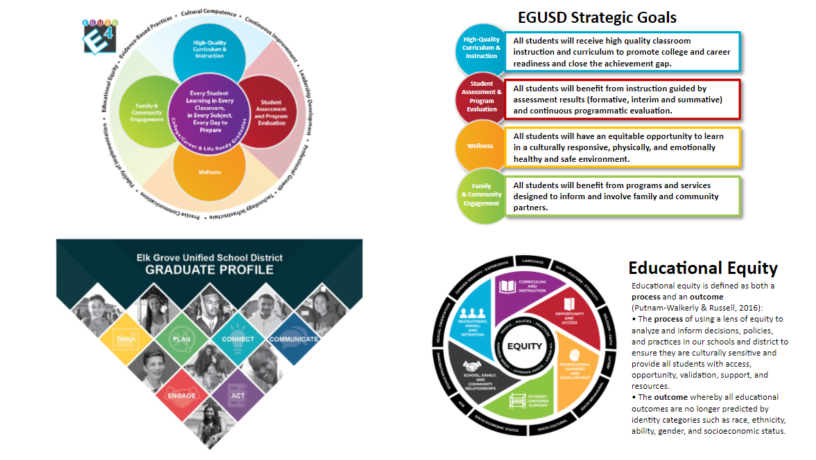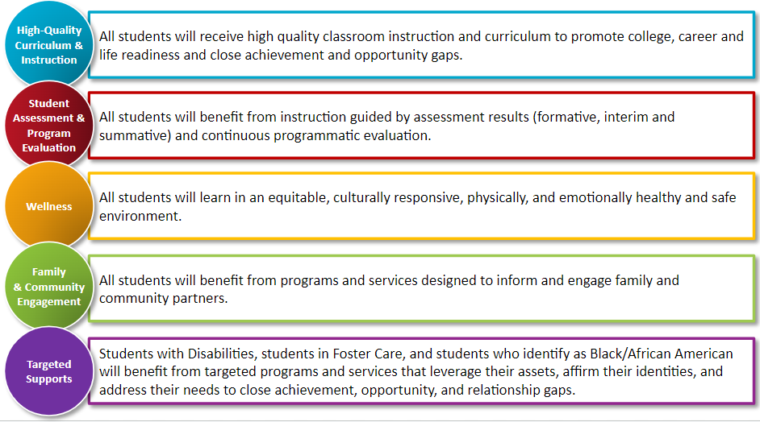

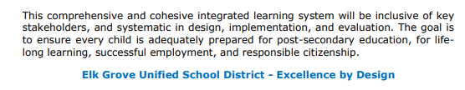

CHARLES MACK ELEMENTARY SCHOOL VISION, MISSION, AND MOTTO

Vision
To provide each students with the foundational and essential skills for success

Mission
To educate the whole child through equitable practices, exemplary instruction, and a partnership with Charles Mack Families

Motto
From Mack, To Jackman, To Valley, To College



Charles Mack Elementary 2025-2026 Schedule

Raining Day Schedule
PM Kinder 10:45-11:10 (Stage) Line Up in Mall
1 Grade 11:00-11:20 11:20-11:35
2 Grade 11:20-11:40 11:40-11:55
TK/AM Kinder 11:35-11:55 (Stage)
3 Grade 11:40-12:00 12:00-12:15
4 Grade 12:15-12:35 12:35-12:50
5 Grade 12:35-12:55 12:55-1:10
6 Grade 12:55-1:35

Min Day Schedule
TK/Kinder – same as regular day schedule
1st – 6th grades 8:10 – 12:25
Min Day Morning Recess
1st | 9:10 - 9:25 | 4th | 10:10 – 10:25
2nd | 9:25 - 9:40 | 5th | 10:25 – 10:40
3rd | 9:40 - 9:55 | 6th | 10:40 – 10:55
PALSS | 9:55 – 10:10

Min Day Lunch
GRADE | LUNCH | RECESS
1ST | 10:40 | 10:55 - 11:10
2ND (Reversed) | 10:55-11:10 | 10:40 - 10:55
3RD | 11:15 | 11:30 - 11:45
4TH (Reversed) | 11:30-11:45 | 11:15 – 11:30
5TH | 11:50 | 12:05 - 12:20
6TH (Reversed) | 12:05-12:20 | 11:50 - 12:05

Regular Day Schedule
TK/AM Kinder 8:10 – 11:30
PM Kinder 11:10 – 2:30
1st – 6th grades 8:10 – 2:30

Morning Recess
GRADE | RECESS
1st | 9:30 – 9:45
2nd | 9:45 – 10:00
3rd | 10:00 – 10:15
PALSS /K Yard | 10:15 – 10:30
4th | 10:35 – 10:50
5th | 10:50 – 11:05
6th | 11:05 – 11:20
Lunch Schedule
GRADE | LUNCH | RECESS
TK/AM Kinder | 11:30 | NA
PM Kinder | 10:45 | NA
1ST | 11:00 | 11:20 - 11:40
PALSS | 11:40-12:00 | 12:20-12:35
2ND | 11:20 | 11:40 - 12:00
3RD | 11:40 | 12:00 - 12:20
4TH | 12:15 | 12:35 - 12:55
5TH | 12:35 | 12:55 - 1:15
6TH | 12:55 | 1:15 - 1:35

Early Out Wednesday
1st – 6th grades 8:10 – 1:40
TK/Kinder – same as regular day schedule

PALSS BREAKFAST 8:15 IN MP ROOM
PALSS LUNCH 11:40-12:00 IN MP ROOM
RECESS 12:20-12:35

Greetings Awesome Charles Mack Mustang Families,

It is my pleasure to welcome you to the 2025-2026 school year. I am so happy to continue our journey together for our kids.

Our dedicated teachers will continue to work and grow as educators to ensure that your children receive exemplary instruction in the classroom. However, your role in your child’s academic success is just as important. They will need you to embrace the “Must Do” list below in order to ensure academic success this year.

“Must Do” List

Participation: Charles Mack has a full calendar of Parent University classes and family-centered activities for the 2025-2026 school year. Check your text messages through Talking Points, emails through School Messenger, the school website at https://mack.egusd.net/ or our Facebook page @ Charles Mack Elementary, and the parent portal in Synergy for updates. These community building events will provide parents with opportunities to interact and share a meal with teachers, other parents, and administrators in addition to getting tips, materials, and books to take home with you. Look for flyers for each event and check the marquee as well!

ELAC: Multi-lingual Families are welcomed to join our ELAC (English Language Advisory Committee) which presently meets in the morning. This meeting is a great time to learn how to support our bilingual students with their learning.

Our school focus is on Math this year. Please make sure your child knows his or her numbers and math facts. You can support them by quizzing them with flashcards and or by having them play math games on their computers. A helpful website for math support for PK through college-aged students is khanacdemy.org. This website offers language support as well and more.

Attendance: Research shows that students who miss 10 days per year (that’s an average of 1 per month) are often below grade level by the end of the school year. We need to improve last year’s attendance from 91% to at least 95% daily enrollment this school year. We have skilled and dedicated teachers at Charles Mack. If you make sure your students are at school everyday and on time (by 8:10 am), we will make sure that they make progress towards meeting the Common Core grade level standards.

During the school year, if your child is absent, please call the school to inform us why they are out particularly if they are ill.

Preparedness: Please make sure your children are prepared for school each day including having backpacks, books, and a charged Chromebook. It is also important to make sure your child continues to follow the 3 Mack PBIS expectations of Being Safe, Being Respectful, and Being Responsible.

Reading: In order to improve as readers, students must read every day. Several Charles Mack classes have embraced our incentivized Accelerated Reader (AR) reading program for independent reading. Please take a close look at the AR reading targets on page 8 and encourage your children to reach them. Participation in this incentivized reading program will not only support them becoming better readers, they will earn some great rewards including medals, free shirts, and gift cards as well.

Communicating: It is important for students to know that their parents and teachers have formed an educational partnership where the lines of communication will always be open and accessible. Please make every effort to keep email addresses and phone numbers current. We need to be able to talk to you about your child’s progress, successes, concerns, and any other important information. If your address or phone numbers should change, please call the office right away at 916-422-5524.

New This School Year:
Remodeled Front of the School (to be completed in October 2025)
Increased support for our Afghani students (5 days a week)
Two TK classes
Increased Attendance Incentives
Electronic monthly newsletters sent via Talking Points and School Messenger

Your support will go a long way towards making the 2025-2026 school year an incredible success.

Sincerely,

Samantha Moorer
Principal
smoorer@egusd.net

ACCELERATED READER GOLDEN HORSESHOE MATRIX

 | 1st | 2nd | 3rd | 4th | 5th | 6th | Award
Copper  Horseshoe | 16 KidzRead | 10 | 10 | 15 | 20 | 25 | Horseshoe on the wall
Bronze  Horseshoe | 32 KidzRead | 20 | 20 | 30 | 40 | 45 | Horseshoe on the wall
Silver  Horseshoe | 48 KidzRead | 25 | 35 | 45 | 55 | 60 | Horseshoe on the wall
Golden  Horseshoe | 64 KidzRead | 45 | 50 | 55 | 60 | 65 | Horseshoe on the wall, certificate,  AR Shirt & Backpack mini medal
Double Golden  Horseshoe | 64 KidzRead and 10 AR Points | 90 | 100 | 110 | 120 | 130 | Horseshoe on the wall in the MP, picture in the Golden Corral & a pencil pouch
Triple Golden  Horseshoe | 64 KidzRead and 15 AR Points | 135 | 150 | 165 | 180 | 195 | Horseshoe on the wall in the MP, picture in the Golden Corral & a spirit shirt
Quadruple Golden  Horseshoe | 64 KidzRead and  20 AR Points | 180 | 200 | 220 | 240 | 260 | Horseshoe on the wall in the MP, picture in the Golden Corral, spirit shirt & backpack

AR INCENTIVES

If you get your Golden Horseshoe by December 19^{th,} you get a Golden Horseshoe T-Shirt, a special AR Assembly, the Ice Cream truck, and the AR picnic.
If you get your Golden Horseshoe by February 20th, you get the Ice Cream truck. You will also get the AR Picnic.
If you get your Golden Horseshoe by May 8th you will get to attend the AR Picnic.

Special Prize Assembly Feb 6
Ice Cream Truck May 22
AR Picnic June 5
AR Assemblies Held throughout the Year

CHARLES MACK ELEMENTARY SCHOOL DRESS CODE

Students are expected to dress in acceptable school attire. Guidelines are listed below.

SHIRTS
- No tube tops, bare midriffs (stomach area), strapless tops, or shirts with spaghetti straps
- No tank tops with shoulder straps of less than one inch (2.5 centimeters)
- No shirts with inappropriate slogans, pictures, or graphics

PANTS/SHORTS/SKIRTS
- Pants must be neat, in good repair and not overlong. Pants must stay at or above the waist. No sagging or baggies. A twist tie will be given to students who sag at school.
- No shorts or skirts less than " end of fingertip length"

HATS
- No hats/bandanas/hoods inside any school buildings

SHOES
- Must be worn at all times and must be appropriate for physical activities; closed-toed shoes are required for PE
- Must have a back strap or closed heel
- No clogs, flip-flops, high heels or “heelies”

OTHER
- No clothing, jewelry or accessories with any offensive writing, pictures or any insignia (with regards to any race, ethnicity, religion, gender, etc.)
- No clothing, jewelry or accessories which advocate the use of drugs, alcohol or hate messages
- No clothing, jewelry or accessories which represent gang affiliation
- No see-through clothing material
- No make-up
- No pajamas (unless a dress-up day)

Consequences for noncompliance may include a verbal or written warning, and a telephone call or note to the home. Consequences WILL include the loan of acceptable clothing, and/or or a requirement that other clothes be brought from home.

STUDENT SUPPORT POLICIES, PROGRAMS AND SERVICES

LOCAL CONTROL ACOUNTABILITY PLAN (LCAP)

The Academic Improvement Plan/LCAP, which is revised yearly, outlines the assessed needs of our school, goals and plans for improvement, and budget expenditures. It is a requirement for every school that receives State and Federal funding. The plan is overseen by the School Site Council, which is composed of an equal number of elected staff and parent/community members. In addition, all Charles Mack stakeholders have opportunities to contribute in the decision making process through ELAC, FTO, and Title 1 meetings. A copy of Charles Mack’s LCAP is available online and in the office.

EXL AFTER SCHOOL EDUCATION

EXCEL serves approximately 250 children at grades 1-6 immediately after dismissal time until 5:30 every day. It provides academic intervention, homework assistance and enriching activities such as art, physical education, sports, computers, music, and drama. The program is free of cost. Students apply to participate by having their parent/guardian complete an enrollment application. For questions about the program please see the Champions Coordinator. Registered students must maintain expected standards of behavior and attendance or they will be dropped from the program.

ARRIVAL AND DISMISSAL: GRADES 1-6

School begins at 8:10 a.m. for students in grades 1-6. Supervision on the school grounds begins at 7:50 a.m., unless students have breakfast in the cafeteria. Students who come for breakfast may enter through the Multipurpose Room door facing the parking lot at 7:30 a.m. – 7:55 a.m. Breakfast service ends promptly at 8:00. Students who do not participate in the breakfast program should not arrive at school before 7:45 a.m. All students should enter the MP upon arrival and sit in designated areas.

Students line up in their designated blacktop area between 7:50 and 8:10. At 8:10 their teacher will meet them and escort them to class. The front gates are closed at 8:10 a.m. Students will be marked LATE on the daily attendance if they miss the escort to class by their teacher. All students in grades 1-6 are dismissed at 2:30 p.m. and must leave campus promptly, unless they are participating in the Extended Day or the Champions programs. Please remind your child that he/she is to go directly home after dismissal. All TK-Kindergarten and 1st grade students will be dismissed from the classroom. It is important to pick up students on time as supervision is limited.

Every Wednesday is Early Out Wednesday. Grades 1-6 attend 8:10-1:40. Kindergarten schedule remains the same unless otherwise noted. Students who remain until 1:50 will wait behind locked gates. Parents must walk to the office to collect their children. We appreciate everyone’s support with this procedure.

Vehicle Procedures-No double parking and no parking in the red zone. The red zone is for drop off and pick up only. Family parking is in front of the office in the main parking lot. At dismissal, enter parking lot and veer to the right to enter back parking lot and join the pick-up line.

We are a Safe, Respectful, and Responsible school. Please make sure to respect staff and other families.

ARRIVAL AND DISMISSAL: KINDERGARTEN

TK and A.M. Kindergarten classes begin at 8:10 a.m. and end at 11:30 a.m.
TK and P.M. Kindergarten classes begin at 11:10 a.m. and end at 2:30 p.m.
Kindergarten maintains the same schedule almost every day of the school year, including the days when 1st – 6th grades are on a minimum day schedule. On rare occasions, all students will attend on the early schedule. It is very important that our kindergarten students are picked up promptly in order to avoid emotional difficulties. The Kindergarten teachers and office staff are not available to wait with those who are late. If there is a true emergency, please contact the school office immediately and your child will be allowed to wait in the office.

ATTENDANCE

The importance of regular, daily attendance cannot be over-emphasized. State law requires it, it builds life skills, and research shows that student success depends on it. It is difficult for a child to make up a day he has missed. Classroom instruction and discussions are invaluable and cannot be replaced by make-up assignments. However, it is best for sick students to stay home to get the care needed and prevent the exposure of illness to others. If your child is absent, we require that you call our office (916-422-5524) or send a note with your child when he returns to school. The note should state the reason and the dates of absence. State law permits excused absences for only the following reasons:

- Illness
- Quarantine, as directed by the Health Department
- Medical, dental or eye services rendered for the student
- Attendance at the funeral of an immediate family member (1 day)

Absences of more than 3 days due to illness require a doctor’s verification and students who are absent from school will not be allowed to participate in extracurricular activities on the day of the absence. This includes but is not limited to sporting events, festivals, and dances. In addition, family trips, vacations, and visits that occur outside of, or in addition to vacation days off the district calendar will likely be unexcused. Please make every effort to schedule your family events to align with the breaks from school that are outlined on the district calendar.

CALIFORNIA ASSESSMENT OF STUDENT PERFORMANCE AND PROGRESS (CAASPP)

Each spring, students in California participate in state wide grade level assessment testing. As part of the testing, grades 3 – 6 take the California Assessment of Student Performance and Progress (CAASPP). These assessments enable us to monitor the progress of individual students, grade levels, the school and the entire school district. Students in grade 5 will still take the additional science test called California Science Test (CAST). Students in Kindergarten through 2nd grade will engage in benchmark testing in the spring as well.

CELEBRATIONS

All items need to be brought to the office and a staff member will deliver items to the classroom. Balloons are not allowed in class.

CELL PHONES, ELECTRONICS, AND TOYS

- Students are not allowed to use cell phones at school. All phones must be turned off prior to walking through the gates, into the MP or anywhere on campus and placed in student’s backpack. Phones may be turned on once you are outside the gates after our 2:30 dismissal. The Mack staff cannot and will not take responsibility for lost or stolen cell phones.

- Students are to use the classroom phone or office phone to contact their parents between 7:45 and 2:30 pm.

- Students are not allowed to bring ANY electronic game devices to school. The Mack staff will not take responsibility for lost or stolen electronic devices.

- If any of the above is taken out during the school day, it may be taken and kept in the office. It is the responsibility of the child to inform his/her parent of any toy, electronic device, or phone that has been confiscated.

- Students are not to bring their own sports equipment to school.

- No toys should be brought to school. This includes fidget spinners, fidget cubes, and Beyblades. This also includes playing cards like Pokemon and Yu-Gi-Oh.

CHECKOUT OF STUDENTS DURING SCHOOL HOURS

To protect students, we require anyone who picks up students before regular dismissal time to go to the office first and sign them out. We will not have your children come to the office for early dismissal until you are present and have signed them out. We ask that you refrain from making telephone requests to release your child from school since it is not possible to establish identity over the telephone. Teachers will direct children to the office for check out once they receive a call from the office. Persons not listed on the child's emergency card will not be allowed to take the child.

If you are picking your child up before his or her regular dismissal time or during the day for an appointment, it is very helpful to the teacher if you send a note with your child. In the interest of safety, you will still have to come to the office at the designated time and sign out your child. The office will then call your child out of class.

CLASSROOM INTERRUPTIONS

We make every effort to protect valuable classroom instructional time from unnecessary interruptions. Parent/guardian requests to send messages to their child or the teacher during the instructional day cannot be accommodated unless there is an emergency. Therefore, we ask you to help eliminate all unnecessary classroom interruptions by doing the following:
- Please do not call the office to relay messages to your child unless it is an absolute emergency. Inform children, before they leave for school in the morning, of any plans for after school that they may need to know such as: Who is picking them up after school? Who are they to go home with? What are they to do if it rains? Do they have their lunch?
- Halloween costumes may be worn on Halloween Day and at the Harvest Festival. Scary masks, gory masks, or masks that cover the face are never allowed and if worn, students will be asked to remove them.

CLASSROOM VISITORS/VISITORS ON CAMPUS

We welcome and encourage parents to visit and participate in their children’s classroom. Parents may visit the classroom anytime they wish except during testing periods. Twenty-four-hour notice is expected for all visits. All visitors must, however, check with office personnel before entering the school grounds or before going to the classroom. A "Visitor's Pass" will be provided for approved visitors, including joining kinders at lunch. This is required for the protection of our students.

COMMUNICATION BETWEEN HOME AND SCHOOL

Home/school communication with teachers is critical to students’ success and occurs in a variety of ways. Back to School Night to hear about the grade level programs and expectations, Open House to see what their children have been learning, and other events that demonstrate student efforts. Class or grade newsletters come home periodically. All school personnel can be reached by email or over the telephone, and all respond to written notes.

If you wish to speak to the teacher, please make an appointment to see him/her after the children have left for the day. If you call while classes are in session, we will be happy to send a message and ask that the call be returned as soon as possible. We also encourage you to send an email or a note with your child requesting a call from their teacher, if you have a particular need.

If you would like homework for a sick child, please call the office the day before you plan to pick it up. This will allow the teacher time to prepare the homework without taking time away from the rest of the class.

MEETING WITH ADMINISTRATORS

If you have a concern that requires the attention of one of the school administrators, you will receive a call within 24 hours. If a face to face meeting is required, you will be called within 24 hours or less with a date and meeting time.

CONFERENCE AND REPORT CARD PERIODS

We have three report card periods during the school year, when conferences normally are scheduled. Parent/Teacher conferences can also be arranged throughout the year at the request of either party. The information will show parents their child’s progress based on California Common Core Standards for each content area by grade level. Grades are based on grade level standards and/or a student’s Individualized Educational Plan. At the end of each grading period, report cards are available on ParentVue.

DISCIPLINE POLICY/BEHAVIOR MANAGEMENT

The Discipline policy at Charles Mack Elementary School focuses on the positive behavior of students through direct instruction of rules and expectations, the use of recognitions and rewards for exemplary behavior, and logical, progressive consequences for misbehavior. Parents and guardians are also asked to review the School Rules, Expectations, and discipline policy sections on Page 21. This ensures that students, parents, and school staff know and understand expected behavior.

A variety of classroom and school wide incentives for positive behavior are used. All staff members reward students with Golden Tickets for showing a commitment to being safe, respectful and responsible students, and for showing a connection to 2nd Step Social, Emotional, and behavioral themes and in turn, those Golden Tickets are collected for random drawings for prizes.

EMERGENCY FORMS

Since the school must be able to contact family members in an emergency, updated information is requested at the beginning of each school year and whenever situations change. When filling out the emergency form, it is extremely important that telephone numbers for home, work, daycare, emergency contacts, and doctor are included. Please notify the school immediately when there is a change of address, telephone number or guardianship.

ENGLISH LEARNER ADVISORY COMMITTEE (ELAC)

Charles Mack Elementary encompasses a diverse community, with 59% of our students speaking another primary language and at least 21 different languages represented at the school. The English Learner Advisory Committee meets regularly to discuss issues related to this linguistic diversity and the needs associated with it. The chairperson also attends the district-wide advisory committee. We welcome our family members with a second language to be involved in all our school activities.

ENGLISH LEARNERS

The goal is that all English Learners advance at least one level each year until they are redesignated as Fluent English Proficient. They will be tested yearly on the ELPAC to determine their level in reading, writing, listening and speaking. Students that are new to the state, new to the country, or have been identified as having a primary language other than English will take the ELPAC test twice their first school year. Parents are encouraged to participate in meetings of the English Language Advisory Committee (ELAC) at our school site and at the district level to give input about students’ needs and learn about instructional offerings and legal requirements. In addition, our English Learner students are placed in leveled groups and provided with additional English Language Development intervention support on a daily basis in their WIN class.

FIELD TRIPS

Field trips are a regular part of the educational process. Parents must submit a signed permission slip prior to their child’s attendance on field trips, which includes important information such as telephone numbers and other emergency contact information. A minimum number of adults must accompany students on field trips to provide adequate supervision. For this reason, parents are often called upon to join classes on field trips. This is an excellent way for parents to be involved in their child’s education. Chaperones must be cleared through the Finger Printing Process prior to going on field trips. A reasonable donation may be requested of each child to help pay the cost of a trip. Please talk with the teacher if your family is in need of a scholarship to cover the field trip costs. Please note: students who exhibit a pattern of challenging behavior may require parent or guardian supervision on the field trip in order to attend. Restrictions from field trips will align with EGUSD board policies, administrative regulations, California education codes, and identified equitable practices.

G.A.T.E. (GIFTED AND TALENTED EDUCATION) PROGRAM
A district committee of parents, teachers, school leaders, and administrators reviewed research and best practices and proposed new GATE identification criteria to the Office of Civil Rights for review and approval. The recommended criteria were approved by the Office of Civil Rights in January 2015. GATE identification will be based on students exhibiting exceptional ability in one of the following areas:
- Creative Ability
- Leadership Ability
- Visual and Performing Arts Ability
- Academic Ability
- Cognitive Ability
G.A.T.E. is a 3rd through 6th grade program where our dedicated teachers, administrators, and parents identify, nurture, and support students with exceptional talent in the areas of music, art, writing, and leadership. If your child receives an invitation to participate and you accept, they will be enrolled in accelerated classes and/or be given specific tasks to complete at home to build the foundational information and portfolios that will qualify them for future participation in the district G.A.T.E. program for 3rd through 6th graders.

HOMEWORK

Parent support and supervision of homework is an extremely important factor in building positive attitudes and study habits. Homework assignments also give parents an awareness of the student’s skill development and allow the parent to participate in developing academic skills.
Students may be required to use recess to complete unfinished assignments.
The average time spent on homework is dependent upon a student's individual capabilities and work habits. Special projects may require additional time. If you feel that too much homework is required, contact the teacher in order to find a solution. Below you will find the EGUSD guidelines for homework completion.

TK-Kindergarten 10-20 minutes daily
Grades 1 & 2 15-30 minutes daily
Grades 3 & 4 20-40 minutes daily
Grades 5 & 6 30-60 minutes daily

HOMEWORK MAKE-UP

Required assignments missed due to non-attendance in school are to be made up at teacher’s discretion. Teachers will provide students with assignments and a reasonable time limit for completion. Parents should arrange to pick up student's assignments if an absence is expected to be lengthy.

INTERVENTION

Students receive intervention in the classrooms through differentiated instruction, workshop/small group instruction, re-teaching, one-on-one instruction, and pull out services.

LEARNING CENTER

Our Learning Center offers specialized learning services to regular and special education students who qualify for academic support in reading and math. This may occur within the classroom structure or in a small group setting. Special education teachers, support staff and a speech/language therapist provide services.

LIBRARY

Our library/media center is equipped with state-of-the-art technology and contains approximately 15,000 books. Students must have parent permission to check out books and are liable for replacement of lost or damaged books and textbooks.

LUNCH AND BREAKFAST PROGRAM

All students at grades PreK-6 may have breakfast and lunch served at no charge to them. A letter outlining the free and reduced price meal program is distributed to all students each year, as required by State and Federal Governments. The cafeteria is equipped with the CAFS (Computer Assisted Food Service) system. All students are assigned a four-digit PIN (Personal ID Number). This number is only for internal, departmental use and is used only for tracking meal count information. Students are welcome to bring a healthy snack such as fruit, granola bar, etc. Please refrain from sending unhealthy snacks with students.

MEDICATION

For the safety of all students, medication is given at school by our office staff only under the following conditions:
- Medical Permit Forms are signed by the parent and physician. These forms are available in our office and must be completed annually.
- Medication must be in the original container, properly labeled with the prescription number, patient’s name, doctor’s name, and dosage clearly marked.

- Medications will be stored in the school office. This service is optional and families agree to hold the school and its personnel harmless from any and all liability which might arise out of these arrangements.

PARENT MEETING GUIDELINES

CA Education Code 51101 and Board Policy 5020
Parents and/or guardians have the right, as supportive and respectful partners in the education of their child, to be informed by the school, and to participate in the education of their child, as follows:
-To meet with their child's teacher or teachers and/or the principal, within a reasonable time of the request
-To observe their child’s class or classes, within a reasonable time following their request
-To be informed of their child's progress and of the appropriate staff to contact if problems arise with their child
-To examine the curriculum materials of their child’s class or classes
A parent/guardians lack of English fluency does not preclude them from exercising these rights (EC 51101.1).

Urgent Requests

When there is an urgent need for a parent meeting, as determined by a school administrator, the administrator will notify the teacher and coordinate a time to meet. If the teacher is unable to meet that day within the teacher workday/workweek time limits, a meeting time will be scheduled/coordinated between the teacher, the administrator and the parent.

Parents or teachers may request that an administrator attend and participate in a parent/teacher meeting. If for any reason a teacher desires to have the principal attend a meeting with a parent, it is appropriate and recommended that they ask a site administrator to accompany the parent during the class visitation or to attend a parent/teacher meeting.

PARENT VOLUNTEERS

Parents are welcomed and encouraged to volunteer time and service. All volunteers must complete a DOJ fingerprint LiveScan as part of a criminal background check and must receive background clearance from the District before volunteering. If you wish to volunteer, complete the Volunteer Request Form in the office. Once the request is approved by the principal, the office staff will make an appointment with Fingerprinting Services. Results are available in approximately two weeks.
A volunteer is someone who:
- Has regularly scheduled classroom support
- Is a field trip chaperone
- Is an overnight field trip chaperone
- Makes copies for teachers
- Volunteers in the office
- Provides service for any staff member during the school day.
Visitors and observers do not need to be fingerprinted. A visitors and observers are parents, guardians, and community members who:

- Pick up and drop off children
- Attend parent/teacher conferences
- Attend class parties
- Attend school-wide events (open house, back to school night, parent university, awards assemblies)
- Visit their child’s classroom (24 hours’ notice)
Please feel free to discuss volunteering with any member of the Charles Mack staff. Only volunteers who work with children without direct supervision of a district employee must submit their fingerprints for a criminal background check by the Department of Justice. For more information call 916-686-7795, ext. 67172. Fingerprinting is provided free of charge at the Robert Trigg Education Center office at 9510 Elk Grove Florin Road, Elk Grove, 95624.

PRESCHOOL

The preschool program at Charles Mack Elementary prepares young children for kindergarten. Children who will be three or four years old on or before December 2 are eligible. Income guidelines apply for some classes. The preschool program focuses on emerging literacy and numeric skills, as well as social and physical development. State-funded classes operate five days per week. Registrations are done at Prairie Elementary School. Please call 916-761-0016 for more information or to register a child.

PROMOTION AND RETENTION

Parents of children who are “at risk of retention” are informed through the following process: In the fall, parents will receive a letter from the principal stating that their child is “at risk of retention”, with the reason why, and describing the support that is available.
Please make every effort to work closely with the school to make sure that your child is in attendance daily, turns in all assignments, and receives support at home. Intervention options will be offered to assist your child in meeting grade level expectations.

SCHOOL NURSE

The health program at Charles Mack is administered by a district-assigned school nurse, who provides the following services: vision and hearing screening; obtaining medical information; keeping records; providing nutritional and dental health education; and acting as Student Study Team member upon request. When entering first grade, all students must provide the district with written evidence of a physical examination (by a licensed physician or clinic), completed no sooner than 18 months prior to first grade entry (Health and Safety Code 3235; 324.2,324.3L).

General Rules for Students
- Maintain a ‘Hands Free” policy. Keep hands and feet to oneself at all times and avoid physical contact with others. Fighting is not permitted on school grounds at any time; any tag game, play fighting, kick fighting, or wrestling will be considered a “Hands Free” violation.
- Arrive no earlier than 20 minutes before school starts, except to go to the Multipurpose Room for breakfast. Students will not be allowed to loiter in front of the school at any time. All students line up in designated lines before school.
- At dismissal time, leave school right away unless participating in an after-school program. The playground is not available for free play.
- Students must have a pass to walk around the school without immediate adult supervision.
- Remain on the school grounds for the entire school day. Permission to leave will be granted only by parents and staff. Parents are required to sign out students from the office for early dismissal.
- Dress according to the Dress Code and appropriately for the weather.
- Playing in the restrooms is not permitted.
- Scooters, roller blades, roller skates or skateboards must be carried and must not be used on school grounds.
- Walk bicycles at all times. This includes visitors and students. Lock bikes securely. Do not lock one bicycle to another. The school is not responsible for damage or loss of bicycles.
- Toys, playground equipment, electronic games, and pagers may not be brought to school without the teacher's permission. Lasers and laser pens are prohibited.
- All types of bullying are strictly prohibited.
- Gang-related activity is strictly prohibited.
- Weapons or “look alike” guns are not permitted on campus.
- Food from the Cafeteria has to be eaten by the registered
student and cannot be taken outside.

Playground and Equipment Rules
- Students will participate in a school-approved activity at all times.
- Students are not allowed to throw, kick, or bounce balls against the side of any buildings.
- Students will walk from their classrooms to the blacktop area.
- Respect the authority of adult supervisors.
- Play within the designated playground boundaries
- When the whistle is blown, stop playing, freeze and squat down. Then walk to the line immediately when the second whistle is blown. This is a daily rehearsal for ensuring safety in case of an emergency.
- Do not jump off or push others off equipment.
- Use two hands on bars at all time (No cherry drops or chicken fights).
- Do not use the very top of bars of playground equipment.
- Wait your turn to use equipment.
- The throwing of bark, rocks, or other objects is not permitted.
- Climb only on poles that are playground equipment poles.
- Slide down the slide in sitting position with feet forward only. Do not walk up the slide.
- Slide down the fireman's pole with feet first.

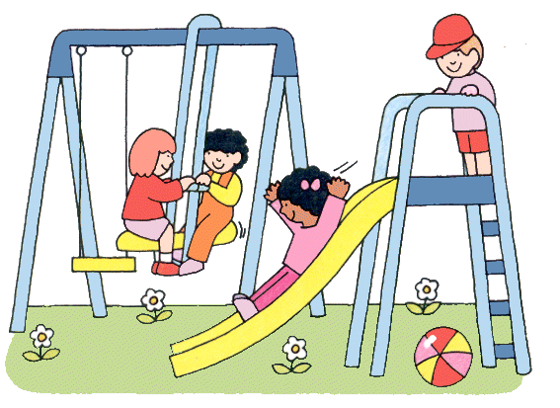

Everywhere | Keep hands, feet, and objects to  yourself  Walk from place to place on campus | Use kind and appropriate school  language to all school staff and parents  Do not bully  Treat other as you want to be treated  Apologize when you make a mistake and accept others’ apologies | Listen to and be respectful of all  school staff and parents  Dress appropriately for school
Cafeteria | Walk in a straight line  Keep space between you and the people  around you  Stay seated  Raise a hand for assistance | Sit at your assigned table  Allow anyone to sit next to you  Don’t touch others’ food  Use quiet voices | Eat your lunch  Pick up food and trash -throw it away  Remain quiet for dismissal
Playground | Play games that do not involve  chasing or direct contact  Stay in boundaries  Follow yard supervisors’ directives  Stand in a straight and quiet line while waiting for your teacher | Play fairly  Follow game rules  Allow everyone to play  Invite others to play with you  Take turns | Freeze and squat down for the first  whistle  Line up quickly without running when  the second whistle blows  Leave equipment where it is
Classrooms | Walk  Keep feet on the floor  Keep floors clear of trash,  backpacks, etc.  Use materials appropriately | Raise your hand and wait to speak  Speak respectfully to others  Respect the rights and properties of others | Be a professional student  Be here on time everyday  Learn with your ears, eyes, & whole body  Do your homework and complete all  assigned work to the best of your ability  Follow directions the first time
Bathrooms | Keep water in the sink  Throw trash in the garbage cans,  not the toilets or floor  Keep feet on the floor | Respect privacy - stay out of stalls  of other students  Do not play in the bathroom | Use the bathroom quickly at an appropriate time - during recess
Office | Walk in quietly and stand patiently at the counter | Wait your turn at the counter | Show your office pass  State your name and business when asked
Computer  Lab | Protect your online identity –  never share personal information  Protect passwords  Stay on “safe” website links provided on Computer Lab homepage | Don’t be a Cyberbully Never send or  respond to mean/insulting messages  Use good “netiquette” – the informal rules of online courtesy | Protect computers from damage.  Keep fingers on keyboard and off  monitor  Keep all food and drink (including gum) out of the lab.
Library | Walk  Push in chairs  Ask for help if you need to reach an item | Use your “library voice”  Use shelf markers  Keep books on outer edge of shelf | Clean up table – stack books in center  Put markers in order on shelf  Return/re-check out books on time
The Mack Way School Rules and Expectations

Be Safe | Be Respectful | Be Responsible

CHARLES MACK POSITIVE BEHAVIOR INTERVENTIONS AND SUPPORTS

Step 1 | Verbal Redirect/Reteaching
Step 2 | Reflection/Time-out
Step 3 | Refer to Administration
Step 4 | Administration Follow-up


PBIS STEPS (Response to not meeting school-wide expectations)

PBIS INTERVENTIONS
TIER I INTERVENTIONS | TIER II INTERVENTIONS
Golden Tickets | Teacher/Student Conference
Golden Lunchbox | Behavioral Student Study Team (SST)
Teaching School-wide Expectations | Multi-Tiered Systems of Support (MTSS) Form
Classroom Rules/Expectations | Check-in Check-out (CICO)
Classroom Rewards | Counselor Support
Positive Parent Contact | Mental Health Therapist Support
Campus Climate/Signage | Buddy Room/Time-out
Teacher greeting at the door | Student Mentors
Fist-bump Fridays | Office Referral/Administrative Support
Parent communication | Suspensions
Regular breaks in the classroom
Character Education Assemblies

SCHOOL SAFETY

Our goal is to maintain a positive and safe learning environment. We have a Safe School Plan and an Emergency Preparedness Plan, posted in every classroom, to ensure an environment that is conducive to learning and prepares us to deal with emergency situations. In addition, the following safety topics and procedures are addressed in assemblies or through classroom discussions: Fire Safety, School Bus Safety, Safety Walking To and From School, Bicycle Safety, School Safety Drills (Evacuation, Lock Down, and Earthquake).

It is with safety in mind that we have established rules regarding school access and we ask for everyone’s cooperation. Traffic Enforcement officers patrol our area and will cite drivers who violate laws.
- Use the crosswalk areas when crossing the street.
- Do not block the crosswalk.
- Do not block the flow of traffic by double parking or stopping in the No Parking Zone, Bus Zone, fire lane, or driving lane next to drop off in the front of the school.
- Never leave vehicles unattended, unless in an approved parking space.
- Do not block or move traffic cones. That is a traffic misdemeanor.
- Please do not drop students off in the parking lot without parking in an authorized stall.

The Board of Education has authorized schools to send out information on a school accident insurance policy. Accidents do occur at school and since the school district, by law, cannot pay for medical or hospital expenses incurred as a result of them, we recommend this insurance policy. The policies will be sent home with each student during the first week of school. If you have any questions, please call our office.

SCHOOL SITE COUNCIL

The School Site Council is responsible for the development, monitoring, and evaluation of the School Improvement Local Control and Accountability Plan (LCAP), which is described in the School Programs and Services section of this handbook. The School Site Council meets regularly, and is composed of five each of staff and parent/community members, who normally serve a two-year term. Meeting announcements and agendas are posted in the office, on the school website and on the marquee three days before meetings. Everyone is welcome to attend.

SPEECH/LANGUAGE THERAPY

Our school district provides a Speech and Language specialist, who is trained to assist students with identifiable, moderate to severe problems in these areas. Students receive instruction in small groups or in their classroom, according to their Individualized Educational Program goals.

STUDENT RECOGNITION & AWARDS

Academic achievement, good citizenship, punctuality, and attendance are encouraged and rewarded. Each trimester, students are recognized for District Honor Roll, reading, math, Character Development, and Perfect Attendance. Families of students receiving awards will receive an invitation prior to the assembly.



