Pacific Grove Unified School District

School Bus Routes

Home to School and Return

2025/2026

HOME TO SCHOOL BEACH TRACT

**AM Route #1 Beach Tract to PGMS**

7:03 AM- Stuart & Seaview

7:09 AM- 3rd St. & Central

7:11 AM- Bayview & Jewell

7:13 AM- Del Monte & Esplanade

7:16 AM- Asilomar & Arena

**7:24 AM- PGMS Drop Off**

**AM Route #2 Beach Tract to PGMS**

7:29 AM- Stuart & Seaview

7:34 AM- 3rd St. & Central

7:36 AM- Bayview & Jewell

7:38 AM- Del Monte & Esplanade

7:41 AM- Asilomar & Arena

**7:50 AM- PGMS Drop Off**

**AM Route #3 Beach Tract to Elementary Schools**

8:00 AM- Stuart & Seaview

8:05 AM- 3rd & Central

8:07 AM- Bayview & Jewell

8:09 AM- Del Monte & Esplanade

8:12 AM- Lighthouse & Jewell

**8:26 AM- Drop off at Robert Down**

8:33 AM- Ransford & Syida

**8:37 AM- Forest Grove Drop Off**

**ALL TIMES ARE APPROXIMATE**

**Please arrive at the bus stop 5 minutes prior to the bus’s arrival time. The bus departs when all students at the stop are safely on the bus.**

Returns

**Afternoon Route #4 Kindergarten/TK to Beach Tract**

**2:05 PM- Robert Down**

Stuart & Seaview

Eardley & Junipero

3rd & Central

Bayview & Jewell

Del Monte & Esplanade

Lighthouse & Jewell

Asilomar & Arena

**Afternoon Route #5 Elementary and Middle School to Beach Tract**

**3:20 PM- Robert Down**

**3:25 PM- Middle School (wait for transfers)**

Stuart & Seaview

**Robert Down**

3rd St. & Central

Bayview & Jewell

Del Monte & Esplanade

Lighthouse & Jewell

Asilomar & Arena

THURSDAYS ONLY

**Afternoon Route #6 Elementary and Middle School to Beach Tract**

**2:05 PM- Robert Down**

**2:10 PM- Middle School (wait for transfers)**

Stuart & Seaview

**Robert Down**

3rd St. & Central

Bayview & Jewell

Del Monte & Esplanade

Lighthouse & Jewell

Asilomar & Arena

**ALL TIMES ARE APPROXIMATE**

**Please arrive at the bus stop 5 minutes prior to the bus’s arrival time. The bus departs when all students at the stop are safely on the bus.**

MINIMUM DAY

**Elementary to Beach Tract**

**12:20 PM- Robert Down**

**12:25 PM- Middle School (wait for transfers)**

Stuart & Seaview

**Robert Down**

3rd St. & Central

Bayview & Jewell

Del Monte & Esplanade

Lighthouse & Jewell

Asilomar & Arena

**ALL TIMES ARE APPROXIMATE**

**Please arrive at the bus stop 5 minutes prior to the bus’s arrival time. The bus departs when all students at the stop are safely on the bus.**

HOME TO SCHOOL DEL MONTE PARK & PB

**AM Route #1 Del Monte Park & Pebble Beach to Middle School**

6:56 AM- Funston & Bena Vista (on Funston @ stop sign)

6:57 AM- Montecito & Miles

6:58 AM- David & Buena Vista

7:00 AM- Arkwright & Moreland

7:10 AM- Sloat & Mestres

7:11 AM- Sloat & Strawberry Hill

7:13 AM- Bird Rock & Colton

7:14 AM- Colton & Arrowhead

7:15 AM- Congress & Ortega

**7:20 AM- PGMS Drop Off**

**AM Route #2 Del Monte Park & Pebble Beach to Middle School**

7:27 AM- Funston & Bena Vista (on Funston @ stop sign)

7:28 AM- Montecito & Miles

7:29 AM- David & Buena Vista

7:31 AM- Arkwright & Moreland

7:41 AM- Sloat & Mestres

7:42 AM- Sloat & Strawberry Hill

7:44 AM- Bird Rock & Colton

7:45 AM- Colton & Arrowhead

7:46 AM- Congress & Ortega

**7:53 AM- PGMS Drop Off**

**AM Route #3 Del Monte Park & Pebble Beach to Elementary Schools**

8:08 AM- Sloat & Mestres

8:09 AM- Sloat & Strawberry Hill

8:11 AM- Bird Rock & Colton

8:12 AM- Colton & Arrowhead

8:13 AM- Congress & Ortega

8:19 AM- Buena Vista & Funston (mid block)

8:21 AM- Montecito & Miles

8:23 AM- David Ave. & Buena Vista

8:25 AM- Arkwright & Moreland

**8:30 AM- Drop off at Forest Grove**

**8:35 AM- Drop off at Robert Down**

**ALL TIMES ARE APPROXIMATE**

**Please arrive at the bus stop 5 minutes prior to the bus’s arrival time. The bus departs when all students at the stop are safely on the bus.**

RETURNS

**Afternoon Route #4 Kindergarten/TK to Del Monte Park & Pebble Beach**

**2:00 PM- Forest Grove**

Ransford & Syida

Arkwright & Moreland

Buena Vista & Funston

Montecito & Miles

Congress & Ortega

Sloat & Mestres

Sloat & Strawberry Hill

Bird Rock & Colton

Colton & Arrowhead

**Afternoon Route #5 Middle School & Elementary to Del Monte Park & Pebble Beach**

**3:15 PM- Forest Grove**

**3:25 PM- Middle School (wait for transfers)**

Ransford & Syida

Arkwright & Moreland

Buena Vista & Funston

Montecito & Miles

**Forest Grove**

Congress & Ortega

Sloat & Mestres

Sloat & Strawberry Hill

Bird Rock & Colton

Colton & Arrowhead

THURSDAYS ONLY

**Afternoon Route #6 Elementary and Middle School to Del Monte Park & Pebble Beach**

**2:00 PM- Forest Grove**

**2:10 PM- Middle School (wait for transfers)**

Ransford & Syida

Arkwright & Moreland

Buena Vista & Funston

Montecito & Miles

**Forest Grove**

Congress & Ortega

Sloat & Mestres

Sloat & Strawberry Hill

Bird Rock & Colton

Colton & Arrowhead

Minimum Day

**Elementary to Del Monte Park & Pebble Beach**

**12:15 PM- Forest Grove**

**12:25 PM- Middle School (wait for transfers)**

Ransford & Syida

Arkwright & Moreland

Buena Vista & Funston

Montecito & Miles

**Forest Grove**

Congress & Ortega

Sloat & Mestres

Sloat & Strawberry Hill

Bird Rock & Colton

Colton & Arrowhead

**ALL TIMES ARE APPROXIMATE**

**Please arrive at the bus stop 5 minutes prior to the bus’s arrival time. The bus departs when all students at the stop are safely on the bus.**

PICTURES OF BUS STOPS

BEACH TRACT

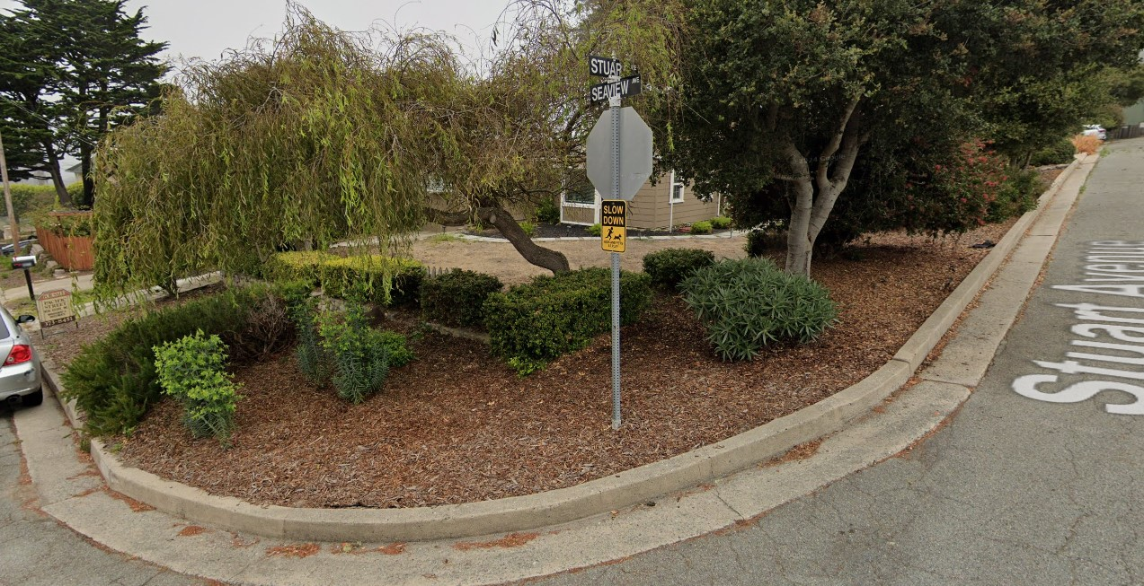

**Stuart & Seaview**

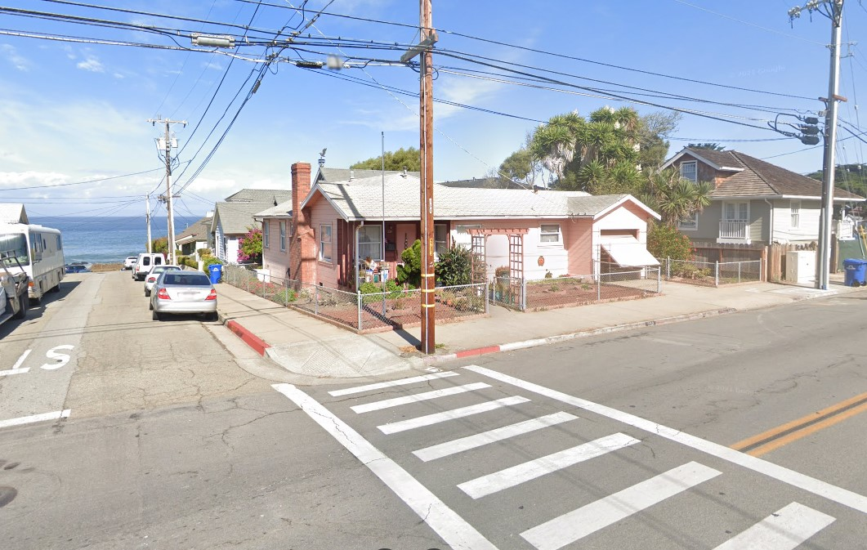

**3rd & Central**

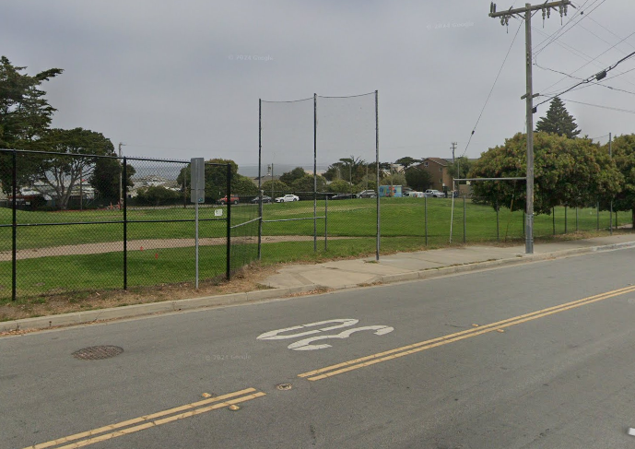

**Bayview & Jewell**

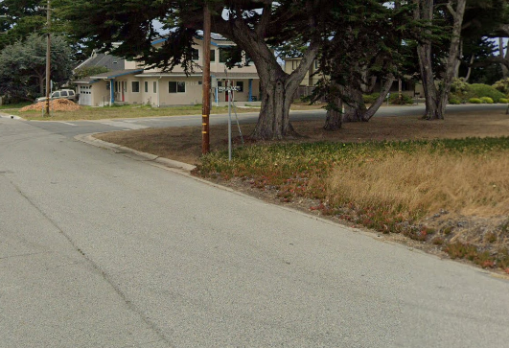

**Del Monte & Esplanade**

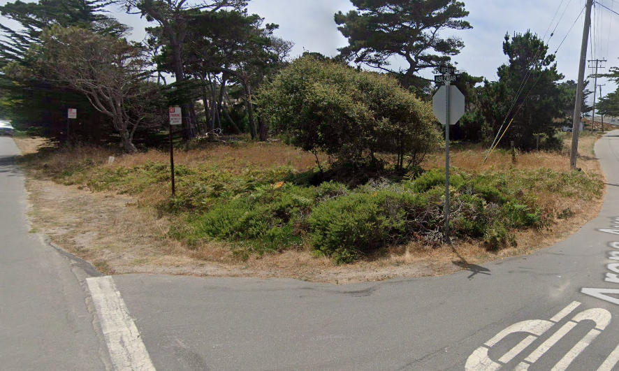

**Asilomar & Arena**

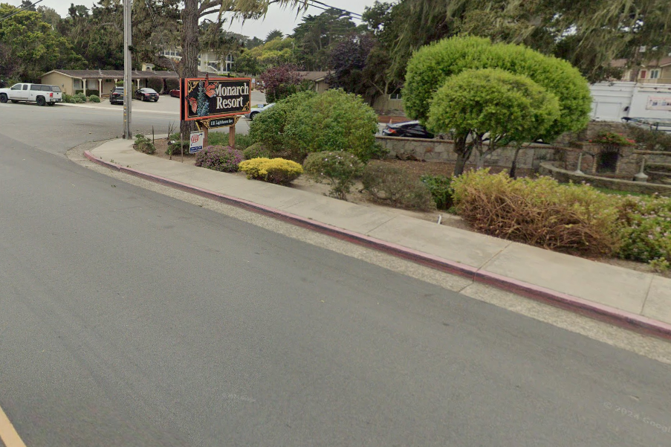

**Lighthouse & Jewell**

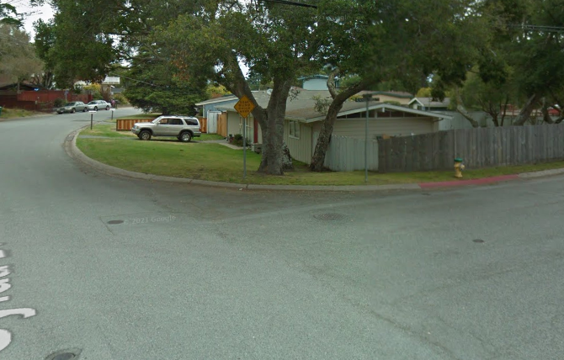

**Ransford & Syida**

PICTURES OF BUS STOPS

DEL MONTE PARK & PEBBLE BEACH

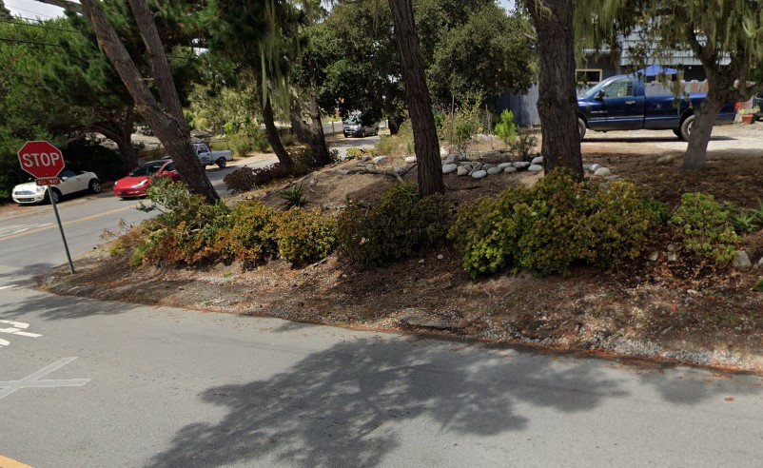

**Funston & Buena Vista (PGMS)**

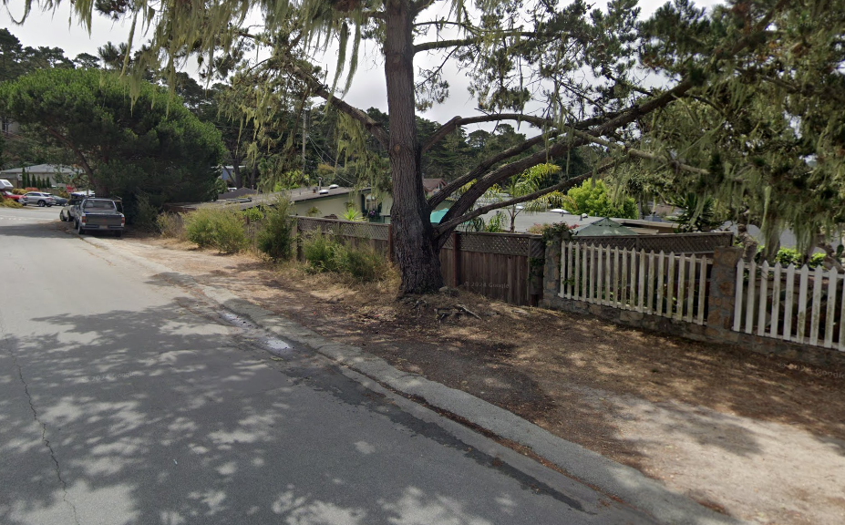

**Buena Vista & Funston-mid black (Elementary)**

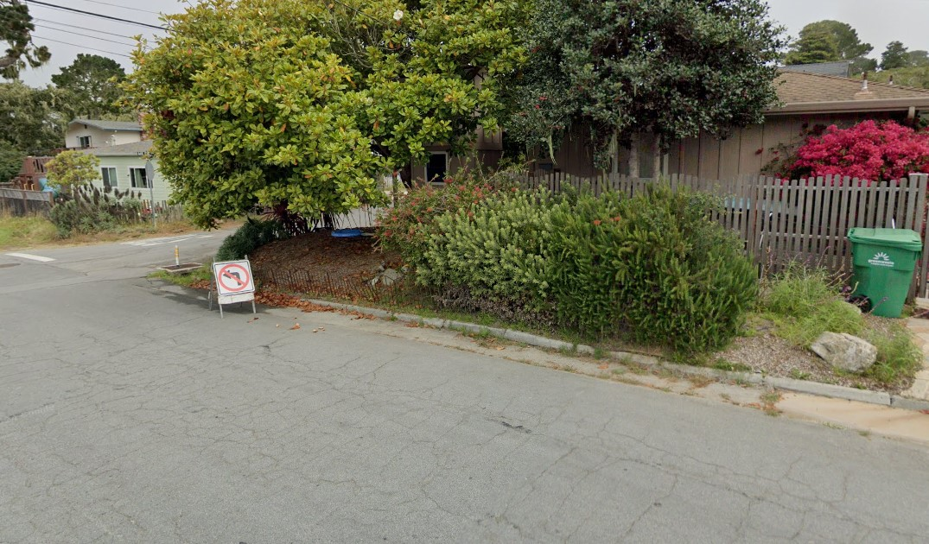

**Montecito & Miles**

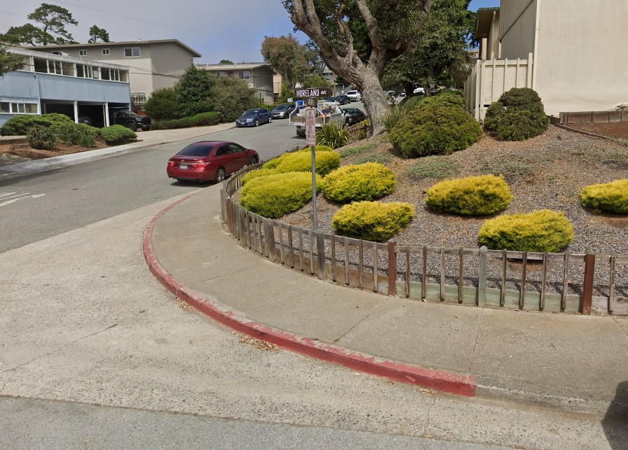

**Arkwright & Moreland**

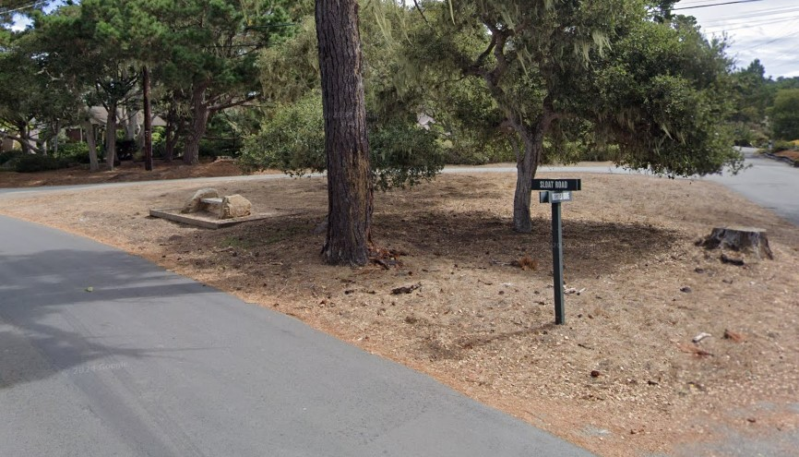

**Sloat & Mestres**

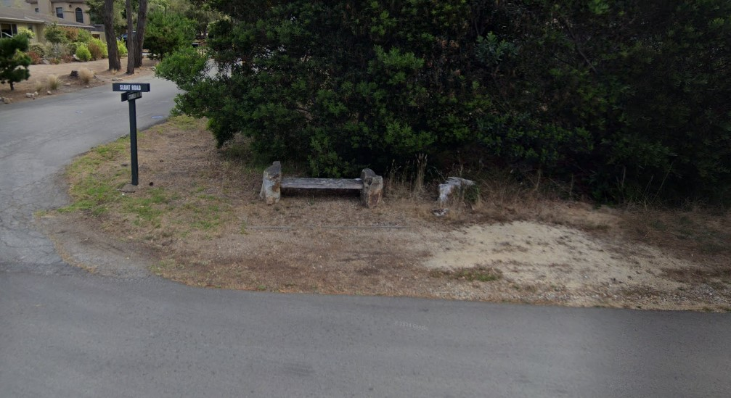

**Sloat & Strawberry Hill**

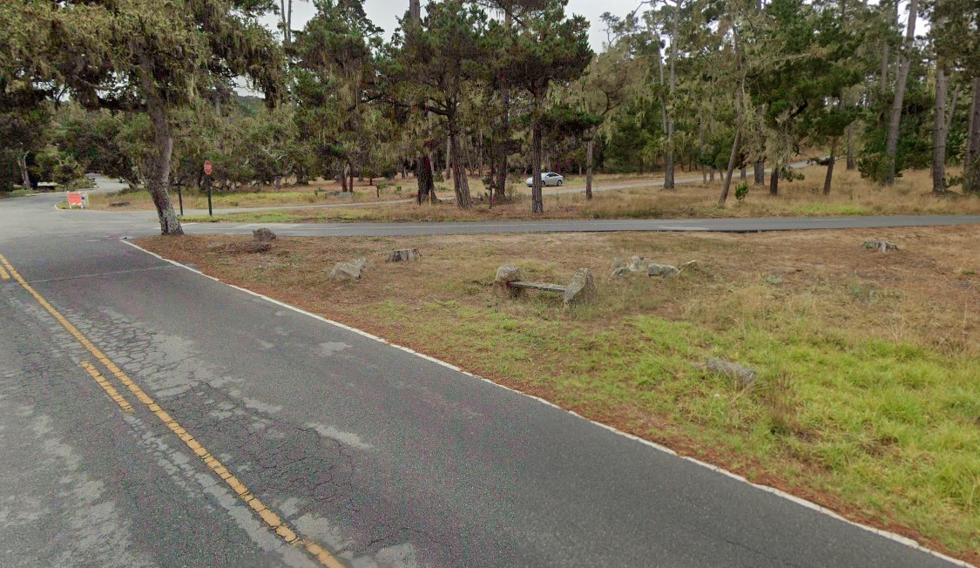

**Bird Rock & Colton**

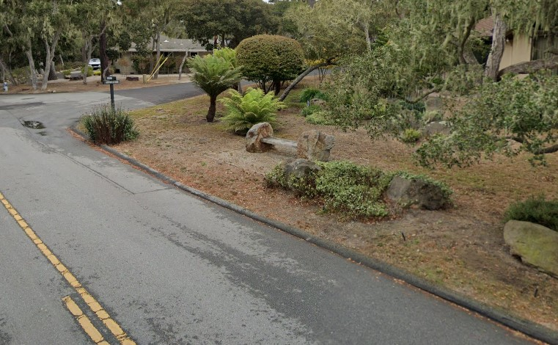

**Colton & Arrowhead**

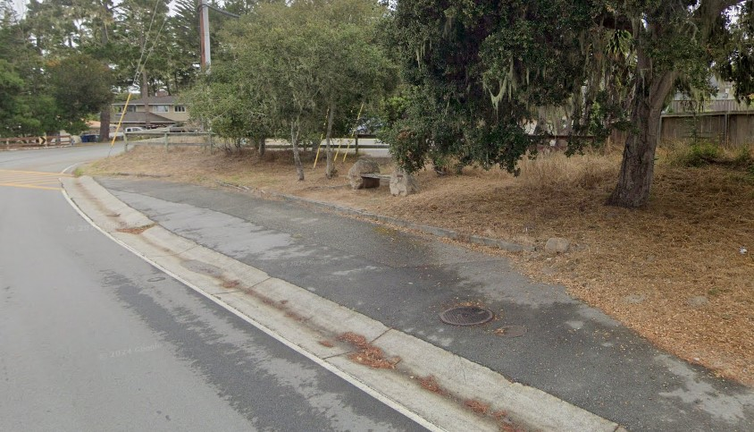

**Congress & Ortega**